BUAN/OPRE 6398.003 Prescriptive Analytics

Homework 10

Team 6

Taeho Kim

Lin Li

Thomas Trieu

Manasa Venkatesh

Yu-Min Wang

Madhuri Ramamohan Kashyap

2.

(1)  Reelected Not elected

Sell Half 720,000 105,000

Sell All 390,000 390,000

(2)

Reelected Not elected Maximin Maximax

Sell Half 720,000 105,000 105,000 720,000

Sell All 390,000 390,000 390,000 390,000

(a)Maxi-min: Sell All since 390,000 > 105,000

(b)Maxi-max: Sell Half since 720,000 > 390,000

(c) Min-max regret : Sell Half because 285,000 < 330,000

Reelected Not elected Mini-Max regret

Sell Half 0 285,000 285,000

Sell All 330,000 0 330,000

(3)

Reelected Not elected

Sell Half 720,000 105,000

Sell All 390,000 390,000

0.55 0.45

(a)MO : Sell Half since when reelected 720,000 > 390,000

(b)EV :

Sell Half: 0.55x720,000 + 0.45x105,000 = 443,250

Sell All: 0.55x390,000 + 0.45x390,000 = 390,000

John should choose Sell Half because 443,250 > 390,000

(c) ER:

Regret matrix

Reelected Not elected ER

Sell Half 0 285,000 128,250

Sell All 330,000 0 181,500

0.55 0.45

John should select Sell Half since 128,250 < 181,500

(4) EVPI :

Reelected Not elected

Sell Half 720,000 105,000

Sell All 390,000 390,000

0.55 0.45

Expected payoff with perfect information = 0.55x720,000 + 0.45x390,000 = 571,500

Expected payoff with EV criterion = 443,250

EVPI = abs(571500-443250) = 128,250

John should not accept the offer because 160,000 > 128,250

3. Optimal solution is seeded because the expected damage of seeded is $102.32 (million) < $112.89 (million) of not seeded

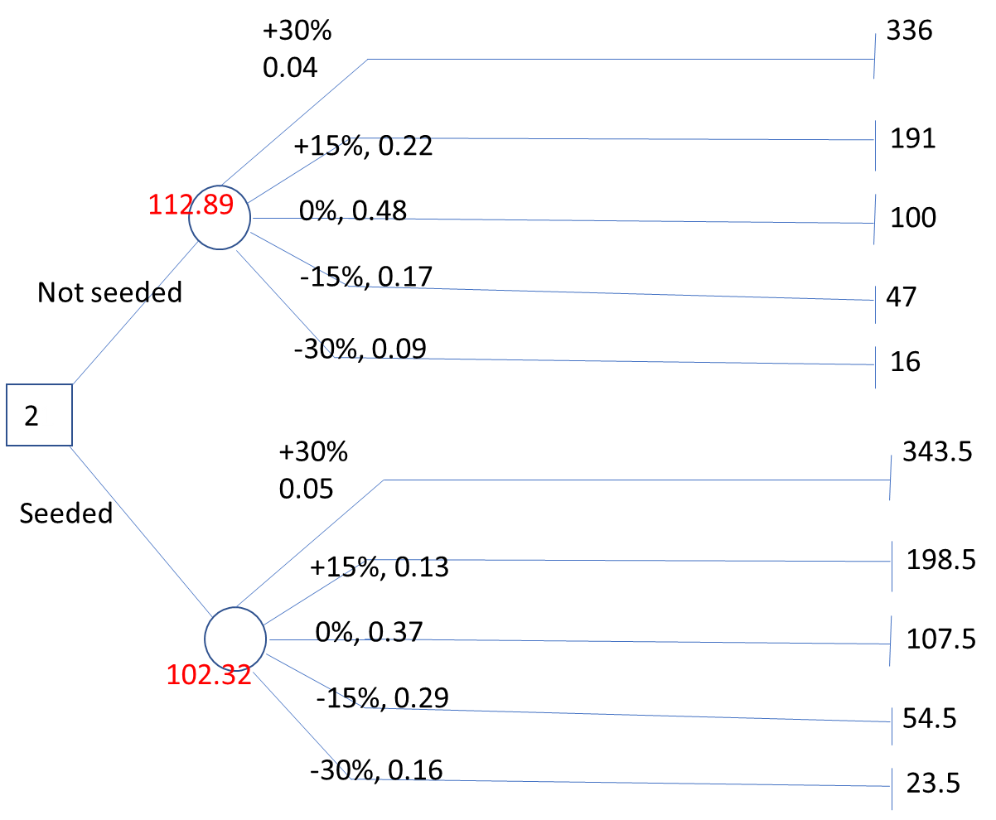

4. She should wait in the first year. If the house price increases, still wait in the 2nd year. If the house price decreases, then sell it at the beginning of year 2. The optimal expected payoff is $211,000

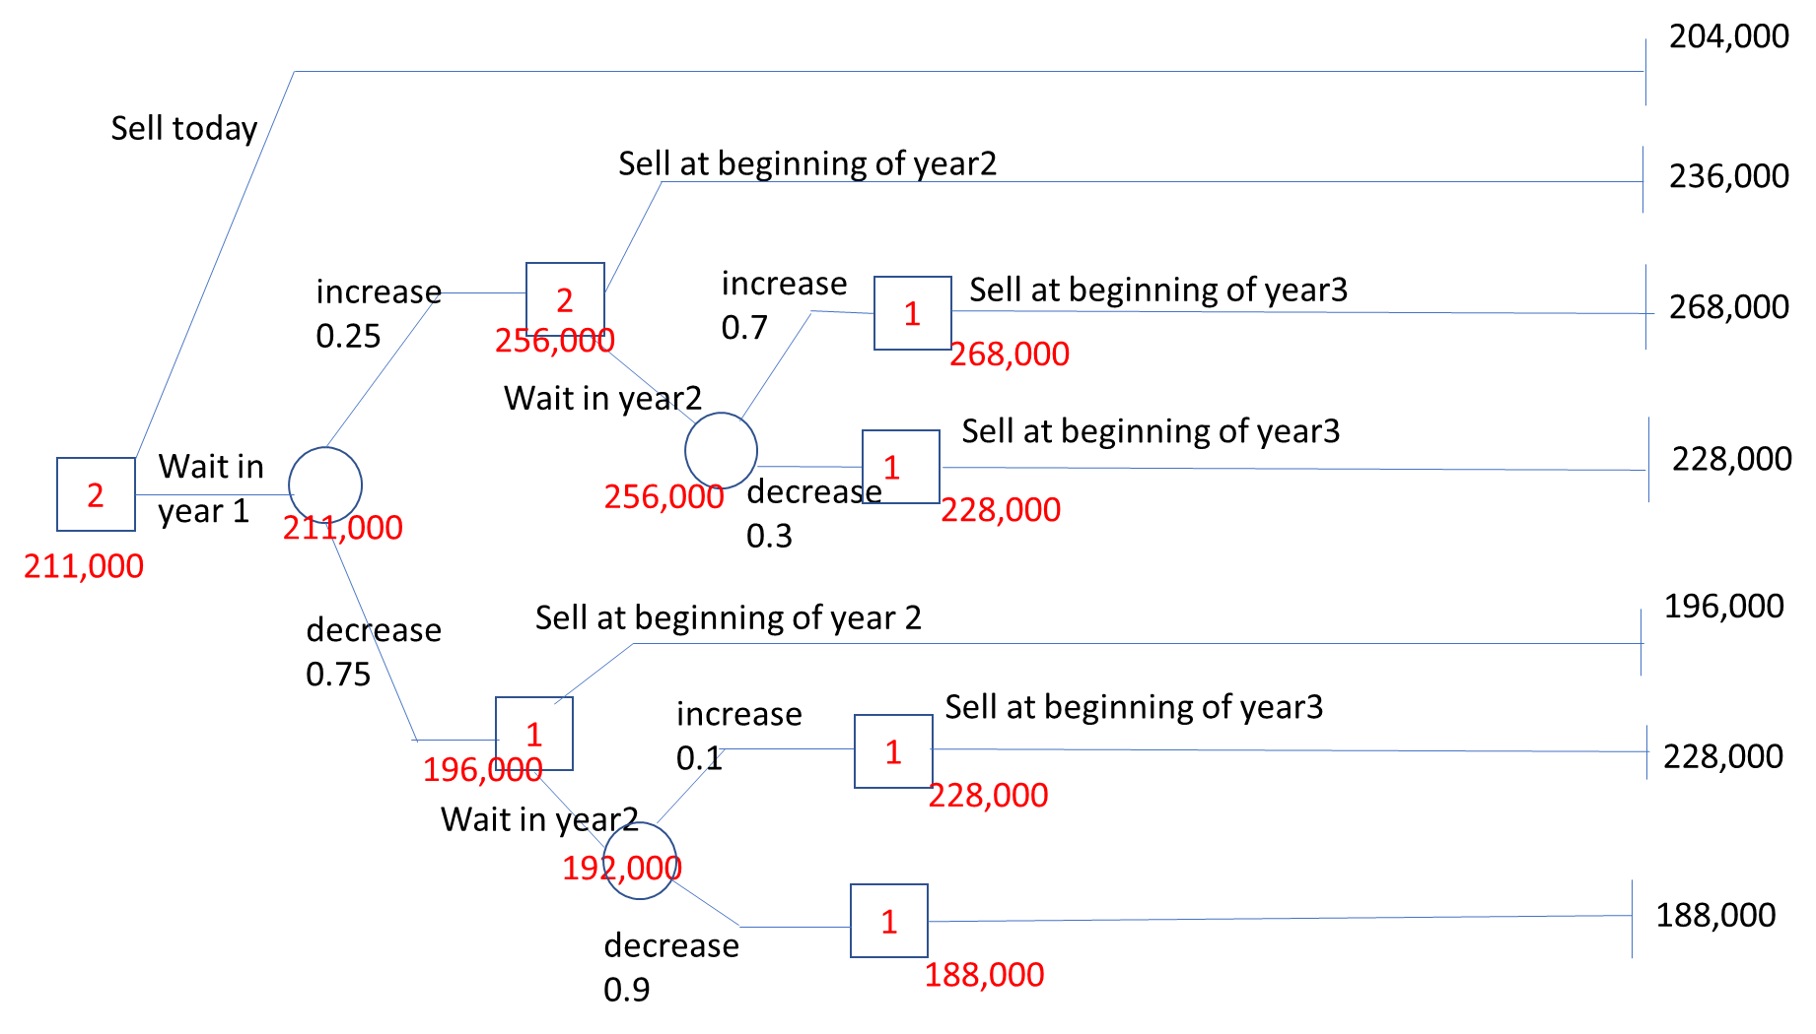

5. The CEO should go test. If the test result is favorable, go national. If the test result is unfavorable, abort. The optimal expected payoff = $ 390,000

