BUAN/OPRE 6398.003 Prescriptive Analytics

Homework 11

Team 6

Taeho Kim

Lin Li

Thomas Trieu

Manasa Venkatesh

Yu-Min Wang

Madhuri Ramamohan Kashyap

2.

(1)

Path Length Slack

1-2-3-9 3+7+9=19 11

1-2-3-7-8-9 3+7+7+7+3=27 3

1-2-4-6-7-8-9 3+5+4+3+7+3=25 5

1-2-4-5-7-8-9 3+5+3+8+7+3=29 1

1-2-4-5-9 3+5+3+8=19 11

1-2-5-9 3+9+8=20 10

**1-2-5-7-8-9 3+9+8+7+3=30 0**

Critical path = 1-2-5-7-8-9

(2) A, D, I, K, M

(3) 30 weeks

(4) As shown in the table above

(5) If J delays by 6 weeks, it will NOT lengthen the whole project duration because 6 < 11 (slack)

(6) D is critical activity. So if D delays by 1 week, the whole project duration will delay by 1 week.

3. (1) Critical path = 1-2-5-7, critical activities = A,D,G. Project duration=22

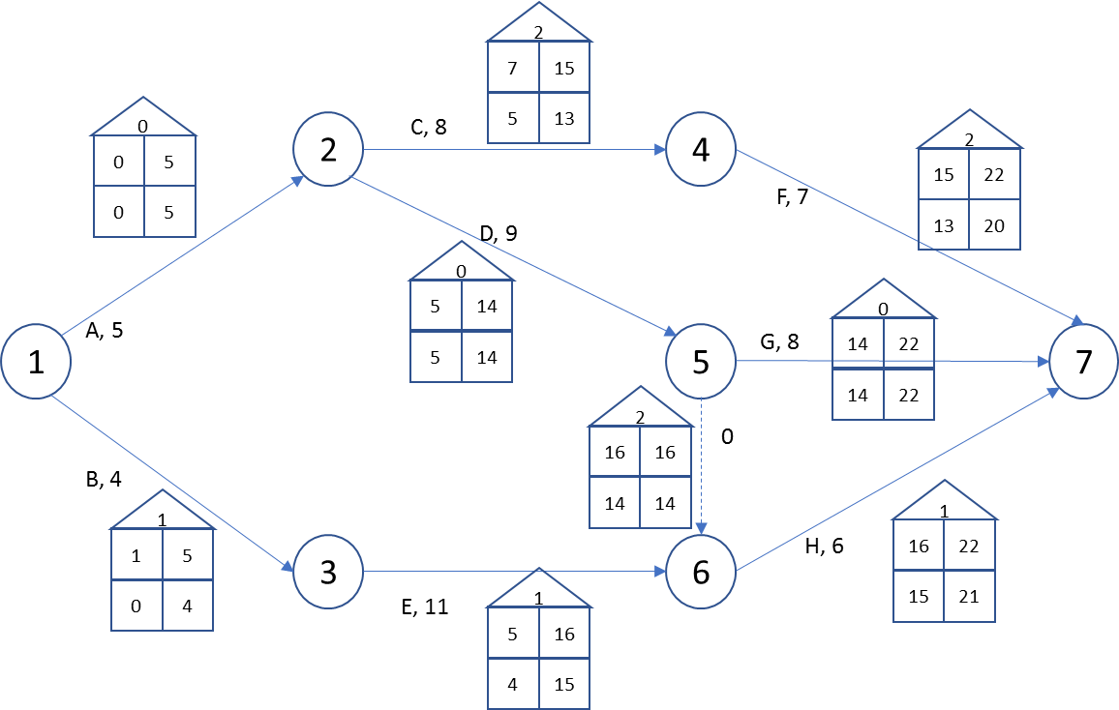

(2) Let I be an imaginary activity starting at node 7 and finishing at node 8, Y denote the dummy activity.

Let Xi denote the ES of activity I, where I = A, B, ….I, Y

Minimize Z = XI

Subject to: XA=0

XB=0

-XA + XC $≥$ 5

-XA + XD $≥$ 5

-XB + XE $≥$ 4

-XC + XF $≥$ 8

-XD + XG $≥$ 9

-XE + XH $≥$ 11

-XY + XH $≥$ 0

-XD + XY $≥$ 9

-XF + XI $≥$ 7

-XG + XI $≥$ 8

-XH + XI $≥$ 6

Xi $≥0 , i=A,B,….I$, Y

(3)



(4) Yes, project duration =22, consistent by computational algorithm and by LP.