MIS 6320.501 - ACCT 6320.501- BUAN 6320.501- OPRE 6393.501
Database Foundations
Fall 2016
ASSIGNMENT 3
Due Date: November 9, 2016 (Beginning of the class)

This assignment involves writing single-table SQL Select statements to query the data contained in a simple database. The relational schema and tables with sample data for this database are given below. As you can see from the relational model, this database has two tables: Product_T and Vendor_T. The product table includes the records of products while the vendor table contains the records of vendors. Each product (i.e., product with a unique product code) can be supplied by a single vendor only. A vendor may supply many products. The vendor table contains the list of vendors who are referenced in the product table. Product is optional for vendor (i.e., a vendor does not have to supply a product). A few products are made in-house. Therefore, vendor is optional for product (i.e., a product is not necessarily supplied by a vendor).

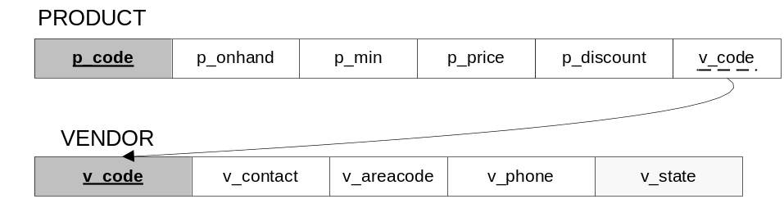

Product_T
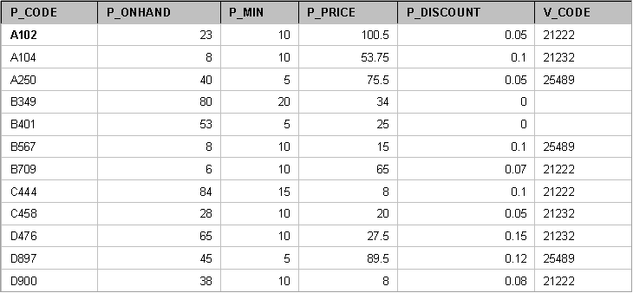

Vendor_T
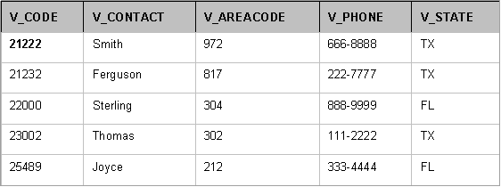

Here are the definitions of attributes and their data types.
p_code : product code of the product (text)
p_onhand : quantity available in inventory (number)
p_min : minimum stock quantity (number)
p_price : unit price of the product in $ (number)
p_discount : product discount rate (number)
v_code : vendor code of the vendor (text)
v_contact : contact name of the vendor (text)
v_areacode : area code of the vendor (text)
v_phone : phone number of the vendor (text)
v_state : state of the vendor (text)

Please write single-table SQL Select queries to answer the following questions.

- List the products and corresponding vendor codes for products whose inventory is less than the minimum stock quantity or products that are priced less than $75 with discount greater than 5%.

- List the product code and price for products for which the dollar value of the on hand inventory is greater than $1000.

- List the product code, price and discount rate of all products in a descending order of their price.

- Display all product attributes for every product with a product code starting with a ‘B’ in an ascending order of their price.

- List the distinct codes of vendors supplying products for which minimum stock quantity is less than 10.

- How many products are there in the product table?

- What are the total quantity of products on hand, the average price of products, the minimum discount rate and the maximum discount rate available?

- For each vendor, list the minimum price and the average discount rate for their products for which the quantity on hand is less than the minimum stock quantity.

- For each available discount rate of less than 10%, show the minimum price and the maximum price of products with the same discount rate.

- List the minimum and maximum prices of products for each vendor for vendors who supply more than 3 items.

Please write these queries in a text file (such as MS Word). Submit a soft copy of the file (only one submission for each group) by the due date stated above (refer to the class syllabus for late submission penalties) on eLearning.

You are not required to write these queries in Oracle Application Express, though you may want to build this simple database and test your queries in Oracle Application Express before submitting your text file for grading.

Get in touch with your group members. It is your responsibility to contact your group members in a timely manner to work on this assignment as a group. If your group completes the assignment without you, they can choose not to include your name in the assignment and you will be required to do the assignment alone and submit your own copy. No excuses!

Please note that you can submit only once. Therefore, do not submit your solution if you think that you can modify it later on before the deadline.

If you have any questions, please do not hesitate to contact me.

GOOD LUCK!

