MIS 6320.501 - ACCT 6320.501- BUAN 6320.501- OPRE 6393.501
Database Foundations
Fall 2016
ASSIGNMENT 4
Due Date: November 30, 2016 (Beginning of the class)

This assignment involves writing multiple-table SQL Select statements to query the data contained in a simple database. The relational schema and tables with sample data for this database are given below. As you can see from the relational model, this database has two tables: Product_T and Vendor_T. The product table includes the records of products while the vendor table contains the records of vendors. Each product (i.e., product with a unique product code) can be supplied by a single vendor only. A vendor may supply many products. The vendor table contains the list of vendors who are referenced in the product table. Product is optional for vendor (i.e., a vendor does not have to supply a product). A few products are made in-house. Therefore, vendor is optional for product (i.e., a product is not necessarily supplied by a vendor).

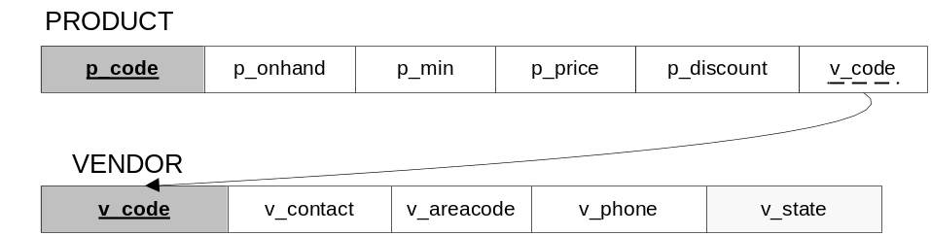

Product_T
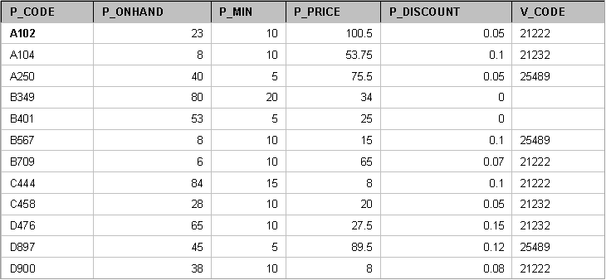

Vendor_T
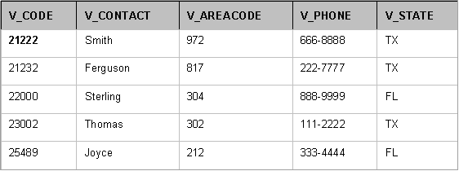

Here are the definitions of attributes and their data types.
p_code : product code of the product (text)
p_onhand : quantity available in inventory (number)
p_min : minimum stock quantity (number)
p_price : unit price of the product in $ (number)
p_discount : product discount rate (number)
v_code : vendor code of the vendor (text)
v_contact : contact name of the vendor (text)
v_areacode : area code of the vendor (text)
v_phone : phone number of the vendor (text)
v_state : state of the vendor (text)

Please write multiple-table SQL Select queries (i.e., Join and/or Subquery) to answer the following questions.

- Which products are priced more than the average price? Display product code and product price.

- List the products for which either the quantity on hand is minimum or the discount rate is maximum. Display all product-related attributes.

- What are the products supplied by the vendors of products having product codes starting with a ‘B’? Display all product-related attributes.

- List the contact person, area code and phone number for every vendor who supplies at least one product. Display the same vendor information only once.

- What are the average price and the maximum discount available for products from vendors located in Texas?

- Get the contact person, area code and phone number of vendors for products whose quantity on hand is less than the minimum stock quantity. Display the same vendor information only once.

- List all products supplied by the vendor with the highest-priced product. Include vendor details together with product details.

- Get the detail of the vendor who has supplied the product for which the dollar value of the on hand inventory is the highest.

- For each vendor, list the product codes of products supplied along with vendor code and vendor contact name. Display vendor information even if there is no product currently supplied by the vendor. Sort the results by vendor code.

- Display the phone number (with area code) of each vendor whose average price of supplied products is greater than the average price of the products manufactured in house.

Please write these queries in a text file (such as MS Word). Submit a soft copy of the file (only one submission for each group) by the due date stated above (refer to the class syllabus for late submission penalties) on eLearning.

You are not required to write these queries in Oracle Application Express, though you may want to build this simple database and test your queries in Oracle Application Express before submitting your text file for grading. Keep in mind that you MUST use the Oracle 11g syntax, which is described in lecture notes, in your queries.

Get in touch with your group members. It is your responsibility to contact your group members in a timely manner to work on this assignment as a group. If your group completes the assignment without you, they can choose not to include your name in the assignment and you will be required to do the assignment alone and submit your own copy. No excuses!

Please note that you can submit only once. Therefore, do not submit your solution if you think that you can modify it later on before the deadline.

If you have any questions, please do not hesitate to contact me.

GOOD LUCK!

