CHAPTER 1

What is a project?
Any planned undertaking that takes or consumes resources, has a starting and ending time, results in a finished product.

Two essential features of a project that must be present in every project:
- All projects must be planned out in advance, if they are to be successful.
- The execution of the project must be controlled to ensure that the desired results are achieve.

Activity or Task
This is the smallest unit of work effort within the project and consumes both time and resources which are under the control of the project management.

Project Management
The use of techniques and skills in planning and controlling tasks and resources needed for the project from both inside and outside the organisation to achieve results.
- The purpose of project management is to achieve successful completion with the resources available.

Characteristics of a successfully completed project
- Completed on time.
- Completed within its cost budget.
- Performs to a technical or performance criteria

Purpose of Project Management
- To achieve successful project completion with the resources available.
- The effectiveness of project management is critical in ensuring the success of any project.
- Planning, control and implementation are some of the areas of responsibility for the project manager.

Successful Project
To be successful, a project must have the following characteristics:

- A clearly defined business objective.
- A partnership approach.
- A project sponsor.
- Support of senior management.
- Regular progress reporting.
- Consistent progress reporting.
- A proven project management methodology.
- Benefits realization.

Responsibilities of a project Manager
Planning all aspects of the project.
- Controlling the organisation of manpower needed by the project.
- Controlling the basic technical definition of the project, ensuring that technical versus cost trade-off is determined, and the specific areas where optimization is necessary.
- Leading the people and organizations assigned to the project at any given point in time.
- Monitoring performance, costs, and efficiency.
- Completing the project on schedule and within costs, these being the overall standards by which performance of the project manager is evaluated.

Reasons for project failures
- Project goals are not clearly defined.
- Constraints arising from the different objectives of short-time scale, resource availability, quality factors and human factors.

Problems with project Goals
- The project sponsor or client has inadequate idea of what the project is about at the start.
- Failure of communication between the client and the project manager, and due to lack of technical knowledge on the part of the clients and use of jargons by the project manager.
- Specifications may be subject to constant change due to problems with individual clients, decision making processes, at the client end, or environmental changes.
- The project goals are unrealistic and unachievable and this may only be realised once the project is started.
- Project may be highly complex and may have a number of objectives that contradict each other.

Properly defined and Achievable Goals
- The client specification is clear and understandable.
- This is done through establishing the objectives of the project.
- This can be validated by finding answers to the following questions:
- What is it that the organisation is setting out to achieve?
- Will the suggested project fulfil these objectives?
Questions?
  - Has all the alternatives been considered and is the choice option the best one available?
  - Has the full effects of the project, both inside and outside the organisation been considered.

SMART Goals
- Specific: Goals are clear to everyone with the basic knowledge of the project.
- Measurable: Goals must have an indicator to show that the goal is achievable.
- Agreed-upon: there must be agreement between users and the project team on the goals.
- Realistic: The goals can be accomplished with resources, knowledge and time available.
- Time-framed: The time needed to accomplish the goal should be determined.

Constraints on the completion of the Project
- Time: There is likely to be some relationship between the time taken for a project and its cost. Trade-off between the 2 constraint factors (time & Cost) may then be necessary.
- Resource Availability: The overall resource available may in theory be insufficient to complete the project. However, there may be difficulties arising from the way in which the project has been scheduled.
- Quality Factors: The project should deliver the goals or products of the right qualities.

Techniques to overcome constraints
- Budgeting
- Project planning
- Project control

Defining a Project
Effective project management involves careful operations and clear thought out processes. Before any tools or techniques can be used in the process of project management, the project must be clearly defined.
The 3 key components that need to be considered and understood are:
- Specific outcomes of the project: e.g. goals, results, deliverables and products.
- Deadlines.
- Established budgets for finances, personnel and equipment’s.
Project life Cycle
Conceive
Define
Start
Perform
Close

Conceive Phase
Is concerned with the idea and the potential for the project.
It is critical because the decision to pursue a project or not is taken according to the measures of the project.
Key questions asked are:
- Should the project be done?
- Can the project be done?

Define Phase
The project plan is the key to defining the project and must include the following:
Reasons for the project.
- Details of results of products.
- Listing of all work or tasks to be performed.
- Detailed schedule of work and tasks.
- Budgets for work
- Assumptions made.
- Contingency plans.

Start Phase
The key tasks in this phase are:
- Assigning people to roles.
- Giving and explaining tasks to all members.
- Defining how the team will perform tasks.
- Setting-up necessary tracking systems.
- Announce project to organisation.

Perform Phase
Tasks done are:
- Comparison of planned and actual project performance is made.
- Problem solving: proactive problem solving can help in avoiding major deviations from planned project work and keeping the deviations within allowed contingency.

Close Phase
This phase involves stopping tasks and accepting or approving results and deliverables.

Common problems with software projects
- Lack of quality standards.
- Lack of measurable milestones.
- Making progress visible is difficult.
- Poor communication.
- Poor documentation.
- Frequent changes of requirements.
- Over budget and late delivery of software.

Project Management and Information Technology Context

Acknowledgments
Notes adapted from Information Technology Project Management (7th Edition) By Kathy
Schwalbe

Learning Outcomes
By the end of this chapter, the learner should be able to:
- Understand the growing need for better project management, especially for information technology (IT) projects
- Explain what a project is, provide examples of IT projects, list various attributes of projects, and describe the triple constraint of project management
- Describe project management and discuss key elements of the project management framework.
- Discuss the relationship between project, program, and portfolio management and the contributions each makes to enterprise success
- Understand the role of project managers by describing what they do, what skills they need, and career opportunities for IT project managers – Describe the project management profession.
Introduction
- New technologies have become a significant factor in many businesses.
- Computer hardware, software, networks, and the use of interdisciplinary and global work teams have radically changed the work environment.
- IT projects involve using hardware, software, and networks to create a product, service, or result.
- Today’s companies, governments, and non-profit organizations are recognizing that to be successful, they need to use modern project management techniques, especially for IT projects.
- Individuals are realizing that to remain competitive in the workplace, they must develop skills to become good project team members and project managers.
- They also realize that many of the concepts of project management will help them in their everyday lives as they work with people and technology on a day-to-day basis.

Advantages of Using Project Management Techniques
- Better control of financial, physical, and human resources
- Improved customer relations
- Shorter development times
- Lower costs and improved productivity
- Higher quality and increased reliability
- Higher profit margins
- Better internal coordination
- Positive impact on meeting strategic goals
- Higher worker morale

What is a Project?
A project is “a temporary endeavour undertaken to create a unique product, service, or result.”
Operations, on the other hand, is work done in organizations to sustain the business.
Projects are different from operations in that they end when their objectives have been reached or the project has been terminated.

Examples of IT Projects
- A team of students creates a smartphone application and sells it online.
- A company develops a driverless car.
- A small software development team adds a new feature to an internal software application for the finance department.
- A college upgrades its technology infrastructure to provide wireless Internet access across the whole campus.
- A company develops a new system to increase sales force productivity and customer relationship management that will work on various laptops, smartphones, and tablets.
- A television network implements a system to allow viewers to vote for contestants and provide other feedback on programs via social media sites.
- A government group develops a system to track child immunizations.
- A large group of volunteers from organizations throughout the world develops standards for environmentally friendly or green IT.
- A global bank acquires a smaller financial institution and needs to reconcile systems and procedures into a common entity.
- Government regulations require new reporting of commercial business data for a manufacturing company.
- A multinational firm decides to consolidate its information systems into an integrated enterprise resource management approach

Project Attributes
- A project has a unique purpose.
- A project is temporary.
- A project is developed using progressive elaboration.
- A project requires resources, often from various areas.
- A project should have a primary customer or sponsor.
- A project involves uncertainty.

Project Constraints
- Every project is constrained in different ways, often by its scope, time, and cost goals.
- These limitations are sometimes referred to in project management as the triple constraint.
- To create a successful project, a project manager must consider scope, time, and cost and balance these three often-competing goals
- Managing the triple constraint involves making trade-offs between scope, time, and cost goals for a project.
  - E.g. a project manager might need to increase the budget for a project to meet scope and time goals.
- Alternatively, project manager might have to reduce the scope of a project to meet time and cost goals.
- Experienced project managers know that you must decide which aspect of the triple constraint is most important.
- If time is most important, you must often change the initial scope and cost goals to meet the schedule.
- If scope goals are most important, you may need to adjust time and cost goals.

What Is Project Management?
- Project management is “the application of knowledge, skills, tools, and techniques to project activities to meet project requirements.”
- Project managers must strive not only to meet specific scope, time, cost, and quality goals of projects, they must also facilitate the entire process to meet the needs and expectations of people involved in project activities or affected by them.

Project Stakeholders
- Stakeholders are the people involved in or affected by project activities, and include:
  - Project sponsor,
  - Project team, – Support staff,
  - Customers, users, suppliers, and even opponents of the project.
- These stakeholders often have very different needs and expectations.

Project Management Knowledge Areas
Project management knowledge areas describe the key competencies that project managers must develop:
- Project scope management involves defining and managing all the work required to complete the project successfully.
- Project time management includes estimating how long it will take to complete the work, developing an acceptable project schedule, and ensuring timely completion of the project
- Project cost management consists of preparing and managing the budget for the project.
- Project quality management ensures that the project will satisfy the stated or implied needs for which it was undertaken.
- Project human resource management is concerned with making effective use of the people involved with the project.
- Project communications management involves generating, collecting, disseminating, and storing project information.
- Project risk management includes identifying, analyzing, and responding to risks related to the project.
- Project procurement management involves acquiring or procuring goods and services for a project from outside the performing organization.
- Project stakeholder management includes identifying and analyzing stakeholder needs while managing and controlling their engagement throughout the life of the project.
- Project integration management is an overarching function that affects and is affected by all of the other knowledge areas.
Project Management Tools and Techniques
- Thomas Carlyle, a famous historian and author, stated, “Man is a tool-using animal.
- Without tools he is nothing, with tools he is all.”
- As the world continues to become more complex, it is even more important for people to develop and use tools, especially for managing important projects.
- Project management tools and techniques assist project managers and their teams in carrying out work in all 10 knowledge areas.
  - E.g. some popular time-management tools and techniques include Gantt charts, project network diagrams, and critical path analysis.

Knowledge  Area/Category | Tools and Techniques
Scope management | Scope statements, work breakdown structures, statements of work, requirements analyses, scope management plans, scope verification techniques, scope change controls
Time management | Gantt charts, project network diagrams, critical path analysis, crashing, fast tracking, schedule performance measurements
Integration  management | Project selection methods, project management methodologies, stakeholder analyses, work requests, project charters, project management plans, project management software, change requests, change control boards, project review meetings, lessonslearned reports
Cost  management | Project budgets, net present value, return on investment, payback analysis, earned value management, project portfolio management, cost estimates, cost management plans, cost baselines
Quality  management | Quality metrics, checklists, quality control charts, Pareto diagrams, fishbone diagrams, maturity models, statistical methods, test plans
Risk management | Risk management plans, risk registers, probability/impact matrices, risk rankings
Procurement management matrices | Make-or-buy analyses, contracts, requests for proposals or quotes, source selections, supplier evaluation
Communications management |  | plans, kick-off meetings, conflict  management, communications media selection, status and progress reports, virtual communications, templates, project Web sites
Human resource management | Motivation techniques, empathic listening, responsibility assignment matrices, project organizational charts, resource histograms, team building exercises Communications management

Project Management
Despite its advantages, project management is not a silver bullet that guarantees success on all projects.
Project management is a very broad, often complex discipline.
What works on one project may not work on another, so it is essential for project managers to continue to develop their knowledge and skills in managing projects.
It is also important to learn from the mistakes and successes of others.
Project Success
- The project met scope, time, and cost goals.
- The project satisfied the customer/sponsor.
- The results of the project met its main objective, such as making or saving a certain amount of money, providing a good return on investment, or simply making the sponsors happy.
What helps projects succeed?

- User involvement
- Executive support
- Clear business objectives
- Emotional maturity
- Optimizing scope
- Agile process
- Project management expertise
- Skilled resources
- Execution
- Tools and infrastructure

- Project managers play an important role in making projects, and therefore organizations, successful.
- Project managers work with the project sponsors, the project team, and other stakeholders to meet project goals.
- They also work with sponsors to define success for particular projects.
- Good project managers do not assume that their definition of success is the same as the sponsors’.
- They take the time to understand their sponsors’ expectations and then track project performance based on important success criteria.
Program and Project Portfolio Management
- A program is “a group of related projects managed in a coordinated way to obtain benefits and control not available from managing them individually.
- It is often more economical to group projects together to help streamline management, staffing, purchasing, and other work.
Examples of common Programs in the IT field
- Infrastructure
An IT department often has a program for IT infrastructure projects.
This program could encompass several projects, such as providing more wireless Internet access, upgrading hardware and software, and developing and maintaining corporate standards for IT.

Applications development
This program could include several projects, such as updating an enterprise resource planning (ERP) system, purchasing a new off the-shelf billing system, or developing a new capability for a customer relationship management system.
- User support
In addition to the many operational tasks related to user support, many IT departments have several projects to support users.
For example, a project might provide a better e-mail system or develop technical training for users.
What do Program Managers do?
- A program manager provides leadership and direction for the project managers heading the projects within a program.
- Program managers also coordinate the efforts of project teams, functional groups, suppliers, and operations staff supporting the projects to ensure that products and processes are implemented to maximize benefits.
- Program managers are responsible for more than the delivery of project results; they are change agents responsible for the success of products and processes developed by those projects.
Project Portfolio Management
- In many organizations, project managers also support an emerging business strategy of project portfolio management (also called portfolio management), in which organizations group and manage projects and programs as a portfolio of investments that contribute to the entire enterprise’s success.
- Portfolio managers’ help their organizations make wise investment decisions by helping to select and analyse projects from a strategic perspective.
- Portfolio managers may or may not have previous experience as project or program managers.
- It is most important that they have strong financial and analytical skills and understand how projects and programs can contribute to meeting strategic goals

Project management compared to project portfolio management
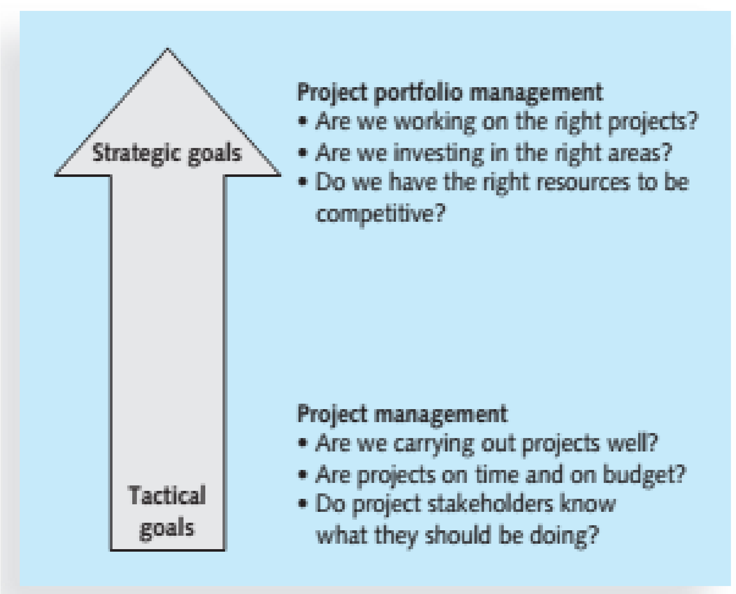

Three basic IT project Portfolio categories
- Venture
Projects in this category help transform the business.
For example, a large retail chain might have an IT project to provide kiosks in stores and similar functionality on the Internet where customers and suppliers could quickly provide feedback on products or services.
This project could help transform the business by developing closer partnerships with customers and suppliers.
- Growth
Projects in this category would help the company grow in terms of revenues.
For example, a company might have an IT project to provide information on its corporate Web site in a new language, such as Chinese or Japanese.
This capability could help the company grow its business in those countries
- Core
Projects in this category must be accomplished to run the business.
For example, an IT project to provide computers for new employees would fall under this category.
The Role of Project Manager
- A project manager can have many different job descriptions, which can vary tremendously based on the organization and the project.
- The job description for a project manager can vary by industry and by organization, but most project managers perform similar tasks regardless of these differences.
The Role of Project Manager
Responsibilities include business analysis, requirements gathering, project planning, budget estimating, development, testing, and implementation. Responsible for working with various resource providers to ensure development is completed in a timely, high-quality, and cost-effective manner.
Suggested Skills for Project Managers
- The Project Management Body of Knowledge
- Application area knowledge, standards, and regulations
- Project environment knowledge
- General management knowledge and skills
- Soft skills or human relations skills
Project environment knowledge
- The project environment differs from organization to organization and project to project, but some skills will help in almost all project environments.
- These skills include understanding change and understanding how organizations work within their social, political, and physical environments.
- Project managers must be comfortable leading and handling change, because most projects introduce changes in organizations and involve changes within the projects themselves.
- Project managers need to understand the organization in which they work and how that organization develops products and provides services
General management knowledge and skills
- They should understand important topics related to financial management, accounting, procurement, sales, marketing, contracts, manufacturing, distribution, logistics, the supply chain, strategic planning, tactical planning, operations management, organizational structures and behaviour, personnel administration, compensation, benefits, career paths, and health and safety practices.
Soft skills or human relations skills
- Achieving high performance on projects requires soft skills, otherwise called human relations skills. Some of these soft skills include effective communication, influencing the organization to get things done, leadership, motivation, negotiation, conflict management, and problem solving
Ethics in Project Management
- Ethics, loosely defined, is a set of principles that guides decision making based on personal values of what is considered right and wrong.
- Making ethical decisions is an important part of project managers’ personal and professional lives because it generates trust and respect with other people.
Ethics in Project Management
Project managers often face ethical dilemmas.
- For example, several projects might involve different payment methods If project managers can make more money by doing their jobs poorly, should they? No! Should a project manager who is personally opposed to the development of nuclear weapons work on a project that helps produce them? Yes! Ethics guide us in making these types of decisions
A Systems View of Project Management
- Even though projects are temporary and intended to provide a unique product or service, you cannot run projects in isolation.
- If project managers lead projects in isolation, it is unlikely that they will ever truly serve the needs of the organization.
- Therefore, projects must operate in a broad organizational environment, and project managers need to consider projects within the greater organizational context.
- To handle complex situations effectively, project managers need to take a holistic view of a project and understand how it relates to the larger organization.
- Systems thinking describes this holistic view of carrying out projects within the context of the organization.
What Is a Systems Approach?
- The term systems approach emerged in the 1950s to describe a holistic and analytical approach to solving complex problems that includes using a systems philosophy, systems analysis, and systems management.
- A systems philosophy is an overall model for thinking about things as systems.
- Systems are sets of interacting components that work within an environment to fulfil some purpose.
- Systems analysis is a problem-solving approach that requires defining the scope of the system, dividing it into components, and then identifying and evaluating its problems, opportunities, constraints, and needs.
- Once this is completed, the systems analyst then examines alternative solutions for improving the current situation; identifies an optimum, or at least satisfactory, solution or action plan; and examines that plan against the entire system.
- Systems management addresses the business, technological, and organizational issues associated with creating, maintaining, and modifying a system.
- Using a systems approach is critical to successful project management.
The Three-Sphere Model for Systems Management
The simple idea of addressing the three spheres of systems management:
- business,
- organization, and
- Technology can have a huge impact on selecting and managing projects successfully.
Life Cycle
- Because projects operate as part of a system and involve uncertainty, it is good practice to divide projects into several phases.
- A project life cycle is a collection of project phases.
- Some organizations specify a set of life cycles for use in all of their projects, while others follow common industry practices based on the types of projects involved.
Project Phases and the Project Life Cycle
- In general, project life cycles define what work will be performed in each phase, what deliverables will be produced and when, who is involved in each phase, and how management will control and approve work produced in each phase.
Life Cycle
A deliverable is a product or service, such as a technical report, a training session, a piece of hardware, or a segment of software code, produced or provided as part of a project
Project Phases and the Project
- Project phases vary by project or industry, but general phases in traditional project management are often called the concept, development, implementation, and close-out phases.
Project Phases and the Project Life Cycle
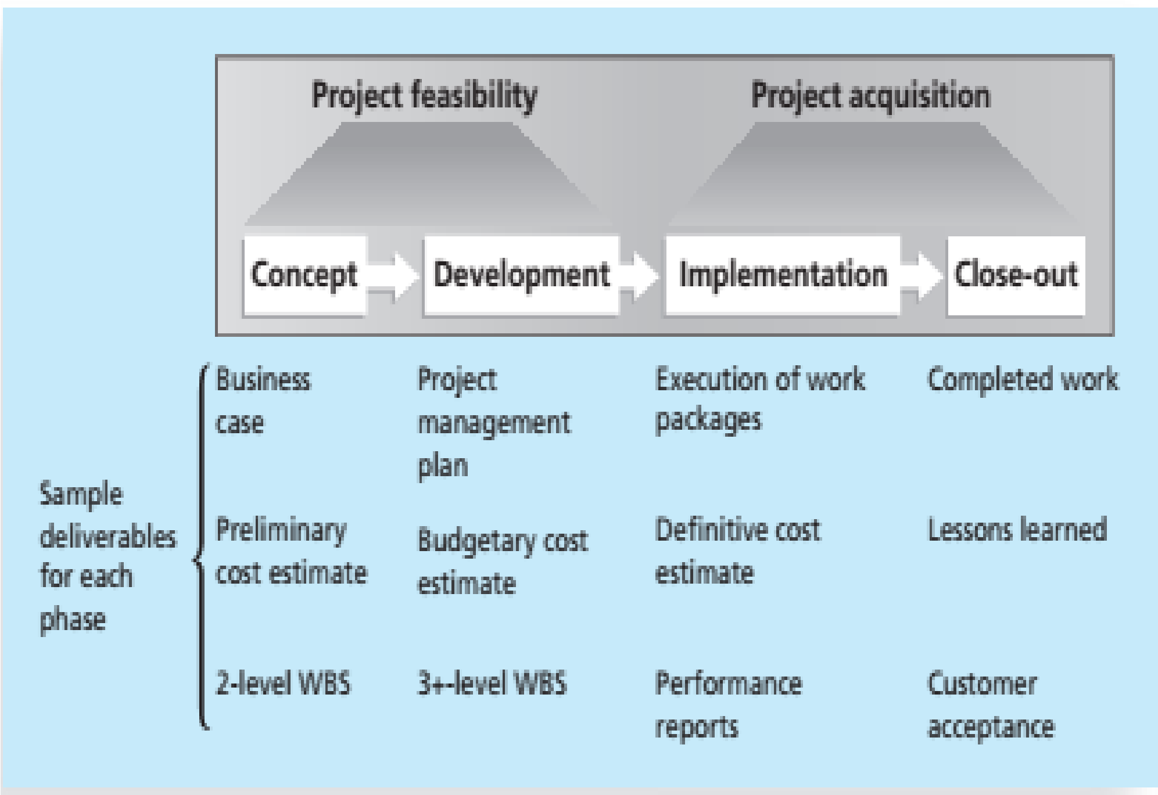

Life Cycle: Concept Phase
- In the concept phase of a project, managers usually develop some type of business case, which describes the need for the project and basic underlying concepts.
- A preliminary or rough cost estimate is developed in this first phase, and an overview of the required work is created
Life Cycle: Concept Phase
- A work breakdown structure (WBS) outlines project work by decomposing the work activities into different levels of tasks.
- The WBS is a deliverable oriented document that defines the total scope of the project.
- At the end of the concept phase, a committee would be able to deliver a report and presentation on its findings.
- The report and presentation would be examples of deliverables.
Life Cycle: Development Phase
- In the development phase, the project team creates more detailed project management plans, a more accurate cost estimate, and a more thorough WBS.
Life Cycle: Implementation Phase
- In this phase, the project team creates a definitive or very accurate cost estimate, delivers the required work, and provides performance reports to stakeholders.
Life Cycle: Implementation Phase
- During the implementation phase, the project team would need to obtain the required hardware and software, install the necessary network equipment, deliver the hardware required, create a process for collecting fees, and provide training to clients.
- The project team usually spends the bulk of its efforts and money during the implementation phase of projects.
Life Cycle: Close Out Phase
- In this phase, all of the work is completed, and customers should accept the entire project.
- The project team should document its experiences on the project in a lessons learned report.

Product Life Cycles
- Developing a product often involves many projects.
- Software development projects are one subset of IT projects.
- Many IT projects involve researching, analysing, and then purchasing and installing new hardware and software with little or no actual software development required.
- However, some projects involve minor modifications to enhance existing software or to integrate one application with another.
- Other projects involve a major amount of software development.
- Many argue that developing software requires project managers to modify traditional project management methods, depending on a particular product’s life cycle
Systems Development Life Cycle (SDLC)
This is a framework for describing the phases of developing information systems.
Some popular models of an SDLC include:
- Waterfall model
- Spiral model
- Incremental build model
- Prototyping model, and the
- Rapid Application Development (RAD) model

Systems Development Life Cycle (SDLC)
- These life cycle models are examples of a predictive life cycle, meaning that the scope of the project can be articulated clearly and the schedule and cost can be predicted accurately.
- The project team spends a large portion of the project attempting to clarify the requirements of the entire system and then producing a design.
- Users are often unable to see any tangible results in terms of working software for an extended period.
Waterfall and Spiral Model
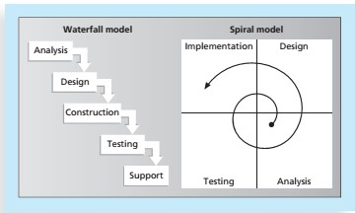

Adaptive Software Development (ASD) Life Cycle
- In contrast to the predictive models, the adaptive software development (ASD) life cycle model assumes that software development follows an adaptive approach because the requirements cannot be clearly expressed early in the life cycle.
- An adaptive approach is also used to provide more freedom than the prescriptive approaches.
- It allows development using a more free-form approach to create components that provide the functionality specified by the business group.
- Important attributes of this approach are that the projects are mission driven and component based, using time-based cycles to meet target dates.
- Requirements are developed using an iterative approach, and development is risk driven and change tolerant to address and incorporate risks rather than mitigate them.
Adaptive Software Development Agile Software Development
- The term agile software development has become popular to describe new approaches that focus on close collaboration between programming teams and business experts.
- Agile approaches are used in rapid software development and to handle frequent system changes and maintenance to production systems.
Agile Software Development
- Because many of these changes might be relatively minor, the more traditional project approaches would take much longer and cost more.
- Agile techniques have an iterative, short-cycle focus on delivery of working software.
The Importance of Project Phases and Management Reviews
- Due to the complexity and importance of many IT projects and their resulting products, it is important to take time to review the status of a project at each phase.
- A project should successfully pass through each of the main project or product phases before continuing to the next.
The Importance of Project Phases and Management Reviews
Because the organization usually commits more money as a project continues, a management review should occur after each phase to evaluate progress, potential success, and continued compatibility with organizational goals.

The Nature of IT Projects
- Unlike projects in many other industries, IT projects can be very diverse.
- Some involve a small number of people installing off-theshelf hardware and associated software.
- Others involve hundreds of people analyzing several organizations’ business processes and then developing new software in a collaborative effort with users to meet business needs.
- Even for small hardware-oriented projects, a wide diversity of hardware types could be involved e.g. personal computers, mainframe computers, network equipment, kiosks, laptops, tablets, or smartphones, to name a few.
- The network equipment might be wireless, phonebased, cable-based, or require a satellite connection.
- The nature of software development projects is even more diverse than hardware-oriented projects.
- A software development project might include creating a simple, stand-alone Microsoft Excel or Access application, or a sophisticated, global e-commerce system that uses state-of-the-art programming languages and runs on multiple platforms
- Because of the diversity of IT projects and the newness of the field, it is important to develop and follow best practices in managing these varied projects.
- That way, IT project managers will have a common starting point and method to follow with every project.
Characteristics of IT Project Team Members
Even with different educational backgrounds, there are common job titles for people working on most IT projects, such as business analyst, programmer, network specialist, database analyst, quality assurance expert, technical writer, security specialist, hardware engineer, software engineer, and system architect. Within the category of programmer, several other job titles describe the specific technologies used.

