## Lesson 1: Lots of Flags

### Goals

* Compare (orally and in writing) the dimensions and scale factors of multiple scaled copies of the same figure.
* Explain (orally) how to estimate or calculate the percentage of a rectangular area that is covered by another region.
* Generate the dimensions for a scaled copy of an original figure that has fractional side lengths.

### Learning Targets

* I can find dimensions on scaled copies of a rectangle.
* I remember how to compute percentages.

### Lesson Narrative

In this unit students will be applying proportional relationships to solve problems with fractional ratios, rates, percents, and constants of proportionality. The purpose of this lesson is to start the unit with an engaging activity where these arise naturally, in the scaling of flags and in questions about what percentage of the flag is taken up by a particular part of the design.

#### Alignments

#### Building On

* 6.RP.A: Understand ratio concepts and use ratio reasoning to solve problems.
* 7.G.A.1: Solve problems involving scale drawings of geometric figures, including computing actual lengths and areas from a scale drawing and reproducing a scale drawing at a different scale.

#### Building Towards

* 7.RP.A: Analyze proportional relationships and use them to solve real-world and mathematical problems.
* 7.RP.A.1: Compute unit rates associated with ratios of fractions, including ratios of lengths, areas and other quantities measured in like or different units. For example, if a person walks $1/2$ mile in each $1/4$ hour, compute the unit rate as the complex fraction $\frac{1/2}{1/4}$ miles per hour, equivalently $2$ miles per hour.
* 7.RP.A.2.a: Decide whether two quantities are in a proportional relationship, e.g., by testing for equivalent ratios in a table or graphing on a coordinate plane and observing whether the graph is a straight line through the origin.

#### Instructional Routines

* MLR5: Co-Craft Questions
* MLR8: Discussion Supports
* Think Pair Share

#### Student Learning Goals

Let’s explore the U.S. flag.

## 1.1 Scaled or Not?

**Warm Up: 5 minutes**

This warm-up prompts students to reason about proportional relationships in geometric objects as a review of work done earlier in grade 7. As students discuss their answers with their partner, select students to share their answers to the second question during the whole-class discussion. Select students so that different sets of objects and their scale factors are represented in the discussion.

#### Building On

* 7.G.A.1

#### Building Towards

* 7.RP.A.2.a

#### Instructional Routines

* Think Pair Share

#### Launch

Arrange students in groups of 2. Give students 1 minute of quiet work time and another 1–2 minutes to share their solutions with their partner. Ask students to make sure they have the same objects identified in the first question. If one partner is missing a set of scaled objects, they should add them to their list during their partner discussion.

#### Anticipated Misconceptions

Students might think H is a scaled version of A or B. Suggest that they consider possible scale factors to get from, for example, A to H.

#### Student Task Statement

1. Which of the geometric objects are scaled versions of each other?

* 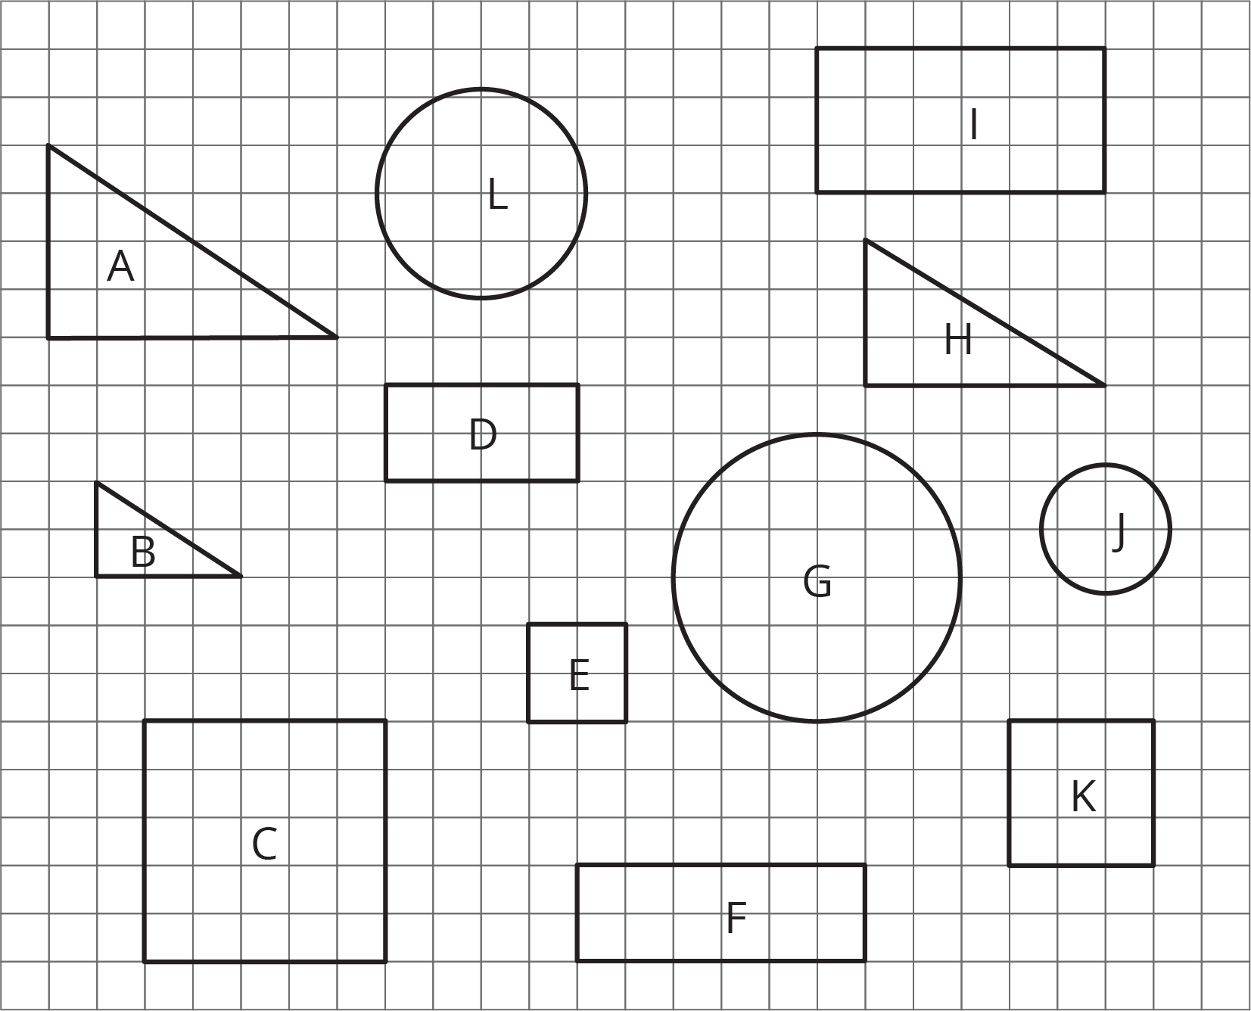

1. Pick two of the objects that are scaled copies and find the scale factor.

#### Student Response

1. * A and B
   * C, E, and K
   * D and I
   * G, J, and L
2. Answers vary. Sample response: A is 2 times the size of B. The height of A is 4, and the length of its base is 6. The height of B is 2, and the length of its base is 3.

#### Activity Synthesis

Select a couple of students, with a variety of answers to the second question, to share their answers to the second question. Ask students, “Did you encounter any objects that you initially believed were scaled versions of one another? How did you decide that they weren't?”

## 1.2 Flags Are Many Sizes

**15 minutes**

In this introductory lesson students get a chance to recall what they have previously learned about ratios and proportional relationships. They will build on these ideas in the next few lessons where they will work with ratios and rates involving fractions. In this activity, students can leverage their recent work on creating scale drawings to make connections between the dimensions of a different sized flag and the ratio of the side lengths.

A note about flag dimensions: The official government flag has sides with ratio $1:1.9$, i.e., the width of the flag is 1.9 times its height. However, many commercially sold flags use different ratios. This activity is working with the official ratio. If there is a flag displayed in the classroom, it would be interesting to check if it uses the official ratio or one of the other common commercial ratios, such as $2:3$ or $5:8$ or $6:10$.

Another interesting note about the flag: The current 50 star version of the flag was designed by a 17 year old HS student as a class project.

#### Building On

* 7.G.A.1

#### Building Towards

* 7.RP.A

#### Instructional Routines

* MLR5: Co-Craft Questions

#### Launch

Arrange students in groups of 3–4. If the class room has a display of the flag which can be reached, ask a student to measure the dimensions of the flag.

Tell students, "The United States flag is displayed in many different sizes and for different purposes. One standard size is 19 feet by 10 feet. What would be a possible use for a flag of this size?"

Ask student where else they have seen flags displayed.

*Representation: Internalize Comprehension*. Activate or supply background knowledge of the definition of scale factor. Allow students to use calculators to ensure inclusive participation in the activity.  
*Supports accessibility for: Memory; Conceptual processing* *Conversing: MLR5 Co-Craft Questions.* Display the task statement without the questions and students to write possible mathematical questions about the situation. Invite students to share their questions with a partner before selecting 2–3 students to share with the class. Highlight mathematical language students use related to ratios and proportions. This helps students produce the language of mathematical questions and talk about the relationship between side lengths of a rectangle and scale factors.  
*Design Principle(s): Cultivate conversation; Support sense-making*

#### Student Task Statement

One standard size for the United States flag is 19 feet by 10 feet. On a flag of this size, the union (the blue rectangle in the top-left corner) is $7\frac{5}{8}$ feet by $5\frac{3}{8}$ feet.

There are many places that display flags of different sizes.

* Many classrooms display a U.S. flag.
* Flags are often displayed on stamps.
* There was a flag on the space shuttle.
* Astronauts on the Apollo missions had a flag on a shoulder patch.



1. Choose one of the four options and decide on a size that would be appropriate for this flag. Find the size of the union.
2. Share your answer with another group that used a different option. What do your dimensions have in common?

#### Student Response

Answers vary. Sample scale factors and dimensions:

* Classroom scale factor $\frac{1}{5}$ and union dimensions 1.525 feet by 1.075 feet
* Stamp scale factor $\frac{1}{240}$ and union dimensions 0.032 feet by 0.022 feet
* Shuttle scale factor $\frac{1}{2}$ and union dimensions 3.813 feet by 2.688 feet
* Patch scale factor $\frac{1}{60}$ and union dimensions 0.127 feet by 0.090 feet

#### Activity Synthesis

Record the groups' measurements in a table to show that there is a constant of proportionality.

## 1.3 What Percentage Is the Union?

**15 minutes**

This activity continues to look at the U.S. flag by asking questions about percentages, which students studied in grade 6. Later in this unit, students will continue working with percentages, including percent increase and decrease.

Knowing the side lengths of the flag and of the union allows you to compute the area of the flag and of the union. Students can then compute what percentage of the flag is taken up by the union. Finding out what percentage of the flag is red requires additional reasoning. Students can either compute the area of the red stripes or they can see what fraction of the non-union part of the flag is red.

This is a good opportunity for students to estimate their answers and get a visual idea of the size of different percentages.

#### Building On

* 7.G.A.1

#### Building Towards

* 7.RP.A

#### Instructional Routines

* MLR8: Discussion Supports

#### Launch

Arrange students in groups of 3–4. Tell students that they will continue to examine the United States flag, this time looking at area.

#### Student Task Statement

On a U.S. flag that is 19 feet by 10 feet, the union is $7\frac{5}{8}$ feet by $5\frac{3}{8}$ feet. For each question, first estimate the answer and then compute the actual percentage.

1. What **percentage** of the flag is taken up by the union?
2. What percentage of the flag is red? Be prepared to share your reasoning.

#### Student Response

Answers vary. Sample response:

1. * Approximately 20%
   * 21.6%. Since the area of the union is about 41 square feet and the area of the flag is 190 square feet, the percentage is $41÷190$ or about 0.216.
2. * Approximately 40%
   * 41.5% Since the total red area is 78.875 square feet and the area of the flag is 190 square feet, the percentage is $78.875÷190$, or about 0.415.

#### Are You Ready for More?

The largest U.S. flag in the world is 225 feet by 505 feet.

1. Is the ratio of the length to the width equivalent to $1:1.9$, the ratio for official government flags?
2. If a square yard of the flag weighs about 3.8 ounces, how much does the entire flag weigh in pounds?

#### Student Response

1. No.
2. About 3,000 pounds.

#### Activity Synthesis

The purpose of this discussion is to emphasize the use of proportion when working with areas of rectangles. Ask students to compare their estimated percentage with their calculated percentage. Ask students such as:

* “Did you use the image of the flag—a rectangle—to guide your estimate?”
* “Did you round the given dimensions to find the estimated percentage?”

*Engagement: Develop Effort and Persistence.* Encourage and support opportunities for peer interactions. Prior to the whole-class discussion, invite students to share their work with a partner. Display sentence frames to support student conversation such as “First, I _____ because...”, “I noticed _____ so I...”, “Why did you...?”, “I agree/disagree because….”  
*Supports accessibility for: Language; Social-emotional skills* *Speaking: MLR8 Discussion Supports.* Provide sentence frames to help students produce statements that compare their estimated percentage with their calculated percentage. For example, “The percentages are (similar/different) because ________.”  
*Design Principle(s): Support sense-making, Optimize output (for comparison)*

### Lesson Synthesis

In this lesson, we used what we know about scale factors and dimensions of rectangles to answer questions related to the United States flag. Consider asking some of the following questions:

* “How can you tell whether two objects are scaled versions of one another?”
* “What properties stay the same when an object is scaled up or down?”
* “What strategies did you use to find properties of a scaled object, e.g. the dimensions of the union on a small flag?”
* “How did you go about finding the estimated percentage of total area on the United States flag (taken up by the union or the red region)?”

## 1.4 Colorado State Flag

**Cool Down: 5 minutes**

#### Building On

* 6.RP.A
* 7.G.A.1

#### Building Towards

* 7.RP.A.1

#### Student Task Statement

The side lengths of the state flag of Colorado are in the ratio $2:3$. If a flag is 12 feet long, what is its height?



#### Student Response

8 feet

### Student Lesson Summary

Imagine you have a painting that is 15 feet wide and 5 feet high. To sketch a scaled copy of the painting, the ratio of the width and height of a scaled copy must be equivalent to $15:5$. What is the height of a scaled copy that is 2 feet across?

| width | height |
| --- | --- |
| 15 | 5 |
| 2 | $h$ |

We know that the height is $\frac{1}{3}$ the width, so $h=\frac{1}{3}⋅2$ or $\frac{2}{3}$.

Sometimes ratios include fractions and decimals. We will be working with these kinds of ratios in the next few lessons.

### Glossary

* percentage



© CC BY Open Up Resources. Adaptations CC BY IM.

## Lesson 1 Practice Problems

1. **Problem 1** **Statement**

* A rectangle has a height to width ratio of $3:4.5$. Give two examples of dimensions for rectangles that could be scaled versions of this rectangle.
* **Solution**
* Answers vary. Sample response: A rectangle measuring 6 units by 9 units and a rectangle measuring 9 units by 13.5 units.

1. **Problem 2** **Statement**

* One rectangle measures 2 units by 7 units. A second rectangle measures 11 units by 37 units. Are these two figures scaled versions of each other? If so, find the scale factor. If not, briefly explain why.
* **Solution**
* No, these two figures are not scaled versions of each other. The 2 unit side is scaled by a factor of 5.5 to correspond to the 11 unit side, but 7 multiplied by 5.5 is 38.5, not 37.

1. **Problem 3** **Statement**

* Ants have 6 legs. Elena and Andre write equations showing the proportional relationship between the number of ants, $a$, to the number of ant legs $l$. Elena writes $a=6⋅l$ and Andre writes $l=\frac{1}{6}⋅a$. Do you agree with either of the equations? Explain your reasoning.
* **Solution**
* Neither of them are correct. Although 6 and $\frac{1}{6}$ are the correct constants of proportionality, they are being multiplied by the wrong variables. For example, using Elena's equation, 1 leg is equal to 6 ants.
* (From Unit 2, Lesson 5.)

1. **Problem 4** **Statement**

* On the grid, draw a scaled copy of quadrilateral ABCD with a scale factor $\frac{2}{3}$.
* 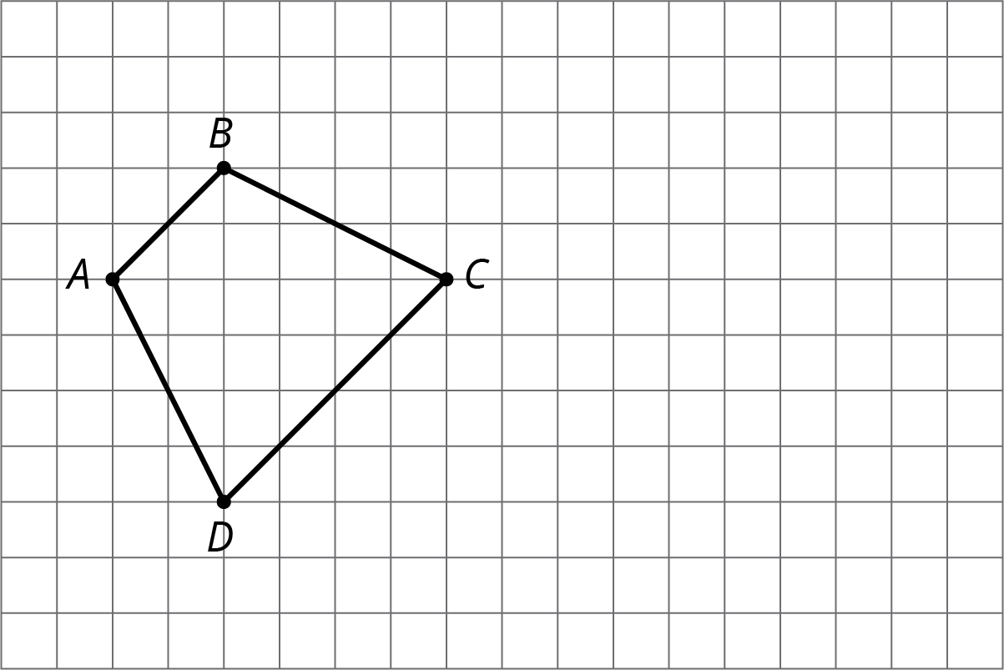
* **Solution**
* Answers vary. Sample response on the right.
* 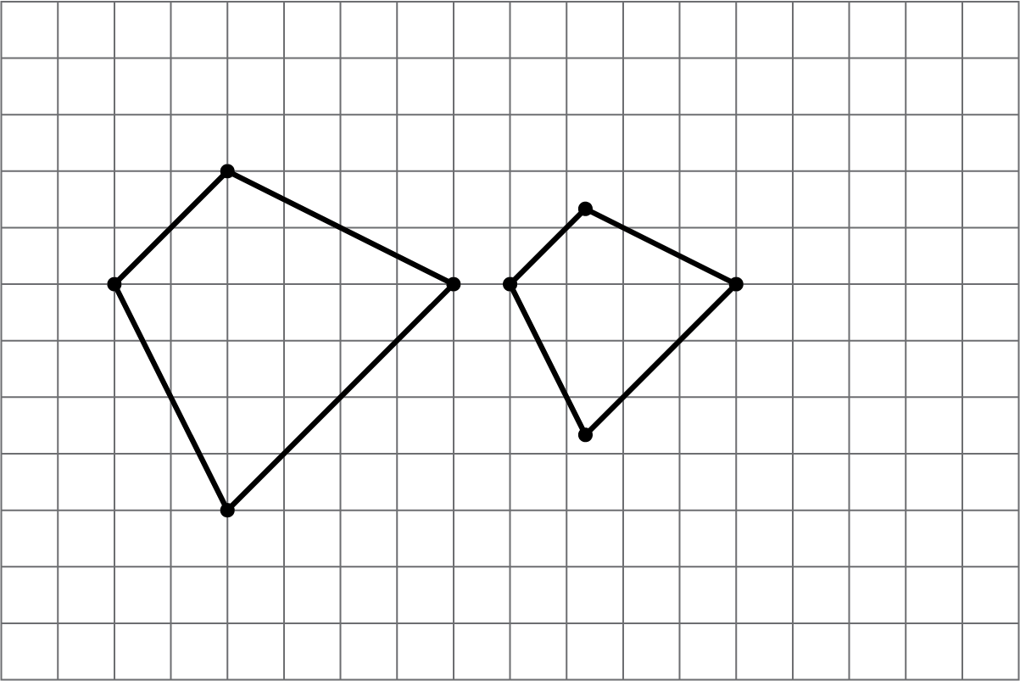
* (From Unit 1, Lesson 4.)

1. **Problem 5** **Statement**

* Solve each equation mentally.
$\frac{5}{2}⋅x=1$

$x⋅\frac{7}{3}=1$

$1÷\frac{11}{2}=x$

* **Solution**
$x=\frac{2}{5}$

$x=\frac{3}{7}$

$x=\frac{2}{11}$

* (From Unit 1, Lesson 5.)

1. **Problem 6** **Statement**

* Lin has a scale model of a modern train. The model is created at a scale of 1 to 48.
  1. The height of the model train is 102 millimeters. What is the actual height of the train in meters? Explain your reasoning.
  2. On the scale model, the distance between the wheels on the left and the wheels on the right is $1\frac{1}{4}$ inches. The state of Wyoming has old railroad tracks that are 4.5 feet apart. Can the modern train travel on those tracks? Explain your reasoning.
* **Solution**
  1. 4.896 meters. Sample reasoning:
     + The actual height is 48 times the scaled height. $102⋅48=4,896$. 4,896 mm is 4.896 m.
     + 102 mm is 0.102 m. The actual train is 48 times 0.102 m. $0.102⋅48=4.896$.
  2. No. Sample explanation: The modern train needs tracks that are 60 inches apart, because $1\frac{1}{4}⋅48=60$. The old tracks are only 54 inches, so they are not wide enough.
* (From Unit 1, Lesson 11.)