<https://www.youtube.com/watch?v=pmiIhgG08pQ&list=PL_c9BZzLwBRJOmvlnRQpnZS7ZpEvtwkXb&index=4>

D:\eclipse-workspace>git status

On branch master

No commits yet

Untracked files:

(use "git add <file>..." to include in what will be committed)

.gitignore

HandsOnJAVA/

JAVA_tutorial/

nothing added to commit but untracked files present (use "git add" to track)

D:\eclipse-workspace>git add .

D:\eclipse-workspace>git status

On branch master

No commits yet

Changes to be committed:

(use "git rm --cached <file>..." to unstage)

new file: .gitignore

new file: HandsOnJAVA/src/MySweetProgram.java

new file: JAVA_tutorial/src/Jen.java

new file: JAVA_tutorial/src/MyArray.java

new file: JAVA_tutorial/src/MyPasswd.java

new file: JAVA_tutorial/src/MyPeople.java

new file: JAVA_tutorial/src/MySweetProgram.java

new file: JAVA_tutorial/src/MyUserAutoload67.java

new file: JAVA_tutorial/src/MyUserClass.java

new file: JAVA_tutorial/src/People.java

new file: JAVA_tutorial/src/Student.java

new file: JAVA_tutorial/src/Talk.java

new file: JAVA_tutorial/src/Teacher.java

new file: JAVA_tutorial/src/User.java

D:\eclipse-workspace>git log

fatal: your current branch 'master' does not have any commits yet

D:\eclipse-workspace>git commit -m "initial commit"

*** Please tell me who you are.

Run

git config --global user.email "you@example.com"

git config --global user.name "Your Name"

to set your account's default identity.

Omit --global to set the identity only in this repository.

fatal: unable to auto-detect email address (got 'Peter Jen@DESKTOP-6QCRLM7.(none)')

D:\eclipse-workspace>git config --global user.email "ptjen@yahoo.com"

D:\eclipse-workspace>git config --global user.name "Peter Jen"

D:\eclipse-workspace>git commit -m "initial commit"

[master (root-commit) b8515db] initial commit

14 files changed, 599 insertions(+)

create mode 100644 .gitignore

create mode 100644 HandsOnJAVA/src/MySweetProgram.java

create mode 100644 JAVA_tutorial/src/Jen.java

create mode 100644 JAVA_tutorial/src/MyArray.java

create mode 100644 JAVA_tutorial/src/MyPasswd.java

create mode 100644 JAVA_tutorial/src/MyPeople.java

create mode 100644 JAVA_tutorial/src/MySweetProgram.java

create mode 100644 JAVA_tutorial/src/MyUserAutoload67.java

create mode 100644 JAVA_tutorial/src/MyUserClass.java

create mode 100644 JAVA_tutorial/src/People.java

create mode 100644 JAVA_tutorial/src/Student.java

create mode 100644 JAVA_tutorial/src/Talk.java

create mode 100644 JAVA_tutorial/src/Teacher.java

create mode 100644 JAVA_tutorial/src/User.java

D:\eclipse-workspace>git status

On branch master

nothing to commit, working tree clean

D:\eclipse-workspace>git log

commit b8515db3ecfbaeb3bf58507d182548d7606de5dc (HEAD -> master)

Author: Peter Jen <ptjen@yahoo.com>

Date: Fri Apr 17 21:24:10 2020 -0400

initial commit

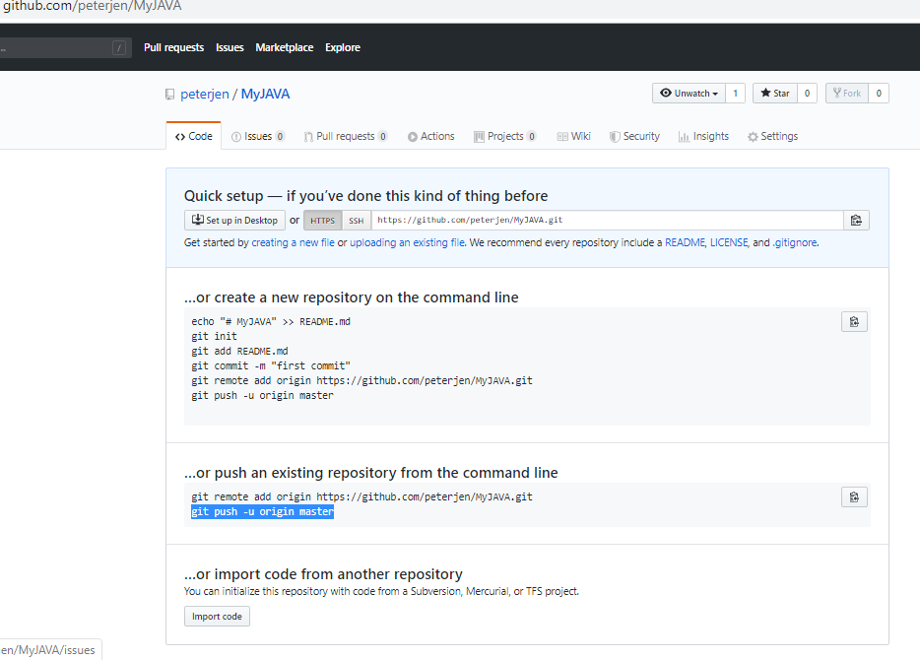

D:\eclipse-workspace>**git remote add origin https://github.com/peterjen/MyJAVA.git**

D:\eclipse-workspace>**git push -u origin master**

Enumerating objects: 20, done.

Counting objects: 100% (20/20), done.

Delta compression using up to 4 threads

Compressing objects: 100% (16/16), done.

Writing objects: 100% (20/20), 5.72 KiB | 1.91 MiB/s, done.

Total 20 (delta 1), reused 0 (delta 0), pack-reused 0

remote: Resolving deltas: 100% (1/1), done.

To https://github.com/peterjen/MyJAVA.git

* [new branch] master -> master

Branch 'master' set up to track remote branch 'master' from 'origin'.

**CRESTED A NEW PROJECT ‘TEST’ ON ECLIPSE:**

D:\eclipse-workspace>**git status**

On branch master

Your branch is up to date with 'origin/master'.

Untracked files:

(use "git add <file>..." to include in what will be committed)

Test/

nothing added to commit but untracked files present (use "git add" to track)

D:\eclipse-workspace>**git add Test/**

D:\eclipse-workspace>**git status**

On branch master

Your branch is up to date with 'origin/master'.

Changes to be committed:

(use "git restore --staged <file>..." to unstage)

new file: Test/src/Test.java

D:\eclipse-workspace>**git commit -m "Test for GitHub"**

[master 3007a73] Test for GitHub

1 file changed, 9 insertions(+)

create mode 100644 Test/src/Test.java

D:\eclipse-workspace>**git log**

commit 3007a73c20aabcb6ff4f204fbf104ce9621f11d1 (HEAD -> master)

Author: Peter Jen <ptjen@yahoo.com>

Date: Fri Apr 17 21:54:30 2020 -0400

Test for GitHub

commit b8515db3ecfbaeb3bf58507d182548d7606de5dc (origin/master)

Author: Peter Jen <ptjen@yahoo.com>

Date: Fri Apr 17 21:24:10 2020 -0400

initial commit

D:\eclipse-workspace>**git push -u origin master**

Enumerating objects: 6, done.

Counting objects: 100% (6/6), done.

Delta compression using up to 4 threads

Compressing objects: 100% (3/3), done.

Writing objects: 100% (5/5), 451 bytes | 451.00 KiB/s, done.

Total 5 (delta 1), reused 0 (delta 0), pack-reused 0

remote: Resolving deltas: 100% (1/1), completed with 1 local object.

To https://github.com/peterjen/MyJAVA.git

b8515db..3007a73 master -> master

Branch 'master' set up to track remote branch 'master' from 'origin'.

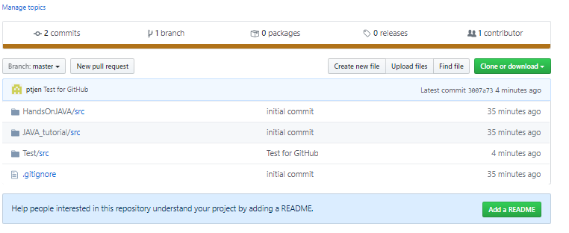

IF MODIFIED test.java from ECLIPSE

D:\eclipse-workspace>**git status**

On branch master

Your branch is up to date with 'origin/master'.

Changes not staged for commit:

(use "git add <file>..." to update what will be committed)

(use "git restore <file>..." to discard changes in working directory)

modified: Test/src/Test.java

no changes added to commit (use "git add" and/or "git commit -a")

D:\eclipse-workspace>**git add Test/**

D:\eclipse-workspace>**git status**

On branch master

Your branch is up to date with 'origin/master'.

Changes to be committed:

(use "git restore --staged <file>..." to unstage)

modified: Test/src/Test.java

D:\eclipse-workspace>**git commit -m "Test for GitHub"**

[master 816ebf8] Test for GitHub

1 file changed, 1 insertion(+), 1 deletion(-)

D:\eclipse-workspace>**git log**

commit 816ebf815bf37b5d14f0e3f394865f75dff8ca3f (HEAD -> master)

Author: Peter Jen <ptjen@yahoo.com>

Date: Fri Apr 17 22:17:16 2020 -0400

Test for GitHub

commit 3007a73c20aabcb6ff4f204fbf104ce9621f11d1 (origin/master)

Author: Peter Jen <ptjen@yahoo.com>

Date: Fri Apr 17 21:54:30 2020 -0400

Test for GitHub

commit b8515db3ecfbaeb3bf58507d182548d7606de5dc

Author: Peter Jen <ptjen@yahoo.com>

Date: Fri Apr 17 21:24:10 2020 -0400

initial commit

D:\eclipse-workspace>**git push -u origin master**

Enumerating objects: 9, done.

Counting objects: 100% (9/9), done.

Delta compression using up to 4 threads

Compressing objects: 100% (3/3), done.

Writing objects: 100% (5/5), 442 bytes | 442.00 KiB/s, done.

Total 5 (delta 1), reused 0 (delta 0), pack-reused 0

remote: Resolving deltas: 100% (1/1), completed with 1 local object.

To https://github.com/peterjen/MyJAVA.git

3007a73..816ebf8 master -> master

Branch 'master' set up to track remote branch 'master' from 'origin'.

**git status**

**git add .**

**git commit -m "JAVA Day4"**

**git push**