LLM Personality Matching Experiment Framework
This project provides a fully automated and reproducible pipeline for testing a Large Language Model’s (LLM) ability to solve a “who’s who” personality matching task. It handles everything from data preparation and query generation to LLM interaction, response parsing, and final statistical analysis.

Research Question
At its core, this project investigates whether a Large Language Model (LLM) can solve a complex matching task: given a set of sanitized, narrative personality descriptions (derived from birth data) and a corresponding set of general biographical profiles, can the LLM correctly pair them at a rate significantly greater than chance?
This study introduces a novel methodological twist to probe the limits of LLM pattern recognition. The link between the narrative descriptions and the biographical profiles is a faint, systematic signal generated by a deterministic, non-scientific system (an astrology program). This transforms the experiment into a rigorous test of an LLM’s ability to detect subtle, rule-based patterns within a noisy, high-dimensional dataset. The central question is not about the validity of the generating system, but about the capability of the AI to find a signal in its output.

A Note on Stimulus Generation and Experimental Design
The experiment is built upon a custom database of 5,000 famous historical individuals, for whom accurate and verified birth data (date, time, place) was meticulously collected. This population was chosen for two reasons:
- Signal Integrity: Accurate birth data ensures the deterministic generation of consistent personality narratives.
- Task Feasibility: The public prominence of these individuals makes it plausible that LLMs have encountered their biographical information during training, making the matching task tractable.
To create a uniquely challenging test, we employed a two-step process to generate textual stimuli for each trial:
- Generation: A commercial astrology program was used as a “black box” function to deterministically map an individual’s birth data to a narrative description. The generation was intentionally constrained to a foundational subset of the algorithm’s rules (e.g., categorical placements and dominances), creating a signal of limited complexity.
- Sanitization: An LLM was then used to programmatically rewrite these descriptions, removing all explicit references to astrology, planets, or other esoteric terms.
The result is a clean dataset of personality profiles where the connection to the individual’s biographical profile is systematic but non-obvious.
Crucially, this study does not seek to validate astrology. Instead, it treats the generating program as an arbitrary, complex algorithm. The scientific objective is to determine whether an LLM, a third-party pattern-recognition system, can detect the subtle statistical regularities produced by this algorithm and use them to perform a successful matching task. The findings speak to the profound capabilities of LLMs to find signal in noisy, high-dimensional data, regardless of the source’s theoretical basis.

Key Features
- Automated Experiment Runner: A single command executes an entire experiment, running dozens of replications, each with hundreds of trials.
- Standardized, Reproducible Reporting: Each replication produces a comprehensive, consistently formatted report that includes run parameters, the base query, a human-readable analysis summary, and a machine-readable JSON block. The format is identical whether running a new experiment or reprocessing an old one.
- Guaranteed Reproducibility: Each replication automatically archives the config.ini file used for that run, permanently linking the results to the exact parameters that generated them.
- Robust Error Handling & Resumption: The pipeline is designed for resilience. Interrupted runs can be safely resumed. The rebuild command ensures data integrity after an interruption, and the finalize command is idempotent, automatically cleaning up corrupted summary data before writing a correct final version.
- Advanced Artifact Management:
  - Reprocessing Engine: The main runner has a --reprocess mode to re-run the analysis stages on existing experimental data, with a --depth parameter for recursive scanning. You can even add or override run notes during reprocessing.
  - Configuration Restoration: Includes utilities to reverse-engineer and archive config.ini files for historical data that was generated before the auto-archiving feature was implemented.
- Hierarchical Analysis: The compile_results.py script performs a bottom-up aggregation of all data. It now generates level-aware summary files: REPLICATION_results.csv in each replication folder, EXPERIMENT_results.csv at the experiment level, and a final master STUDY_results.csv at the top study level. This creates a fully auditable and easily navigable research archive.
- Streamlined ANOVA Workflow: The final statistical analysis is now a simple two-step process. compile_results.py first prepares a master dataset, which run_anova.py then automatically finds and analyzes, generating tables and publication-quality plots using user-friendly display names for factors and metrics.
- Smart Console Output: The main process_study.ps1 wrapper provides a clean, high-level summary of compilation and analysis steps, showing progress without overwhelming detail. A -Verbose flag is available to switch to real-time raw output for debugging.

Visual Architecture
The project’s architecture can be understood through three different views: the code architecture, the data flow, and the experimental logic.

1. Code Architecture Diagram
This diagram shows how the scripts in the pipeline call one another, illustrating the hierarchy of control.
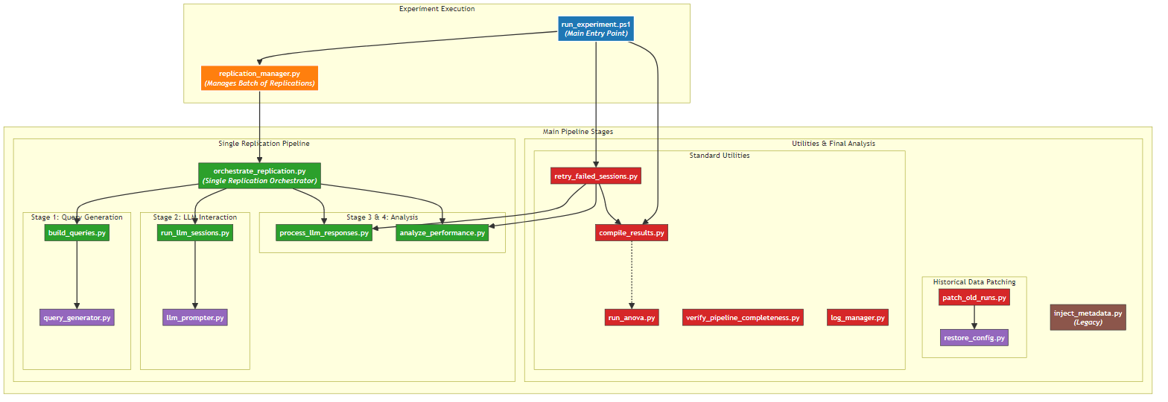

2. Data Flow Diagram
This diagram shows how data artifacts (files) are created and transformed by the pipeline scripts.
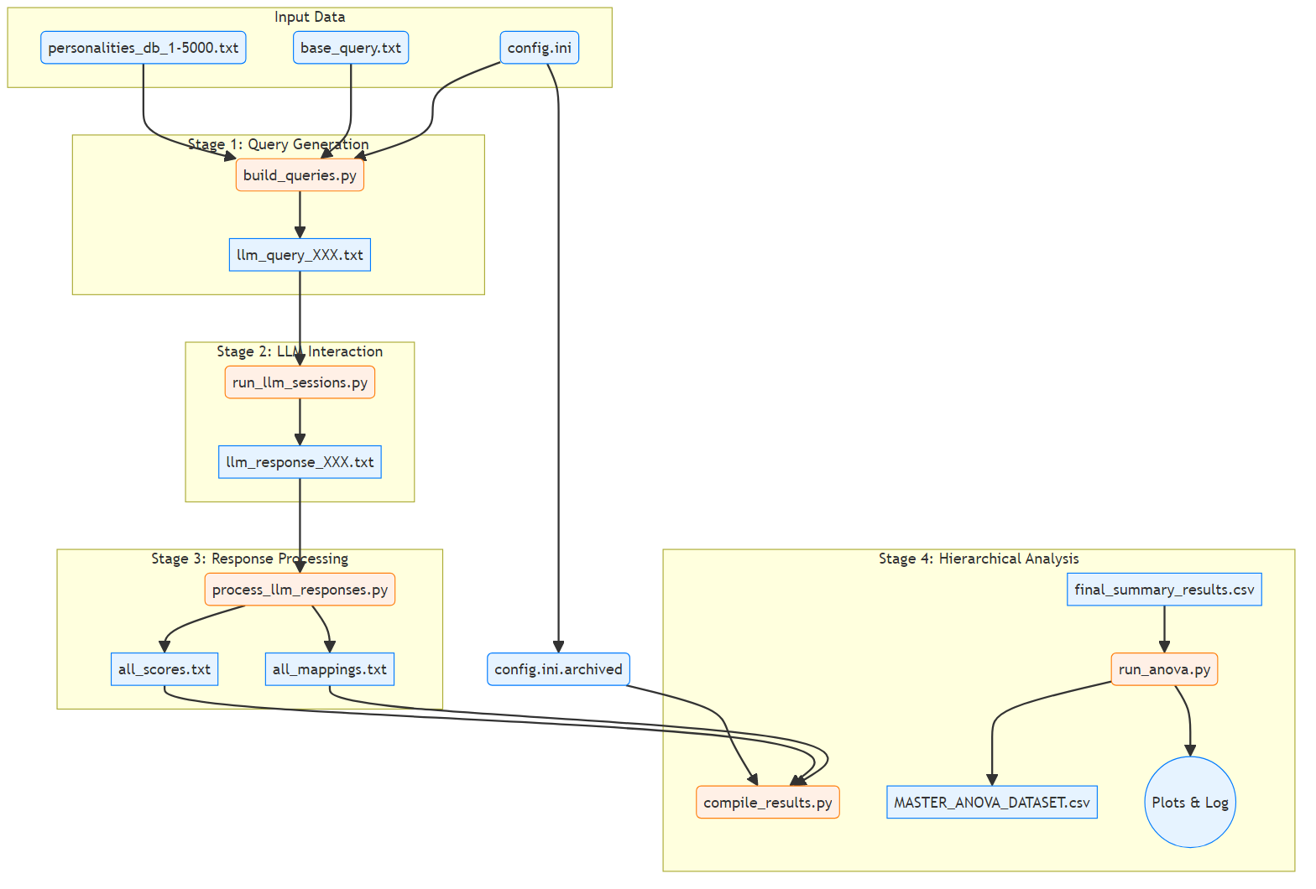

3. Experimental Logic Flowchart
This diagram illustrates the scientific methodology for a single replication run.
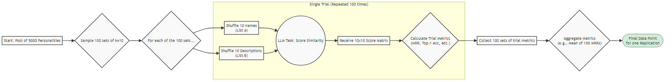

Project Structure
The project’s experiments are organized in a logical hierarchy:
- Study: The highest-level grouping, representing a major research question (e.g., “Performance on Random vs. Correct Mappings”).
- Experiment: A complete set of runs for a single condition within a study (e.g., “Gemini 2.0 Flash with k=10 Subjects”).
- Replication: A single, complete run of an experiment, typically repeated 30 times for statistical power.
- Trial: An individual matching task performed within a replication, typically repeated 100 times.
This logical hierarchy is reflected in the directory structure of the project and its outputs:
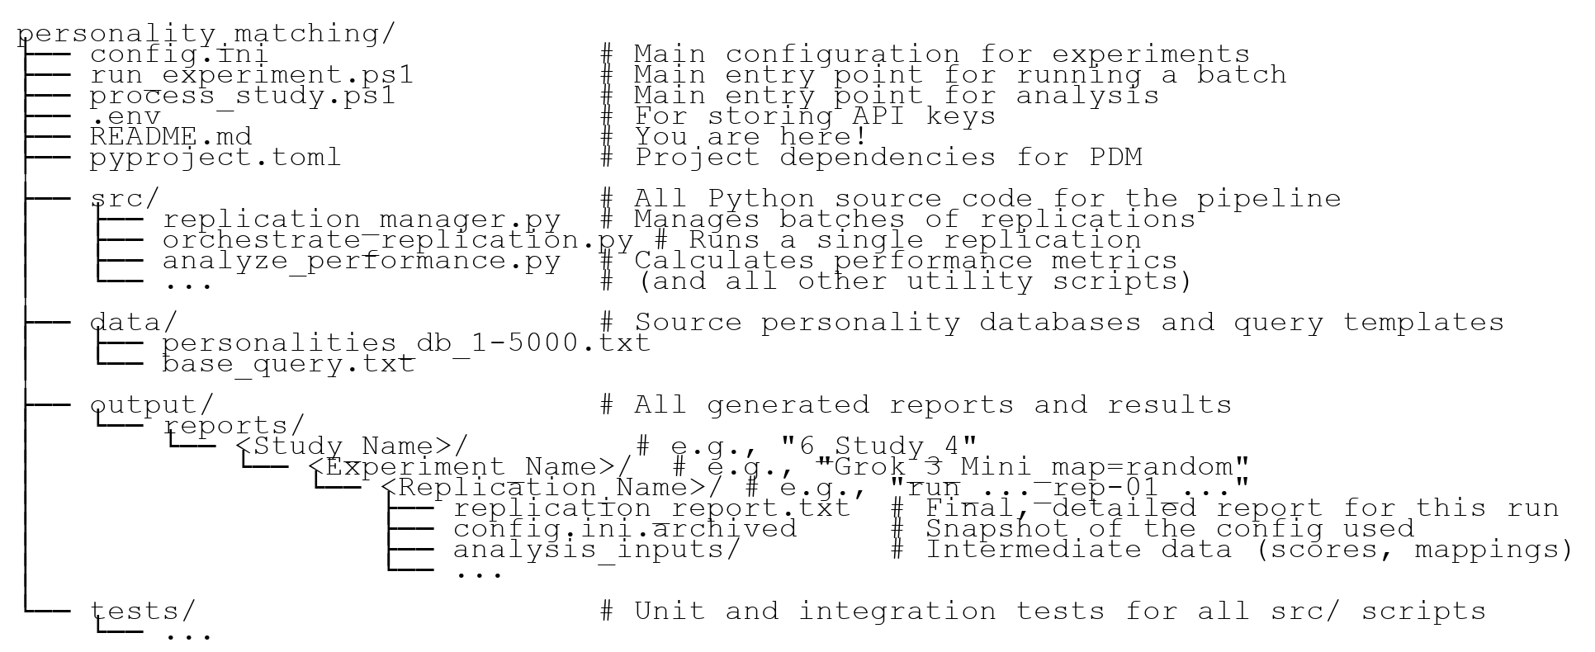

Setup and Installation
This project uses PDM for dependency and environment management, which simplifies setup into a few commands.
- Install PDM (One-Time Setup): If you don’t have PDM, install it with pip. It’s best to run this from a terminal outside of any virtual environment.
- pip install --user pdm
- Note: If you see a pdm: The term 'pdm' is not recognized... error in a new terminal, the most reliable way to run PDM is to use python -m pdm instead of just pdm.
- Install Project Dependencies: From the project’s root directory, run the main PDM installation command.
- pdm install
- This single command automatically:
  - Detects your Python version.
  - Creates a local virtual environment in the project’s .venv folder.
  - Installs all required packages from the pdm.lock file for a reproducible setup.
- Configure API Key:
  - Create a file named .env in the project root.
  - Add your API key: OPENROUTER_API_KEY=sk-or-your-key.
To run commands within the managed environment, prefix them with pdm run. For example: pdm run python src/some_script.py.

Configuration (config.ini)
The config.ini file is the central hub for defining all parameters for your experiments. The pipeline automatically archives this file with the results for guaranteed reproducibility.

Display Name Settings
- [ModelDisplayNames]: Maps sanitized model names to friendly names (e.g., meta-llama-4-maverick = Llama 4 Maverick).
- [FactorDisplayNames]: Maps factor names to plot labels (e.g., mapping_strategy = Mapping Strategy).
- [MetricDisplayNames]: Maps metric names to plot titles (e.g., mean_mrr = Mean Reciprocal Rank (MRR)).

Experiment Settings ([Study])
- num_replications: The number of times the experiment will be repeated (e.g., 30).
- mapping_strategy: A key experimental variable. Can be correct or random.

LLM Settings ([LLM])
- model_name: The API identifier for the LLM to be tested (e.g., mistralai/mistral-small-3.1-24b-instruct).

Model Selection Philosophy and Future Work
The selection of models for this study was guided by a balance of performance, cost, speed, and technical compatibility with the automated framework. Several top-tier models were not included for one of the following reasons: - Prohibitive Cost: Models like o1 pro, GPT 4.5 Preview, and Claude 4 Opus were excluded as a single experiment (requiring ~3,000 queries) was financially infeasible. - Technical Incompatibility: Models like Gemini 2.5 Pro lacked a “non-thinking” mode, making the automated parsing of a structured response table overly challenging. - Excessive Runtime: A number of large models, including Qwen3 235B and Llama 3.1 Nemotron Ultra 253B, were excluded as a full experimental run would take longer than 20 hours.
A follow-up study is planned to evaluate other powerful, medium-cost models as API costs decrease and technical features evolve. Candidates include: Grok 3, Claude 4 Sonnet, Claude 3.7 Sonnet, GPT-4o, o3, GPT-4.1, Mistral Large 2, Gemini 1.5 Pro, and various o1/o3/o4 mini-variants.

Analysis Settings ([Analysis])
- min_valid_response_threshold: Minimum average number of valid responses (n_valid_responses) for an experiment to be included in the final analysis. Set to 0 to disable.

Standard Workflow
The workflow is designed to be fully automated.

Phase 1: Running Experiments
The run_experiment.ps1 PowerShell script is the main entry point for executing a complete experiment.
- Configure: Adjust experimental parameters in config.ini.
- Execute: Open a PowerShell terminal (with the virtual environment activated) and run the main script.
- # Run with standard output
.\run_experiment.ps1
# Add descriptive notes to the report
.\run_experiment.ps1 -Notes "First run with random mapping strategy"
# For detailed debugging, run with the -Verbose switch
.\run_experiment.ps1 -Verbose
  - The script manages the entire batch run. It automatically detects and skips any replications that have already been completed successfully. This allows you to safely resume an interrupted batch run without re-doing work. To force a re-analysis of existing data, you must use the --reprocess mode described in the maintenance section.
  - The script will then automatically enter a repair phase for any failed replications from the current batch.
  - Crucially, each replication’s output directory will now contain a config.ini.archived file, making it a self-contained, reproducible artifact.
- Repeat for All Conditions: Repeat steps 1-2 for each experimental condition, organizing the outputs into separate folders.

Phase 2: Processing the Study
After running all experiments, this phase aggregates all data and performs the final statistical analysis.
- Run Study Processor: Execute process_study.ps1, pointing it at the top-level directory containing all experiment folders.
- .\process_study.ps1 -StudyDirectory "output/reports"
- This automates two stages:
  - Compilation: Runs compile_results.py to scan the directory tree and create level-specific summaries, aggregating them into a master STUDY_results.csv.
  - Analysis: Runs run_anova.py on the master dataset to perform a full statistical analysis.
- Review Final Artifacts: In the top-level analysis directory (output/reports/anova/), you will find publication-quality plots (*.png), a complete analysis log (STUDY_analysis_log.txt), and an archive/ of previous results.

Standardized Output
The pipeline now generates a consistent, standardized replication_report.txt for every run, whether it’s a new experiment or a reprocessed one. This ensures that all output is easily comparable and machine-parsable.

Replication Report Format
Each report contains a clear header, the base query used, a human-readable analysis summary, and a machine-readable JSON block with all calculated metrics.
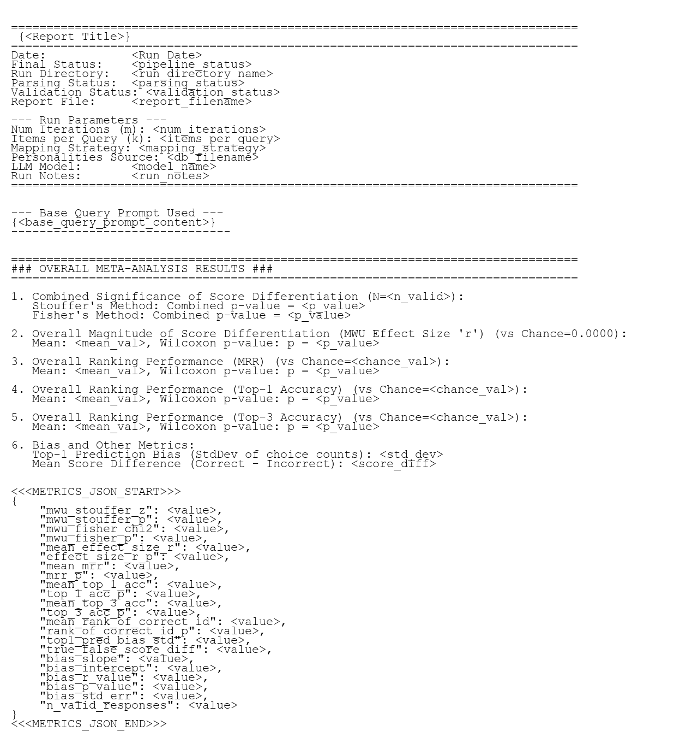
Date Handling by Mode: - Normal Mode: The report title is REPLICATION RUN REPORT and the Date field shows the time of the original run. - --reprocess Mode: The report title is REPLICATION RUN REPORT (YYYY-MM-DD HH:MM:SS) with the reprocessing timestamp. The Date field continues to show the time of the original run for clear traceability.

Study Analysis Log Format
The final analysis script (run_anova.py) produces a comprehensive log file detailing the full statistical analysis of the entire study. The report is structured by metric, with each section providing descriptive statistics, the ANOVA summary, post-hoc results (if applicable), and performance groupings.
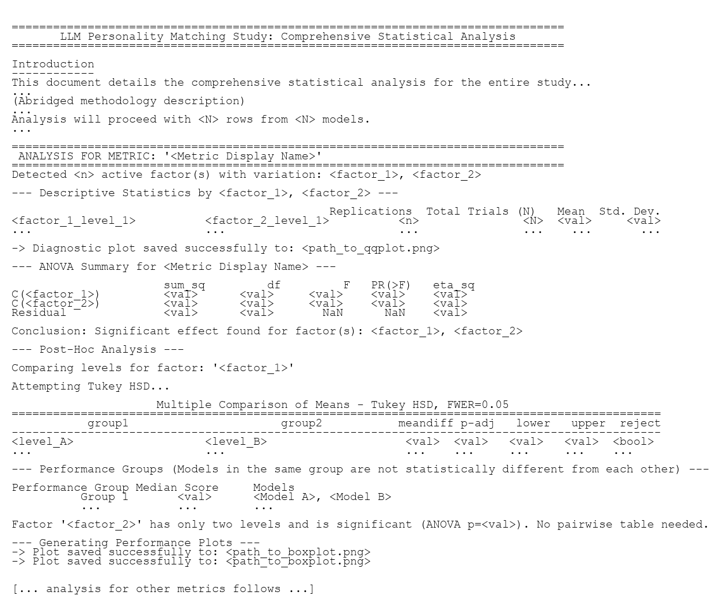

Migrating Old Experiment Data
A one-time migration process is required to upgrade older, incompatible data directories.

Migration Steps
Ensure your Python environment is activated before running these commands from the project root directory.
A. Manual Steps
- Patch Configs: This archives the config.ini file in each run_* subdirectory.
- python src/patch_old_runs.py "<path_to_old_experiment_dir>"
- Rebuild Reports: This uses the archived configs to regenerate each replication_report.txt with a modern structure and a valid METRICS_JSON block.
- python src/rebuild_reports.py "<path_to_old_experiment_dir>"
- Clean Artifacts: Manually delete the following old files and directories from within the <path_to_old_experiment_dir>:
  - The top-level final_summary_results.csv or STUDY_results.csv.
  - The top-level batch_run_log.csv
  - The analysis_inputs directory inside each run_* subdirectory.
  - All *.txt.corrupted files inside each run_* subdirectory.
- Final Reprocess: This will regenerate the summary CSV files, logs, and all analysis artifacts using the modern, rebuilt reports. You can also add notes during this step.
- python src/replication_manager.py --reprocess "<path_to_old_experiment_dir>" --notes "Migrated to new format"
B. Automated Scripts
Scripts are provided to automate all four steps for Windows environments (migrate_old_experiment.ps1 and .bat).

Maintenance and Utility Scripts
- replication_manager.py:
  - The main batch runner for managing multiple replications. Can be invoked in a reprocessing mode (--reprocess) to fix or update the analysis for existing runs without re-running expensive LLM sessions. Can also add/override run notes (--notes).
  - Usage: python src/replication_manager.py path/to/experiment --reprocess --depth 1
- rebuild_reports.py:
  - A powerful utility to regenerate complete replication_report.txt files from the ground-truth archived config. Useful for applying fixes to the processing or analysis stages across an entire study.
  - Usage: python src/rebuild_reports.py path/to/study
- patch_old_runs.py:
  - Utility for historical data. Scans a directory for old experiment runs that are missing a config.ini.archived file and generates one for each by reverse-engineering the replication_report.txt. Supports recursive scanning with --depth.
  - Usage: python src/patch_old_runs.py "path/to/old/experiments" --depth -1
- log_manager.py:
  - The core utility for automated log management. Called by the main runner but can also be used manually.
  - start: Archives any old log and creates a new, empty one with a header.
  - rebuild: Recreates the log from scratch by parsing all existing replication reports in a directory.
  - finalize: Cleans any existing summary from the log, recalculates a correct summary, and appends it.
- retry_failed_sessions.py:
  - Used automatically by the main runner for the repair cycle. Can be run manually to fix failed API calls in a specific run.
- verify_pipeline_completeness.py:
  - A diagnostic tool to check for missing files or incomplete stages in a run directory.
- inject_metadata.py:
  - LEGACY UTILITY: No longer part of the standard workflow.
- compile_results.py:
  - The core script for hierarchical data aggregation. Recursively scans a directory structure, performing a bottom-up summary.
  - Generates level-aware filenames: REPLICATION_results.csv, EXPERIMENT_results.csv, and STUDY_results.csv.
  - Usage: python src/compile_results.py path/to/study
- run_anova.py:
  - Performs a comprehensive statistical analysis on a study’s master CSV.
  - Uses display names from config.ini to produce clean, human-readable plots and logs.
  - Usage: python src/run_anova.py path/to/study
- list_project_files.py:
  - A diagnostic tool for creating a snapshot of the project’s structure.
  - Usage for a full recursive scan: python src/list_project_files.py . --depth -1

Testing
The project includes a suite of unit and integration tests managed by PDM. To run the complete test suite, use the PDM script command:
pdm run test

