**--Display a list of student assignments for a subject.Sample subject id = 1**

SELECT S.SUBJECT_NAME, g.ASSIGNMENT_ID, g.ASSIGNMENT_NAME, g.URL

FROM ASSIGNMENT G, SUBJECT S

WHERE S.SUBJECT_ID = G.FK_SUBJECT_ID

and g.fk_subject_id=1;

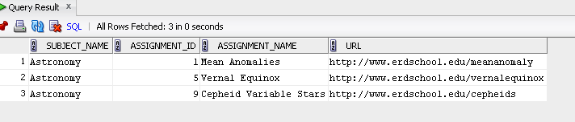

**-- Display a list of all students taught by a given teacher. Sample teacher - Teacher id 2, Carolyn Porco**

SELECT T.First_name||' '||t.last_Name as teacher_Name, S.FNAME||' '||s.LName as student_name

FROM STUDENT S, HOMEROOM H, teacher t

WHERE S.FK_HOMEROOM_ID = H.HOMEROOM_ID

AND H.FK_TEACHER_ID = T.TEACHER_ID

and t.teacher_id = 2;

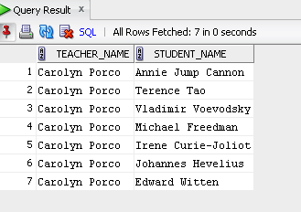

**-- DISPLAY A LIST OF ALL THE STUDENT WORK BY A STUDENT. Sample student_id = 22**

SELECT S.FNAME||' '||S.LNAME as student_Name, H.URL as homework_URL

FROM HOMEWORK H, STUDENT S

WHERE S.STUDENT_ID = H.FK_STUDENT_ID

and S.STUDENT_ID = 22;

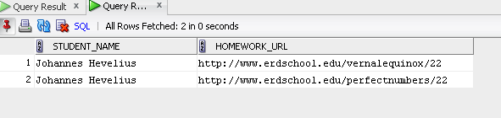

**-- Display a list of student work for a classroom. Sample homeroom_id = 2**

SELECT h.FK_STUDENT_ID AS HOMEROOM_2_STUDENTS, s.fname||' '||s.lname as Student_Name, h.URL AS STUDENT_WORK

FROM HOMEWORK h, STUDENT S

WHERE FK_STUDENT_ID IN ( SELECT STUDENT_ID FROM STUDENT WHERE FK_HOMEROOM_ID = 2)

and s.student_id = h.fk_student_id;

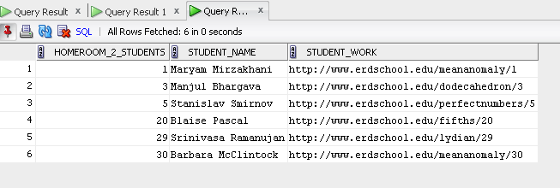

**Primary key validation – inserting duplicate student_id displays appropriate error messages**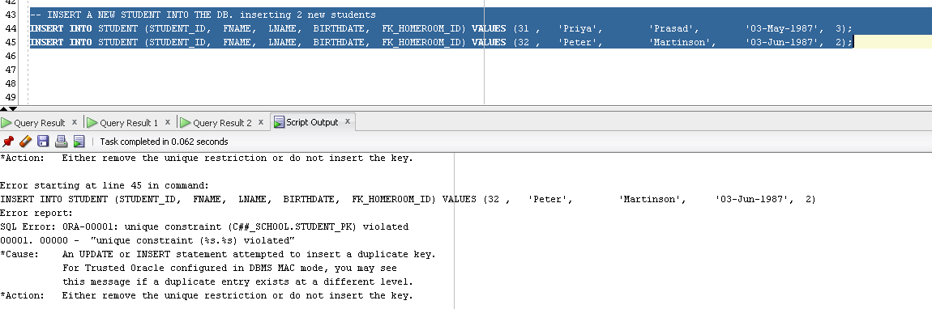

**Update operations –**

