Math with your Coffee?
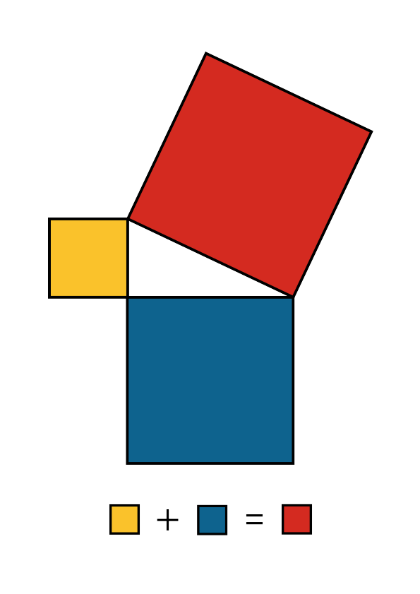

https://distractedfortune.com/product/pythagorean-theorem-formula-mug/

