Math with your Coffee?
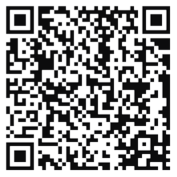
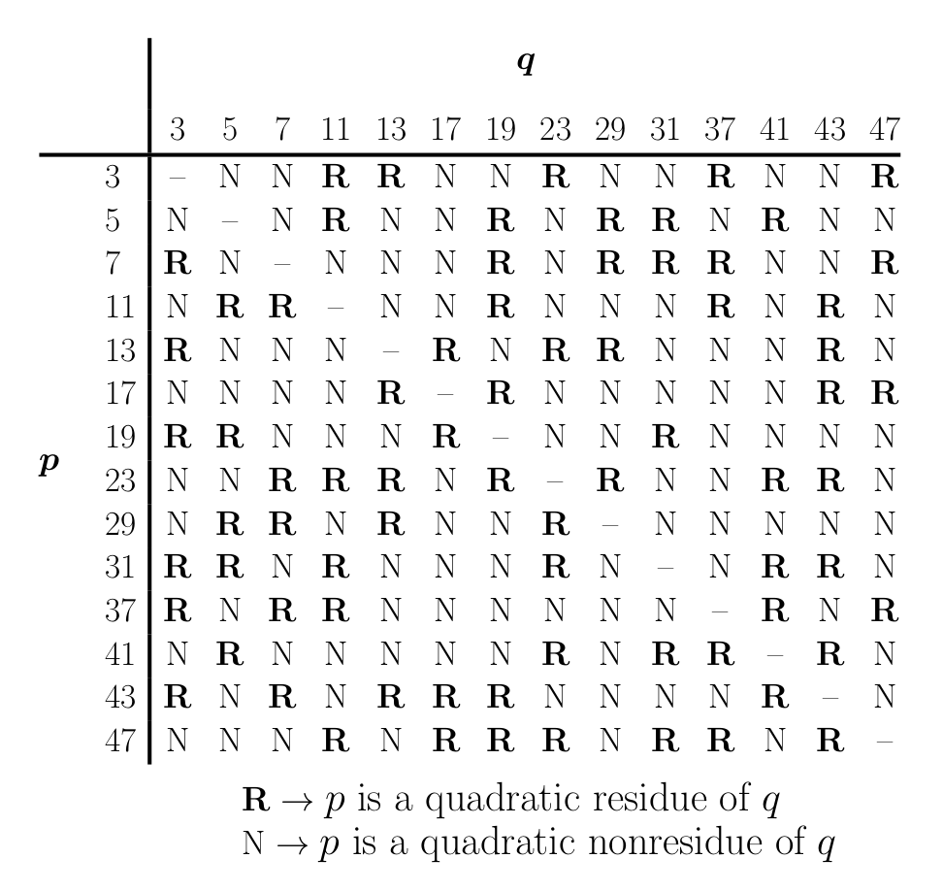

https://distractedfortune.com/product/law-of-quadratic-reciprocity

