detlimitr3

Peter Watkins

2023-08-22

### An introduction to the detlimitr3 package

The *detlimitr3* (estimating **det**ection **limit**s using **R** with S**3**) package is to be used calibration data in analytical chemistry. It is intended as a follow-on from the *detlimitr* package, with the aim for the package to be simpler to use.

The detection limit is an important figure of merit in chemical analysis. It is also known as the lower limit of detection, or LOD (limit of detection), and can be defined as the lowest quantity of a substance that can be distinguished from the absence of that substance (a blank value) with a stated confidence level (generally 99%).

Using an S3 class, the package describes an object class (“lod”) and has needs three functions for application; *det.limit* which constructs the “lod” object, *print* and *plot*.

If required, the *detlimiter* package can be downloaded using

#install.packages("devtools")   
devtools::install_github("peterjwatkins/detlimitr", force=TRUE)

In this package, the detection limit can be calculated for linear, quadratic or power regression. For the latter, the model for the measured response, $y$, and concentration, $x$, is given by $y=C+Ax^{b}$ where $C$, $A$ and $b$ are the estimated parameters.

In this package, the detection limit for linear regression is calculated using three approaches; i) Miller and Miller, ii) Vogelsang and Hädrich, and iii) Hubert and Vos, and these references are described below.

The user can review the data using a residuals plot. In this case, the data is modeled using a suitable regression, and the residuals (that is, the difference between the fitted and experimental values) are plotted against the fitted values for the regression model. These plots provide a good indication on the suitability of the regression model for the data.

An example of a residual plot is shown below, using the *plot* function.

library(detlimitr3)  
data("vhtab6")  
m1 <- det.limit(vhtab6$concentration, vhtab6$area) # Linear regression assumed by default  
  
plot(m1, residplot = TRUE)

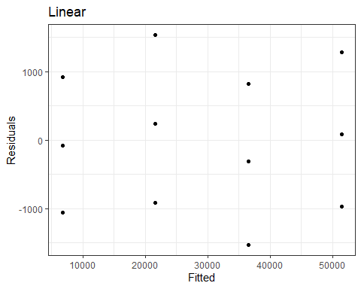

If the model is suitable then the plot will show the residuals have a Gaussian distribution, be independent and have constant variance, that is, be homoscedastic. This is the case in the figure shown above.

Some further examples are shown below. Here, simple models were defined and linear regression was set as the most suitable model. In this instance, $y_{1}=0.1+2x$, $y_{2}=0.1+2x−0.25x^{2}$, and $y_{3} =0.1+2x^{0.85}$, with some added Gaussian noise ( $σ$ = 0.1). For the first model, the residual is as expected, while the other plots indicate that the linear model is not appropriate for the data (as also expected)

mod1 <- det.limit(x,y1,"Linear")  
mod2 <- det.limit(x,y2,"Linear")  
mod3 <- det.limit(x,y3,"Linear")  
  
plot(mod1, residplot = TRUE)

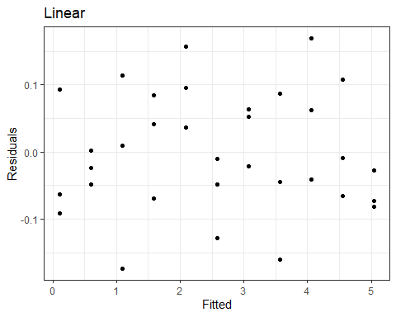

plot(mod2, residplot = TRUE)

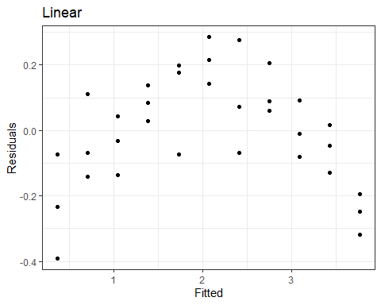

plot(mod3, residplot = TRUE)

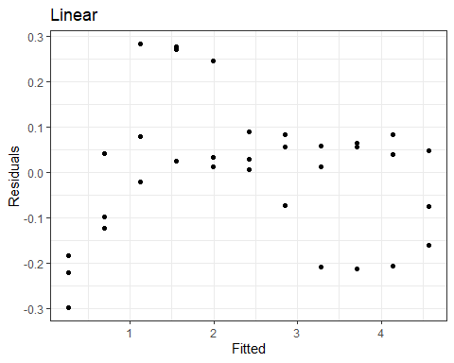

Another example of not selecting the appropriate regression model is shown below:

data("chloromethane")  
x <- chloromethane$Concentration  
y <- chloromethane$Response  
m2 <- det.limit(x,y)  
plot(m2, residplot = TRUE)

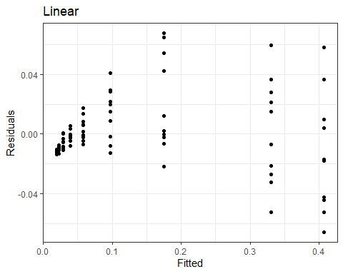

A better fit is found with quadratic regression, although the residuals are not homoscedastic; they are heteroscedastic since there is increasing variance.

m2 <- det.limit(chloromethane$Concentration,chloromethane$Response,"Quadratic")  
plot(m2, residplot = TRUE)

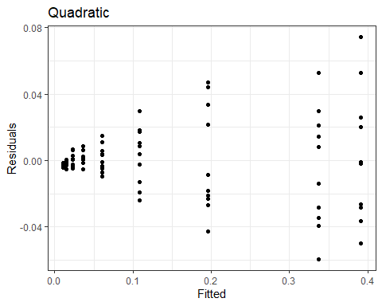

The *print* function shows the calculated DLs. .

print(m1) ## by default, number of decimal points = 1

## Linear regression   
## -----------------   
## Miller 12.6   
## Vogelsang-Hadrich 8.7   
## Hubert-Vos 21.8

print(m2, dp = 2) ## number of decimal points = 2

## Quadratic regression   
## --------------------   
## Hubert-Vos 0.7

For linear regression, the DLs are calculated using i) Miller and Miller, ii) Vogelsang and Hädrich, and iii) Hubert and Vos while *plot* shows the calibration curve, showing the estimated detection limit, according to Hubert and Vos, using an iterative approach.

The plot from linear regression is shown below:

plot(m1)

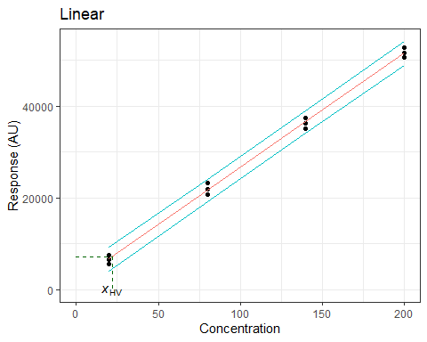

For quadratic and power regression, the DL is estimated empirically using an approach described by Coleman and Vanatta. These authors state that a detection limit is any combination of α, β, and concentration that satisfies the following relationship, referencing the figure shown below where he response corresponding to the intersection of the upper prediction limit with the $x$ = 0 line is the same as the response corresponding to the intersection of the lower prediction limit with the $x$ = DL line. This approach is also indicated in the figure. It should be noted that this was suggested in the case of linear regression and thus, for quadratic and power regression, this is intended to be an approximation. Reference iv) provides further details on this approach.

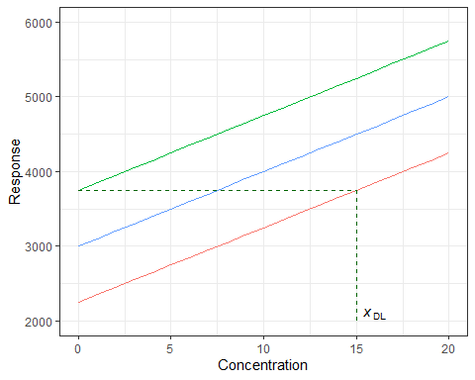

Example plots for quadratic and power regression are shown below.

plot(m2)

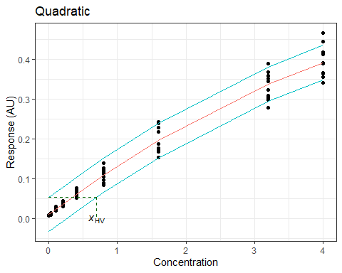

#Power regression example  
x <- sort(rep(seq(0,25,5),3))  
y <- 2 + 20 * x ^ 0.85 + rnorm(x,0, 5)  
m3 <- det.limit(x,y,"Power")  
plot(m3)

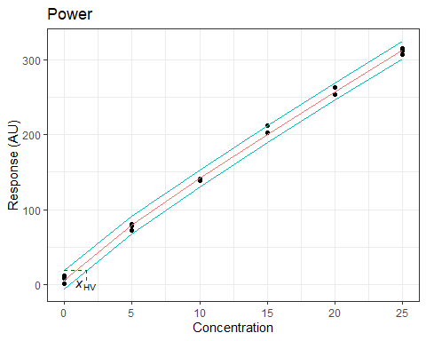

**References**

1. J.C. Miller and J.N. Miller (1993), “Statistics for Analytical Chemistry”, 3rd ed., Prentice-Hall.
2. J. Vogelgesang and J. Hädrich (1998), Accred. Qual. Assur., 3:242-255.
3. A. Hubaux and G. Vos (1970), Anal. Chem., 42:849-855 & D.T. O’Neill, E.A. Rochette and P.J. Ramsay, (2002), Anal. Chem., 74:5907-5911
4. D. Coleman and L. Vanatta (2009). American Laboratory, Statistics in Analytical Chemistry: Part 34 - Detection Limit Summary.