Report

Team UnderGrad005

*The purpose of this project was to design an information system for a private dental practice; Sheffield Dental Care. The business wanted the system to manage client registration, appointments and fee calculation. We have included in this report: the organisation of the work; the UML diagrams; the secretary user interface; query processing of the system itself and an effort declaration of the group.*

*When embarking on the project we reviewed the work required and our own strengths and weaknesses in respect of each requirement, dividing the work up so that we would all have an input into every section of the system and the diagrams. However, when putting this into practice over the weeks it was difficult to be so inclusive, therefore we decided that Georgia would complete the UML diagrams for the design while Peter and Daniel began creating the system. Peter initialised the three databases so that there was a database for patient information, hygiene appointments and dentist appointments. Dan started to create the GUI which would allow us to use the system.*

*When creating the system, we predominately utilised the information and data model, as this was an outline of how we intended the system to be created. After the completion of the system we all tested different areas to ensure that all the criteria were met and as part of our quality assurance. Daniel tested the section of the system that after a patient chose a particular healthcare plan, the plan would be updated on their record so that following an appointment the subsequent payment would take into account their specific plan and charge/deduct costs based on this. Georgia tested diary management to see for example, if appointments could be double booked and that blank appointments could be made for leave. Peter tested the overall system to ensure that no parts were missing.*

Use Case Diagram

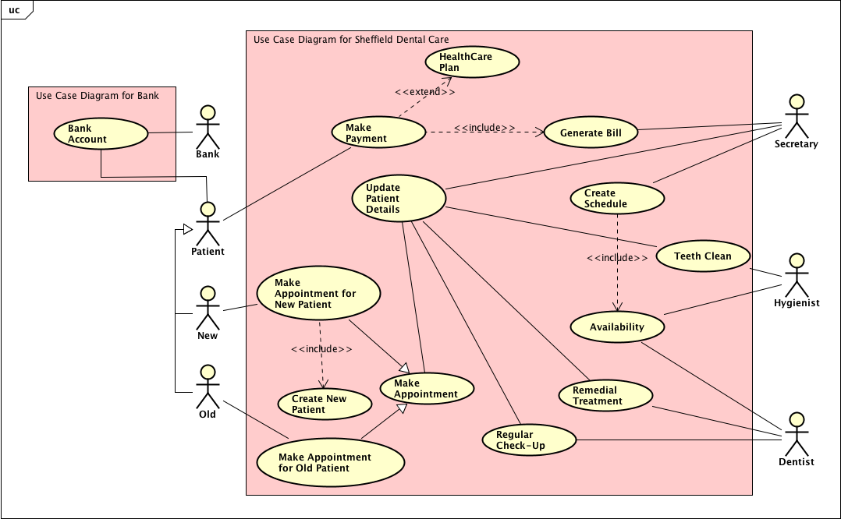

Class Diagram Information Model

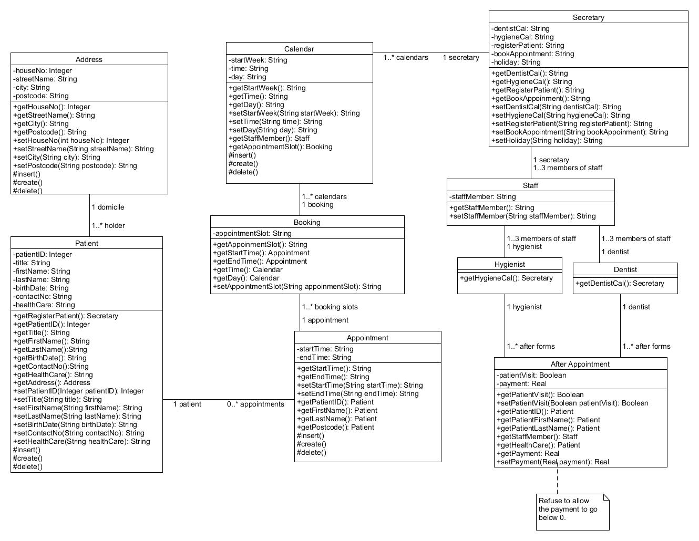

Class Diagram Data Model

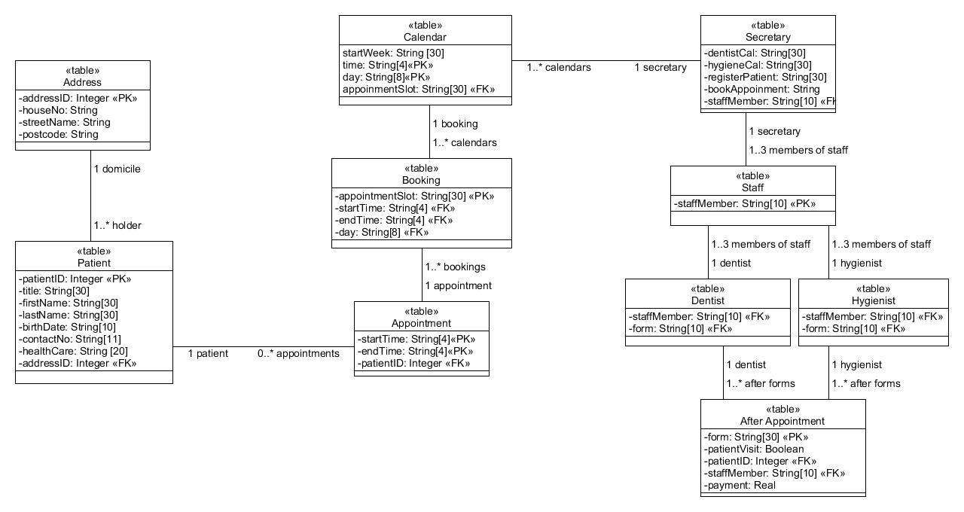

Secretary UI

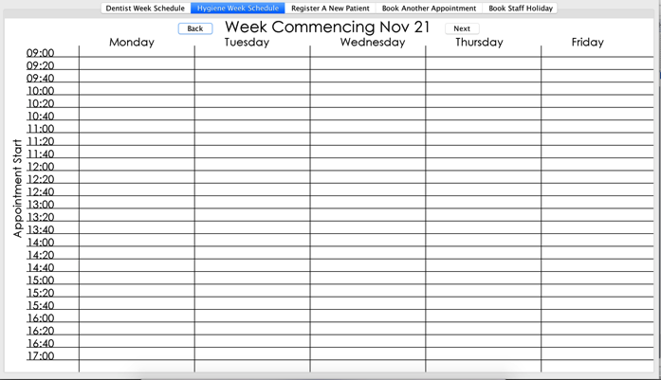The secretary UI opens on the dentist week schedule tab, and has a selection of tabs for the secretary to chose. The second is a week schedule for the hygienist. The third is the registration tab, the fourth an appointment booking tab and the last is a holiday booking tab.

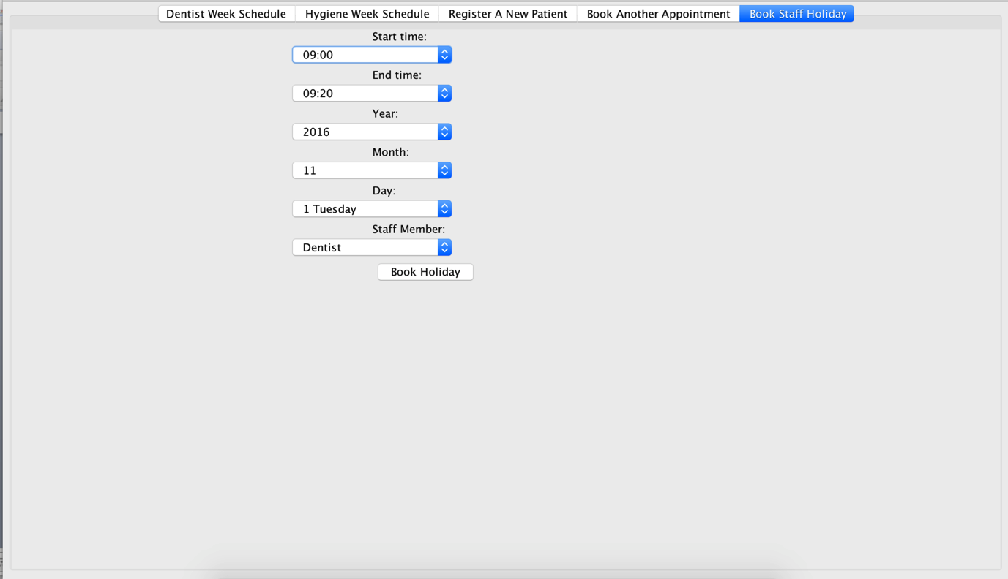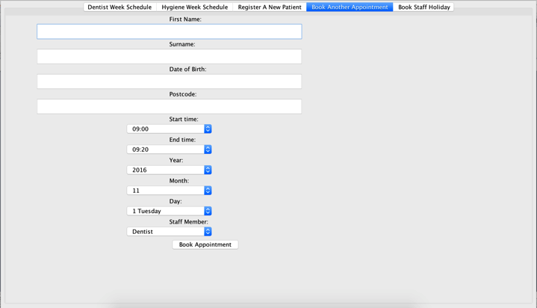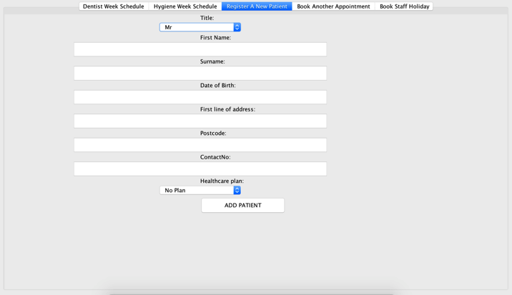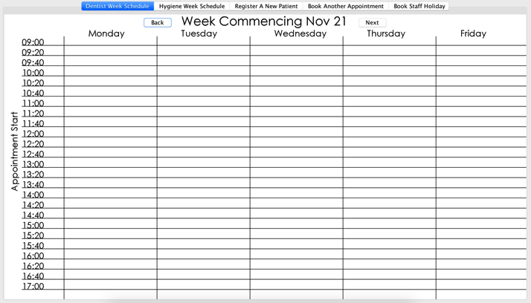

Query Processing

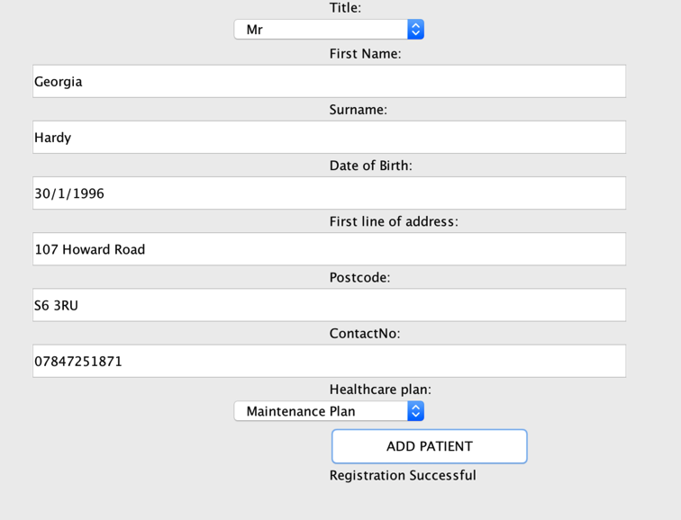Registration Functionality:

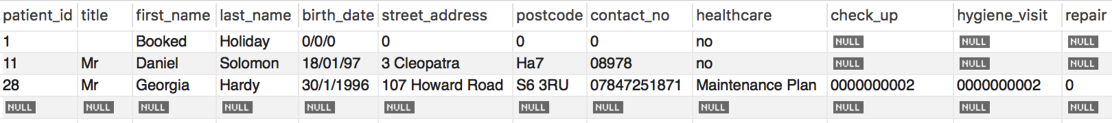After attempting to register Georgia Hardy as a patient in the database, I can check the database and see that she has been added with all the relevant fields. I can also see that she as been given the relevant credits she is owed for the healthcare plan she is on.

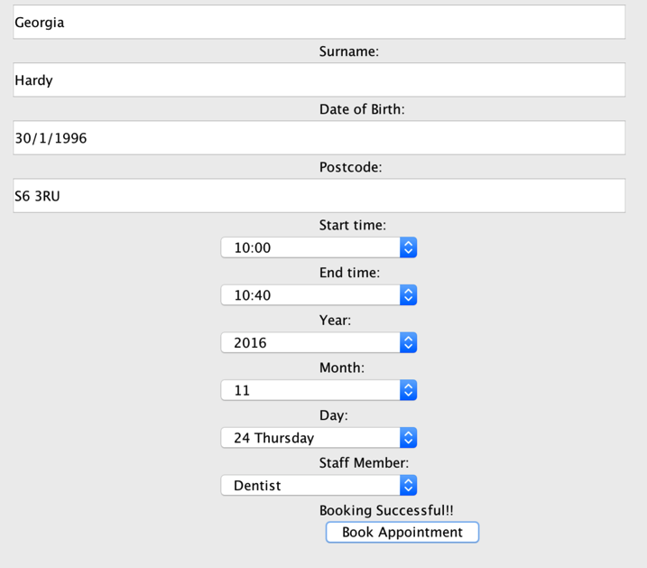Appointment Booking

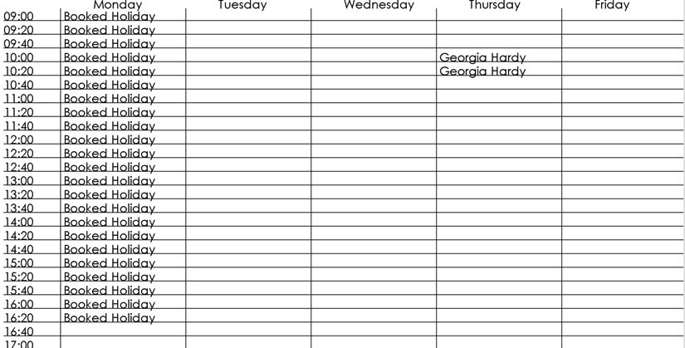Attempting to book an appointment for Georgia Hardy with the dentist on Thursday the 24th at 10:00 to 10:40. I can then go to the Secretaries week view and see the appointment on the relevant week at the relevant time. On the dentist’s day view we can also see the appointment once we navigate to the relevant day.

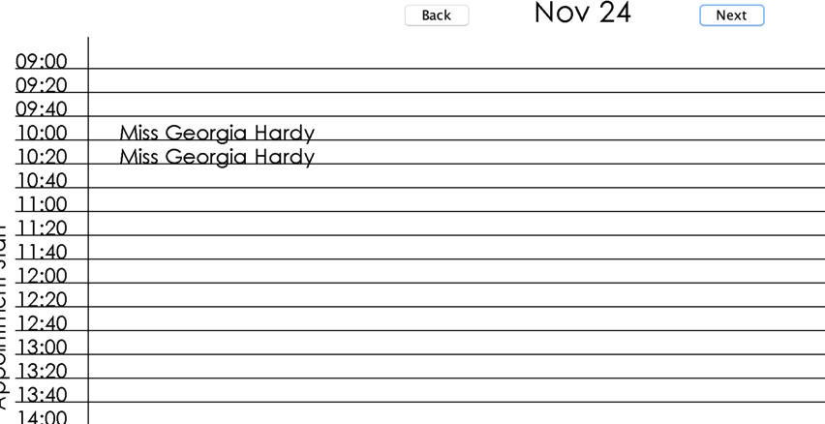

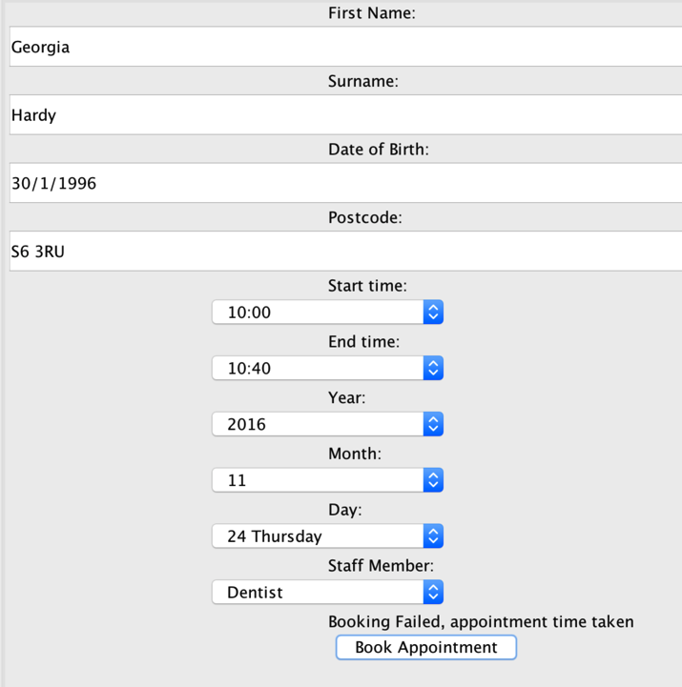

If the appointment time is taken, the appointment should be rejected.

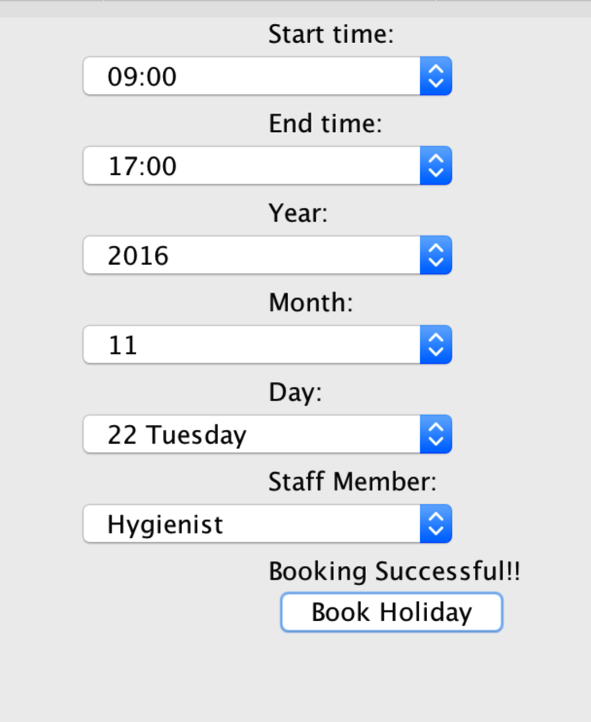Holiday Booking

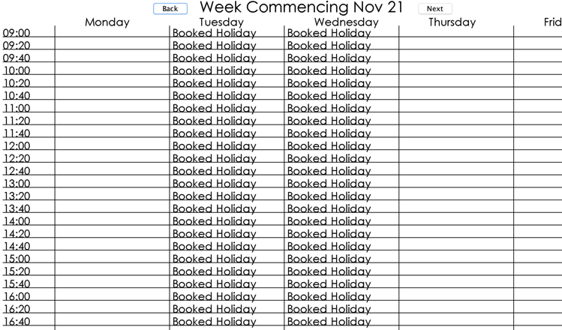Booking holiday for the hygienist on the 22nd of November, followed by booking off the 23rd. These holidays then appear on the secretaries’ and the hygienist’s week to view calendar and the hygienists day view calendar.

Receipt Filling

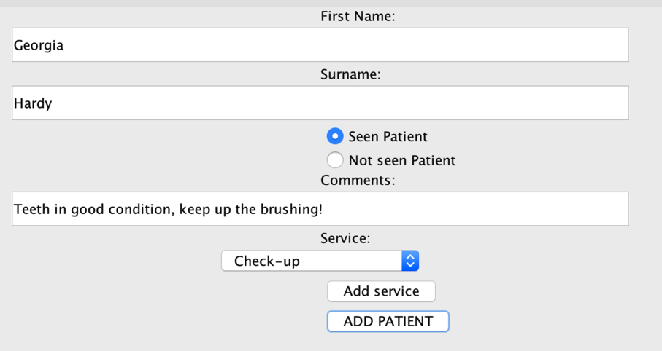The dentist filling in the after patient form, indicating the service given and any comments. It also comes up on the receipt as free due to the fact that the patient is on one of the healthcare plans, and a check-up ‘token’ is removed from their account.

The check-up token in the 3rd field from left has also decreased by 1, so that the patient only has one more free check-up this year.



Effort Declaration

*As a team, we all worked efficiently and effectively together, setting up a git account so that we could share our code and diagrams with each other contemporaneously. We had two weekly meetings to check on progress and ensure we were still on track for reaching our deadline. There were slight problems with the system throughout the project, which we expected, as we were constantly adding to and testing the system, which can then cause problems in previous completed sections of the system. However, we felt able to share our difficulties and support each other working collaboratively as a team to solve each problem. The work allocation changed at the beginning of the project, as we initially all wanted to be involved in every aspect of the project, but this level of inclusivity proved to be impossible, as we were all working ‘on top’ of each other. By allocating different sections of the project between us we had room to work and because we have used git effectively and shared our difficulties openly we have worked efficiently together.*

|  |  |
| --- | --- |
| *Dan* | * *GUI* * *Updating the database and insertion* * *Generating receipts for patients* * *Adding linker tables UML information model* * *Relationships and associations between classes on information model* * *Health care plan selected during registration* * *Creating After and Registration Information panels* * *Creating user select window* * *Testing the system* |
| *Peter* | * *Adding linker tables UML data model* * *GUI* * *Creation and insertion of the database* * *Relationships & associations between classes on data model* * *Testing the system* * *Creating database access layer* * *Creating calendar panels* * *Appointment and holiday booking handling* |
| *Georgia* | * *Use case diagram* * *Information model* * *Data model* * *GUI* * *Testing the system* * *Registration* |
| *Ella* |  |

*Estimate of effort contributed by each member:*

* *Daniel: 133.3%*
* *Peter: 133.3%*
* *Georgia: 133.3%*
* *Ella: 0%*

Signed: