Peter Keres

Assignment 3

Theory of computation

4/20/2020

Question 1:

Question 2:

Question3:

Question 4:

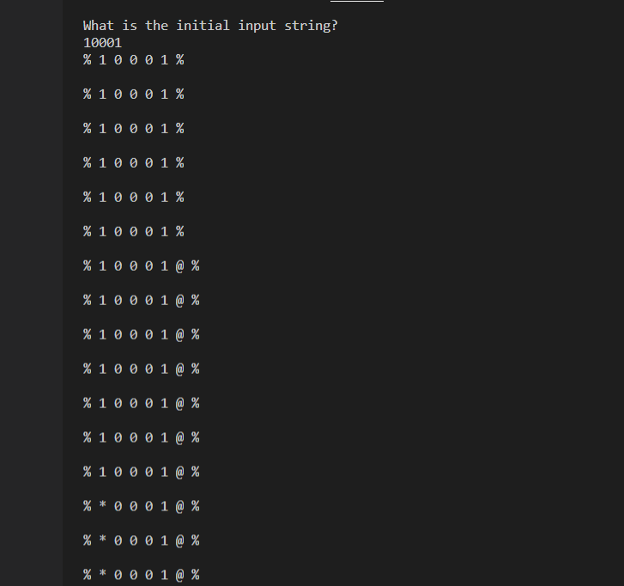

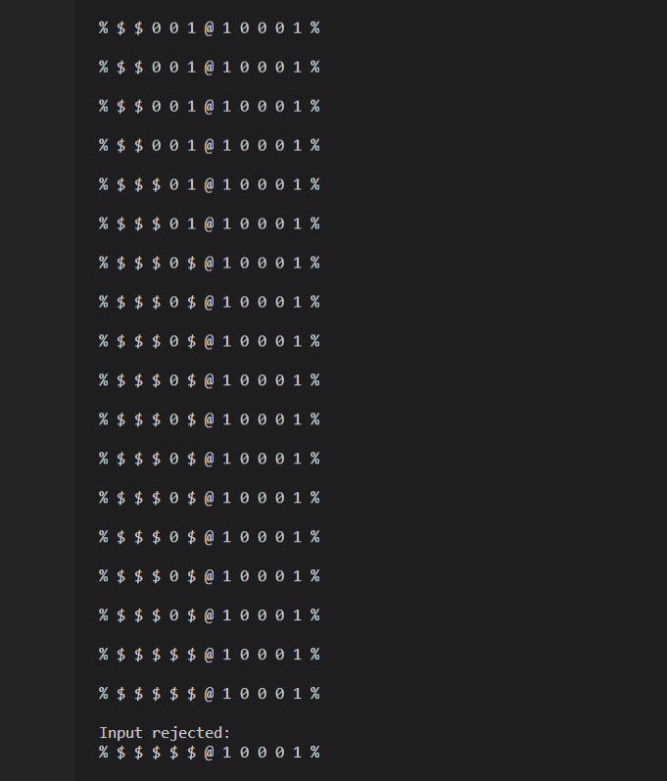

Question 5:

