Findings Presentation

Peter Kim

2023-07-03

**The Options Chain: An Overview**

Options are a type of financial derivative that gives an entity the right to buy or sell a contract.

Call Option: A call option gives the holder the right to buy an underlying asset at a specified price, known as the strike price, before the expiration date. Call options are typically used when an investor expects the price of the underlying asset to rise.

Strike Price: The strike price is the pre-determined price at which the option holder can buy or sell the underlying asset. It is also known as the exercise price.

Expiration Date: The expiration date is the date on which the option contract expires, and the holder loses the right to exercise the option. After the expiration date, the option becomes worthless.

**Options Pricing**

Options pricing refers to the process of determining the theoretical price of an options contract. The models we will study in this paper are the Black-Scholes model and the Monte-Carlo Simulation. These pricing models take into account several key factors that influence the value of an option. The main components considered in options pricing are:

Underlying Asset Price: For call options, as the underlying asset price increases, the value of the call option generally increases, assuming other factors remain constant.

Strike Price: The strike price is the predetermined price at which the underlying asset can be bought (for call options). The difference between the underlying asset price and the strike price affects the value of an option.

Time to Expiration: The time remaining until the options contract expires has a significant impact on its value. As time passes, the time value component of the option diminishes.

Volatility: Volatility refers to the magnitude of price fluctuations in the underlying asset. Higher volatility generally leads to higher option premiums due to the increased likelihood of large price swings, which potentially provide greater opportunities for profits.

Risk-Free Rate: The risk-free rate, such as the interest rate on government bonds, is the rate of return an investor could earn on a risk-free investment. The risk-free rate is used to discount the future cash flows associated with the option to their present value. The closer the expiration date, the lower the present value of future cash flows due to the risk-free rate.

**Stochastic Processes**

Options pricing models rely on stochastic processes to describe the behavior of the underlying asset price.

Stochastic processes are probabilistic models for random quantities evolving in time or space. The evolution is governed by some dependence relationship between the random quantities at different times or locations. (JHU)

There are several types of stochastic processes:

1

1. Discrete Time and Discrete States or Markov Chains: Same number of states per sequential time where the probability of one state is strictly dependent on the state of the previous state.
2. Discrete Time and Continuous States: Changing value of states per sequential time (ex. stock prices)
3. Continuous Time and Continuous States or Brownian motion/Ito process: Changing value of states per high frequency data (options models)

**Brownian Motion: An Introduction**

A normally distributed Brownian motion is a mathematical model used to describe the random movement of variables over time.

Randomness: Brownian motion is inherently random and unpredictable. It simulates the movement of variables that are subject to random forces or fluctuations.

Normally Distributed Increments: The increments of a Brownian motion are normally distributed. This means that the change in value between any two consecutive time steps follows a normal distribution.

Independent Increments: The increments of a Brownian motion are independent of each other. The value at any given time does not depend only on the current time step.

Time Scaling: The magnitude of the increments is scaled by the square root of the time step size. This scaling factor maintains the appropriate variance properties of the Brownian motion as the time step size changes.

**Brownian Motion in the Monte Carlo Simulation**

Brownian motion plays a crucial role in Monte Carlo simulation, particularly in simulating the movement of underlying asset prices or variables over time. Here’s how Brownian motion is used in Monte Carlo simulation:

Brownian motion is used to model the random and unpredictable nature of asset price movements. In Monte Carlo simulation, random numbers following a standard normal distribution are often generated to represent the increments of a Brownian motion. These random increments are then accumulated over time to generate a simulated path of the underlying asset price.

Monte Carlo simulation involves generating a large number of simulated scenarios to estimate the potential outcomes of a given system or process. Brownian motion is used to simulate multiple paths of the underlying asset price, where each path represents a different scenario. By simulating numerous paths, Monte Carlo simulation provides a distribution of possible outcomes, allowing for probabilistic assessments and risk analysis.

By simulating multiple asset price paths based on Brownian motion, Monte Carlo methods can estimate the expected payoff of the derivative at expiration. These simulations can be used to calculate the present value of the derivative and determine its fair price.

Here is a plot of 10000 simulations of normally distributed brownian motion:

2

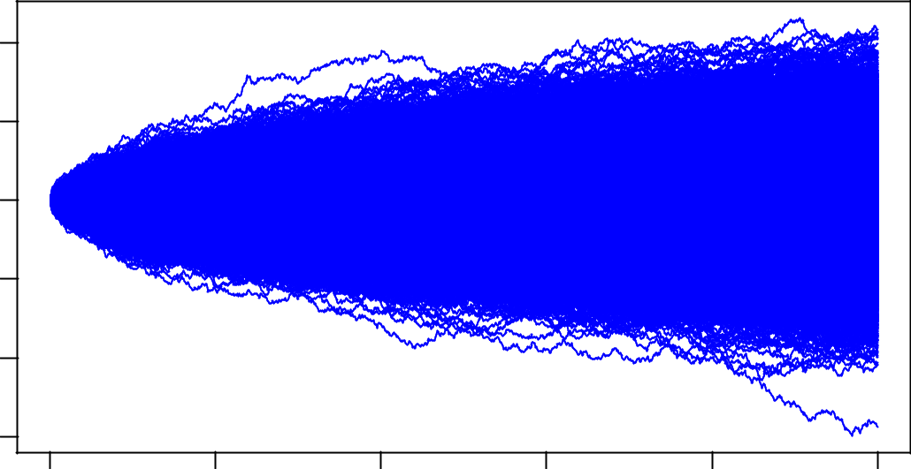

|  |  |  |  |  |  |  |
| --- | --- | --- | --- | --- | --- | --- |
|  | 10 |  |  |  |  |  |
| Motion | 0 5 |  |  |  |  |  |
| Brownian | −5 |  |  |  |  |  |
|  | −10 |  |  |  |  |  |
|  | −15 |  |  |  |  |  |
|  | 0 | 200 | 400 | 600 | 800 | 1000 |
|  |  |  |  | Time |  |  |

**The implementation of Brownian Motion: The Black Scholes Model**

In the Black-Scholes model, the continuous-time stochastic process of the underlying asset price follows geometric Brownian motion. However, when implementing the model numerically, a discrete approximation formula is often used due to the discrete nature of computational simulations.

The most commonly used discrete approximation formula in the Black-Scholes model is known as the Euler discretization method. It approximates the continuous-time dynamics of the asset price by discretizing time into small intervals and updating the asset price at each time step. Here’s the formula for the Euler discretization of the Black-Scholes model:

|  |  |  |  |  |  |  |  |  |  |  |  |  |  |  |  |  |  |  |  |  |
| --- | --- | --- | --- | --- | --- | --- | --- | --- | --- | --- | --- | --- | --- | --- | --- | --- | --- | --- | --- | --- |
|  |  | = *S* |  | + *rS* | ∆*t* + *σS* | |  | √ | |  |  |  | *N*(0*,* 1) The formula computes the new asset price (*S* |  | + *rSt*) at | | | | |  |
| *S* | *t*+∆*t* |  |  | ∆*tε* where *ε* | | ∼ |  |  |
|  |  | *t* | *t* |  |  | *t* |  |  |  |  |  | *t* |  | 1 |  | 2 |  |  |
| the next time step by multiplying the current asset price (*St*) by the exponential of the drift term (*r* − | | | | | | | | | | | | | | | | 2 | *σ* |  | )∆*t* |  |
| and the random term √ | | | | | |  | | |  | | |  |  |  |  |  |  |  |  |  |
| ∆*tε* | | | | | |  |  |  |  |  |  |  |  |  |

By iteratively applying this formula for each time step, you can simulate the asset price path over a specified time horizon. This discretized approximation allows for efficient numerical calculations and is commonly used in option pricing simulations and Monte Carlo methods based on the Black-Scholes model.

Note that the Black-Scholes formula assumes no dividends, efficient markets, constant volatility, and no transaction costs, among other simplifying assumptions.

Here we implement the Black-Scholes formula to price a call option by NVDIA 1. We assume an implied volatility as opposed to a stochastic volatility as the framework of this analytical method:

* [1] "NVDA"
* NVDA.Adjusted
* 2023-08-0879.56012

**The Monte Carlo Simulation**

The Black-Scholes model is an analytical formula that provides a closed-form solution for pricing European options. It has a mathematical formula that directly calculates the option price based on the model inputs.

1All data is taken from call options that expired on July 7th, 2023 at a risk free rate determined at the end of June 29th, 2023.

3

In contrast, Monte Carlo simulation is a numerical method that uses random sampling and statistical analysis to estimate option prices. It involves generating a large number of simulated price paths and averaging the results to obtain the option’s expected value.

1. “NVDA” [1] 0 The call price is: 0 This simulation of the Monte Carlo Process implements the same parameters as done by the previous Black Scholes Model.

This process simulates a large number of random price paths for the underlying asset using geometric Brownian motion. Each price path represents a possible future trajectory of the underlying asset’s price over the given time horizon.

For each simulated price path, the option payoff is calculated at expiration. The payoff depends on the option type (call or put) and is determined by the difference between the underlying asset’s price at expiration and the strike price.

Each simulated payoff is discounted to its present value using the risk-free interest rate. This accounts for the time value of money and brings all future payoffs back to their present values.

Calculate Expected Payoff:

Average the discounted payoffs over all simulated price paths to obtain the expected payoff of the option.

Compute Option Value:

Multiply the expected payoff by the discount factor (exp(-r * T)) to obtain the estimated value of the option.

Repeat and Refine:

Repeat the Monte Carlo simulation process with a larger number of simulated price paths to reduce the variance of the estimate and improve accuracy. Adjust the time step size or other parameters if necessary to enhance the accuracy of the simulation.

**Bootstrapping**

Monte Carlo simulation often requires a large number of random samples to achieve convergence, where the estimated values stabilize and become consistent. By resampling repeatedly, the simulation process has a higher chance of converging to the true value.

Provide Confidence Intervals: Resampling enables the calculation of confidence intervals, which provide a measure of uncertainty around the estimated values. By resampling and obtaining a distribution of estimates, one can determine the range of values within which the true quantity is likely to fall with a specified level of confidence.

* [1] "NVDA"
* Monte Carlo Simulation - Option Prices with 500 iterations

4

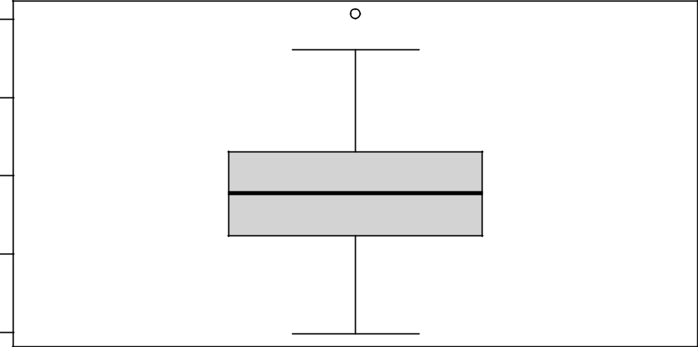

|  |  |  |
| --- | --- | --- |
|  | 84 |  |
| Option Price | 82 |  |
| 80 |  |
|  | 78 |  |
|  | 76 |  |

##

* option price is: 79.57333 sde is: 1.491301
* Black-Scholes Price is: 79.56012
* Black-Scholes option price is within the 95% confidence interval.
* Monte Carlo Simulation - Option Prices with 1000 iterations

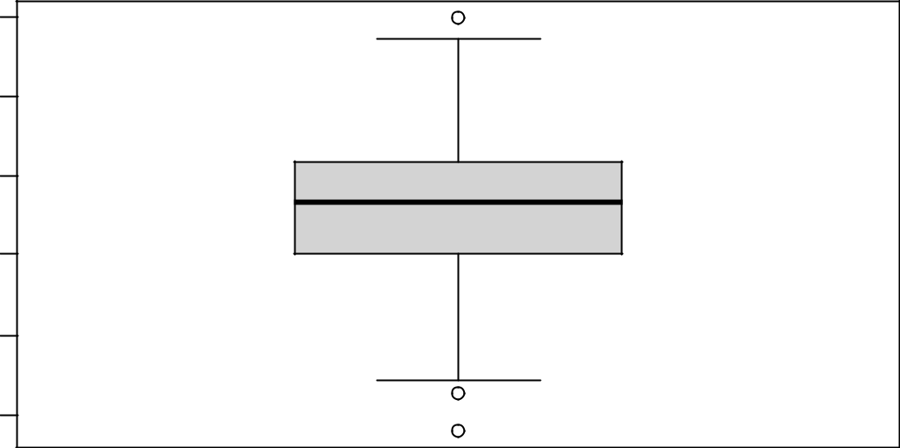

|  |  |
| --- | --- |
|  | 82 |
|  | 81 |
| Price | 80 |
| Option | 79 |
|  | 78 |
|  | 77 |

##

* option price is: 79.59893 sde is: 0.9459316
* Black-Scholes Price is: 79.56012
* Black-Scholes option price is within the 95% confidence interval.
* Monte Carlo Simulation - Option Prices with 2500 iterations

5

|  |  |
| --- | --- |
|  | 81.5 |
| Price | 80.5 |
| Option | 79.5 |
|  | 78.5 |

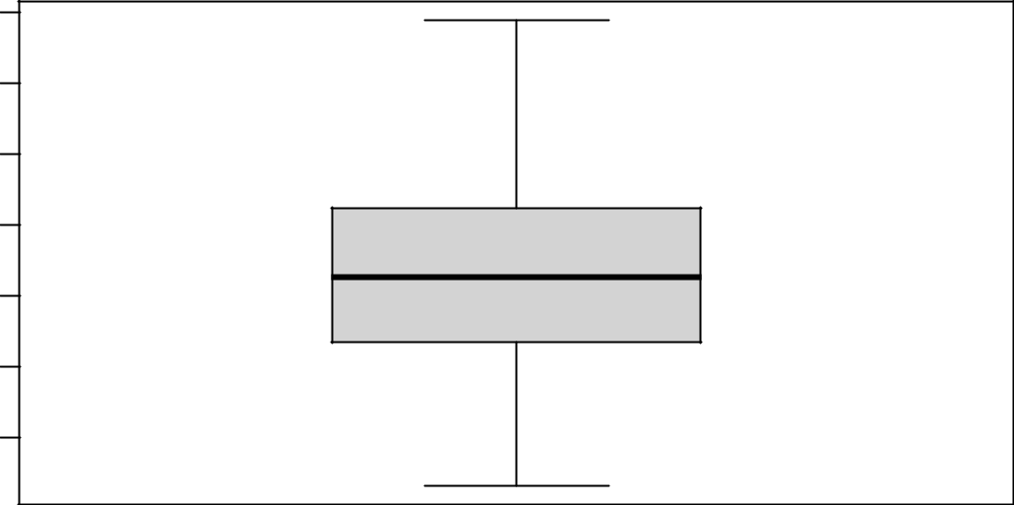

##

* option price is: 79.66605 sde is: 0.7203171
* Black-Scholes Price is: 79.56012
* Black-Scholes option price is within the 95% confidence interval.
* Monte Carlo Simulation - Option Prices with 5000 iterations

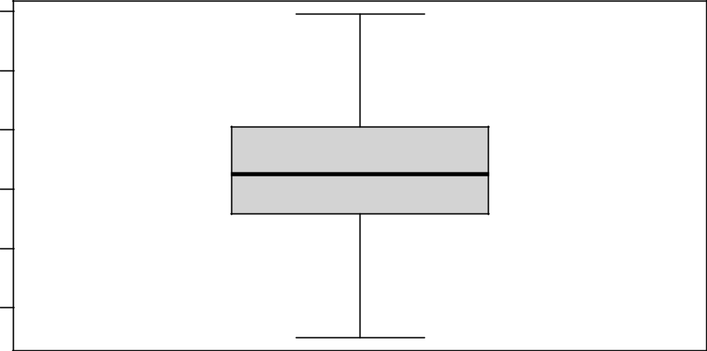

|  |  |
| --- | --- |
|  | 80.5 |
| Option Price | 79.5 |
|  | 78.5 |

##

* option price is: 79.64248 sde is: 0.5038606
* Black-Scholes Price is: 79.56012
* Black-Scholes option price is within the 95% confidence interval.
* Monte Carlo Simulation - Option Prices with 10000 iterations

6

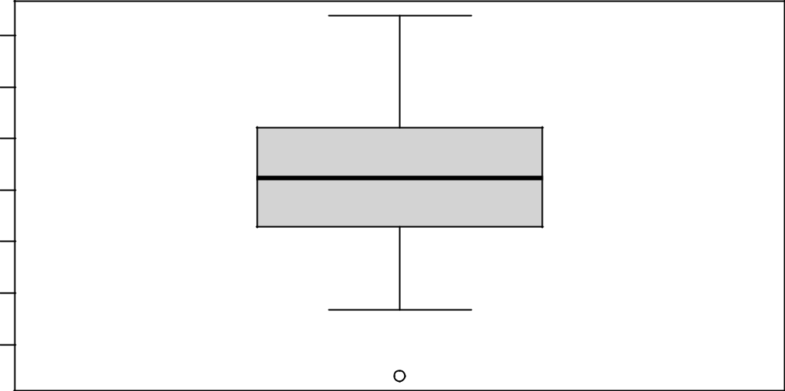

|  |  |
| --- | --- |
|  | 80.2 |
| Price | 79.8 |
| Option | 79.4 |
|  | 79.0 |

##

* option price is: 79.63806 sde is: 0.2640627
* Black-Scholes Price is: 79.56012
* Black-Scholes option price is within the 95% confidence interval.
* Monte Carlo Simulation - Option Prices with 20000 iterations

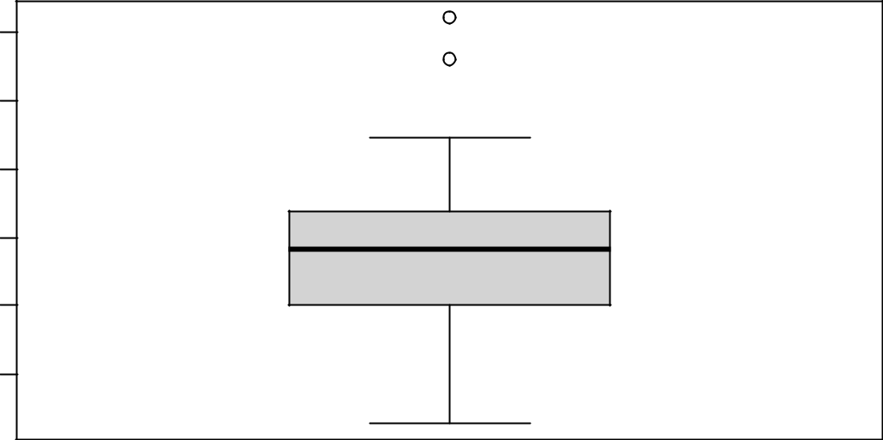

|  |  |
| --- | --- |
|  | 80.0 |
| Option Price | 79.6 |
|  | 79.2 |

##

* option price is: 79.53927 sde is: 0.2240263
* Black-Scholes Price is: 79.56012
* Black-Scholes option price is within the 95% confidence interval.

**Works Cited:**

* <https://engineering.jhu.edu/ams/research/probability-and-stochastic-processes/>

•

7