Peter Klembczyk, Thurein Myint

OS for Engineers

Lab – 2

2/10/2021

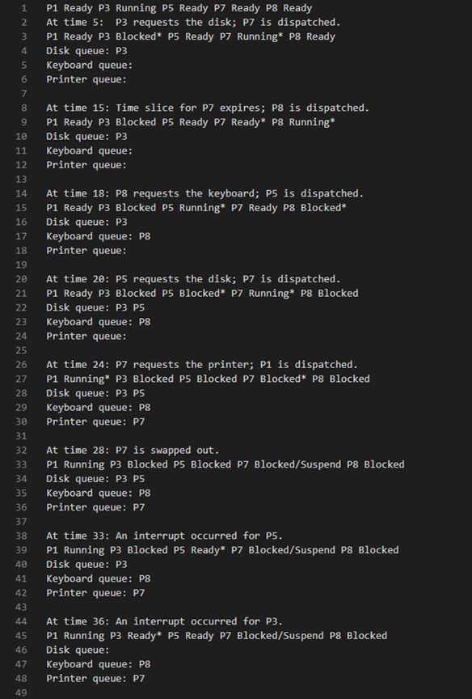

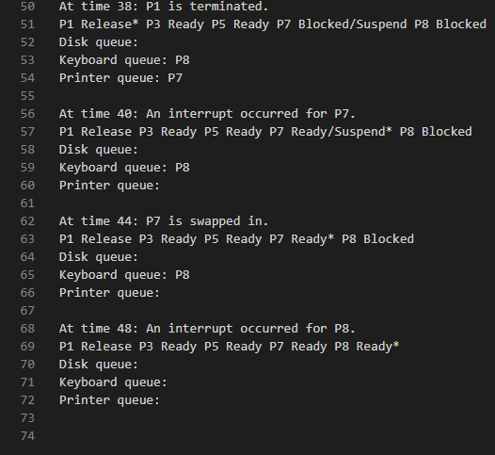

Figure 1 and 2: Fully parsed output file based off of inp1.txt.

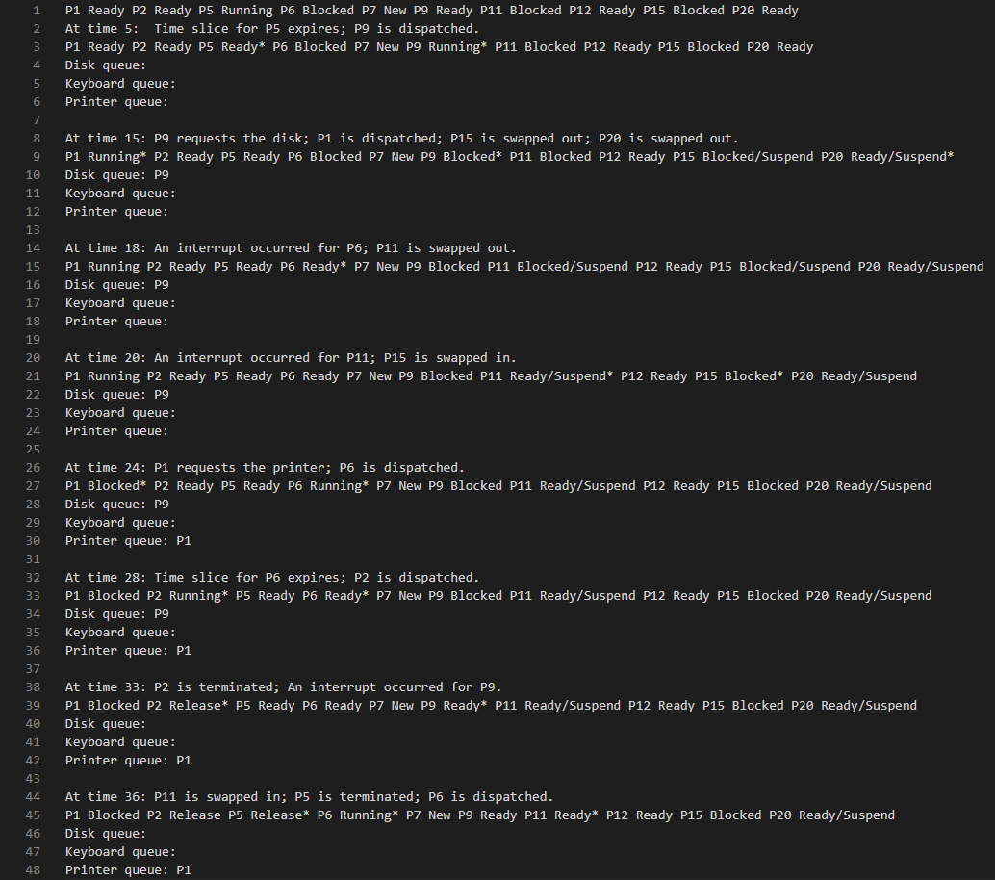

Figure 3: Fully parsed output file based off inp2.txt.