Peter Klembczyk and Thurein Myint

Operating Systems for Engineers

2/12/2021

Lab 3

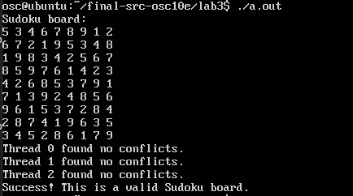

Figure 1: Successful sudoku board verification.

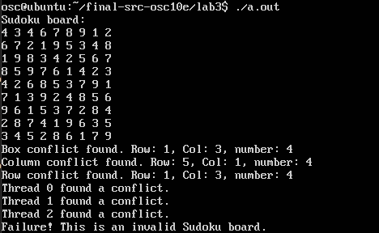

Figure 2: Checker successful finding the error in the puzzle.