Peter Klembczyk

Assignment 3

Incremental Development Process model diagram

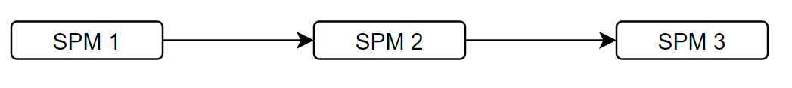

**SPM 1:**

* Create classes, basic user interface functions (no SQL)
* Test and validate that user can run basic commands

**SPM 2:**

* Add database to project
* Add on to functions that need to interface with the database
* Test functions and interactions with database
* Beta access?

**SPM 3:**

* Expand on user interaction with the database, give the user options to sort classes by certain features using queries
  + Sort courses by name, instructor, days of week, …
  + See list of students in a course
  + See all courses taught by each instructor
* Fully test new features in system test
* Adjust and fix functions based on feedback from beta