Daniel’s Edits in red

Peter Klembczyk

Assignment 3

Waterfall Process model diagram

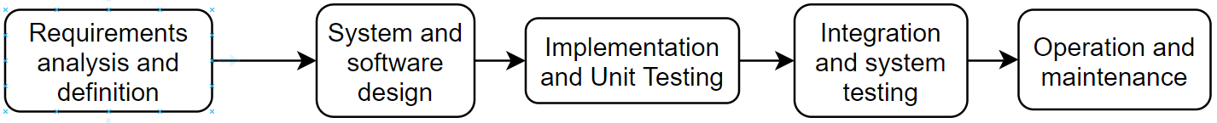

**Requirements analysis and definition:**

* Program will be done in Python
* Alternative to current registration system Wentworth has in place
* Will use a database to store data
* Python will use SQLite3 to interface with SQL files
* Will consist of classes for individuals, students, instructors, and administrators
* Functions will be able to interface with the user and the database

**System and Software Design:**

* No hardware required other than a computer
* Python and SQL will be used
  + Python will hold functions to interface with the user
  + SQL will be used to hold all the data being added, changed, or removed

**Implementation and Unit Testing**

* Code functions in Python for interfacing with each of the users
  + Functions for students, instructors, and admins
* Functions for interfacing with SQL and manipulating data in the database (from each of the three user types)
* Test each of the functions and code individually

**Integration and System Testing**

* Create a strong user interface that will account for user error
* Test entire system as each user type
* Find and fix bugs in the code

**Operational Maintenance**

* Since this is only a class project, there will not be much of maintenance
* However, for it to be maintained, tests would have to be designed and the results observed from people using it for a semester
  + This could be anything from testing new users in the system to making sure that users who no longer need access (graduate or leave the school) can’t still use it
* Keep in communication with the school and work with them to maintain the database