When Wind Drops: Growing Risks in Australia's East Coast Gas Market
March 2026 | Broken Bay Associates
Australia’s east coast gas market had a tense moment in June 2025. On 26 June, gas demand from power generators surged to 882 TJ/day — the highest daily gas-fired power generation (GPG) demand on record — arriving just one day after non-power gas demand peaked at 1,514 TJ/day. As it turned out, the system had sufficient capacity to meet both peaks. But the proximity of those two events, and the extent to which actual GPG spikes exceeded AEMO’s forecasts, raises important questions about how much headroom the system will have in future winters.
This article examines what the 2025 data tells us about the changing character of peak gas demand, where AEMO's forecasts fell short, and why the risk of peak-day supply shortfalls appears to be rising.

Peak demand is rising — even as average demand holds flat
Total gas demand across the southeastern states has remained broadly stable over the past three years, with average daily demand hovering around 1,015–1,037 TJ/day. Yet this apparent stability masks a more troubling dynamic: peak day demand has been climbing steadily, rising from 1,949 TJ/day in 2023 to 2,071 TJ/day in 2024 and 2,119 TJ/day in 2025 — an increase of approximately 9% over three years.
The driver is not industrial or residential demand, which has remained relatively flat. It is gas-fired power generation. As the share of variable renewable energy — particularly wind — in Australia's electricity mix has grown, the residual role of gas generation has become more volatile. During periods of low wind output, gas turbines must ramp hard to fill the gap. These events are predictable in aggregate but difficult to forecast precisely in timing and magnitude.
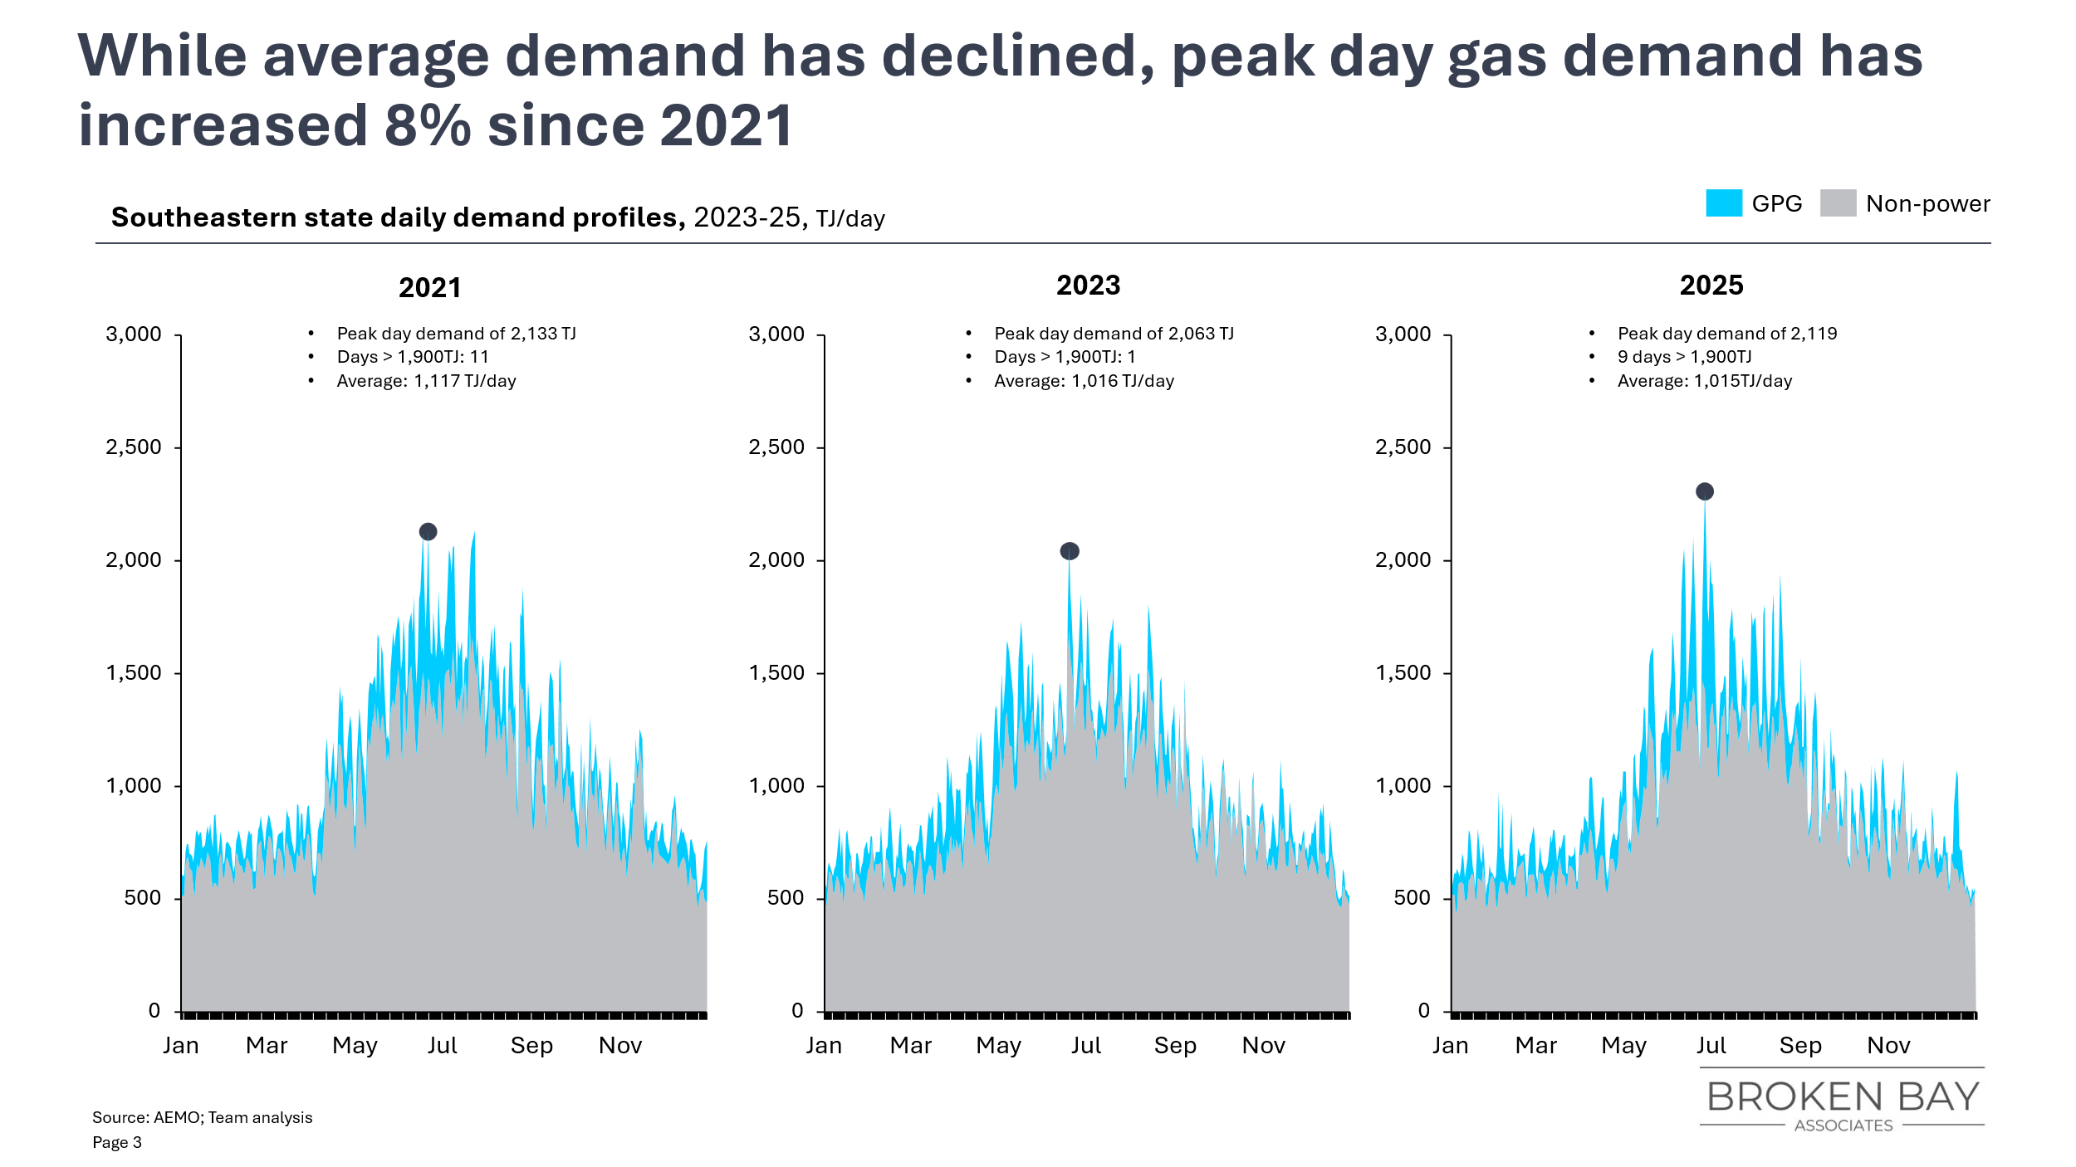
Chart 1: Southeastern state daily gas demand profiles, 2023–2025. Peak day demand has risen 9% over three years, driven by GPG spikes during low-wind periods.

AEMO's 2025 forecast underestimated 2025’s GPG spikes
AEMO's Gas Statement of Opportunities (GSOO), published in March 2025, anticipated GPG demand spikes as part of its modelling. But on almost every relevant metric, the actual 2025 experience exceeded what was forecast.
The GSOO projected a largest single-day GPG spike of 707 TJ/day, occurring in late July. In reality, the largest spike reached 860 TJ/day — 22% higher than forecast — and it arrived in late June, a month earlier than anticipated. The GSOO forecast just one day with GPG demand above 600 TJ; the actual count was eight. For days above 400 TJ, the forecast was 12; the actual was 25.
The 2025 GPG spikes were not just larger than anticipated — they arrived earlier in winter, when pipeline linepack and storage are less well-placed to buffer them.
This matters beyond the raw numbers. Winter gas demand in the southeastern states peaks in June and July, when residential and commercial heating load is highest. GPG spikes occurring in this window are inherently more dangerous because they compete with non-power demand for the same finite supply capacity. The GSOO's forecast placed the key risk period in August; the actual risk concentrated in June — precisely the month of maximum competition for gas supply.
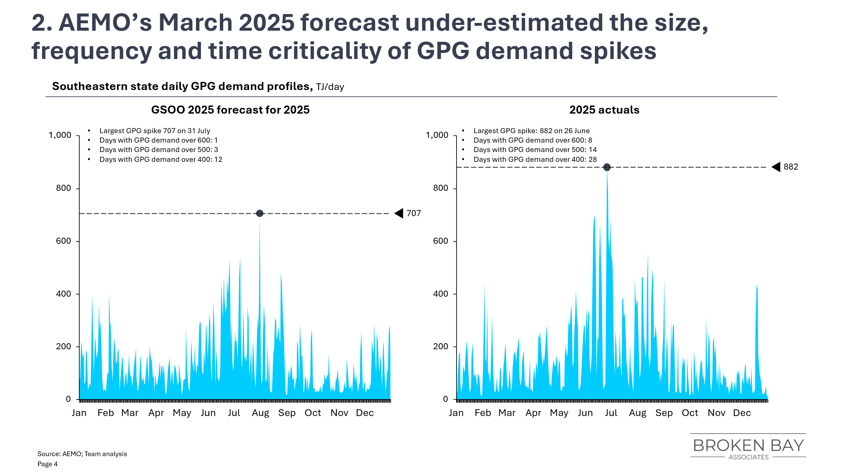
Chart 2: GSOO 2025 forecast vs. actual GPG demand. The actual peak (860 TJ/day on 26 June) exceeded the forecast peak (707 TJ/day) by 22%, and arrived a month earlier in the winter demand season.

A close call in June 2025: GPG drove demand close to capacity limits
The revised indicative peak supply capacity for the southeastern states in 2025 was approximately 2,452 TJ/day, comprising Longford (700 TJ), Moomba and other southern fields (543 TJ), SWQP (432 TJ), deep storage (570 TJ), shallow storage (207 TJ), and linepack (up to 207 TJ). Linepack — the ability to temporarily boost throughput by drawing down pressure in the pipeline network — is an important short-term buffer that was not captured in earlier supply estimates.
On 25 June 2025, non-GPG demand peaked at 1,514 TJ/day. On 26 June, GPG demand peaked at 882 TJ/day, while non-GPG demand that day was 1,476 TJ/day — just 38 TJ/day lower than its own peak the day before. Actual supply on 26 June reached approximately 2,300 TJ/day (drawing on linepack and other flexible sources), comfortably meeting combined demand of 2,311 TJ/day. The system coped — but the margin was tighter than headline capacity figures suggested, and it depended on the fortuitous timing of the two demand peaks arriving one day apart rather than simultaneously.
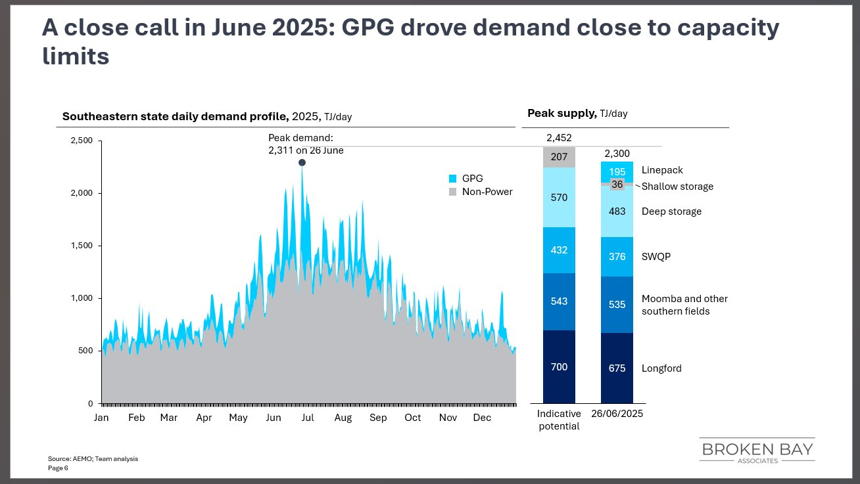
Chart 3: 2025 daily demand profile and supply capacity. Peak demand of 2,311 TJ/day on 26 June was met by actual supply of approximately 2,300 TJ/day, including linepack drawdown. The indicative potential capacity of 2,452 TJ/day was not fully required, but the gap between the two non-power demand peaks (25 vs 26 June) was only 38 TJ/day.
The good news is that the system did cope in 2025, and the revised supply picture — including linepack and previously understated field capacity — provides more comfort than earlier estimates suggested. The more sobering observation is that non-power demand on 26 June was only 38 TJ/day below its own peak recorded the previous day. Had the cold snap that drove residential and commercial heating demand been one day longer, or had GPG dispatch decisions been slightly different, the supply picture would have been considerably tighter. The 2025 data does not suggest a crisis — but it does illustrate how quickly the balance can shift.

Looking ahead: four factors that shape peak-day risk (and one that does not)
The 2025 experience should be understood not as an isolated event but as a data point in a trend. Four factors will determine how peak-day risk evolves over the next several years.
1. Declining field supply capacity
AEMO estimates southeastern state peak supply capacity at approximately 1,020 TJ/day for 2025, falling to around 920 TJ/day for 2026, with further declines projected in 2027 and beyond as mature fields deplete. This steady reduction in the baseline supply ceiling means that the buffer against demand spikes is shrinking even as the spikes themselves are growing.
2. Some new peak capacity - but not much
Investment in additional peaking capacity is underway. The HUGS (Heytesbury
Underground Gas Storage) project will add approximately 45 TJ/day of peak capacity and construction is due for completion in Q2 2026. It is unclear whether it will be able to make a meaningful contribution to supply in Winter 2026. APA plans to raise capacity from Queensland to the SE states by 93 TJ/day by winter 2028. In the intervening period, the system must manage increasing demand variability with essentially the current supply toolkit.
Larger capacity additions sch as the proposed Bulloo interlink or the Narrabri gas pipeline remain in the planning stages.
3. Coal plant reliability
The next scheduled coal plant closure is Yallourn, planned for mid-2028. Until then, coal plants continue to provide a large share of base load power, reducing the residual load that GPG must cover. However, Australian coal plants have experienced increasing reliability issues in recent years. An unplanned outage at Yallourn or another major coal facility — particularly during a winter heat event or cold snap — could substantially increase GPG demand at exactly the wrong time.
4. Weather and wind variability
The extreme GPG demand spike of 26–30 June 2025 was associated with a period of unusually low wind output across the southeastern states. The question this raises is whether such conditions represent a statistical outlier or a pattern that could recur — or worsen — in future winters. Australia's climate variability, combined with the continued buildout of wind capacity creating larger residual demand swings when wind underperforms, suggests that events of this type are likely to remain a feature of the system.
Batteries
Many readers may be thinking that the rapid roll out of batteries will quickly solve this problem. We don’t think it will. The rate of growth of battery capacity within the NEM has been truly impressive and we believe this has an important role to play managing the within day cycle of demand driven peaks and solar driven troughs in household demand. But when you are dealing with a multi-day wind drought the maths of battery capacity simply don’t add up. As an indication, gas power generation on 26 June was approximately [86GWh]. For comparison, total battery capacity on the NEM is currently around 6-7GWh. Of course batteries can be cycled multiple times through a day – that’s true, but it only reduces GPG load if you can find a period during the day when GPG was not producing. Looking at

Conclusion: the margin is narrowing
None of the factors described above is, in isolation, cause for alarm. The gas system managed 2025 without a supply shortfall. AEMO and industry participants are well aware of the trends. New investment in storage and supply is in the pipeline — literally and figuratively.
But the 2025 data provides a useful corrective to complacency. The peaks are higher than forecast, they are arriving at more dangerous times in the seasonal calendar, and the GPG and non-GPG demand peaks coincided within a single day — separated by a margin of just 38 TJ/day in non-power demand. A revised and more complete picture of supply capacity, including linepack, shows the system had more headroom than first appeared. But that headroom is not unlimited, and it is shrinking: field supply is declining, new peaking capacity additions are several years away, and coal plant availability remains a variable.
The question is no longer whether peak-day supply stress can occur on Australia's east coast gas market — it is when, and how well-prepared the system will be when it does.
The probability of a peak-day supply shortfall in any given winter may still be low. But the trend is clear: it is higher today than it was in 2023, it is likely to be higher still in 2026 and 2027, and the consequences of being wrong are material for industrial users, retailers, and consumers alike. That case for prudent risk management — in procurement, in storage contracting, and in demand-side flexibility — has rarely been stronger.
Broken Bay Associates | This analysis is based on publicly available AEMO data and GSOO 2025 forecasts. Supply capacity figures are indicative. March 2026.

