**Name:** peter latif noshy

**Edu. Mail**: [Beter195290@feng.bu.edu.eg](mailto:Beter195290@feng.bu.edu.eg)

**B.N**: 264

**Department:** Engineering Mathematics and Physics

**Division:** ----------

**Academic Year:** 2019-2020 preparatory

**Course name:** Computer

**Course code:** ECE001

**Topic:** artificial intelligence

Application brief

Artificial Intelligence is the ability of machines to seemingly think for themselves. AI is demonstrated when a task, formerly performed by a human and thought of as requiring the ability to learn, reason and solve problems, can now be done by a machine. A prime example is an autonomous vehicle. The vehicle is able to perceive its surroundings and make decisions in order to safely reach its destination with no human intervention. Converging technologies along with Big Data and the Internet of Things (IoT) are driving the growth of AI. Machines communicate with one another and are now capable of advanced perception, capturing millions of data points in seconds, processing the information and making decisions, all in a matter of seconds. As AI evolves, machines will have more capability to physically act based on their intelligence, eventually leading to machines that can build better versions of themselves.

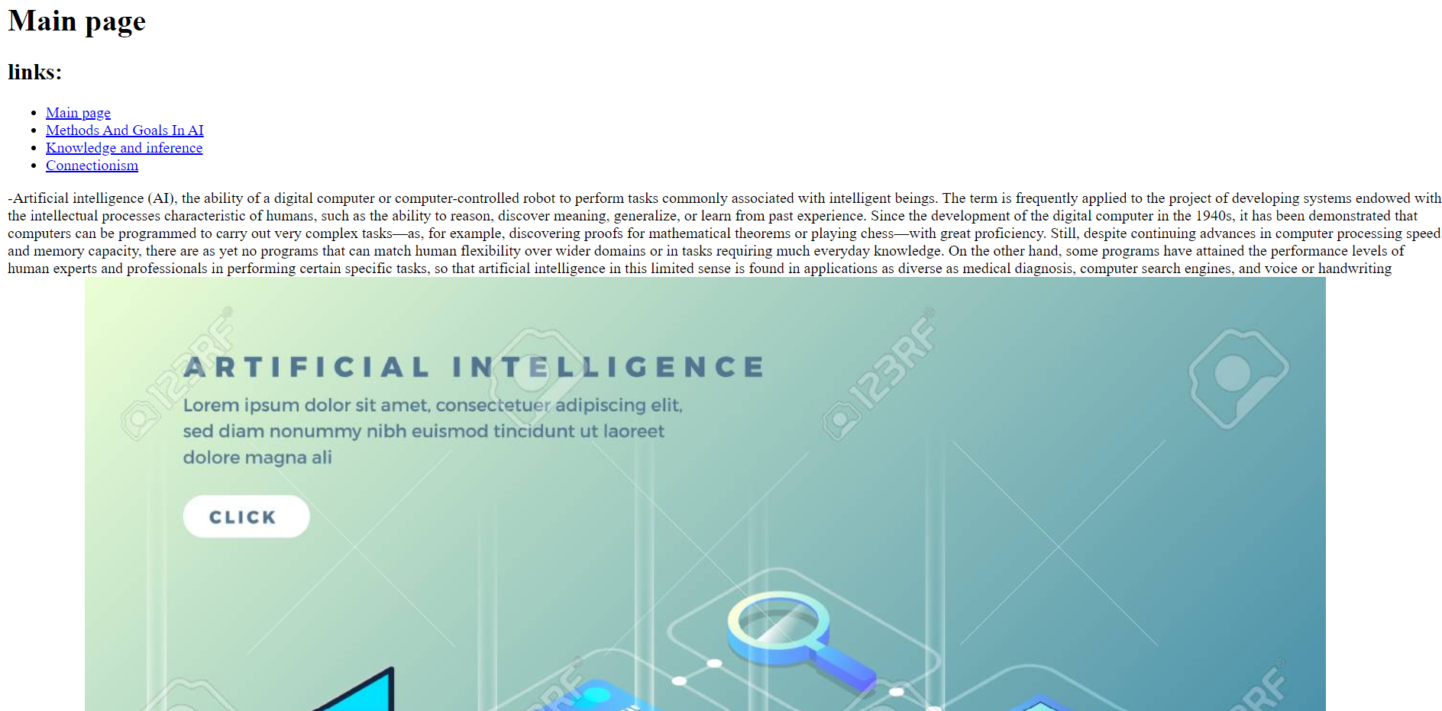Screenshots

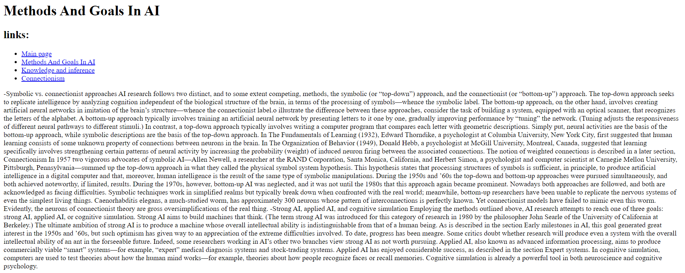

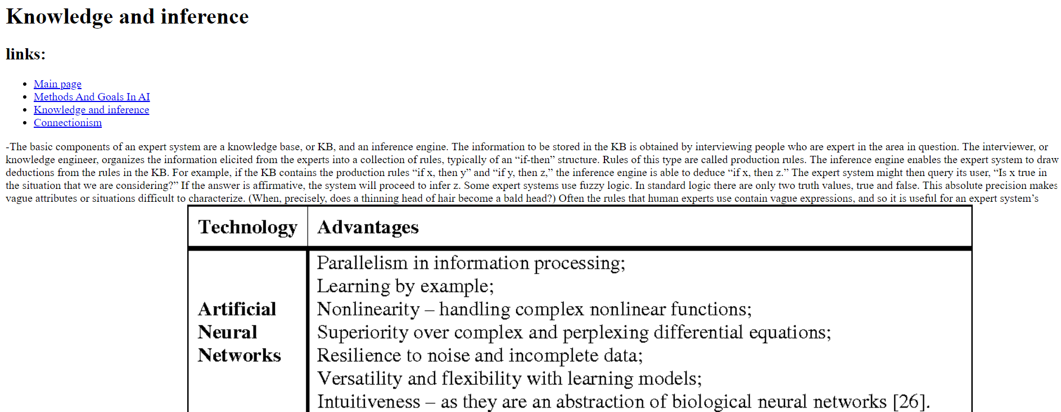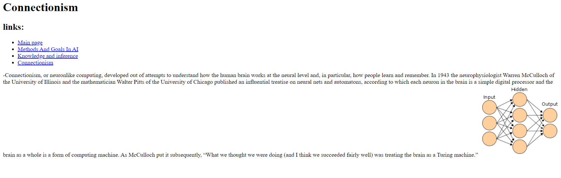Screenshots

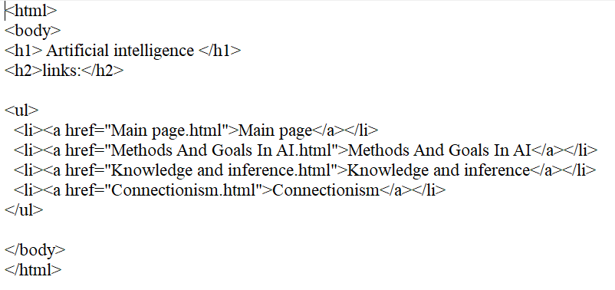Source code