ST7016 Group Project
Group 1
Peter Lavin
Ronan Watson
Kathryn Cassidy
Theresa Doyle
Arifur Rahman

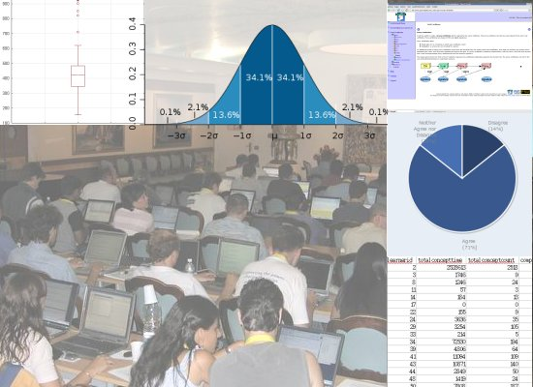
Analysis of user data from
an eLearning application

Table of Contents
Chapter 1: Introduction
Origins of the data
Data Collection
Population and Sampling
Variables measured
System log data
Survey Responses
Other data
Questions and Analyses
Chapter 2: Summary Statistics
Chapter 3: Graphs and Tables
Chapter 4: Normality of the Data
Chapter 5: Relationships and Correlations
Chapter 6: Time Series Analysis
Chapter 7: Other...?
Chapter 8: Conclusions
Appendix A: The data file
Appendix B: the time series data file

Chapter 1: Introduction

Origins of the data
Our data comes from the "eLGrid" eLearning application which aims to teach learners about Grid technologies. A brief overview of the eLGrid system will help to understand some of the variables measured.
The system uses adaptive eLearning technology to provide a personalised navigation menu to learners. Each concept in the navigation menu is annotated with a coloured "traffic-light" icon. The colour chosen indicates the status of the materials associated with that concept:
- Green means that the concept is ready for viewing
- Amber means that the learner has viewed the material for this concept and there is now a test available. It reminds the learner to click on the "Test Me" menu item and complete the test for that concept
- Red indicates that the concept is not ready for viewing as the learner has not yet viewed or completed tests in certain prerequisite concepts
- Clear indicates that the learner has "learned" the concept, i.e. they have correctly answered the test questions associated with this concept
- Grey indicates that the concept is not required material for that learner (e.g. the same course might cater for biologists who want to use Grid technologies and to Computer Scientists who need to know how the underlying Grid technologies work, some concepts will be common to both types of learners, but others will be relevant only to one or the other.
Some concepts do not have any tests associated with them; in which case the traffic-light icon goes directly from green to clear when the learner views the material, bypassing amber.

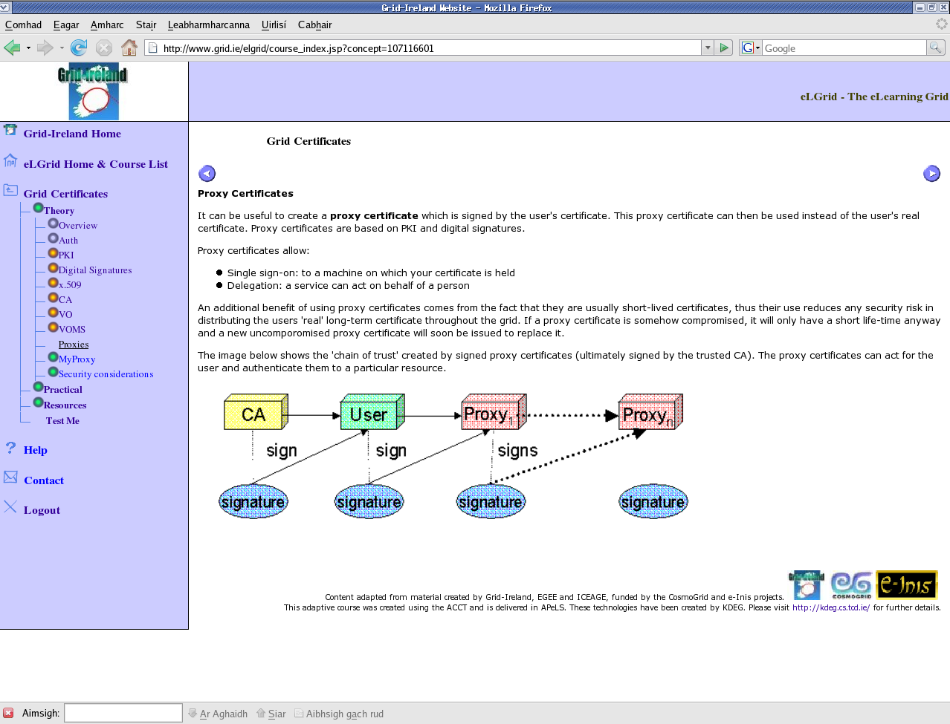
Figure 1: The eLGrid eLearning system showing the personalised navigation menu

Data Collection
Learner activity is logged automatically by the system, giving us a number of metrics such as number of logins, number of times course material is viewed, number of tests taken and passed, etc. There is also timing data showing how long learners have spent viewing course materials which we consider as a continuous variable.
Some of the learners completed an end-of-course survey which gives information about their opinion of, and satisfaction with, the system.
A smaller subset also have a set of final scores. These were undergraduates who were given access to the system in order to learn a particular technology which they would use for their practical exercises. The students were given a mark based on their answers to the eLGrid tests along with a mark for their practical work; and these are combined into a total mark. Most users, however, are research students and scientists attending short workshops on Grid technologies, and for these users there is no final score to capture.

Population and Sampling
The data analysed here is a sample of the population of actual and possible Grid users and we wish to use our analysis to make inferences about this population in order to design better eLearning tools for Grid users, and to be in a position to encourage new users to adopt Grid technologies.
We are analysing the data from all learners who have used the eLGrid system, however as experimenters we have little control over the makeup of this group. For example, it was not possible to design the sampling methods in order to generate a representative sample. Instead the makeup of the sample depends very much on which users chose to sign up to use the eLGrid system or to attend workshops and courses where the system was used. For the purposes of our analysis we assume that the sample available to us is a representative sample of the population of Grid users.

Variables measured
In this section we will explain each of the variables in our data, identifying their type and any other salient points.

System log data
learnerid is an arbitrary identifier assigned by the system and thus no analysis is required.
totalconcepttime is the measure of the total time each learner spent viewing course materials. It is generated by summing the times measured from the learner clicks on on a particular concept to the time that he/she clicks on any other link. In some cases the learner does not click on another link in that session, e.g. the learner might close their browser without clicking on the logout button. In this case a default time of 30 seconds is assumed. The time is stored in seconds, not milliseconds or any smaller units, but we will nonetheless treat it as a continuous quantitative variable.
total_concept_count is the total number of course concepts which each learner has viewed. It is a discrete quantitative variable.
complete_initial_questionaire_count gives the number of times the learner completed an initial questionnaire. This initial questionnaire just asks the learner whether he/she is from a Computer Science or an Application Science (e.g. biology, physics, medical science, etc.) background. It is optional so many learners may not have completed it at all and they can complete it multiple times, perhaps changing their choice of background each time. It is a discrete quantitative variable.
correct_answer_count tells us the number of times that the learner correctly answered the test questions for a concept. Note that if a concept has multiple associated test questions, then the learner must answer all of them correctly in one go before this will be counted as a correct answer. The variable is a count and is thus a discrete quantitative variable.
incomplete_answer_count is the number of incomplete answers to test questions. An incomplete answer occurs where there are multiple questions for a concept and the learner only answers some of them, or answers some correctly and others incorrectly (recall that all answers for a given concept must be correctly answered in one go in order for an attempt to be considered a correct answer). Incomplete_answer_count is a discrete quantitative variable.
incorrect_answer_count gives the number of incorrect answers to test questions; again, this means that all questions associated with a particular concept were answered incorrectly. If the learner got one answer wrong and one right then that would be considered an incomplete answer. This is a discrete quantitative variable.
login_count is the number of times the learner logged into the system. It is a discrete quantitative variable.
logout_count is the number of times the learner logged out. Often learners just close down the browser without logging out so this is not always stored, resulting in a situation where the login count can be significantly higher than the logout count; logout_count is a discrete quantitative variable.
reset_profile_count the number of times a learner reset their profile. Resetting the profile causes the status of all viewed and learned concepts to be reset and the trafficlight menu will therefore also be reset to its initial state. Reset_profile_count is a discrete quantitative variable.
view_concept_count, like totalconceptcount above, is another measure of course concepts viewed. view_concept_count is a more accurate figure than totalconceptcount because totalconceptcount counts every time that the view concept page is loaded, but sometimes this simply results in the menu being displayed. view_concept_count includes only the times that learning material was actually presented to the learner. This figure should be used in preference to totalconceptcount for analysis, though an interesting exercise might be to compare the statistics for the two variables. Like totalconceptcount, view_concept_count is a discrete quantitative variable.
view_test_count is the number of times the learner clicked on the "Test Me" link in the menu to view the available tests. It is a discrete quantitative variable.

Survey Responses
The survey questions were answer on a scale from Strongly Agree to Stronly Disagree. There is also a "No Answer Given" category where learners left a response blank.

While all learners have data available for all of the system log variables described above, the survey response data has some gaps. Not all learners completed an end-of-course survey (many of these were not asked to complete the survey so we can infer nothing from their failure to complete it). This means that some of the learners have no data available for the variables described below. Missing data such as this is marked by a question mark symbol in our data file.
It is important to note that a response category of “No Answer Given” is not the same as missing data (denoted by a “?”). The former indicates that the learner completed the post-course survey, but chose to leave some questions blank. The latter means that the learner did not complete the post-course survey (often because he or she was a remote learner and we did not have an opportunity to forward the survey to him/her).
All survey responses are categorical or qualitative data and because they are ordered from Strongly Disagree to Strongly Agree they can be considered as ordinal data. The “No Answer Given” category does not neatly fit into an ordinal view of the data, but there are not many responses in this category. Where they do exist it might be plausible to interpret them as actual indicating disagreement with the statement presented. However, the question of how to view “No Answer Given” responses is better dealt with on a per-question basis.

elgrid-easy gives the responses to the statement "The eLGrid system is easy to use"
future-elgrid gives the responses to the statement "If I need to learn about Grid technologies in future I would use the eLGrid eLearning system"
future-use-tools gives the responses to the statement "In the future I will probably use the technologies taught in this course"
prac-apply-concepts gives the responses to the statement "The practical exercises helped me to understand and apply the course concepts"
prac-env-easy gives the responses to the statement "The practical environment is easy to use"
prac-good-eval gives the responses to the statement "The practical exercises were a good way for me to evaluate my knowledge"
practical-access gives the responses to the statement "The practical environment was easy to access"
practical-understood gives the responses to the statement "The practical instructions were easy to understand"
tests-good-eval gives the responses to the statement "The tests were a good way for the system to evaluate my knowledge"
theory-comp-prac gives the responses to the statement "The theory in this course supported and complemented the practical exercises"
too-easy gives the responses to the statement "The course was too simple, explaining things that I already knew"
too-hard gives the responses to the statement "The course expected too much prior knowledge"
traffic-light-prac gives the responses to the statement "It would be useful if the traffic-light indicators took into account the results of my practical exercises as well as my test answers"
traffic-understood gives the responses to the statement "I understood how my test answers affected the traffic-light indicators"
trafficlights-nav gives the responses to the statement "The traffic-light indicators helped me to navigate the course"
tutor-req gives the responses to the statement "The presence of a tutor was necessary for me to complete this course, I would have had trouble if I was trying to use this course on my own"

Other Data
The following variables are available for some learners.
projectmark is the final mark given for a practical project using technologies taught via the eLGrid system. This is only available for a subset of the learners who used the eLGrid system as part of their undergraduate studies. Marks are given as a percentage and are treated as a continuous quantitative variable.
elgridmark is a mark based on the correct completion of the test questions in the system. Five concepts had associated tests and 20% was given for each concept, some learners were docked marks because the logs showed that they had gone back into the "Test Me" screen repeatedly and used trial and error to get the correct answer (i.e. they had many incorrect answers before they finally got the correct answer). Marks are given as a percentage and are treated as a continuous quantitative variable.
totalmark is a combination of the weighted project and elgrid marks. This is also a percentage and is treated as a continuous quantitative variable.
gender gives the the learner's gender, it is not known for all learners because many are remote learners about whom we have little information. Gender is a nominal variable.
level gives the learner's level (undergrad, postgrad, postdoc, academic staff (e.g. lecturer, professor, etc.)). As with gender, this variable is not known for all learners. Level is a nominal variable.

Questions and Analyses
The purpose of our analysis is to determine whether there are patterns to how learners use the eLGrid system. For example, do learners tend to spend a similar amount of time viewing course concepts, completing tests, etc., or is there a lot of variation in how they use these features of the system.
For those learners who have completed the end-of-course survey we will also look at the relationships between their satisfaction scores and their usage patterns. For example, is there a relationship between high satisfaction and time spent viewing concepts? Is there a relationship between the number of times the tests were viewed or correctly answered and the learners' answers to the question "The tests were a good way for the system to evaluate my knowledge", or "I understood how my test answers affected the traffic-light indicators".
We will attempt to look at the categorical variables Gender and Level and see if there are differences in any of the other variables when broken out by category.

Performing the Analysis
The sample size is 75 so for all variables n will be 75, except for those situations where outliers are being deliberately excluded from the analysis.
Survey Responses
The survey responses are ordinal variables; however, they have two possible values "Survey Unanswered" and "No Answer Given" which are not actually on an ordinal scale but are simply nominal categories. As such, it is necessary to perform some analysis on these variables ignoring these two answers and looking only at the ordinal values. For example, while we can look at the mode including all responses, only a minority of learners completed the surveys, and thus the mode will always be "Survey Unanswered". This is not particularly useful and so it is best to exclude these missing datapoints when getting the mode. Similarly, the median can be calculated, but it is only really meaningful for the ordinal values (which, recall, correspond to a scale from 1 - Strongly Disagree to 5 - Strongly Agree permitting some limited numeric analysis). We will, thus, exclude both "Survey Unanswered" and "No Answer Given" when getting the mode. The mean may not be appropriate for data on an ordinal scale and it is certainly inappropriate for purely categorical data, so we may simply omit this measurement.
While we have excluded the categorical values in some of the calculations when we go to graph these variables it may make sense to include all the data.
It might also be useful to look simply at whether responses are above or below 3 "Neither Agree nor Disagree" as this will tell us more generally whether learners agree or disagree with the statements.

Structure of this report
We will look at related data together and thus, the next five chapters deal with particular themes of interest in the eLearning system.
Chapter 2 looks at how learners access the system and the learning materials. It includes analysis of variables such as login_count, total_concept_count, totalconcepttime, etc.
Chapter 3 looks at how learners use the test functionality while chapter 4 examines the practical exercises and learners' use and opinions of them.
Learners overall views of the eLGrid eLearning sytem are examined in chapter 5, while chapter 6 looks at those variables which contain the learners final marks, where these are available to us.
Chapter 7 looks at the issue of data normality and the applicability of the normal model to our data.
Chapter 8 graphs some variables against each other in order to look for relationships and correlations in the data.
Finally chapter 9 presents our conclusions.
The data file and a time series analysis graph are included as appendices.

Chapter 2: Accessing the eLearning application and the learning materials
Several of the variables measured have to do with the frequency of access to the system or specifically to the learning materials, or the time spent at these tasks. For example, totalconcepttime measures the time spent viewing course materials which login_count measures the number of time learners logged into the system. These variables all tell use something about the way that learners access the system.
Total Concept Time
The total concept time variable has the following summary statistics:

x̅ | 71491.76
s | 343086.4137
s² | 117708287265.528
median | 3738
min | 0
max | 2528613
range | 2528613
IQR | 10417
From this we can see that there is a huge variance and range in this data. This may make the data difficult to interpret, but looking at the relatively low median of 3738 suggests that most values may be clustered to the left. We will see this more clearly when we graph this variable.
We next attempted to find outliers in the data. Using the notion that any point below Q1 - 1.5(IQR) or above Q3 + 1.5(IQR) was a suspect outlier, we found no outliers on the left but eight on the right.: 38164, 42683, 48723, 72530, 92493, 732600, 1462891 and 2528613. The final point 2528613 is from the row with learnerid = 2, which was previously identified as test data and could have been safely excluded from the analysis. However, these other outliers are valid data and they simply indicate that some learners spend a lot more time viewing course materials than others.
We graphed this variable as a stemplot, a histogram and a boxplot. The first graph below is the stemplot of the raw data in seconds. Our stems in this graph are in units of 1000 seconds as there were a large number of datapoints in the thousands. This gives us a good view of the distribution of the data; however, as you can see the data is strongly skewed to the right; so much so in fact that it was not possible to include all points in the plot and thus the plot jumps at certain points.

0 | 0 0 0 0 0 0 0 0 0 0 14 18 57 155 184 214 214 275 350 759
1 | 246 288 419 517 746
2 | 256 625 629 849
3 | 013 191 254 307 397 553 636 669 738 774
4 | 806
5 | 104 246
6 | 516 904 906 915
7 | 368 808
8 | 257 735 774 895
9 |
10 | 170 450 534 540 767 871
11 | 094 679 715
12 | 143 548 761
13 |
14 |
15 |
16 |
17 |
18 | 597
19 | 072
20 |
21 |
22 |
23 | 663
24 |
25 |
26 |
27 |
28 |
29 |
30 |
31 |
32 |
33 |
34 |
35 |
36 |
37 |
38 | 164
39 |
40 |
41 |
42 | 683
43 |
44 |
45 |
46 |
47 |
48 | 723
.
.
.
70 |
71 |
72 | 530
.
.
.
92 | 493
.
.
.
732 | 600
.
.
.
1462 | 891
.
.
.
2528 | 613

As mentioned the data for this variable is in seconds. Converting to hours would give us smaller and more easily understandable units to work with. However this could cause us to lose precision. In this case the difficulty of representing the data together on a single plot because of its large range and outliers makes it necessary to group the data anyway in order to properly view it; so converting to hours is acceptable. The following is a histogram showing the data when converted to hours.

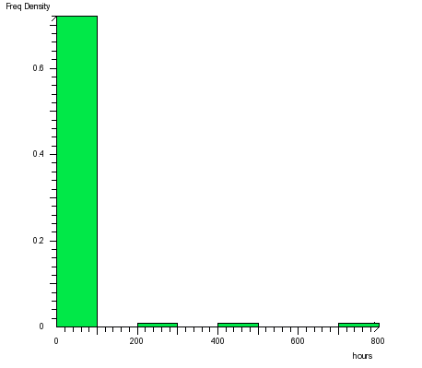
As you can see, because of outliers almost all of the data is grouped together in the 0-100 hours bar. This is not particularly useful, so we created a new version of this histogram which excludes the three outliers above 200 hours.

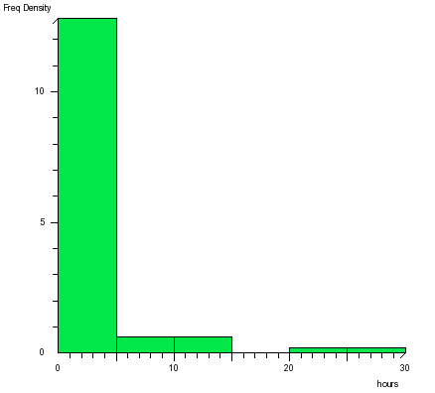

This is a slightly more useful graph showing that most learners spend between 0 and 5 hours viewing concept materials on the system, while a small number spend between 5 and 15 hours and a smaller number again spend between 20 and 30 hours.
In order to attempt to show the outliers and the clustering of the majority of learners in a single graph we have created a boxplot; however, as you can see, because of the huge difference in values it was necessary to make the scale discontinuous in order to fit the outliers into the plot. Thus the rightmost part of the graph is not drawn to scale, it merely shows us that very large outliers exist. Once again the data here is represented in seconds, but the graph would look the same in any units.

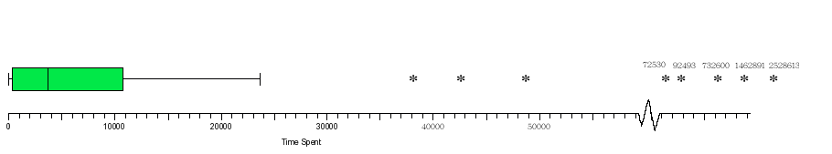

Total Concept Count
When row two is included we get a mean of 117.5 as opposed to 83.83 when w exclude row two. We decided to exclude row two from the analysis this time as it was very far away from the center.
Excluding row two we got the following summary statistics

x̅ | 84.96
s | 97.16
s² | 9440.23
median | 50.5
min | 0
max | 565
range | 565
IQR | 126
The number of times that learners viewed the material has a much smaller range and variation than the time that they spent viewing them.
For this variable we found two outliers (again on the right) 377 and 565 (recall that we have excluded the learnerid = 2 value of 2518 from the analysis)

The following stemplot gives us a good view of the distribution of values for the totalconceptcount variable. As you can see the curve is not normal and there is considerable skew to the right (though, considerably less skew is evident in the counts than the times).

0 | 0 0 0 0 0 0 0 0 0 0 1 3 3 3 5 9 9 9
1 | 1 3 5
2 | 4 4 8
3 | 4 4 5 6 8 9
4 | 2 5 5 6 7 8
5 | 0 1 5 8
6 | 2 4 7 8
7 | 6
8 | 3 9
10 | 2 3 5 8 9
11 | 6
12 | 0 3
13 | 7 7 9
14 | 0 9
15 | 6
16 | 7
17 | 1 6
18 | 7 8
19 | 4 5 8
20 | 1
21 |
22 |
23 |
24 |
25 |
26 | 1
27 |
28 |
29 | 4
30 |
31 |
32 |
33 |
34 |
35 |
36 |
37 | 7
38 |
39 |
40 |
41 |
42 |
43 |
44 |
45 |
46 |
47 |
48 |
49 |
50 |
51 |
52 |
53 |
54 |
55 |
56 | 5

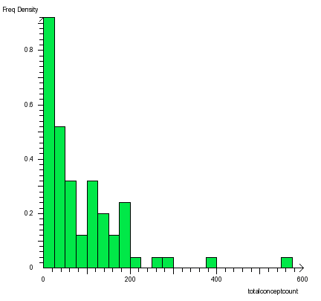

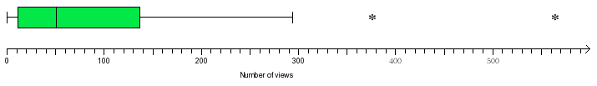

view_concept_count

mean | 137.17
s | 349.17
s2 | 121920.74
median | 63.00
min | 0.00
max | 2972.00
range | 2972.00
IQR | 145.00

Login Count
This variable is a measure of how many times the learners logged in in order to view the available tests. The learnerid = 2 value of 199 has been excluded from the analysis.

x̅ | 5.27
s | 5.261119
s² | 27.67938
median | 3.00
min | 1.00
max | 28.00
range | 27.00
IQR | 7.75
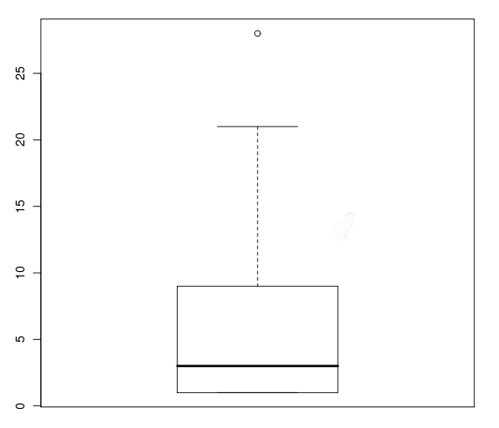
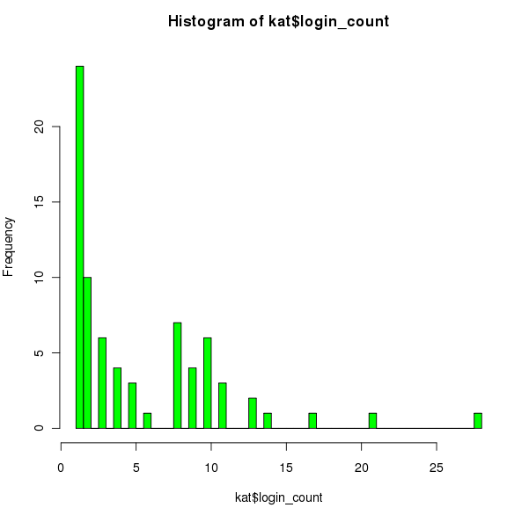

Logout Count
This variable is a measure of how many times the learners logged in in order to view the available tests. The learnerid = 2 value of 199 has been excluded from the analysis.

x̅ | 1.81
s | 2.27
s² | 5.17
median | 1.00
min | 0.00
max | 12.00
range | 12.00
IQR | 1.75

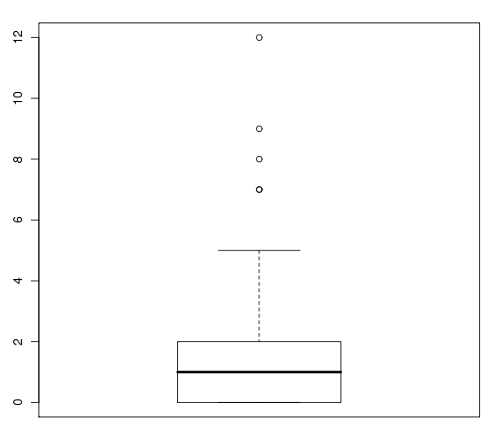
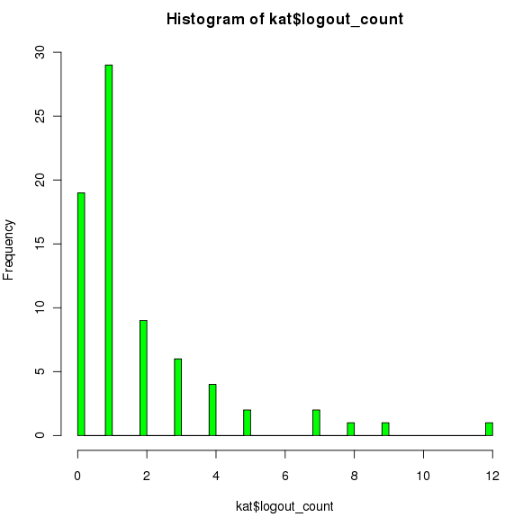

Chapter 3: The "Test Me!" feature
The "Test Me!" link in the eLGrid course menu allows learners to take tests to check their progress. The tests not only give an indication of whether or not the learner has understood the material, they also feed into the adaptive "trafficlight" menu system. When a learner views a concept the trafficlight icon for that concept will change from green to amber. Once the learner completes the associated tests the icon will change to lilac.
The eLGrid system logs data about learners' use of the "Test Me!" feature. For example, how many times the learner views the tests is logged along with the number of correct and incorrect test answers which they give.
The end of course survey also asks some questions specifically about the "Test Me!" feature. Together these variables tell us about the pattern of usage of the tests and also the learners' opinions of and attitudes to the tests and their usefulness.
View Test Count
This variable is a measure of how many times learners clicked on the "Test Me" button in order to view the available tests. The learnerid = 2 value of 122 has been excluded from the analysis.

x̅ | 4.09
s | 9.64
s² | 92.96
median | 1
min | 0
max | 72
range | 72
IQR | 6
These values give us as outliers any datapoint below -9 or above15. There are no outliers to the left and four to the right 19, 22, 29, 72.
As the majority of datapoints for this variable are below 10 a stemplot is not particularly useful
0 | 0 0 0 0 0 0 0 0 0 0 0 0 0 0 0 0 0 0 0 0 0 0 0 0 0 0 0 0 0 0 0 0 1 1 1 1 1 1 1 1 1 1 1 1 1 1 2 2 2 2 3 3 3 3 3 6 6 6 6 7 7 8 8 9 9 9
1 | 0 0 0 3 9
2 | 2 9
3 |
4 |
5 |
6 |
7 | 2
8 |
9 |
10 |
11 |
12 |2

It does show us very quickly that the data is not normal and is skewed to the right. We can see this again in the histogram (this time we have excluded the datapoint 122 which is from the test user with userid=2) and we have also excluded the outlier value 72 for ease of graphing. Both of these values were included in the stemplot.

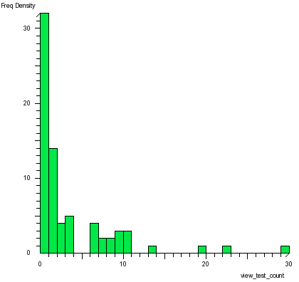

For the boxplot we have included the outlier 72 but excluded the test value 122. Note that while 72 is an obvious outlier which can be identified intuitively by looking at the data, using the formula Q3 + 1.5(IQR) identifies four potential outliers. However, the first three of these might reasonably be considered not to be outliers at all.
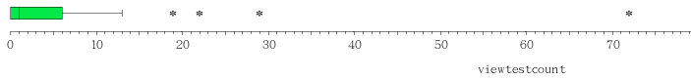

correct_answer_count

mean | 12.75
s | 35.83
s2 | 1283.79
median | 0.00
min | 0.00
max | 188.00
range | 188.00
IQR | 9.50

reset_profile_count

mean | 0.32
s | 1.72
s2 | 2.95
median | 0.00
min | 0.00
max | 14.00
range | 14.00
IQR | 0.00

Chapter 4: Practical Exercises
The eLGrid system teaches users about Grid technologies. As such, many courses include a practical component where learners have an opportunity to try out their knowledge using the tools and environments about which they have been learning. This practical component is an important part of the eLGrid system which aims to integrate, as far as is possible, with the Grid envinronment in order to make is easy to complete the practical exercises.
The learners attitudes about the practical exercises and environments are captured in the end of course survey.
prac-good-eval
The prac-good-eval variable gives learner responses to the statement "The Practical exercises were a good way for me to evaluate my knowledge". The majority of learners did not complete the survey ("Survey Unanswered"). Of these most were not actually asked to complete the survey, or the survey that they completed did not contain this question, so their lack of response tells us nothing about their opinions.
The "No Answer Given" response on the other hand indicates that the learner completed the survey but intentionally (we assume) left this answer blank. We must decide how to handle these blank answers and this is best done on a question-by-question basis. For example, in this case, the learner may not have completed any practical exercises or perhaps they completed a course in the system which contained few or no practical exercises. In such a case the learner might leave this answer blank. It does not seem likely that a blank answer could be interpreted as either agreement or disagreement with the statement, although it is possible that we could consider it to mean that they have no opinion either way, i.e. they "Neither Agree nor Disagree" with the statement. However, in this case it might be more illustrative to treat "No Answer Given" as a completely separate category.
For the summary statistics we have left "Survey Unanswered" and "No Answer Given" out when calculating the summary statistics, but we have included them in the bar graph and exluded just the "Survey Unanswered" values from the pie chart (as they would otherwise dominate the chart).

median (excluding "Survey Unanswered" and "No Answer Given") | 4
Mode | 4
min | 3
max | 5
range | 2
IQR | 1
From the above we can see that there is general agreement with the statement "The practical exercises were a good way for me to evaluate my knowledge". The median is 4 (Somewhat Agree), as is the mode and no answers were less than 3, i.e. no learners disagreed with the statement. The range of responses is also quite low suggesting that most learners had a similar opinion of the efficacy of the practical exercises.
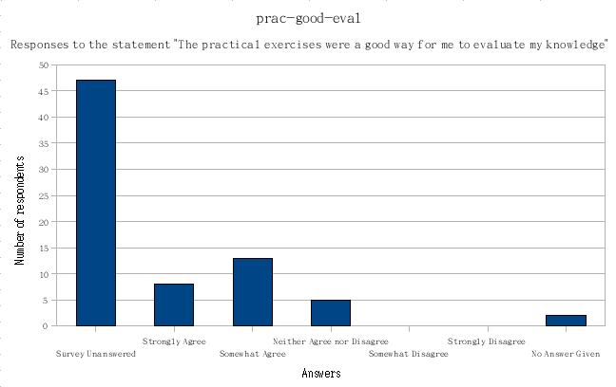
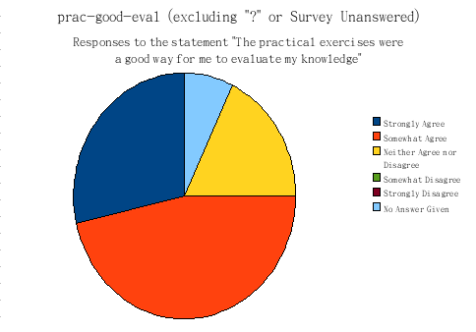

Chapter 5: Overall views of the eLGrid system
Some of the data gives us general information about how learners felt about the eLGrid eLearning system; was it easy to use? was it easy to access? etc. This sort of information can be very useful to the system developers, showing them areas where the system could use improvement.
In this chapter we will also look at the data relating to the adaptive traffic-lights menu system.
traffic-lights-nav

median (excluding "Survey Unanswered" and "No Answer Given") | 3.5
Mode | 4
min | 1
max | 5
range | 4
IQR | 2
Responses to the statement "The traffic-light icons helped me to navigate the course" was quite varied, with an overall range of 4 and an IQR of 2. The median of 3.5 suggests that learners are slightly more inclined to agree with this statement than to disagree, as does the mode of 4.
tutor-req

median (excluding "Survey Unanswered" and "No Answer Given") | 4
mode | 4
min | 1
max | 5
range | 4
IQR | 2
Most learners agreed with the statement "The presence of a tutor was necessary for me to complete this course" as suggested by the median and mode of 4. However, here again we see quite a spread of answers with a minimum of 1 (Strongly Disagree), a maximum of 5 (Strongly Agree) and a range of 4 and IQR of 2. This response is not what we had hoped to see as the eLearning system should ideally be capable of being used by remote learners without any tutor. There were some technical problems during one of the workshops where survey responses were gathered which might have contributed to these results, or the system's content or user interface may need some development in order to make it more suitable for remote learners.
trafficlights-nav
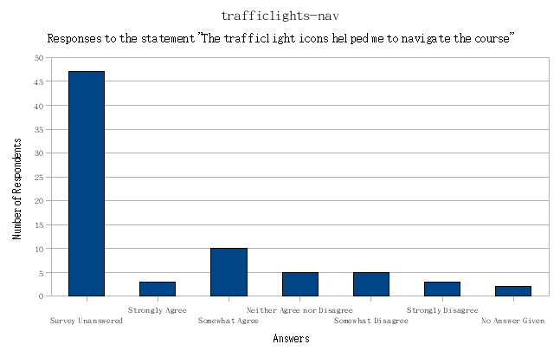
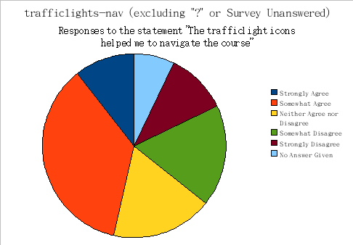
tutor-req
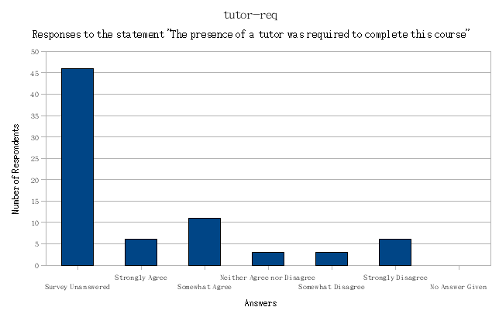
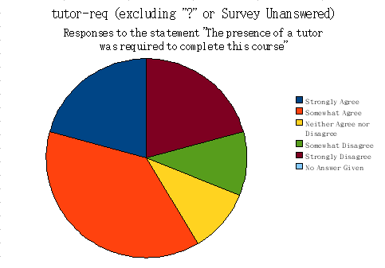

Chapter 6: Final Marks
As mentioned in the introduction, a small number of the learners were undergraduate students for whom we have information about their final scores. This data is available only for 14 learners out of the 75.
elgridmark

mean | 95
s | 10.91
s2 | 119.23
median | 100
min | 60
max | 100
range | 40
IQR | 10

projectmark

mean | 75.00
s | 10.91
s2 | 119.23
median | 75.00
min | 60.00
max | 90.00
range | 30.00
IQR | 10.00

Chapter 7: Normality of the Data
Much of the data collected does not appear to be particularly normal in distribution. We are measuring aspects of human behaviour, which do often fall into a normal distribution. However, in this case many of our measurements would not be expected to have a normal distribution. For example, the time spent viewing course material is an open-ended scale beginning at 0 but continuing unbounded. Our learner accounts were created at different times and learners have thus had different periods of time available to them to use the sytem. Furthermore, there are seven different courses available in the system and learners have studied different ones, some completing just one course, and others completing many. Yet other learners seem to have requested accounts more out of curiousity than any real wish to use the system. These learners have only logged in a few times and may not actually have completed any courses.
We wanted to know if we would see a more normal distribution when we viewed a subset of the learners, all of whom had completed the same course (and no other courses), over the same period. One such subset is data collected from a set of learners who used the system as part of their undergraduate course. Their accounts were all issued at the same time and they began using the system at the same time. They used the system for a number of weeks until their project deadline and exams were over, after which they did not return to the system. All learners completed just one course (although a small number looked briefly at some of the other courses too).
Even with this subset we still see a huge variety in the data. For example, the standard deviation of totalconcepttime for all of the data was 343086.41, but as you can see from the table below when we isolate just this subset we find that they actually have a larger standard deviation and variance.
totalconcepttime for a subset of the data all using the same course

x̅ | 123054.1
s | 386306.9
median | 12654.5
min | 3307
max | 1462891
range | 1459584
IQR | 14297.5
As you can see from the high values of s and the IQR, and the huge difference between the mean and median, this data is likely to have some outliers skewing the data towards the right. A graph confirms this, as you can see one outlier to the far right skews the data.
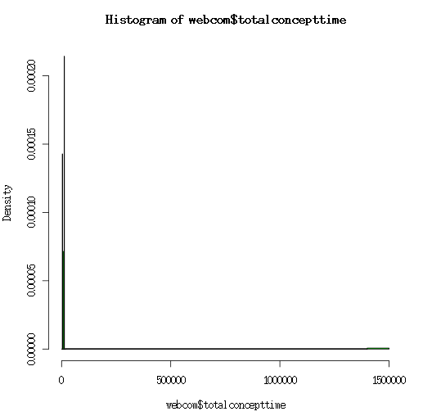
If we remove this outlier we get the following histogram which is still not a normal distribution but rather it is denser around the lower values with a lower frequency as the value increases.
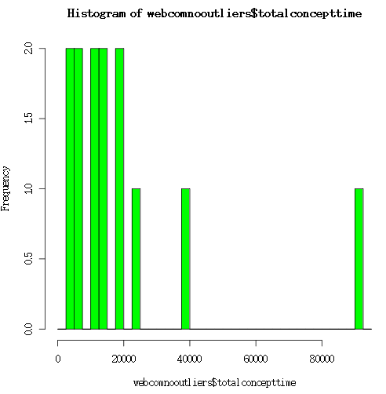
totalconceptcount for a subset of the data all using the same course

x̅ | 197.5714
s | 121.5804
median | 177.5
min | 83
max | 565
range | 482
IQR | 73.75
Concept count appears to have a distribution closer to normal. When we look only at our subset of users, however, it is still not a particularly normal distribution.
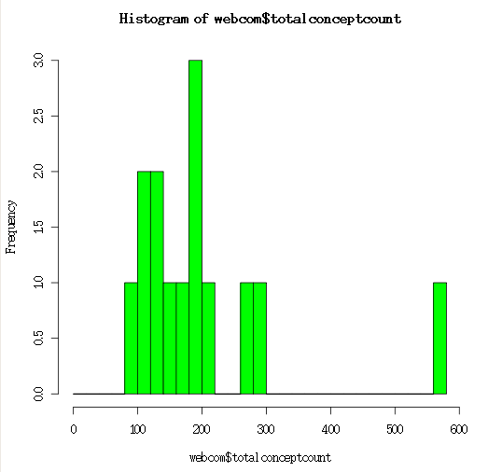

log-normal data
We wondered if it might be possible to find a normal distribution of the logs of the data and we created histograms of the logs of several of our variables. The complete dataset included a number of 0 values, which had to be removed in order to get the logs. This put some constraints on which variables we could use in such an analysis. For some variables, 0 values could safely be ignored, for example, a 0 value for the totalconcepttime or totalconceptcount variables means that the learner has never viewed any learning materials in the system. These learners are most likely those who had accounts created but never used them and it is quite valid to ignore them in any analysis. However, with some of the other variables it might not be acceptable to discard 0 values as they may be telling us something about the learner's use of the data.
The graph below shows the frequency distribution of the log of totalconcepttime for all learners, excluding those who had spend no time and therefore had a 0 value. While the raw data for totalconcepttime was clearly not normal, when we looked at the logs of the data we found a distribution much closer to normal.
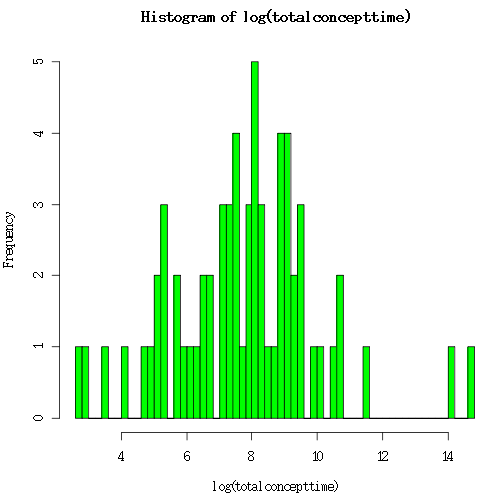

We then performed a Shapiro-Wilk test using the R statistical package and found a W statistic of 0.9664 and a p-value of 0.07465. The relatively large W statistic and p-value greater than our alpha value (here 95% or 0.05), tells us that we cannot reject the null hypothesis that the data comes from a normal population. This does not necessarily tell us that the log data is normal, but it does not rule it out and so we may be able to apply other analyses to the log data which are only appropriate for normally distributed data.

Chapter 8: Relationships and Correlations
Correlation is a comparable method used to assess the association between continuous variables. The standard method leads to a quantity r which can take any value from -1 to +1. This correlation coefficient r measures the degree of ‘straight-line’ association between the values of the two continuous variables. A value of +1.0 or -1.0 is obtained if all the points in a scatter diagram lie on a perfect straight line. The correlation between two variables is positive if higher values of one variable are associated with higher values of the other variable and negative if one variable tends to be lower as the values of the other variable increase. A correlation of around zero indicates that there is no linear relation between the values of the two continuous variables. The correlation coefficient r is a measure of the scatter of the points around the underlying linear trend: the greater the spread of points the lower the correlation. It can be calculated for any data set (Altman, 1991).
Moore & McCabe (2006) define correlation as the measurement of the direction and strength of the linear relationship between two quantitative variables. Suppose we have data on variables x and y for n individuals. The means and standard deviations of the two variables are x bar and sx for the x-values and y bar and sy for the y-values. The correlation r between x and y is: r = 1/n – 1) ∑ (xi – x bar/ sx ) (yi - y bar/ sy )

Altman warns that there is a restriction on the validity of the associated hypothesis test ie the two variables must be observed on a random sample of individuals and the data for at least one of the variables must have a Normal distribution in the population (Altman, 1991).
Concept time versus concept count
We expected a clear correlation between the number of concepts that a learner viewed and the time spent viewing concepts, however as the graph below shows this was not the case. Some learners viewed concepts many times but only spent an average overall time viewing concepts, while others spent a long time viewing concepts but did not view them that frequently. This may come be due to natural variation in how long the learners take to view the concept. Some might read the material quickly but return several times while others may only view each concept once but spend a long time reading and understanding the material.
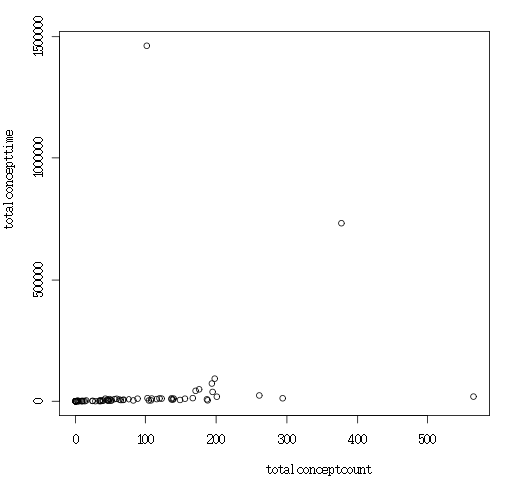
Login count versus concept count
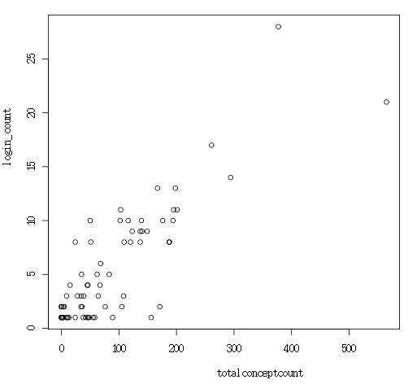
There was a clearer relationship between the login count and the concept count. Thus we can say that learners who returned to the system regularly viewed more concepts on average than those who only logged in a few times. This is what we would expect to see. Results also indicate that when learners viewed concepts they tended to get the correct answer (ie correlation of 0.4957708). One should also note that there was a correlation between viewing the concept and the number of times the profile was reset (ie correlation of 0.9472391).

View test count versus total concept count
We thought that we might see some relationship between the login count and the number of times that the learners viewed and completed the tests, however this was again not the case. A large number of learners appeared to have viewed no tests even though they had logged in many times. These learners may have completed courses with few or no tests or they may simply not have been interested in using the "Test Me!" function. More investigation would be required to understand this.
We did see some correlation, however, between the total concept count and the number of times that the learners viewed the tests. While there is a cluster of values with low view test counts there is also some evidence of a linear relationship between the number of concepts viewed and the number of tests viewed. This is another potential area for further investigation. It might be possible to see a clearer relationship if we take only the subset of learners who have actually viewed some tests.
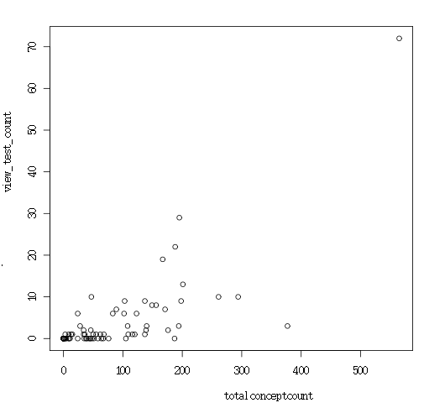
Totalconceptcount versus correct answer
The number of correct answers may also show some evidence of a correlation with the total concept count. The graph below shows the total concept count plotted against the number of correct test answers. As you can see there is again a cluster around 0 correct answers, but if we disregard these learners (who are probably largely the same set as those above who did not view any tests) then there is a trend for the two values to increase together, i.e. there is some evidence of a linear relationship between these two variables, although it appears less clear than that seen for the view test count.

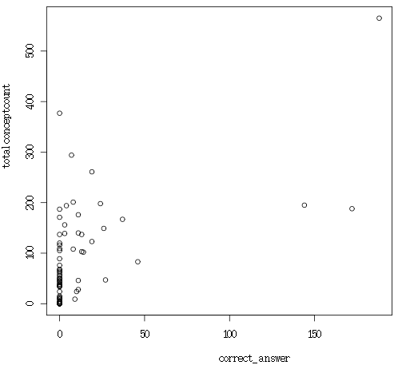

Correct versus Incorrect answers
Interestingly, while one might expect an inverse relationship between the number of correct and incorrect test answers, we actually saw the opposite, as the graph below shows. Those learners who had a high number of correct answers also tended to have a higher incorrect answer count. A likely explanation for this is that the learners with higher values for these variables simply took more tests than those with lower values; thus they had more opportunity to get both correct and incorrect answers.
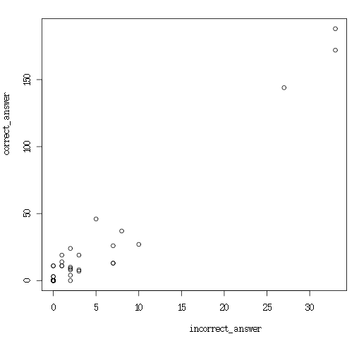
Viewing different classes
We had two nominal variables in our data, so far we have done little analysis of these. In this section we look briefly at these variables and at how some of the other data varies when grouped by these classifier variables.
Total Concept Count by Gender
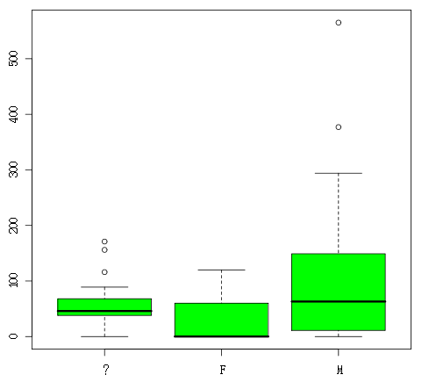
Total Concept Count by Level
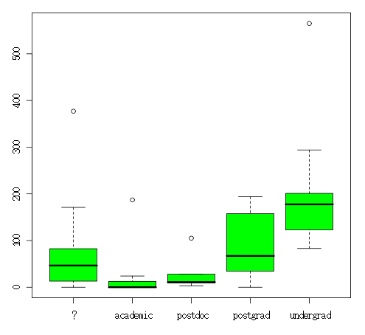
View Test Count by Level
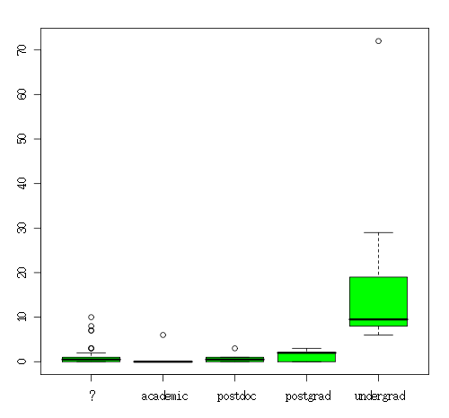
Correct Answer Count by Level
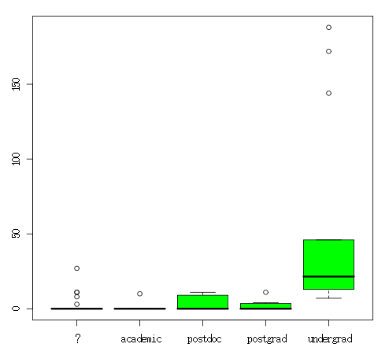

Chapter 9: Exploring differences between populations, application of a t-test
In chapter 7 we took a subset of our data, the group of learners who had completed a particular course as part of their undergraduate studies, and looked at whether their data followed a more normal distribution than that of the other learners. In this chapter we will look again at this subset of learners and compare them to the set of all other learners to look for differences and similarities in how they used the system.
We have chosen to look at the logs of the totalconcepttime variable as this variable may be normally distributed, because of this we can apply a t-test and ask whether the mean of the logs learners' times in the different groups are statistically different, or if any difference that we see is merely due to random variations.
First we needed to split our sample into two distinct samples. The first group was created by removing the 14 learners who completed the course as part of their undergraduate degree, and all learners with a 0 value for the totalconcepttime variable. Removing the 0-values was necessary as we will be working with logs of the data and zero values produce infinite log values. This gave us a sample of 50 learners. We also excluded the test data from the learner with user_id = 2.
The second group comprised the 14 undergraduate learners previously mentioned.
We assume that the logs of times for all users are normal (based on our graph of the variable in chapter 7 and the Shapiro-Wilk test which we performed). Looking at the graphs for our two subgroups we can see that these also both appear fairly normal (the first sugroup looks more normal than the second, but this makes sense as the sample size n is larger for group 1).

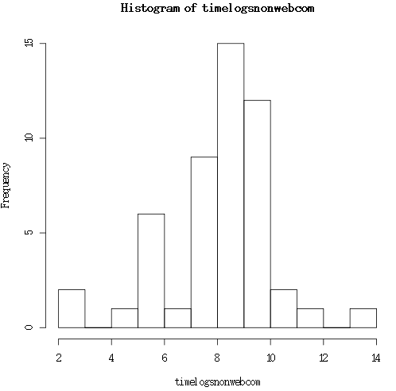
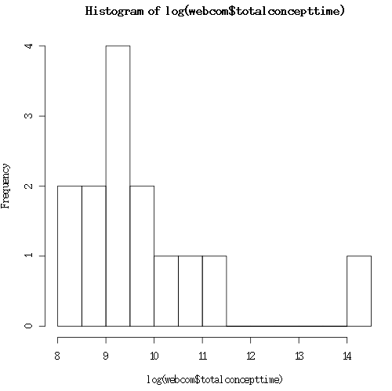
The statistics for the two groups are given in the table below:

Sample | x¯ | s | s² | n
Sample 1 | 7.992 | 1.987698 | 3.95 | 50
Sample 2 | 9.809 | 1.543944 | 2.38 | 14
We then formulated our hypotheses and calculated our t value as follows:
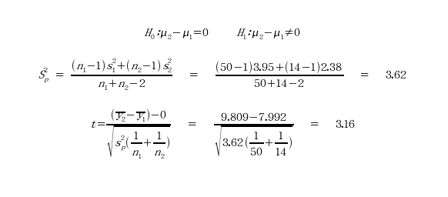
Critical value for two-tailed test with 95% confidence and 62 degrees of freedom (table A2) is 2.0, thus the t-values for which we will reject the null hypothesis that the two samples come from populations with the same mean is t < -2 and t > 2 or the area shaded orange in the graph below.
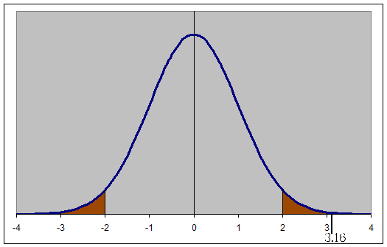
Our t-value of 3.16 falls in the shaded region and thus we must reject the null hypothesis that the two samples come from populations with the same mean. What does this tell us about our two samples? It suggests that there is a statistically significant difference in the logs of time spent viewing concepts for those learners who studied one particular course as part of their undergraduate studies and those who used the eLGrid system in other ways, primarily as part of short 2-day to 1-week workshops. Further analysis might reveal other interesting differences between these two groups.

Chapter 9: Conclusions

The eLGrid System

Missing Data
According to Altman (1991) missing is just an additional category for categorical variables and so these individuals can be included in any cross-tabulation. For continuous variables it is essential that missing data are identified. It is worth thinking about why the data are missing – in particular one ought to know if there is a reason related to the nature of this study.

Frequently values are missing essentially at random, for reasons not related to a study. For example, some participants may not have been asked a particular question.

Chapter XXX: Ordinal Data and Likert Scales.
An ordinal scale of measurement represents an ordered series of relationships or rank order. Examples are the results of a contest or be measurements taken (often in questionnaire format) from participants in an activity. Examples of such activities are participating in a course, viewing a play or film or staying in a hotel, etc.
Whereas this data is useful, it has some limitations, these are outlined here.
These scales do not represent a measurable quantity. In the results of a contest, it is clear that first preformed better that all others, but does not tell by how much or how far first was ahead of second, third, etc. Further details of scores or other measurements are required for this.
Course participants may be asked to rate their experience in terms of enjoyment, understanding of course material or benefit gained.
Answers given are subjective. It is conceivable that a person who thoroughly understood or enjoyed an activity may give a mid-scale answer, while a person with a mediocre experience of the same activity may rate that experience higher.
Answering may also be subject to response biases. Examples of such biases are acquiescence bias and social desirability bias. In acquiesence bias, the respondent has a tendency to agree with all the questions or to indicate a positive connotation. The designer of the questions may decide to remove the possibility of giving a neutral answer (e.g. Neither agree not disagree).
Social desirability bias is a tendency to respond in a way which will be perceived as being socially acceptable and or desirable. Surveys on sensitive areas like religion, bigotry, domestic violence, etc. may likely to be subject to this if questions are not properly structured.
The question used to obtain the ordinal answers in this data can be termed a Likert scale. An typical Likert scale would be...
* Strongly disagree
* Disagree
* Neither agree nor disagree
* Agree
* Strongly Agree
Often five ordered response levels are used although seven or nine levels are also used.A recent empirical study[1] found that a 5- or 7- point scale may produce slightly higher mean scores relative to the highest possible attainable score, compared to those produced from a 10-point scale,
The data examined in this work are responses to questionnaires which used a 5 point Likert scale.

Chapter YYY: Normality test on the projectmark variable (i.e. a small sample).
This data set consists of 14 data points. The (ranked) data set is as follows... [60 60 60 70 70 70 70 80 80 80 80 90 90 90]. When plotted (Figure XX) using a histogram, it resulted in a symmetric graph which somewhat resembled a normal curve. The plot of this data has a normal curve superimposed on it (although this curve does not extend to the tails of the plot).
Normality tests in general assume normality and are looking for evidence to reject that hypothesis. In general small sample sizes or sample where data point are not all unique are problematic for normality testing. With very small sample sizes, there needs to be strong evidence of a deviation from normality in order to get a low p-value. Samples of less than 15 or 20 may produce test results that will usually not reject the null.
This data sets analysed here were not suitable for normality testing using the Anderson-Darling (AD) method as this test is only suitable for sample size over 25. The AD works well for sample sizes between 25 & 1000 data points[2].
The Shapiro-Wilks test was use for this sample and calculated using the GNU software R. Using this software, using a sample size outside the range of 3 to 5000, an error is generated.
[Results go here in a table]
These results should not be used to state that your data are "normally distributed". The Shapiro-Wilk test provides evidence of certain types of "non-normality" and does not guarantee that data is normal.
This data is not discrete, i.e. marks were not intentionally given in multiples of 10, but by using a continuous scale. It is interesting that although the data increments appear to have steps, the Shapiro-Wilk test did not indicate that the data was not normal.

References

Altman, D. G. (1991). Practical Statistics for Medical Research (First ed.). London: Chapman & Hall.

Dawes, J. (2008). Do Data Characteristics Change According to the number of scale points used? An experiment using 5-point, 7-point and 10-point scales. International Journal of Market Research, 50 (1), 61-77.

Minitab available at URL: http://www.minitab.com
Moore, D. S., & McCabe, G. P. (2006). Introduction to the Practice of Statistics (Fifth ed.). New York: W H Freeman and Company.

Appendix A: The data file

learnerid, totalconcepttime, totalconceptcount, complete_initial_questionaire_count, correct_answer_count, incomplete_answer_count, incorrect_answer_count, login_count, logout_count, reset_profile_count, view_concept_count, view_test_count, elgrid-easy, future-elgrid, future-use-tools, prac-apply-concepts, prac-env-easy, prac-good-eval, practical-access, practical-understood, tests-good-eval, theory-comp-prac, too-easy, too-hard, traffic-light-prac, traffic-understood, trafficlights-nav, tutor-req, projectmark, elgridmark, totalmark, gender, level
2, 2528613, 2518, 3, 118, 2, 18, 199, 151, 14, 2972, 122, ?, ?, ?, ?, ?, ?, ?, ?, ?, ?, ?, ?, ?, ?, ?, ?, ?, ?, ?, F, postgrad
3, 1746, 9, 0, 9, 0, 2, 3, 2, 0, 13, 1, ?, ?, ?, ?, ?, ?, ?, ?, ?, ?, ?, ?, ?, ?, ?, ?, ?, ?, ?, M, postdoc
8, 1246, 24, 1, 10, 0, 2, 8, 4, 0, 46, 6, ?, ?, ?, ?, ?, ?, ?, ?, ?, ?, ?, ?, ?, ?, ?, ?, ?, ?, ?, M, academic
11, 57, 3, 0, 0, 0, 0, 1, 0, 0, 4, 0, ?, ?, ?, ?, ?, ?, ?, ?, ?, ?, ?, ?, ?, ?, ?, ?, ?, ?, ?, M, postdoc
14, 184, 13, 0, 0, 0, 0, 1, 0, 0, 14, 1, ?, ?, ?, ?, ?, ?, ?, ?, ?, ?, ?, ?, ?, ?, ?, ?, ?, ?, ?, M, postdoc
17, 0, 0, 0, 0, 0, 0, 1, 1, 0, 0, 0, ?, ?, ?, ?, ?, ?, ?, ?, ?, ?, ?, ?, ?, ?, ?, ?, ?, ?, ?, F, academic
22, 155, 9, 0, 0, 0, 0, 1, 0, 0, 10, 0, ?, ?, ?, ?, ?, ?, ?, ?, ?, ?, ?, ?, ?, ?, ?, ?, ?, ?, ?, M, postdoc
24, 3636, 35, 0, 0, 0, 0, 5, 0, 0, 42, 0, ?, ?, ?, ?, ?, ?, ?, ?, ?, ?, ?, ?, ?, ?, ?, ?, ?, ?, ?, M, postgrad
29, 3254, 105, 0, 0, 0, 0, 2, 1, 0, 111, 0, ?, ?, ?, ?, ?, ?, ?, ?, ?, ?, ?, ?, ?, ?, ?, ?, ?, ?, ?, M, postdoc
33, 214, 5, 0, 0, 0, 0, 2, 1, 0, 7, 0, ?, ?, ?, ?, ?, ?, ?, ?, ?, ?, ?, ?, ?, ?, ?, ?, ?, ?, ?, M, ?
34, 72530, 194, 1, 4, 0, 2, 10, 7, 0, 224, 3, ?, ?, ?, ?, ?, ?, ?, ?, ?, ?, ?, ?, ?, ?, ?, ?, ?, ?, ?, M, postgrad
39, 4806, 64, 0, 0, 0, 0, 3, 1, 0, 75, 0, Somewhat Agree, ?, ?, Somewhat Agree, Somewhat Agree, Somewhat Agree, Somewhat Agree, Somewhat Agree, Somewhat Disagree, Strongly Agree, Somewhat Disagree, Strongly Disagree, ?, Somewhat Disagree, Somewhat Disagree, Somewhat Agree, ?, ?, ?, M, ?
41, 11094, 109, 0, 0, 0, 0, 8, 5, 0, 134, 1, Somewhat Disagree, ?, ?, Somewhat Agree, Somewhat Disagree, Somewhat Agree, Somewhat Agree, Somewhat Disagree, Somewhat Agree, Neither Agree nor Disagree, Somewhat Disagree, Somewhat Disagree, ?, Somewhat Disagree, Somewhat Agree, Somewhat Agree, ?, ?, ?, M, ?
43, 10871, 140, 1, 11, 0, 1, 9, 1, 0, 175, 3, ?, ?, ?, ?, ?, ?, ?, ?, ?, ?, ?, ?, ?, ?, ?, ?, ?, ?, ?, M, ?
44, 2849, 50, 0, 0, 0, 0, 10, 9, 0, 73, 1, Somewhat Agree, ?, ?, Somewhat Agree, Neither Agree nor Disagree, Somewhat Agree, Strongly Agree, Strongly Agree, Somewhat Agree, Neither Agree nor Disagree, Somewhat Disagree, Somewhat Disagree, ?, Neither Agree nor Disagree, Strongly Disagree, Strongly Disagree, ?, ?, ?, M, ?
48, 1419, 24, 0, 0, 0, 0, 1, 0, 0, 27, 0, ?, ?, ?, ?, ?, ?, Neither Agree nor Disagree, Strongly Agree, ?, ?, Somewhat Disagree, Somewhat Disagree, ?, ?, ?, Strongly Disagree, ?, ?, ?, M, ?
50, 7808, 187, 0, 0, 0, 0, 8, 7, 0, 218, 0, ?, ?, ?, ?, ?, ?, ?, ?, ?, ?, ?, ?, ?, ?, ?, ?, ?, ?, ?, M, academic
53, 1288, 11, 0, 0, 0, 0, 1, 0, 0, 12, 0, ?, ?, ?, ?, ?, ?, ?, ?, ?, ?, ?, ?, ?, ?, ?, ?, ?, ?, ?, M, ?
54, 11715, 120, 1, 0, 0, 0, 8, 4, 0, 160, 1, Neither Agree nor Disagree, ?, ?, Strongly Agree, Somewhat Agree, Somewhat Agree, Strongly Agree, Strongly Agree, Somewhat Agree, Neither Agree nor Disagree, Neither Agree nor Disagree, Strongly Disagree, ?, Somewhat Agree, Somewhat Agree, Neither Agree nor Disagree, ?, ?, ?, F, ?
55, 6906, 62, 0, 0, 0, 0, 5, 1, 1, 83, 1, Strongly Agree, ?, ?, Strongly Agree, Strongly Agree, Strongly Agree, Strongly Agree, Strongly Agree, Somewhat Agree, Strongly Agree, Strongly Disagree, Strongly Disagree, ?, Somewhat Agree, Somewhat Agree, Neither Agree nor Disagree, ?, ?, ?, M, ?
57, 3191, 15, 0, 0, 0, 0, 4, 3, 0, 24, 1, ?, ?, ?, ?, ?, ?, ?, ?, ?, ?, ?, ?, ?, ?, ?, ?, ?, ?, ?, M, ?
58, 1517, 47, 1, 27, 0, 10, 1, 0, 0, 58, 10, ?, ?, ?, ?, ?, ?, ?, ?, ?, ?, ?, ?, ?, ?, ?, ?, ?, ?, ?, M, ?
59, 0, 0, 0, 0, 0, 0, 2, 2, 0, 0, 0, ?, ?, ?, ?, ?, ?, ?, ?, ?, ?, ?, ?, ?, ?, ?, ?, ?, ?, ?, M, ?
61, 11679, 137, 0, 0, 0, 0, 9, 3, 0, 159, 1, Neither Agree nor Disagree, ?, ?, Somewhat Agree, Somewhat Disagree, Neither Agree nor Disagree, Somewhat Agree, Somewhat Agree, Somewhat Disagree, Neither Agree nor Disagree, Somewhat Disagree, Somewhat Disagree, ?, Strongly Disagree, Strongly Disagree, Somewhat Disagree, ?, ?, ?, M, ?
64, 3774, 51, 0, 0, 0, 0, 8, 5, 0, 73, 0, ?, ?, ?, ?, ?, ?, ?, ?, ?, ?, ?, ?, ?, ?, ?, ?, ?, ?, ?, M, ?
65, 2625, 38, 0, 0, 0, 0, 1, 0, 0, 44, 0, ?, ?, ?, ?, ?, ?, ?, ?, ?, ?, ?, ?, ?, ?, ?, ?, ?, ?, ?, ?, ?
67, 3669, 45, 0, 0, 0, 0, 1, 0, 0, 53, 0, ?, ?, ?, ?, ?, ?, ?, ?, ?, ?, ?, ?, ?, ?, ?, ?, ?, ?, ?, ?, ?
68, 6516, 68, 0, 0, 0, 0, 6, 1, 1, 85, 1, ?, ?, ?, ?, ?, ?, ?, ?, ?, ?, ?, ?, ?, ?, ?, ?, ?, ?, ?, ?, ?
69, 759, 36, 0, 0, 0, 0, 2, 1, 0, 52, 1, ?, ?, ?, ?, ?, ?, ?, ?, ?, ?, ?, ?, ?, ?, ?, ?, ?, ?, ?, ?, ?
70, 6915, 45, 0, 0, 0, 0, 4, 1, 0, 52, 0, ?, ?, ?, ?, ?, ?, ?, ?, ?, ?, ?, ?, ?, ?, ?, ?, ?, ?, ?, ?, ?
71, 8735, 116, 0, 0, 0, 0, 10, 2, 0, 148, 1, ?, ?, ?, ?, ?, ?, ?, ?, ?, ?, ?, ?, ?, ?, ?, ?, ?, ?, ?, ?, ?
72, 3397, 46, 1, 11, 0, 1, 4, 0, 0, 63, 2, ?, ?, ?, ?, ?, ?, ?, ?, ?, ?, ?, ?, ?, ?, ?, ?, ?, ?, ?, ?, ?
73, 2629, 39, 0, 0, 0, 0, 3, 2, 0, 44, 0, ?, ?, ?, ?, ?, ?, ?, ?, ?, ?, ?, ?, ?, ?, ?, ?, ?, ?, ?, ?, ?
74, 8257, 76, 0, 0, 0, 0, 2, 0, 0, 87, 0, ?, ?, ?, ?, ?, ?, ?, ?, ?, ?, ?, ?, ?, ?, ?, ?, ?, ?, ?, ?, ?
75, 6904, 139, 0, 3, 0, 0, 10, 8, 1, 167, 2, Strongly Agree, ?, ?, Strongly Agree, Strongly Agree, Strongly Agree, Strongly Agree, Strongly Agree, No answer Given, Strongly Agree, Strongly Disagree, Strongly Disagree, ?, No answer Given, Somewhat Disagree, Strongly Disagree, ?, ?, ?, M, postgrad
76, 732600, 377, 1, 0, 0, 0, 28, 0, 0, 457, 3, ?, ?, ?, ?, ?, ?, ?, ?, ?, ?, ?, ?, ?, ?, ?, ?, ?, ?, ?, M, ?
78, 10540, 89, 1, 0, 0, 2, 1, 0, 0, 96, 7, Somewhat Agree, Strongly Agree, Strongly Agree, Somewhat Agree, Somewhat Agree, No answer Given, Strongly Agree, Somewhat Agree, No answer Given, No answer Given, Strongly Disagree, Somewhat Disagree, Somewhat Disagree, Somewhat Disagree, No answer Given, Strongly Agree, ?, ?, ?, ?, ?
79, 42683, 171, 2, 0, 0, 0, 2, 1, 0, 182, 7, Neither Agree nor Disagree, Somewhat Agree, Somewhat Agree, Somewhat Agree, Somewhat Agree, Strongly Agree, Somewhat Agree, Somewhat Agree, Somewhat Agree, Somewhat Agree, Neither Agree nor Disagree, Strongly Agree, Neither Agree nor Disagree, Neither Agree nor Disagree, Somewhat Agree, Somewhat Agree, ?, ?, ?, ?, ?
80, 2256, 34, 0, 0, 0, 0, 3, 2, 1, 39, 2, ?, ?, ?, ?, ?, ?, ?, ?, ?, ?, ?, ?, ?, ?, ?, ?, ?, ?, ?, M, postgrad
81, 10450, 156, 1, 3, 0, 0, 1, 1, 0, 167, 8, Somewhat Agree, Strongly Agree, Somewhat Agree, Somewhat Agree, Neither Agree nor Disagree, Somewhat Agree, Somewhat Agree, Somewhat Agree, Strongly Agree, Somewhat Agree, Strongly Disagree, Strongly Disagree, Somewhat Agree, Somewhat Disagree, Somewhat Disagree, Strongly Agree, ?, ?, ?, ?, ?
82, 10170, 58, 0, 0, 0, 0, 1, 0, 0, 63, 0, Somewhat Agree, Somewhat Agree, Strongly Agree, Somewhat Agree, Somewhat Agree, Somewhat Agree, Somewhat Agree, Somewhat Agree, Somewhat Agree, Somewhat Agree, Somewhat Disagree, Strongly Disagree, Somewhat Agree, Somewhat Agree, Somewhat Agree, Somewhat Agree, ?, ?, ?, ?, ?
83, 8895, 48, 0, 0, 0, 0, 1, 0, 0, 51, 0, Somewhat Agree, Somewhat Disagree, Somewhat Agree, Somewhat Agree, Neither Agree nor Disagree, No answer Given, Somewhat Agree, Neither Agree nor Disagree, No answer Given, Neither Agree nor Disagree, Somewhat Disagree, Strongly Disagree, No answer Given, No answer Given, No answer Given, Somewhat Agree, ?, ?, ?, ?, ?
84, 10534, 42, 0, 0, 0, 0, 1, 0, 0, 47, 0, Somewhat Agree, Neither Agree nor Disagree, Somewhat Agree, Strongly Agree, Somewhat Agree, Somewhat Agree, Neither Agree nor Disagree, Strongly Agree, Neither Agree nor Disagree, Neither Agree nor Disagree, Strongly Disagree, Somewhat Agree, Neither Agree nor Disagree, Neither Agree nor Disagree, Somewhat Agree, Strongly Agree, ?, ?, ?, ?, ?
85, 8774, 55, 0, 0, 0, 0, 1, 0, 0, 60, 1, Somewhat Disagree, Neither Agree nor Disagree, Strongly Disagree, Neither Agree nor Disagree, Neither Agree nor Disagree, Neither Agree nor Disagree, Somewhat Agree, Neither Agree nor Disagree, Neither Agree nor Disagree, Neither Agree nor Disagree, Neither Agree nor Disagree, Neither Agree nor Disagree, Neither Agree nor Disagree, Neither Agree nor Disagree, Neither Agree nor Disagree, Somewhat Agree, ?, ?, ?, ?, ?
102, 275, 9, 0, 0, 0, 0, 1, 0, 0, 10, 0, ?, ?, ?, ?, ?, ?, ?, ?, ?, ?, ?, ?, ?, ?, ?, ?, ?, ?, ?, ?, ?
110, 0, 0, 0, 0, 0, 0, 1, 1, 0, 0, 0, ?, ?, ?, ?, ?, ?, ?, ?, ?, ?, ?, ?, ?, ?, ?, ?, ?, ?, ?, M, ?
111, 0, 0, 0, 0, 0, 0, 1, 1, 0, 0, 0, ?, ?, ?, ?, ?, ?, ?, ?, ?, ?, ?, ?, ?, ?, ?, ?, ?, ?, ?, M, ?
112, 0, 0, 0, 0, 0, 0, 1, 1, 0, 0, 0, ?, ?, ?, ?, ?, ?, ?, ?, ?, ?, ?, ?, ?, ?, ?, ?, ?, ?, ?, M, ?
113, 0, 0, 0, 0, 0, 0, 2, 2, 0, 0, 0, ?, ?, ?, ?, ?, ?, ?, ?, ?, ?, ?, ?, ?, ?, ?, ?, ?, ?, ?, ?, ?
114, 3553, 108, 1, 8, 0, 3, 3, 1, 0, 126, 3, ?, ?, ?, ?, ?, ?, ?, ?, ?, ?, ?, ?, ?, ?, ?, ?, ?, ?, ?, M, ?
115, 0, 0, 0, 0, 0, 0, 2, 1, 0, 1, 0, ?, ?, ?, ?, ?, ?, ?, ?, ?, ?, ?, ?, ?, ?, ?, ?, ?, ?, ?, M, academic
116, 18, 3, 0, 0, 0, 0, 2, 1, 0, 5, 1, ?, ?, ?, ?, ?, ?, ?, ?, ?, ?, ?, ?, ?, ?, ?, ?, ?, ?, ?, M, ?
117, 0, 0, 0, 0, 0, 0, 1, 1, 0, 15, 0, ?, ?, ?, ?, ?, ?, ?, ?, ?, ?, ?, ?, ?, ?, ?, ?, ?, ?, ?, M, academic
118, 3013, 3, 0, 0, 0, 0, 1, 1, 0, 6, 0, ?, ?, ?, ?, ?, ?, ?, ?, ?, ?, ?, ?, ?, ?, ?, ?, ?, ?, ?, ?, ?
124, 0, 0, 0, 0, 0, 0, 1, 0, 0, 0, 0, ?, ?, ?, ?, ?, ?, ?, ?, ?, ?, ?, ?, ?, ?, ?, ?, ?, ?, ?, ?, postgrad
133, 5104, 67, 0, 0, 0, 0, 4, 3, 0, 73, 0, ?, ?, ?, ?, ?, ?, ?, ?, ?, ?, ?, ?, ?, ?, ?, ?, ?, ?, ?, ?, postgrad
135, 14, 1, 0, 0, 0, 0, 1, 1, 0, 4, 0, ?, ?, ?, ?, ?, ?, ?, ?, ?, ?, ?, ?, ?, ?, ?, ?, ?, ?, ?, M, academic
136, 48723, 176, 1, 11, 0, 0, 10, 1, 0, 204, 2, ?, ?, ?, ?, ?, ?, ?, ?, ?, ?, ?, ?, ?, ?, ?, ?, ?, ?, ?, M, postgrad
137, 350, 28, 2, 11, 0, 0, 3, 2, 0, 33, 3, ?, ?, ?, ?, ?, ?, ?, ?, ?, ?, ?, ?, ?, ?, ?, ?, ?, ?, ?, M, postdoc
138, 214, 34, 0, 0, 0, 0, 2, 1, 0, 36, 1, ?, ?, ?, ?, ?, ?, ?, ?, ?, ?, ?, ?, ?, ?, ?, ?, ?, ?, ?, M, ?
149, 3738, 188, 2, 172, 3, 33, 8, 1, 1, 220, 22, Somewhat Agree, Strongly Disagree, Strongly Disagree, Neither Agree nor Disagree, Strongly Disagree, Strongly Agree, Somewhat Disagree, Somewhat Agree, Somewhat Agree, Neither Agree nor Disagree, Neither Agree nor Disagree, Somewhat Disagree, Somewhat Disagree, Neither Agree nor Disagree, Neither Agree nor Disagree, Somewhat Agree, 90, 90, 90, M, undergrad
150, 5246, 149, 2, 26, 0, 7, 9, 4, 0, 163, 8, Strongly Agree, Strongly Agree, Strongly Agree, Strongly Agree, Strongly Agree, Strongly Agree, Somewhat Agree, Strongly Agree, Strongly Agree, Strongly Agree, Strongly Disagree, Strongly Disagree, Somewhat Agree, Somewhat Agree, Strongly Agree, Neither Agree nor Disagree, 70, 60, 66, M, undergrad
151, 1462891, 102, 2, 14, 1, 1, 10, 1, 0, 117, 6, Strongly Agree, Strongly Agree, Somewhat Agree, Strongly Agree, Somewhat Agree, Strongly Agree, Somewhat Agree, Somewhat Agree, Somewhat Agree, Strongly Agree, Strongly Disagree, Strongly Disagree, Strongly Agree, Strongly Disagree, Strongly Disagree, Strongly Disagree, 90, 100, 94, M, undergrad
152, 12143, 294, 1, 7, 0, 3, 14, 12, 0, 316, 10, Strongly Agree, Somewhat Agree, Somewhat Disagree, Somewhat Agree, Neither Agree nor Disagree, Somewhat Agree, Strongly Agree, Somewhat Agree, Strongly Agree, Somewhat Agree, Somewhat Disagree, Neither Agree nor Disagree, Somewhat Disagree, Strongly Agree, Strongly Agree, Strongly Agree, 60, 100, 76, M, undergrad
153, 92493, 198, 1, 24, 1, 2, 13, 2, 0, 218, 9, Strongly Agree, Somewhat Agree, Neither Agree nor Disagree, Strongly Agree, Neither Agree nor Disagree, Strongly Agree, Somewhat Agree, Strongly Agree, Strongly Agree, Strongly Agree, Strongly Disagree, Somewhat Disagree, Neither Agree nor Disagree, Somewhat Agree, Somewhat Disagree, Somewhat Disagree, 90, 100, 94, M, undergrad
154, 18597, 201, 3, 8, 0, 2, 11, 4, 0, 224, 13, Somewhat Agree, Neither Agree nor Disagree, Somewhat Disagree, Neither Agree nor Disagree, Somewhat Agree, Somewhat Agree, Somewhat Agree, Somewhat Agree, Strongly Agree, Neither Agree nor Disagree, Somewhat Agree, Strongly Disagree, Neither Agree nor Disagree, Somewhat Agree, Somewhat Agree, Somewhat Agree, 70, 100, 82, M, undergrad
155, 12761, 167, 3, 37, 2, 8, 13, 3, 0, 190, 19, Somewhat Agree, Somewhat Agree, Somewhat Disagree, Somewhat Agree, Neither Agree nor Disagree, Neither Agree nor Disagree, Somewhat Agree, Somewhat Agree, Somewhat Disagree, Somewhat Agree, Neither Agree nor Disagree, Strongly Disagree, Somewhat Disagree, Somewhat Disagree, Somewhat Agree, Somewhat Agree, 70, 100, 82, M, undergrad
156, 38164, 195, 3, 144, 5, 27, 11, 1, 0, 248, 29, Somewhat Agree, Somewhat Agree, Somewhat Disagree, Somewhat Agree, Strongly Agree, Somewhat Agree, Neither Agree nor Disagree, Somewhat Agree, Somewhat Agree, Somewhat Agree, Somewhat Disagree, Strongly Disagree, Somewhat Disagree, Somewhat Agree, Somewhat Agree, Strongly Disagree, 80, 90, 84, M, undergrad
157, 23663, 261, 1, 19, 1, 1, 17, 2, 0, 282, 10, Strongly Agree, Somewhat Agree, Somewhat Disagree, Neither Agree nor Disagree, Somewhat Disagree, Somewhat Agree, Somewhat Disagree, Strongly Agree, Neither Agree nor Disagree, Strongly Agree, Strongly Agree, Somewhat Disagree, Neither Agree nor Disagree, Neither Agree nor Disagree, Neither Agree nor Disagree, Strongly Agree, 80, 100, 88, M, undergrad
158, 3307, 83, 0, 46, 3, 5, 5, 1, 0, 94, 6, Somewhat Agree, Strongly Agree, Strongly Disagree, Somewhat Agree, Neither Agree nor Disagree, Strongly Agree, Somewhat Agree, Strongly Agree, Neither Agree nor Disagree, Strongly Agree, Neither Agree nor Disagree, Strongly Disagree, Strongly Agree, Neither Agree nor Disagree, Neither Agree nor Disagree, Strongly Disagree, 70, 100, 82, M, undergrad
159, 12548, 103, 2, 13, 0, 7, 11, 1, 0, 120, 9, Somewhat Agree, Strongly Agree, Neither Agree nor Disagree, Somewhat Agree, Somewhat Agree, Neither Agree nor Disagree, Somewhat Agree, Neither Agree nor Disagree, Somewhat Agree, Somewhat Agree, Neither Agree nor Disagree, Strongly Disagree, Strongly Agree, Somewhat Agree, Neither Agree nor Disagree, Somewhat Disagree, 80, 100, 88, M, undergrad
160, 7368, 137, 1, 13, 0, 7, 8, 1, 0, 151, 9, Somewhat Agree, Somewhat Agree, Somewhat Agree, Somewhat Agree, Somewhat Agree, Somewhat Agree, Neither Agree nor Disagree, Somewhat Agree, Strongly Agree, Somewhat Agree, Somewhat Disagree, Strongly Disagree, Strongly Agree, Strongly Agree, Strongly Agree, Somewhat Agree, 80, 100, 88, M, undergrad
161, 19072, 565, 7, 188, 3, 33, 21, 3, 5, 626, 72, Neither Agree nor Disagree, Somewhat Agree, Somewhat Disagree, Somewhat Agree, Neither Agree nor Disagree, Somewhat Agree, Somewhat Disagree, Neither Agree nor Disagree, Somewhat Agree, Somewhat Agree, Strongly Disagree, Neither Agree nor Disagree, Somewhat Agree, Somewhat Agree, Somewhat Agree, Somewhat Agree, 60, 90, 72, M, undergrad
162, 10767, 123, 1, 19, 0, 3, 9, 3, 0, 135, 6, Somewhat Agree, Strongly Agree, Strongly Disagree, Neither Agree nor Disagree, Neither Agree nor Disagree, Neither Agree nor Disagree, Neither Agree nor Disagree, Neither Agree nor Disagree, Somewhat Disagree, Somewhat Disagree, Strongly Disagree, Neither Agree nor Disagree, Strongly Disagree, Somewhat Agree, Somewhat Disagree, Strongly Agree, 60, 100, 76, M, undergrad
163, 0, 0, 0, 0, 0, 0, 1, 1, 0, 0, 0, ?, ?, ?, ?, ?, ?, ?, ?, ?, ?, ?, ?, ?, ?, ?, ?, ?, ?, ?, F, academic

