Title/标题：Standard for the Use of Cleanroom Cleaning Tools /洁净间洁具使用标准
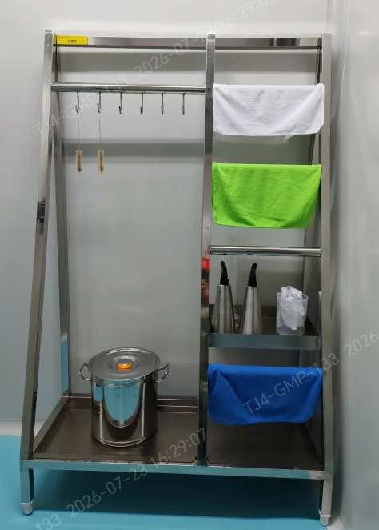 | - Classification and Color Coding/  分类与分色管理  - Color-coded wipes are dedicated by area: white for the external surfaces of equipment and workbenches, green for walls, and blue for floors.-/三色抹布专区专用：白色-设备/操作台外表面、绿色-墙面、蓝色-地面  - Brushes and cleaning buckets are dedicated to their assigned areas and shall not be used across cleanroom grades.-/毛刷、清洁桶对应区域专属，禁止跨洁净级别混用  - On-Site Use Requirements/  现场使用规范  - Damaged or soiled tools shall be taken out of service immediately and discarded./  工具如出现破损、脏污，应立即停用并报废  - All cleaning tools that come into direct contact with the internal surfaces of equipment are single-use.- /所有直接接触设备内表面的清洁工具，均为一次性使用。
- Left zone: hang cleaning brushes and store cleaning containers./左侧区：清洁毛刷悬挂及清洁容器存放
- Right zone: air-dry color-coded wipes and store dedicated cleaning tools./右侧区：分色抹布晾晒+专用清洁工具存放

Reference document No. and title/  参考文件的编号和标题 |  | <DS-GMP-001>《生产厂房清洁（DS）》
Work aid No. and version/  作业辅助文件编号和版本号 |  |  | Work aid approval date/  作业辅助文件审批时间 |  | Copy No./  复制号
TJ4-SC-DS-GMP-001-01.01 |  |  | 11/18/2025
Prepared by/Date/制作人/日期：  _______________________ | Reviewed by/Date/复核人/日期：  _______________________ |  |  | QA Review/Date/QA审核人/日期：  _______________________

