PWS .biz

Total number of sessions on a non-busy day are ~5000. On a busy day like 30th/31st of the month, the total number of sessions are almost 3 times ~15000

On 5th of July

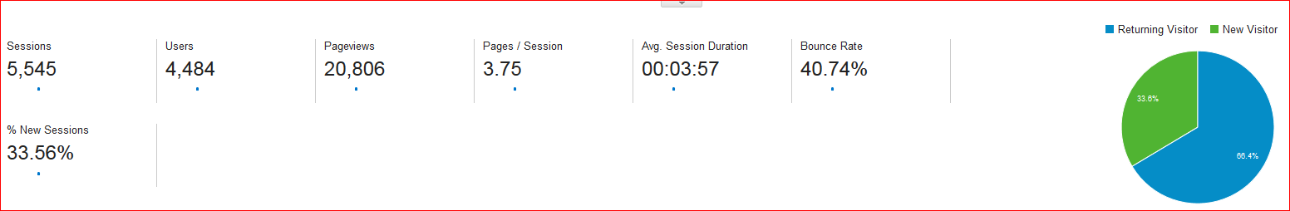

On 31st of July

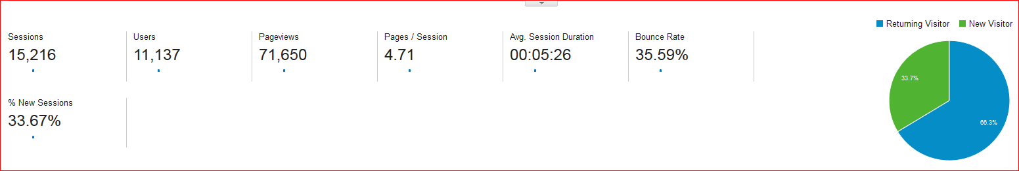

The real time active users on a non-busy day are ~100. On 30th of the month the concurrency expected would be 3 times i.e. ~300 active users

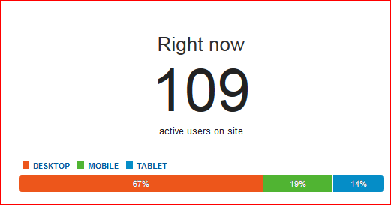

Out of the total page hits on a day, 6% of the requests are doing enrollment:

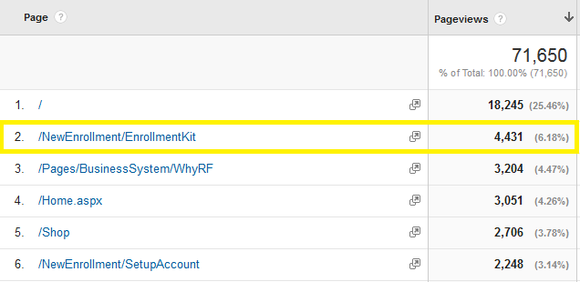

2% of the requests are from PC/RC

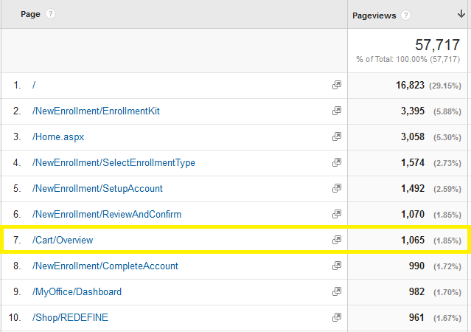

Less than 1% of the requests are adhoc:

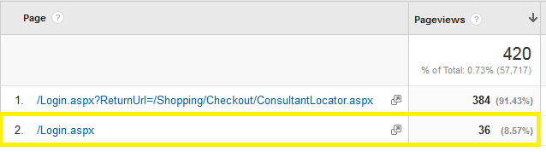

Remaining ~90% of the requests are browsing:

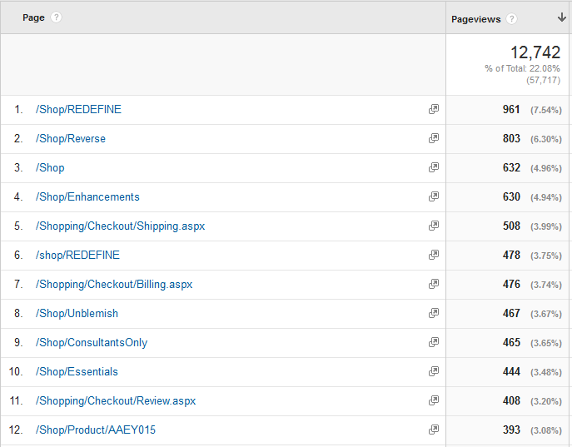

Considering 300 concurrency and the above percentage of requests, the actual breakup of requests would be:

|  |  |  |
| --- | --- | --- |
| PWS .biz (300 Concurrency) | | |
|  | **% Distribution** | **Distributed Concurrency** |
| Enrollment | 6% | 50 |
| PC/RC | 2% | 6 |
| Browsing | 90% | 244 |
| Adhoc | 1% | 3 |

PWS .com

Total number of sessions on a non-busy day are ~32000. On a busy day like 30th/31st of the month, the total number of sessions are almost ~2 times ~60000

On 5th of July

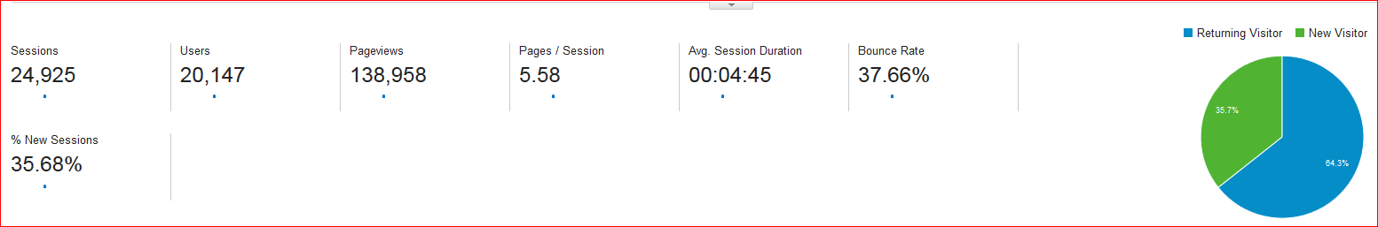

On 31st of July

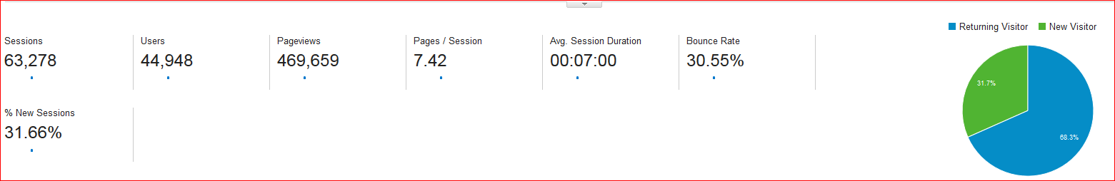

The real time active users on a non-busy day are ~400. On 30th of the month the concurrency expected would be 3 times i.e. ~1260 active users

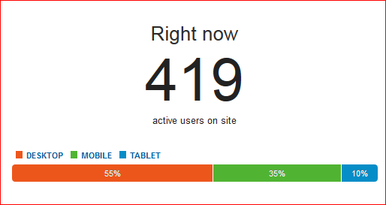

Out of the total page hits on a day, ~2% of the requests are PC/RC:

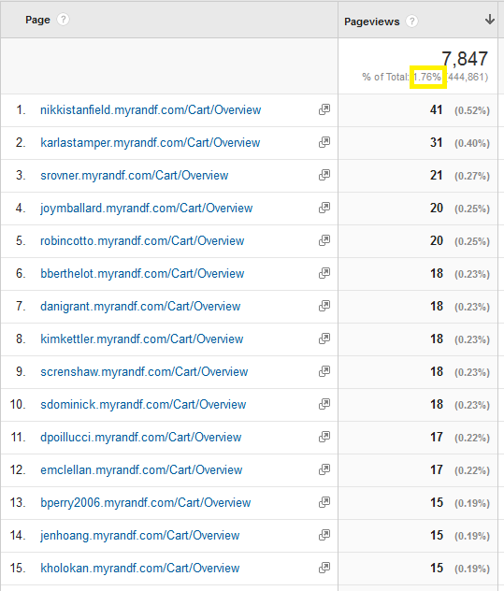

98% of the requests are browsing:

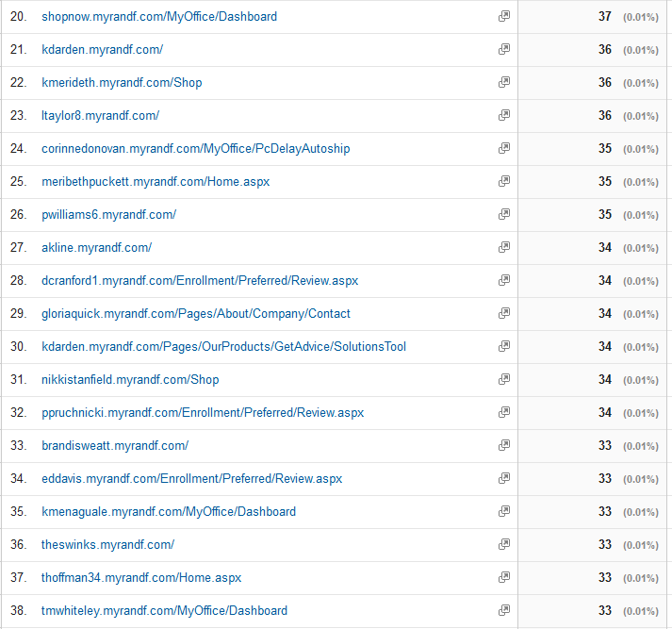

There are no enrollments happening on the .com site.

Considering 1200 concurrency and the above percentage of requests, the actual breakup of requests would be:

|  |  |  |
| --- | --- | --- |
| PWS .com (1260 Concurrency) | | |
|  | **% Distribution** | **Distributed Concurrency** |
| PC/RC + Adhoc | 8% | 96 |
| Browsing | 92% | 1104 |

Corporate Site

Total number of sessions on a non-busy day are ~32000. On a busy day like 30th/31st of the month, the total number of sessions are almost ~2 times ~60000

On 4th of July

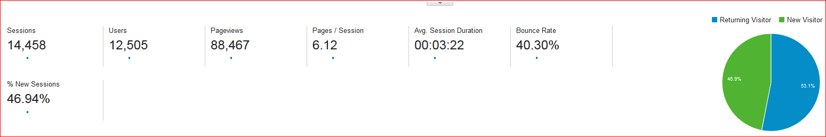

On 31st of July

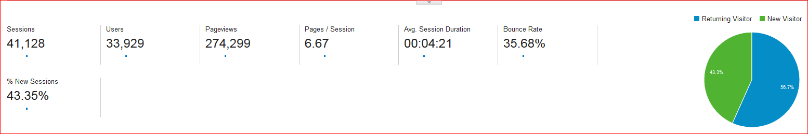

The real time active users on a non-busy day are ~350. On 30th of the month the concurrency expected would be 3 times i.e. ~1050 active users

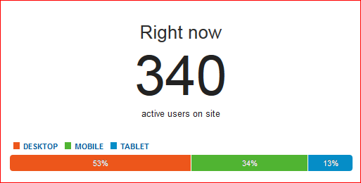

Out of the total page hits on a day, ~4% of the requests are PC/RC:

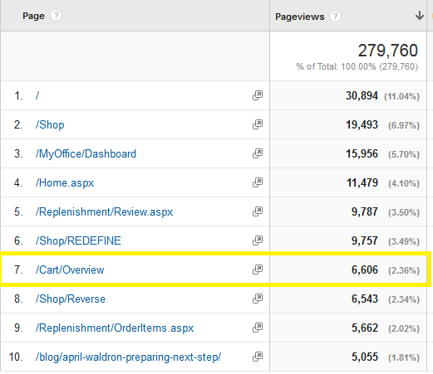

1% of the requests are adhoc:

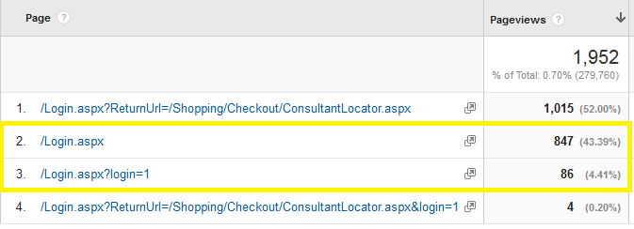

4% requests are search:

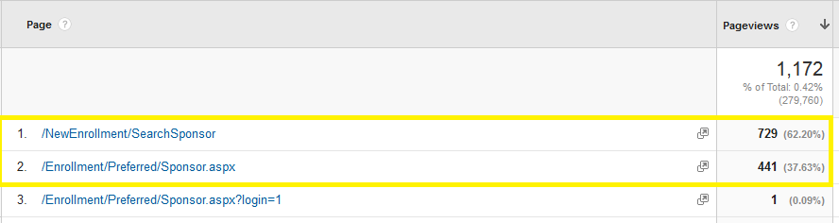

1% requests are enrollment:

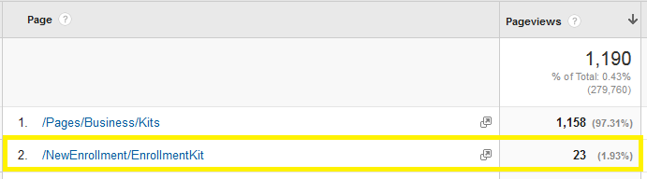

90% requests are browsing:

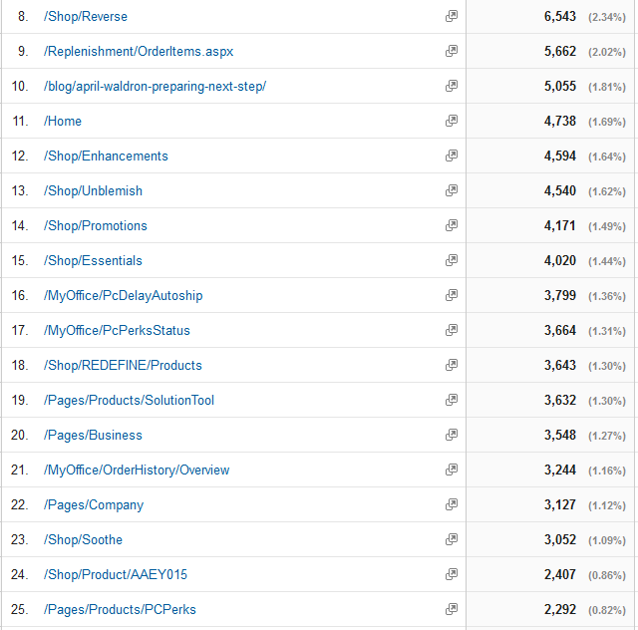

Considering 1050 concurrency and the above percentage of requests, the actual breakup of requests would be:

|  |  |  |
| --- | --- | --- |
| Corporate Site (1050 Concurrency) | | |
|  | **% Distribution** | **Distributed Concurrency** |
| PC/RC | 4% | 42 |
| Adhoc | 1% | 11 |
| Sponsor Search | 4% | 42 |
| Enrollment | 1% | 11 |
| Browsing | 90% | 945 |

We would testing with below concurrencies:

US traffic + 5% (considering Canada)

|  |  |  |  |
| --- | --- | --- | --- |
| 50% more concurrency | | | |
| Site | **Traffic Pattern** | **% Distribution** | **Distributed Concurrency** |
| PWS .biz | Enrollment | 6% | 53 |
| (300 concurrency) | PC/RC | 2% | 7 |
|  | Browsing | 90% | 257 |
|  | Adhoc | 1% | 4 |
| PWS .com | PC/RC + Adhoc | 8% | 100 |
| (1260 concurrency) | Browsing | 92% | 1160 |
| Corporate site | PC/RC | 4% | 44 |
| (1050 concurrency) | Adhoc | 1% | 12 |
|  | Sponsor Search | 4% | 44 |
|  | Enrollment | 1% | 12 |
|  | Browsing | 90% | 993 |

US traffic + 10%

|  |  |  |  |
| --- | --- | --- | --- |
| 50% more concurrency | | | |
| Site | **Traffic Pattern** | **% Distribution** | **Distributed Concurrency** |
| PWS .biz | Enrollment | 6% | 55 |
| (300 concurrency) | PC/RC | 2% | 8 |
|  | Browsing | 90% | 269 |
|  | Adhoc | 1% | 5 |
| PWS .com | PC/RC + Adhoc | 8% | 106 |
| (1260 concurrency) | Browsing | 92% | 1215 |
| Corporate site | PC/RC | 4% | 46 |
| (1050 concurrency) | Adhoc | 1% | 13 |
|  | Sponsor Search | 4% | 46 |
|  | Enrollment | 1% | 13 |
|  | Browsing | 90% | 1040 |

US traffic + 50%:

|  |  |  |  |
| --- | --- | --- | --- |
| 50% more concurrency | | | |
| Site | **Traffic Pattern** | **% Distribution** | **Distributed Concurrency** |
| PWS .biz | Enrollment | 6% | 75 |
| (300 concurrency) | PC/RC | 2% | 9 |
|  | Browsing | 90% | 366 |
|  | Adhoc | 1% | 5 |
| PWS .com | PC/RC + Adhoc | 8% | 144 |
| (1260 concurrency) | Browsing | 92% | 1656 |
| Corporate site | PC/RC | 4% | 63 |
| (1050 concurrency) | Adhoc | 1% | 17 |
|  | Sponsor Search | 4% | 63 |
|  | Enrollment | 1% | 17 |
|  | Browsing | 90% | 1418 |

Total concurrency at US traffic + 50% is:

|  |  |
| --- | --- |
| Traffic Pattern | Total concurrency |
| Enrollment | 92 |
| PC/RC | 216 |
| Adhoc | 22 |
| Sponsor Search | 63 |
| Browsing | 3440 |
|  | **3833** |

Peak Sessions

PWS .biz

On a peak day like 31st August, there were ~2400 sessions and ~2600 users on the system at 6pm. The average session duration time is ~6 minutes.

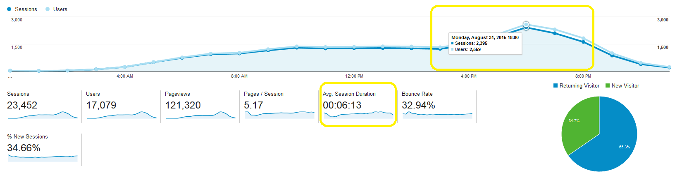

PWS .com

On a peak day like 31st August, there were ~7200 sessions and ~8000 users on the system at 6pm. The average session duration time is ~7 minutes.

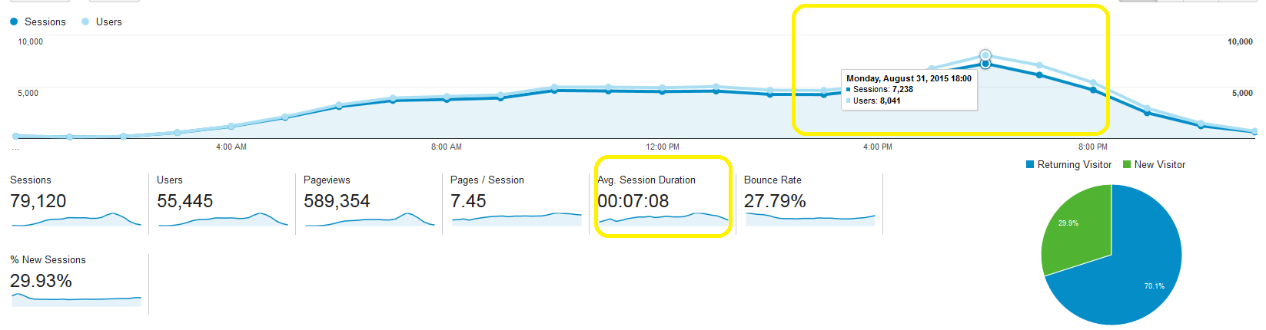

Corporate

On a peak day like 31st August, there were ~4500 sessions and ~5000 users on the system at 7pm. The average session duration time is ~4 minutes

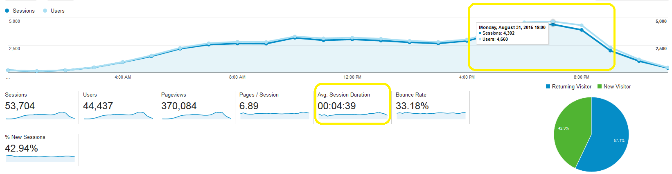

Jan 31:

.biz:

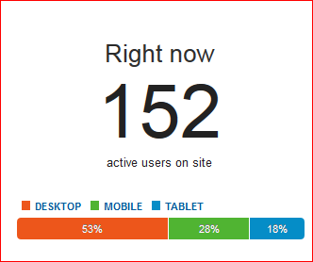

.com:

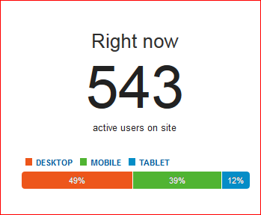

Corporate:

