ad_low_noise_float_2023 instructions (v0.3, v0.4)

ADC as a digitizer for counting experiments. Example: compact_2012, IV_2015 for sensing dot, IV output to AD converter.
Delta-Sigma analog-to-digital converter ADS127L21: Low noise ADC, low noise internal voltage reference.

The ad_low_noise_fload_2023 provides a wide dynamic range. With an input range of ±2.5 V, the ADC noise is negligible compared to the noise of typical I/V converters or voltage amplifiers.
In contrast, low-range ADCs often require techniques such as offset removal or gain adjustment to minimize noise impact.
Additional advantages include an integrated low-pass filter for aliasing suppression and built-in galvanic isolation to prevent ground loops.

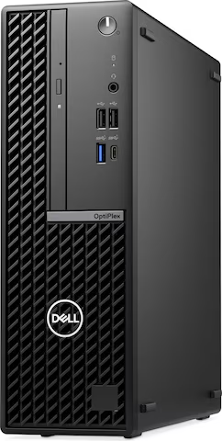
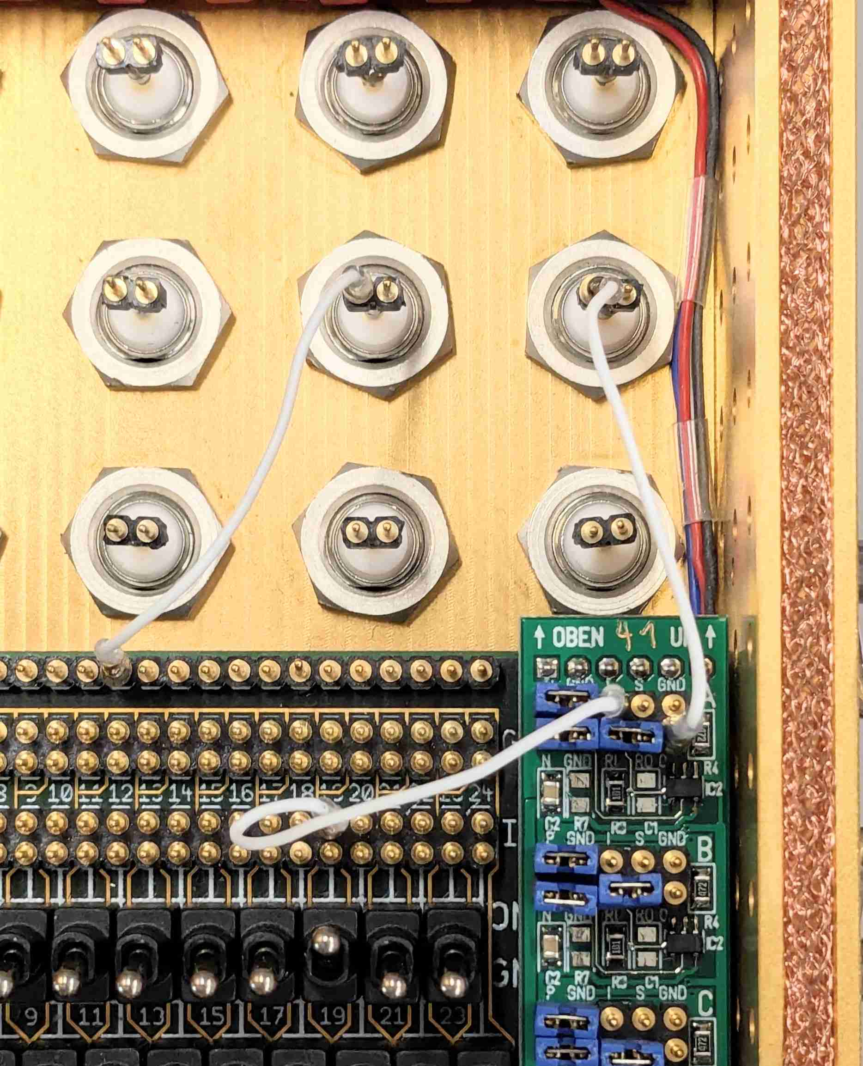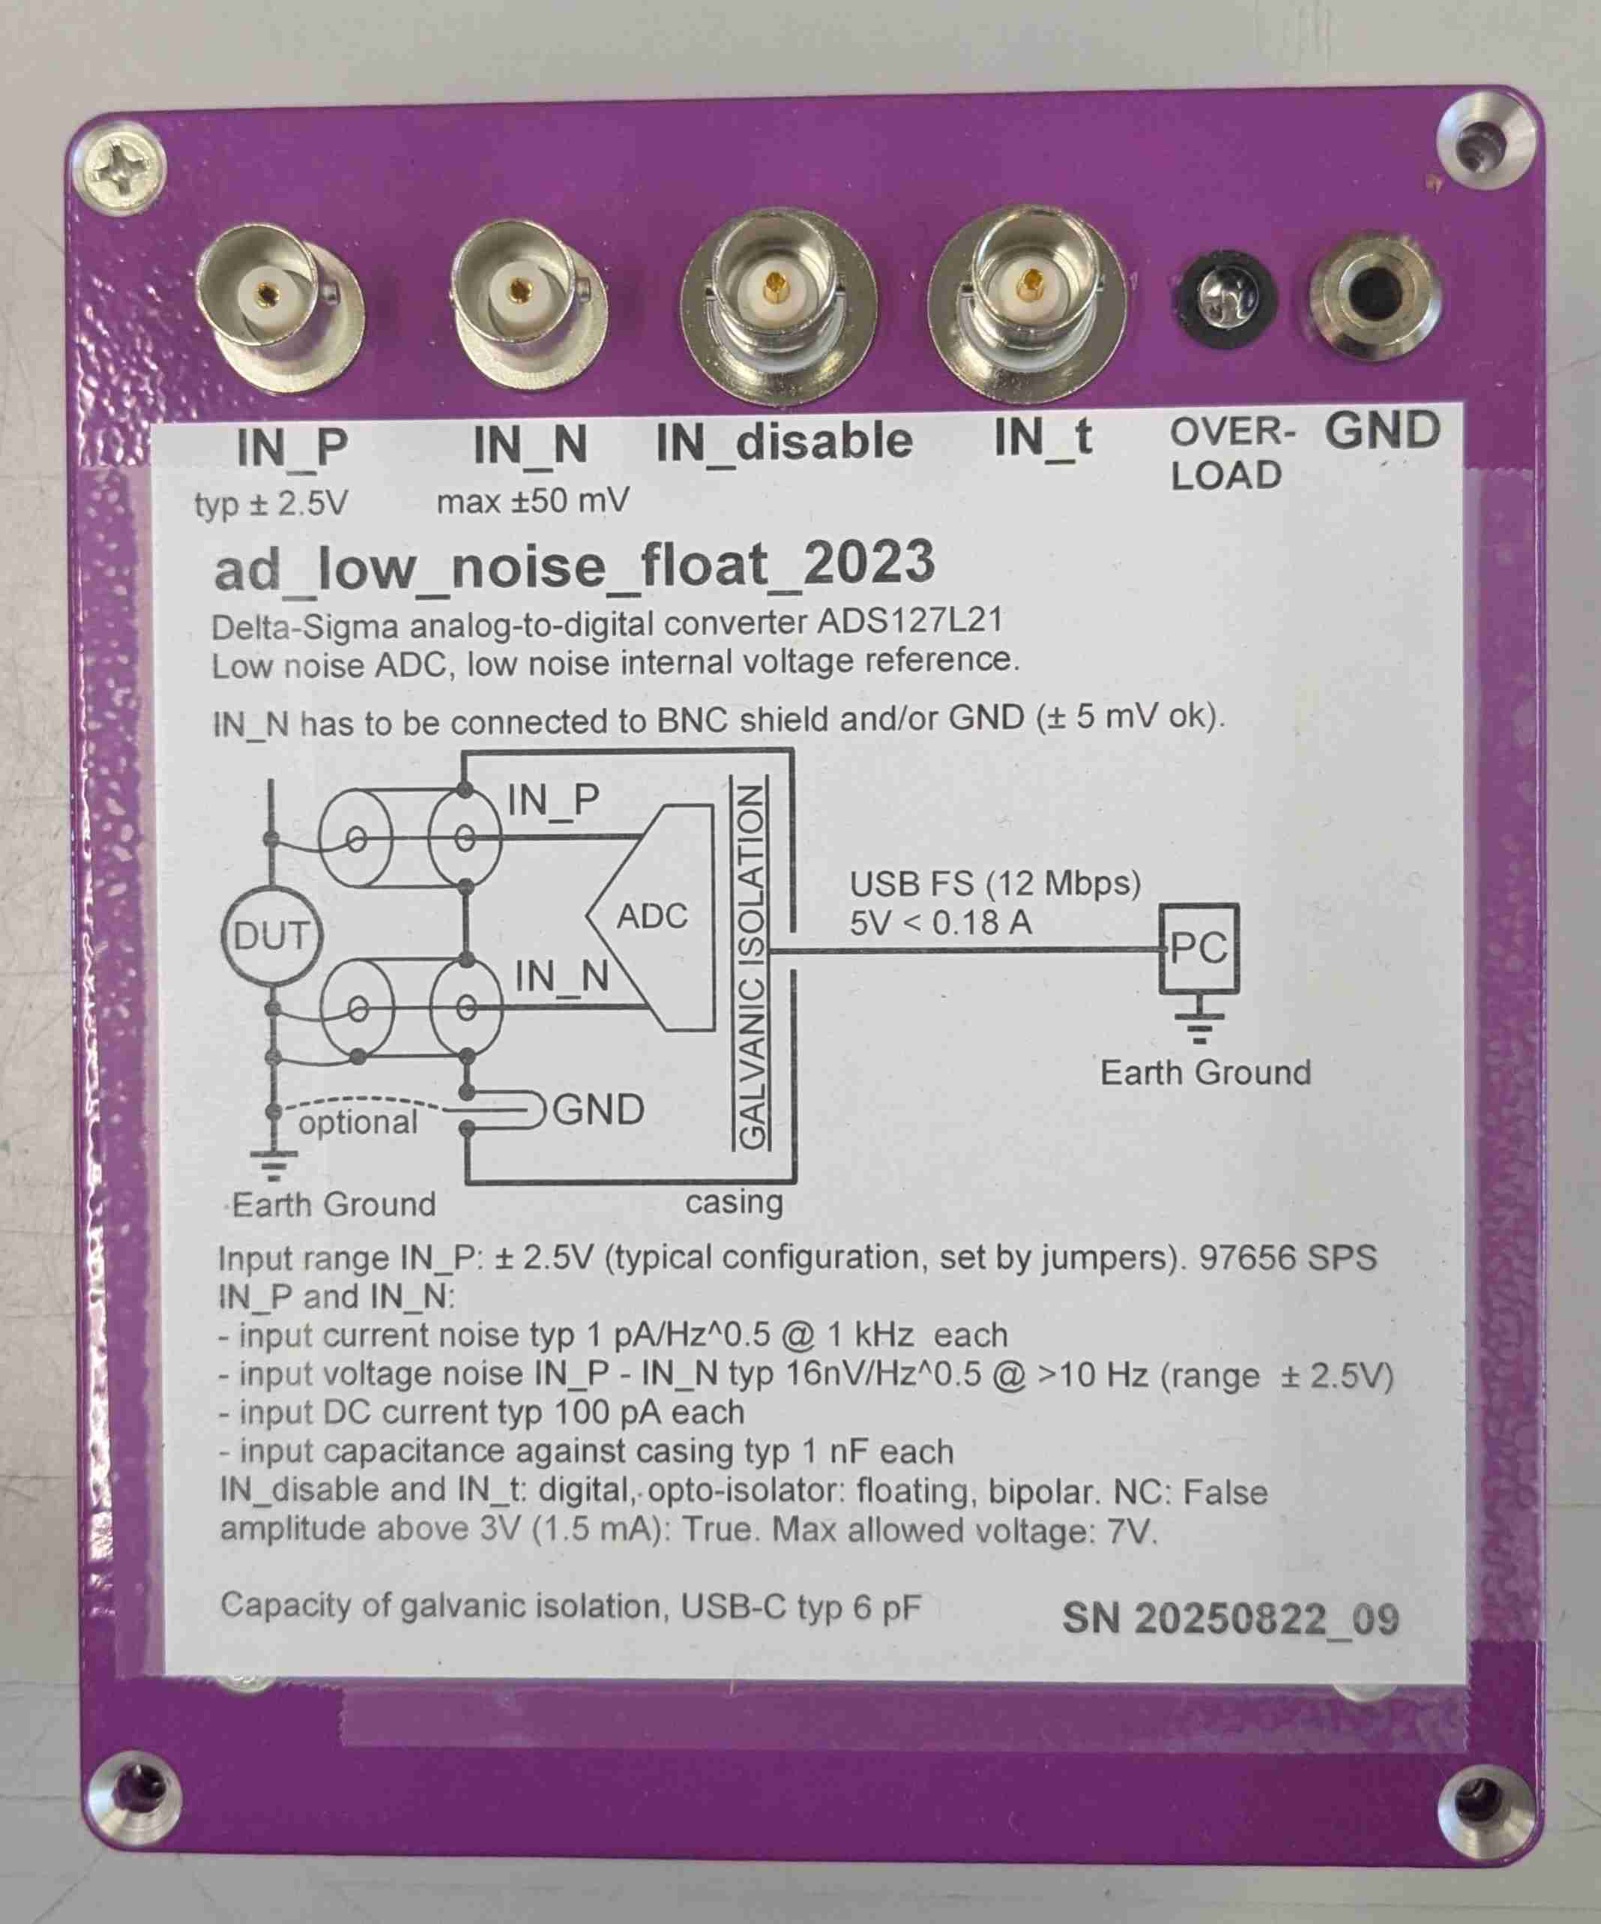
USB
GND
twist bnc cables
IV-
converter
out
Labber
AWG
optional
0V / 5V

- Input range IN_P: ± 2.5V (typical configuration, set by jumpers).
- Sampling rate up to 97656 SPS
- IN_P and IN_N: differential inputs. IN_N tied to GND in compact.
- Its possible to record one analog signal and one digital signal : IN_t, optional. Its possible to stop recording by usind IN_disable: optional.
- input current noise typ 1 pA/Hz^0.5 @ 1 kHz each
- input voltage noise IN_P - IN_N typ 16nV/Hz^0.5 @ >10 Hz (range ± 2.5V)
- input DC current typ 100 pA each
- input capacitance against casing typ 1 nF each
- IN_disable and IN_t: digital, opto-isolator: floating, bipolar. NC: False
- amplitude above 3V (1.5 mA): True. Max allowed voltage: 7V.
- Capacity of galvanic isolation, USB-C typ 6 pF
- USB 2.0 full speed, 12 Mbit/s. Cable lengths of up to 5 m ok.

For the Labber driver, see https://github.com/nanophysics/labber_ad_low_noise_float_2023

Two versions
Except for the two BNC connectors, the firmware and hardware are identical.

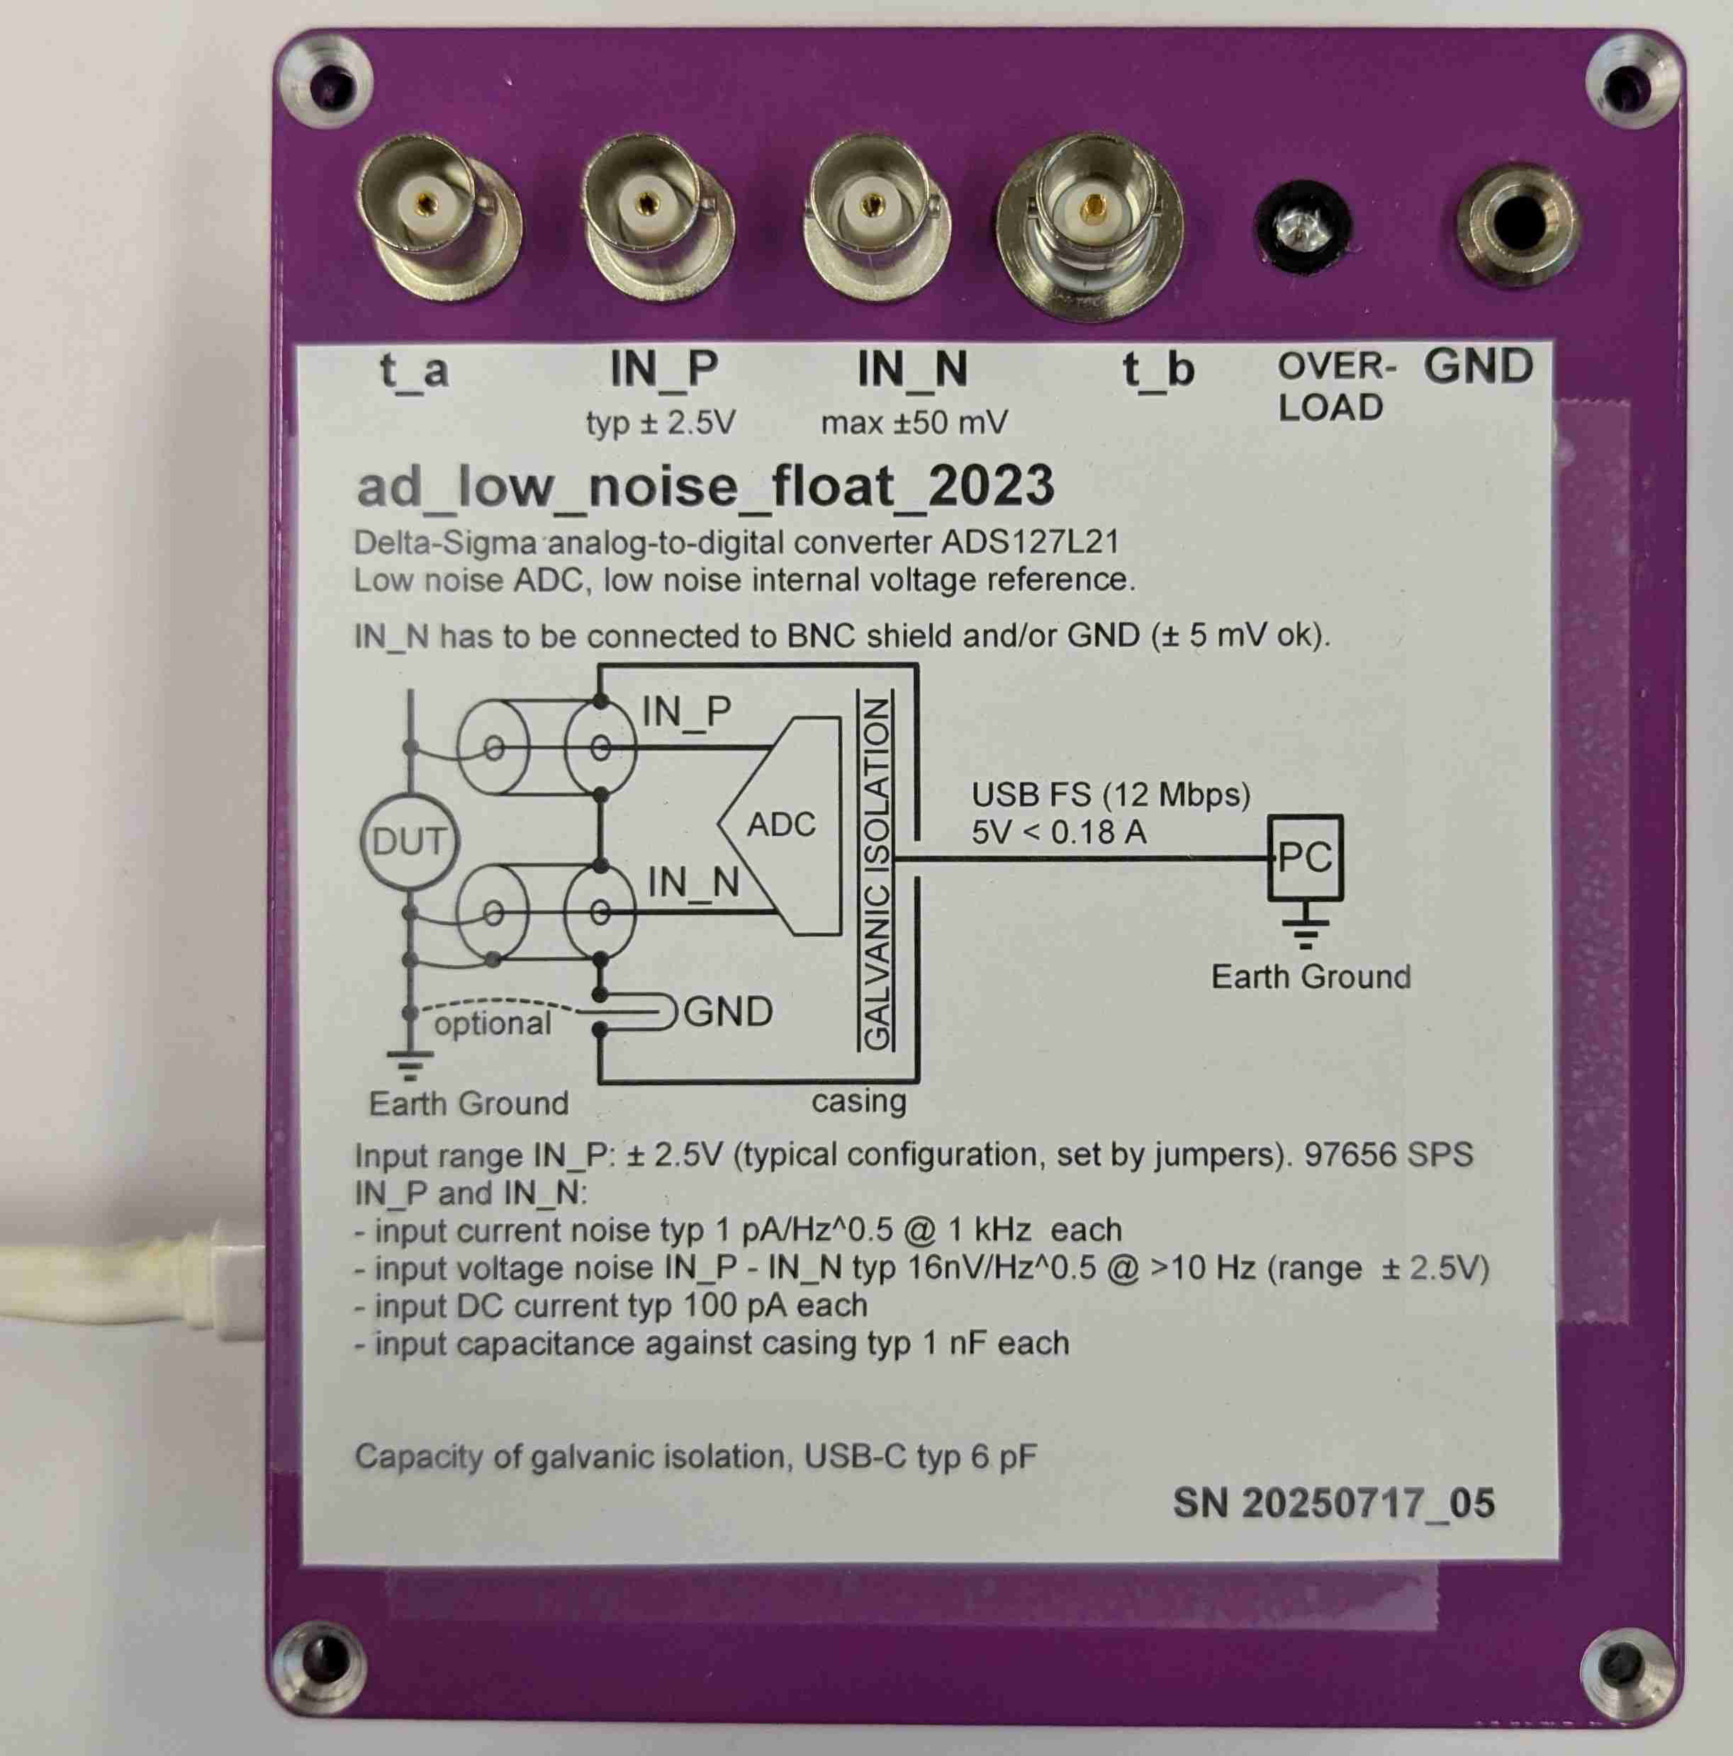

Digitizer for counting experiments. General noise measurements.
Working with Labber. Working with pymeas2019_noise.
22 bit resolution. 24 bit resolution.
Two inputs for digital signals. Two general analog inputs, t_a, t_b,
to be connected inside the box.

Detailed Information – For Interested Readers Only

How to operate
Connection to DUT (Device Under Test)
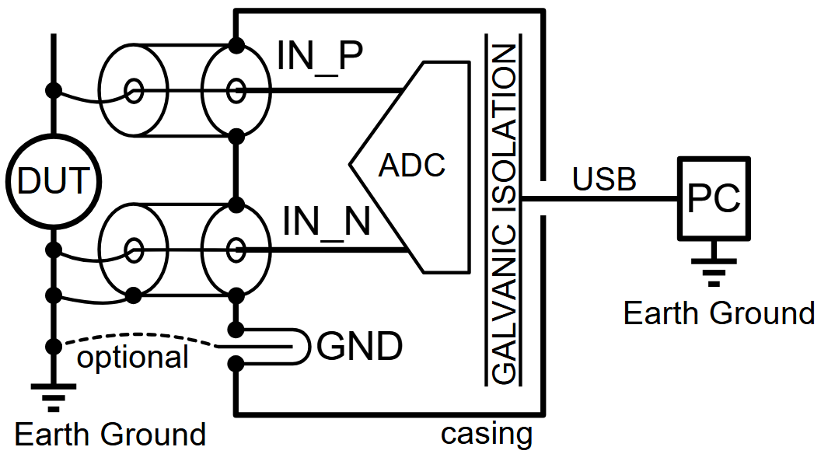
IN_N BNC inner conductor is used to sense the GND of the DUT.
IN_N BNC shield is used to carry GND currents to the DUT earth gnd.
IN_P BNC inner conductor is used to measure the DUT.
IN_P BNC shield can be left floating or can be tied to DUT earth gnd.
4mm GND: can optionally be used to decrease impedance of this connection.

Ground currents from the PC or DC-DC converter can return via the DUT’s earth ground without introducing a voltage drop at the IN_N input.

Gain 1 (special, not used typically)
Input voltage range of each input: 0...5 V against GND.
Input current: up to 600 uA. See ADS127L21 “Input Currend vs Differential Voltage, Precharge buffers off”.

J2 J5 J10 J11 J12 J13 J14 J20 J21 J30 J42 J43 J44 J45 J46 J50 J51
X X
Connect your signal directly to this pins of J11 and J12.
Symmetrical signals:
+FS: red +2.5V against casing, blue -2.5V against casing.
-FS: red -2.5V against casing, blue +2.5V against casing.
Other possibilities J50, J51...
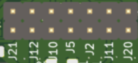

Gain 2
IN_P BNC: input voltage, range ± 2.5V. Input current about 100 pA (ADA4523-1)
IN_N BNC: voltage around 0V. Used to sense the GND of the DUT.

J2 J5 J10 J11 J12 J13 J14 J20 J21 J30 J42 J43 J44 J45 J46 J50 J51
X X X X X

Gain 5
IN_P BNC: input voltage, range ± 1V. Input current about 100 pA (ADA4523-1)
IN_N BNC: voltage around 0V. Used to sense the GND of the DUT.

J2 J5 J10 J11 J12 J13 J14 J20 J21 J30 J42 J43 J44 J45 J46 J50 J51
X X X X X

Gain 10
IN_P BNC: input voltage, range ± 0.5V. Input current about 100 pA (ADA4523-1)
IN_N BNC: voltage around 0V. Used to sense the GND of the DUT.

J2 J5 J10 J11 J12 J13 J14 J20 J21 J30 J42 J43 J44 J45 J46 J50 J51
X X X X X X

Impressions

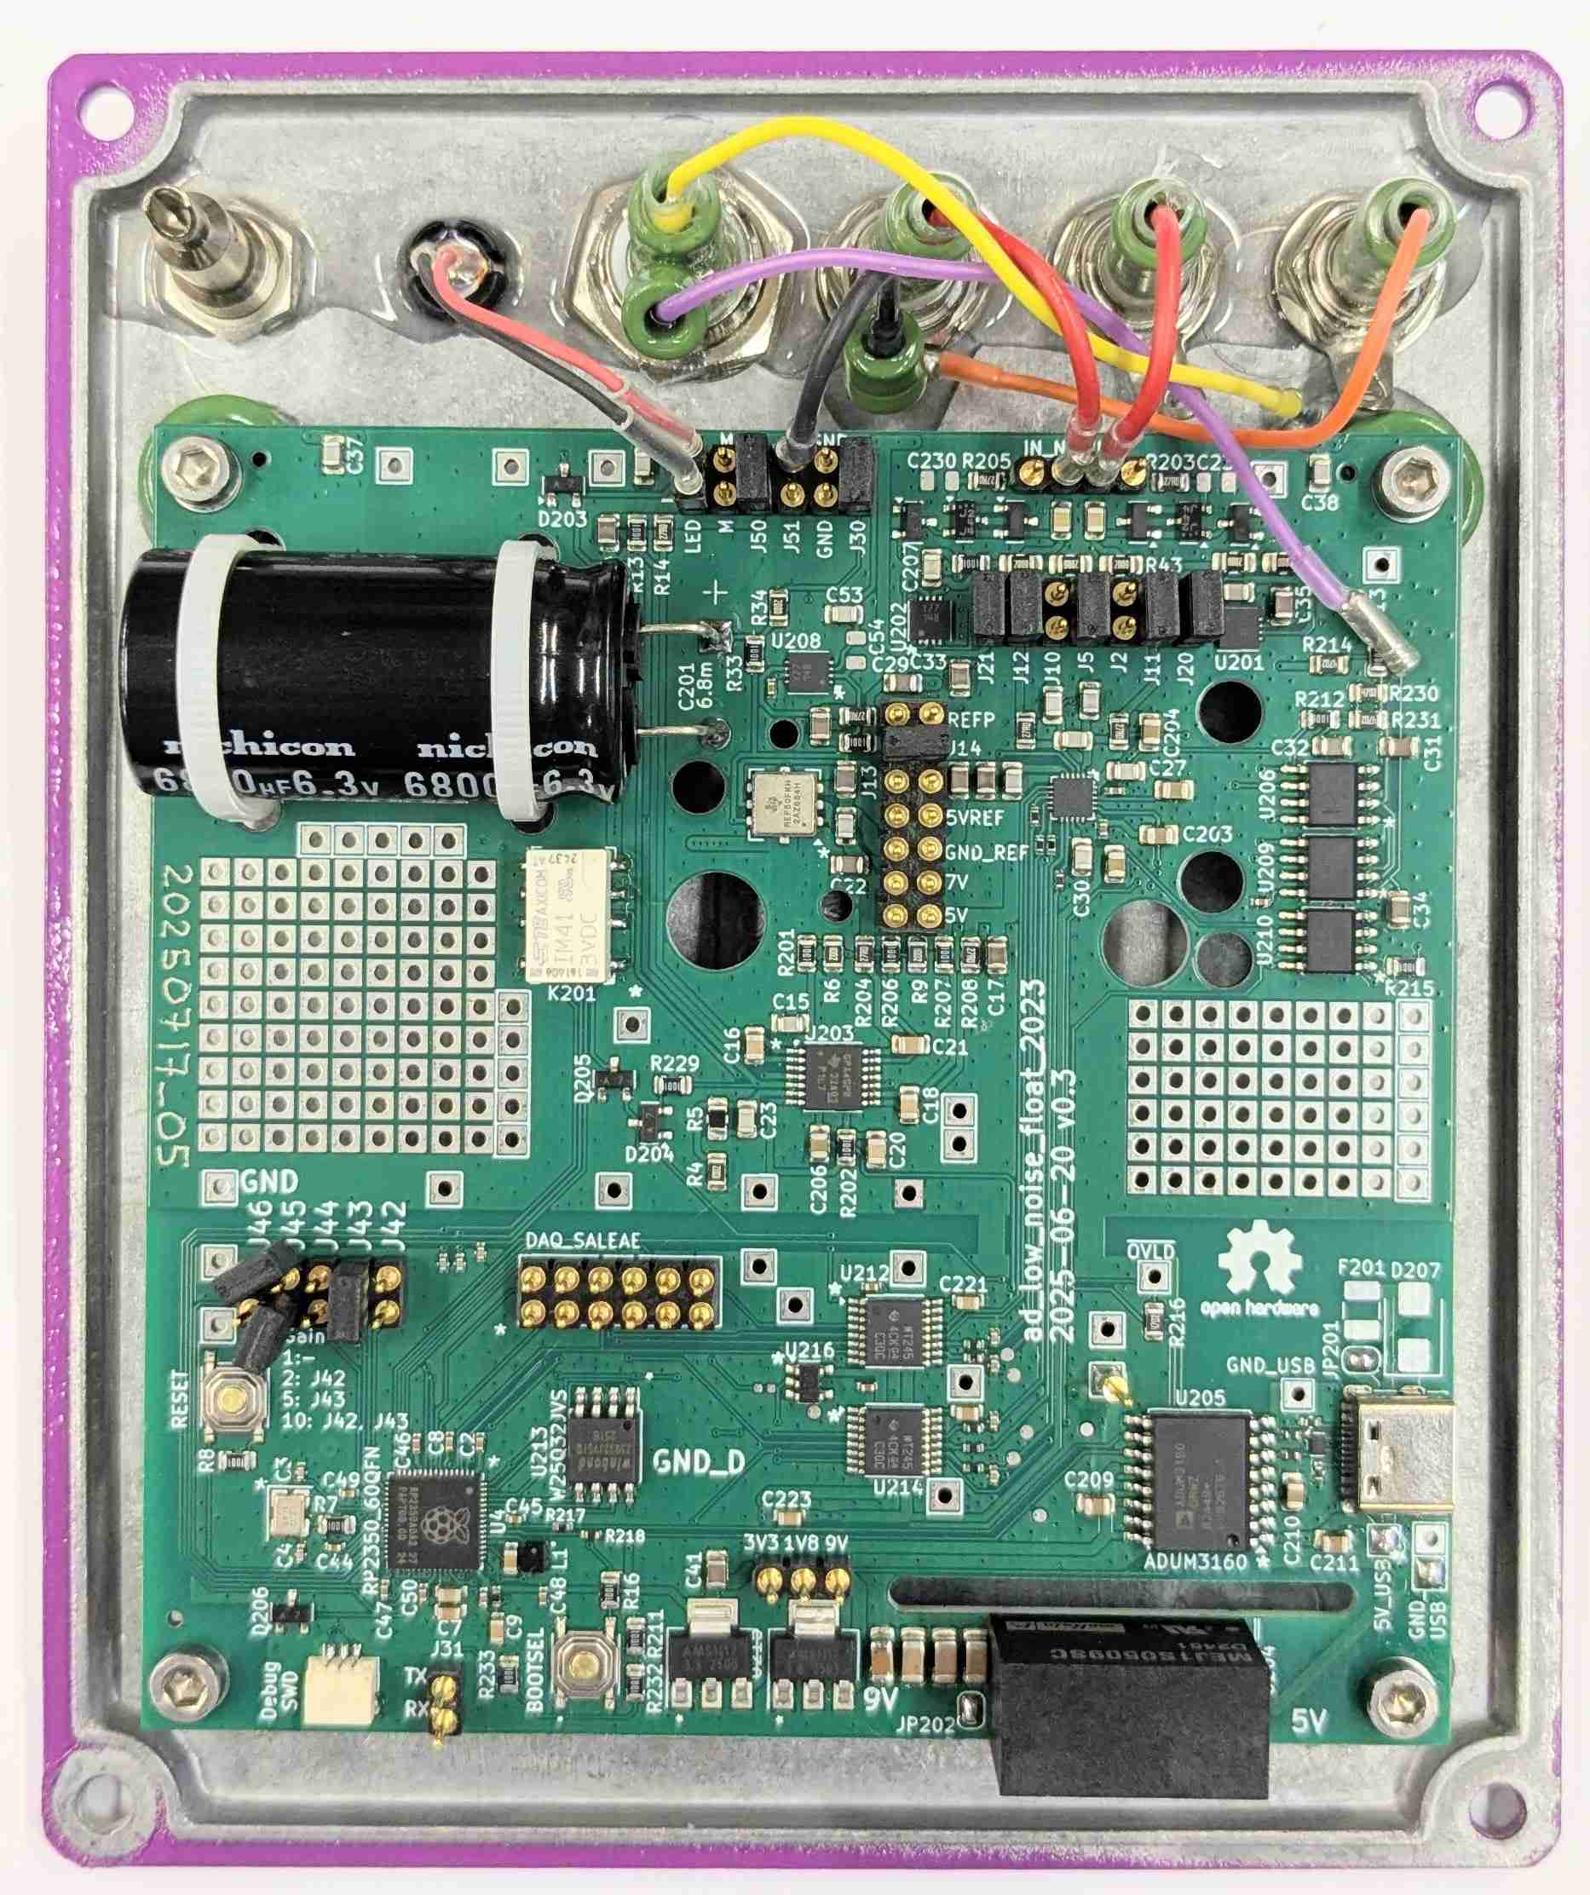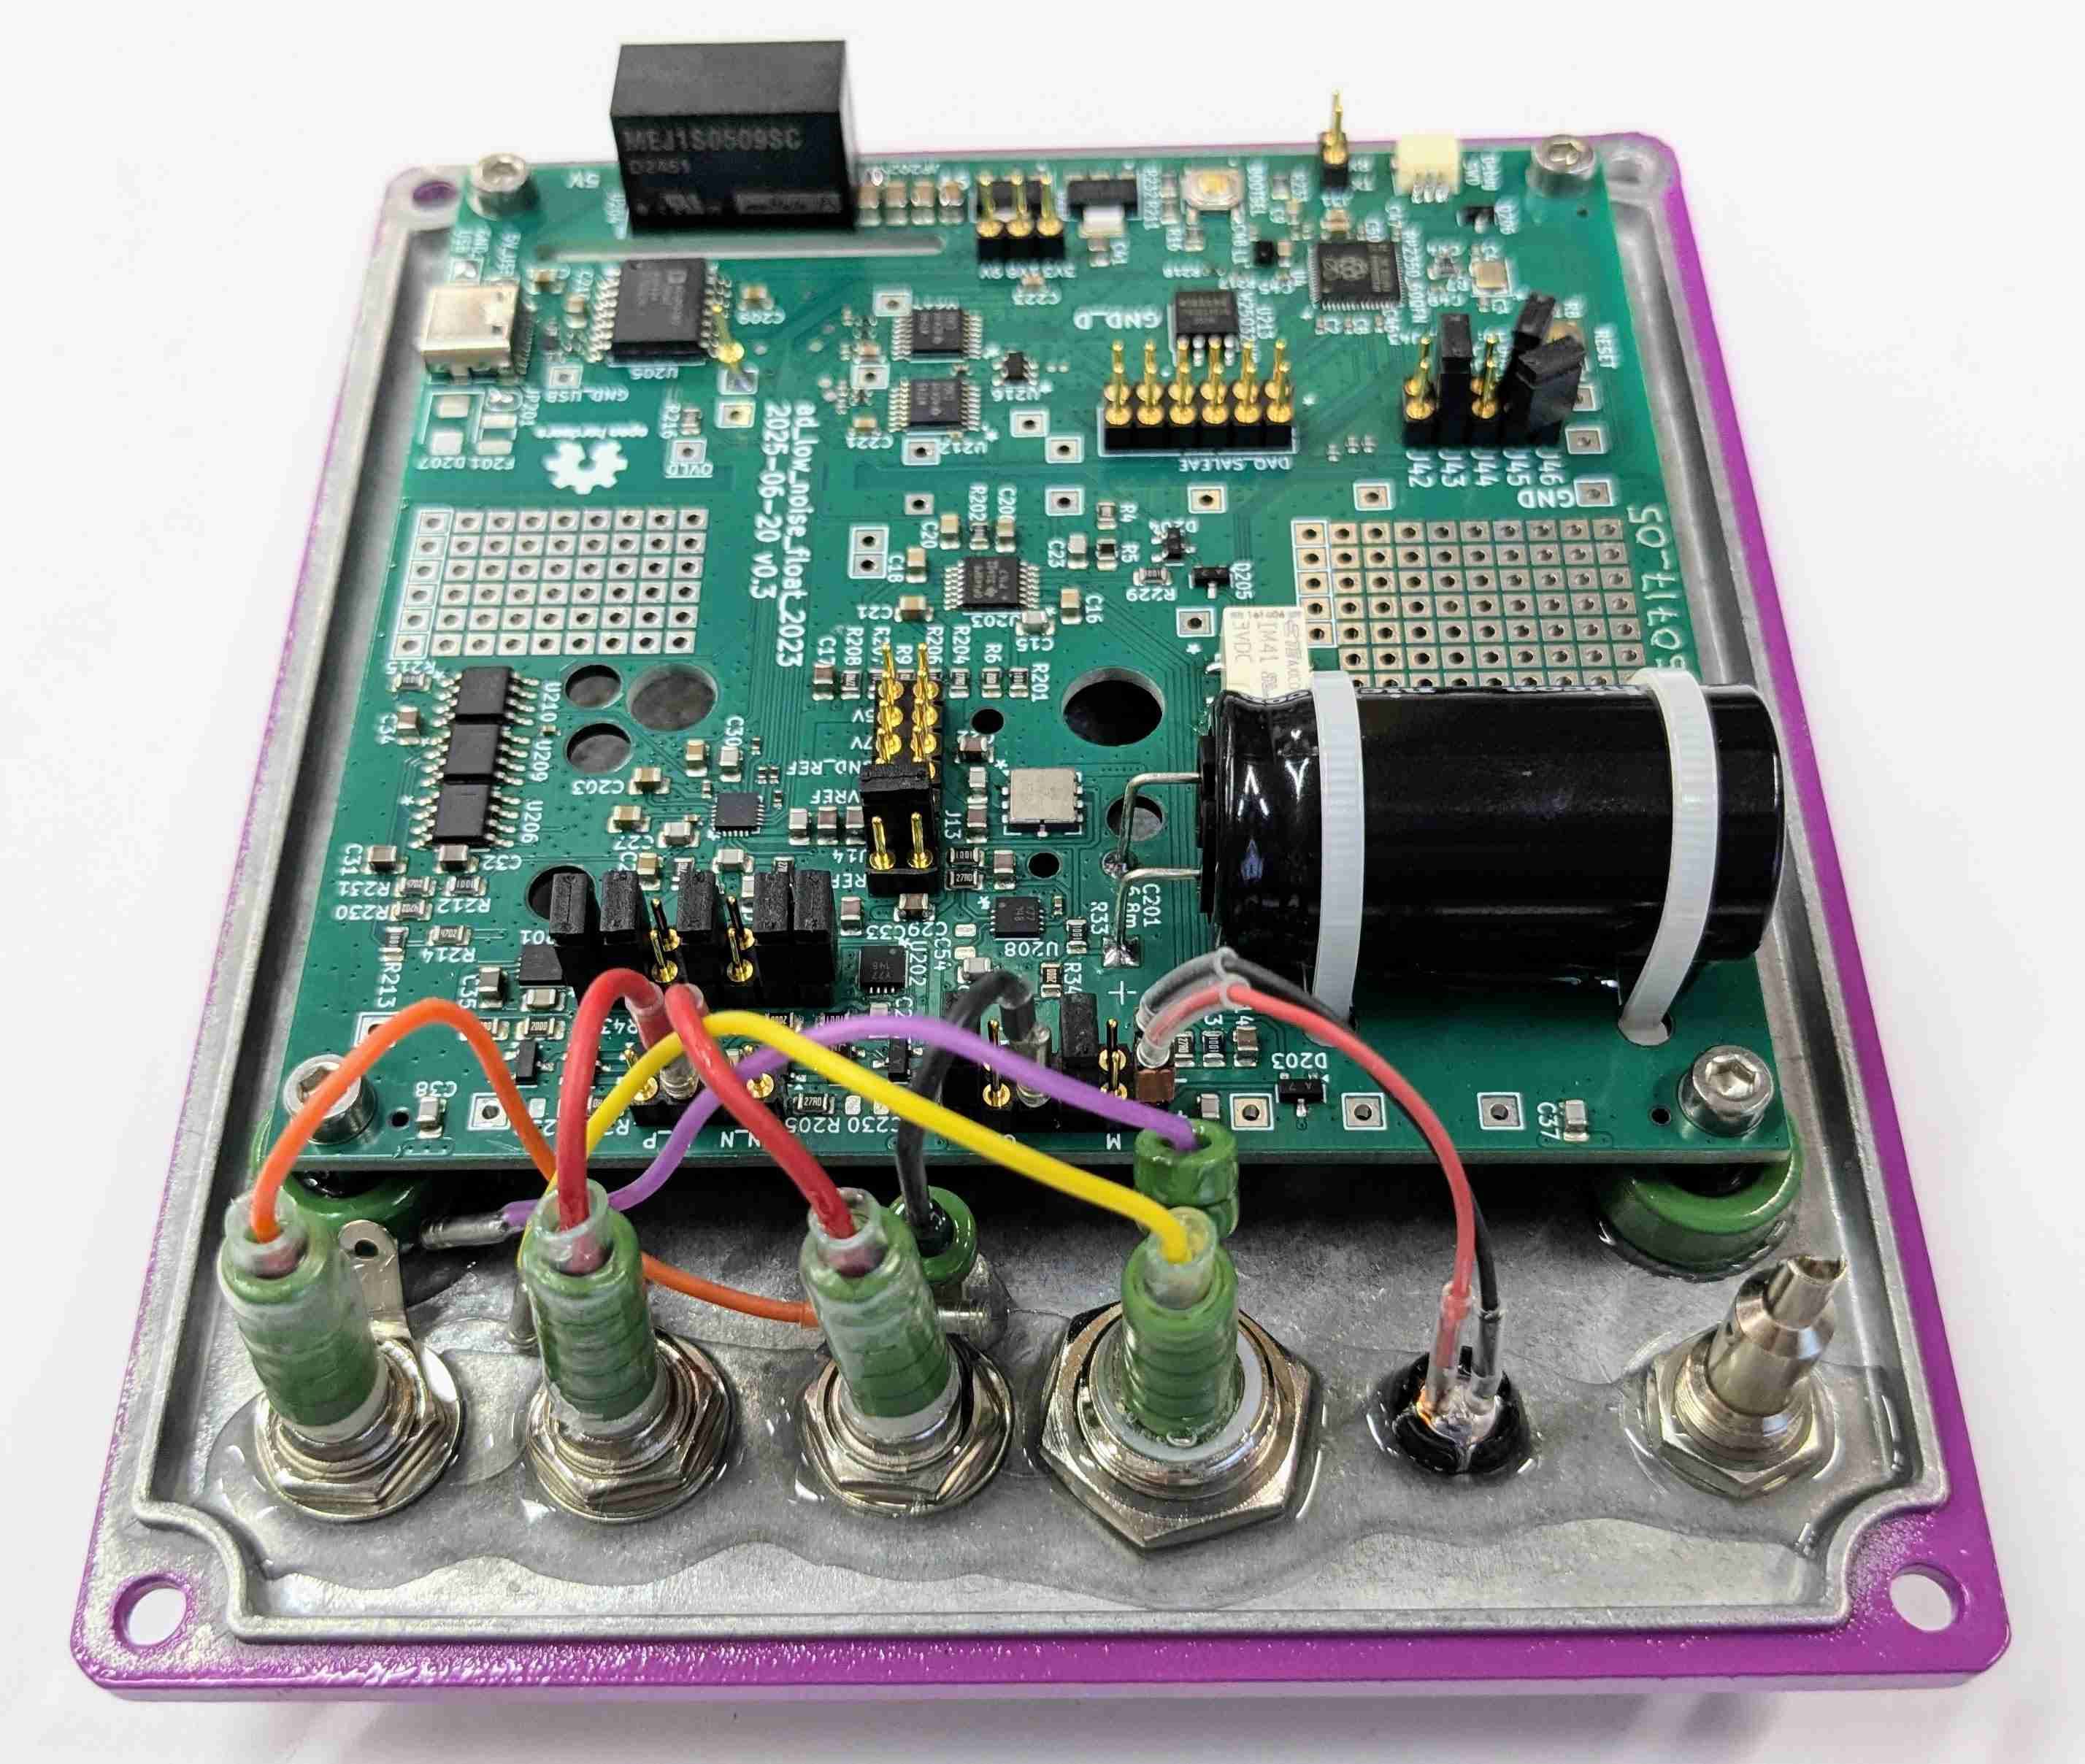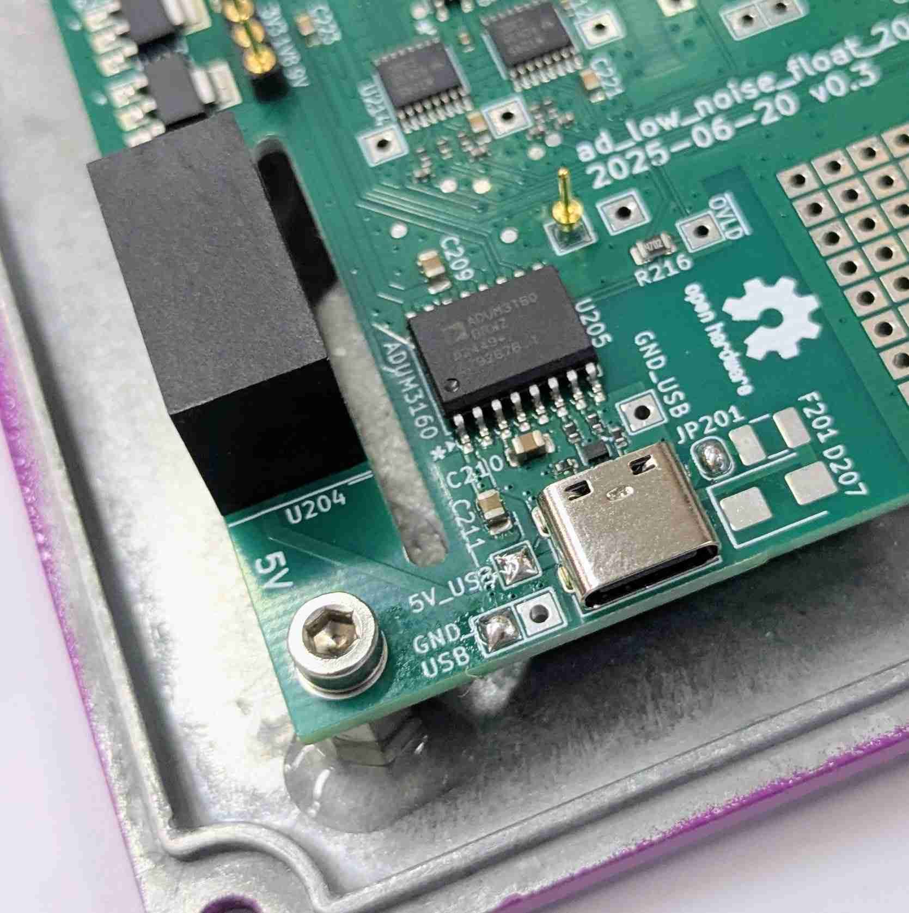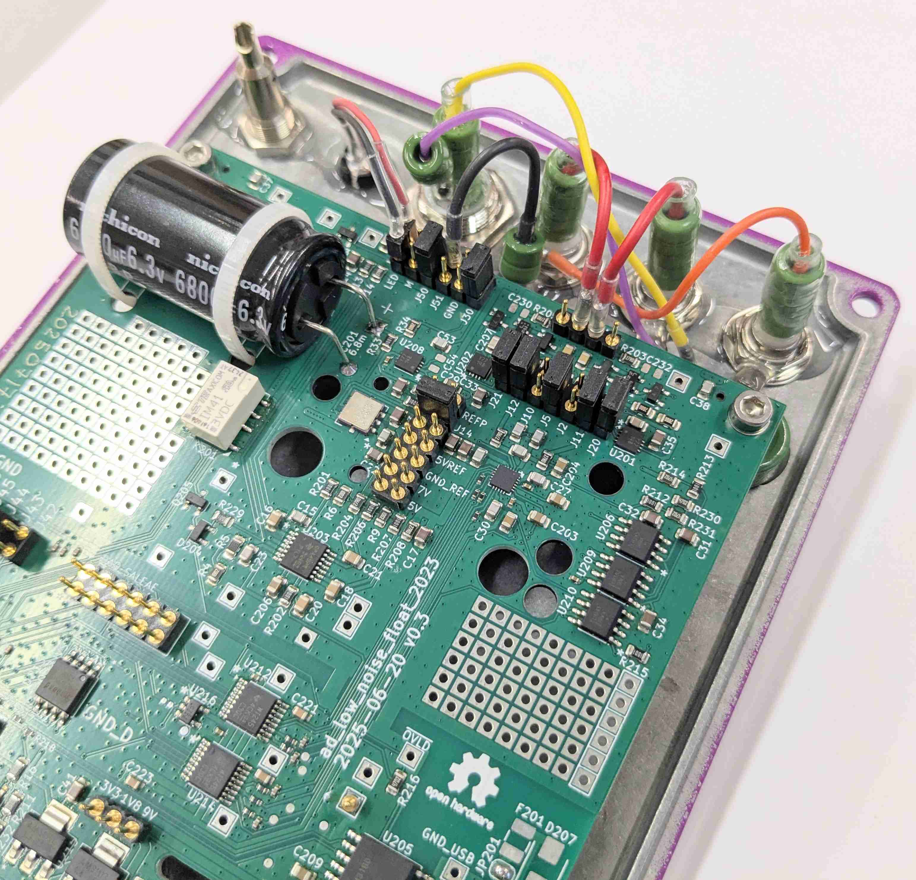
ADS127L21 sigma delta AD converter
galvanic insulation
Power
USB

Reference
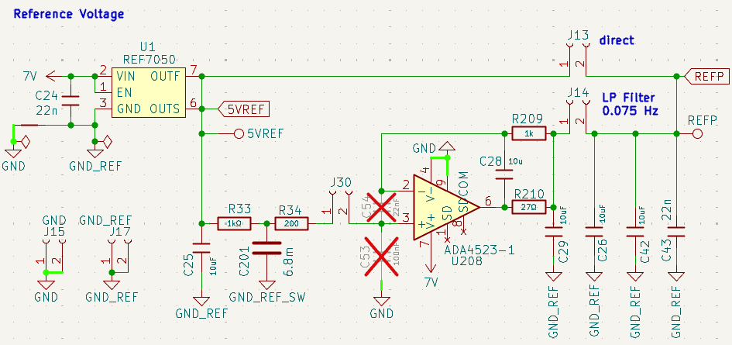
REF7050 is a 5V voltage reference.

J13 closed for unfiltered reference.
J14 closed for low pass filtered reference. Recommended.

A 1 kΩ resistor and a 6.8 mF capacitor form a low-pass filter with a cutoff frequency of approximately 0.023 Hz.
The filter reduces reference voltage noise above fc, but increases noise below fc due to leakage currents in the electrolytic capacitor.
Prolonged charging leads to a reduction in leakage current.

Tip: Connect the USB one week prior to use to allow the capacitor leakage to settle. It works with both a PC connection or a USB power supply.
Short disconnections (up to 1 hour) are not critical – the capacitor will hold its charge.

External reference: you can feed the external voltage reference to J30 pin 2.

Measuring ADC Noise
short_gain_01_in_box
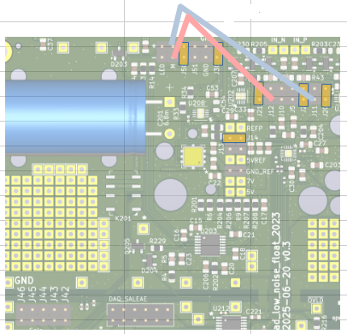
Only ADC, 0V, no preamplifier

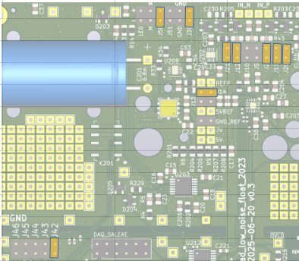
Preamplifier and ADC, 0V, gain 2. Accordingly for gain 5 or 10.

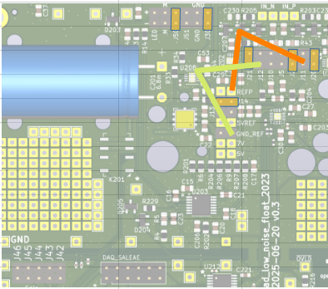
Only ADC, measuring the own reference voltage. The reference-voltage noise gets canceled out.
The input current of ADS127L21 leads to a small voltage drop on R11 and R12. The indicated voltage is therefore 4.975V. This voltage can be converted correctly as it is just within the measurement range.

The ADC provides possibilities to short inside the ADC. See
RegisterMux.NORMAL_INPUT_POLARITY
RegisterMux.INVERTED_INPUT_POLARITY
RegisterMux.OFFSET_AND_NOISE_TEST
RegisterMux.COMMON_MODE_TEST
Prototype v0.3
97656 SPS, wideband filter. Usable bandwith 0 … 39 kHz.
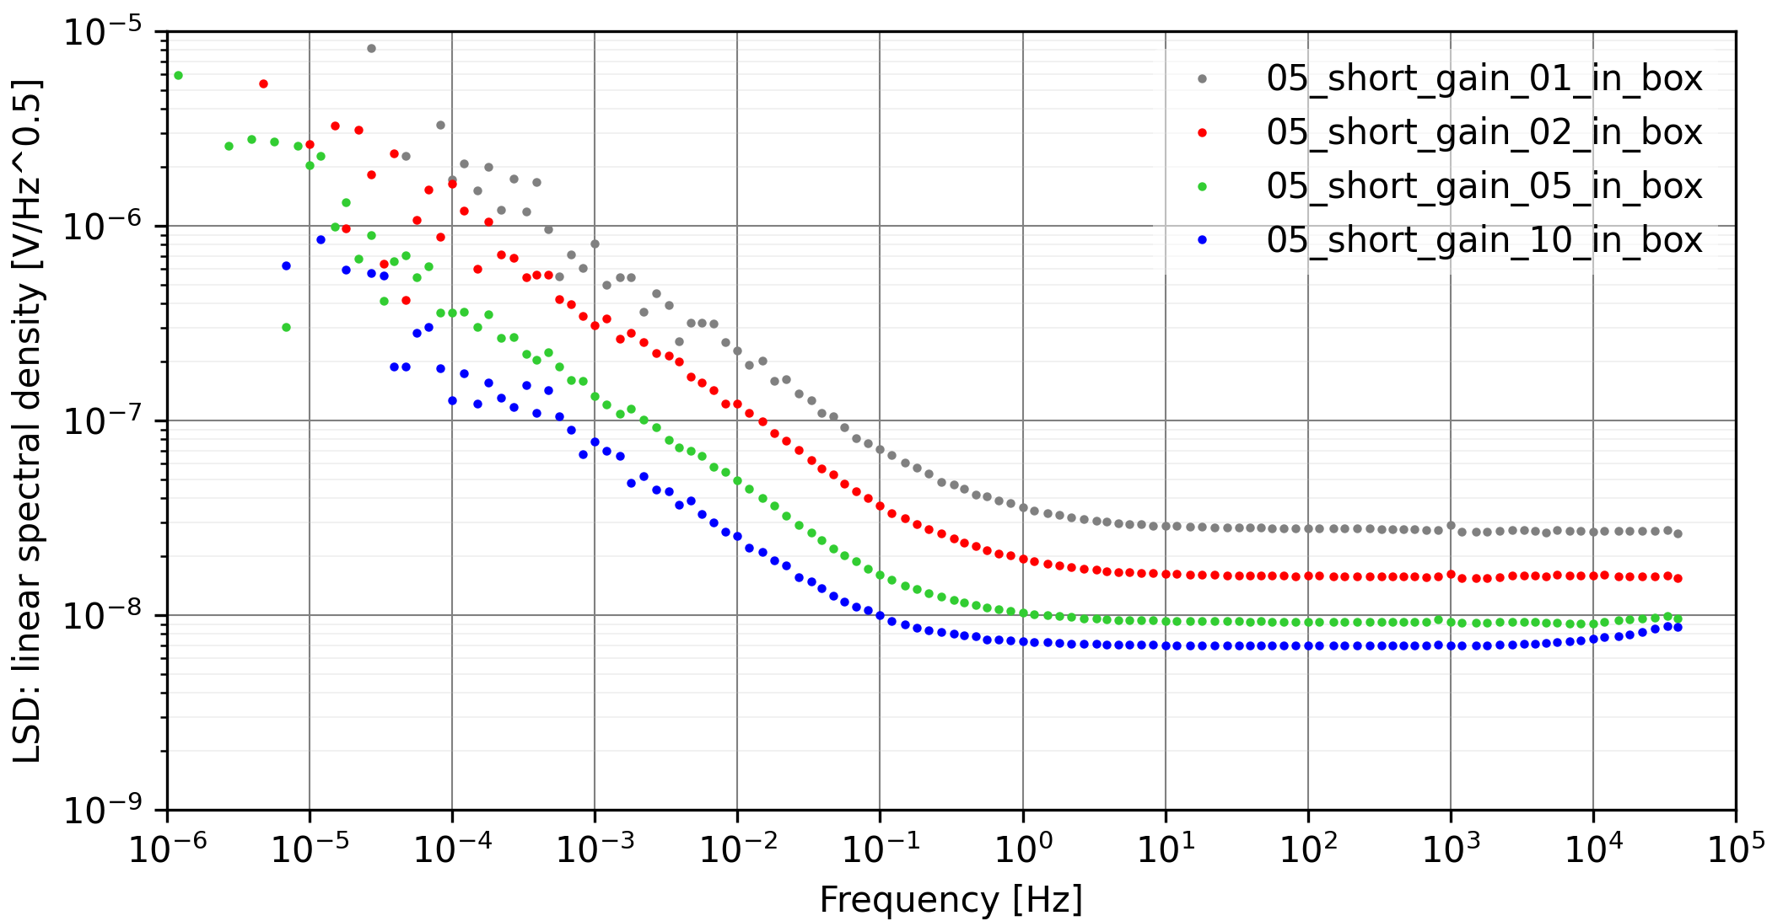
Different gains, shortet with BNC shorts on the metal casing.
At a gain of 10, a small increase above 10 kHz can be observed. This is due to the noise contribution of the operational amplifiers used in the input stage (ADA4523-1).
Red, gain of 2, input range of ±2.5V is typical.

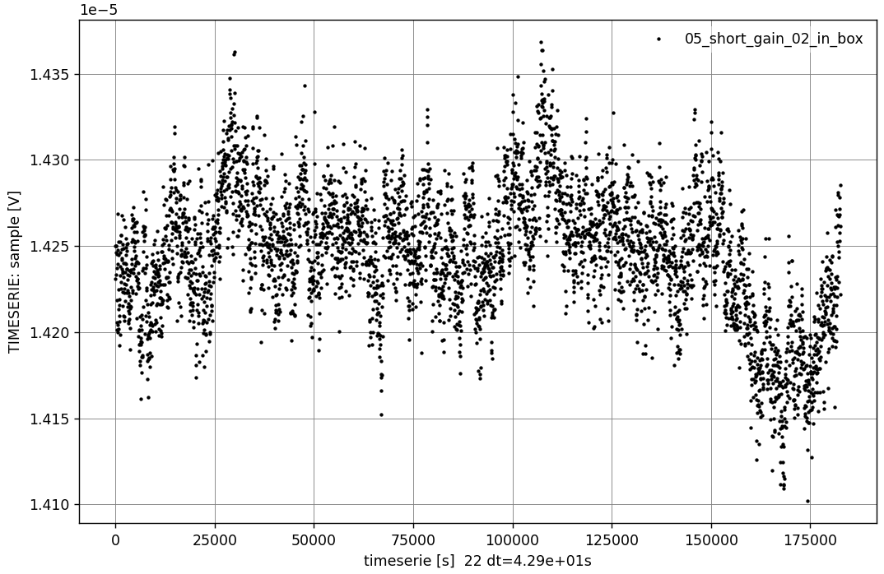

Gain 2, shortet with BNC shorts on the metal casing. 2 days. The voltage remains inside a band of 300 nV.

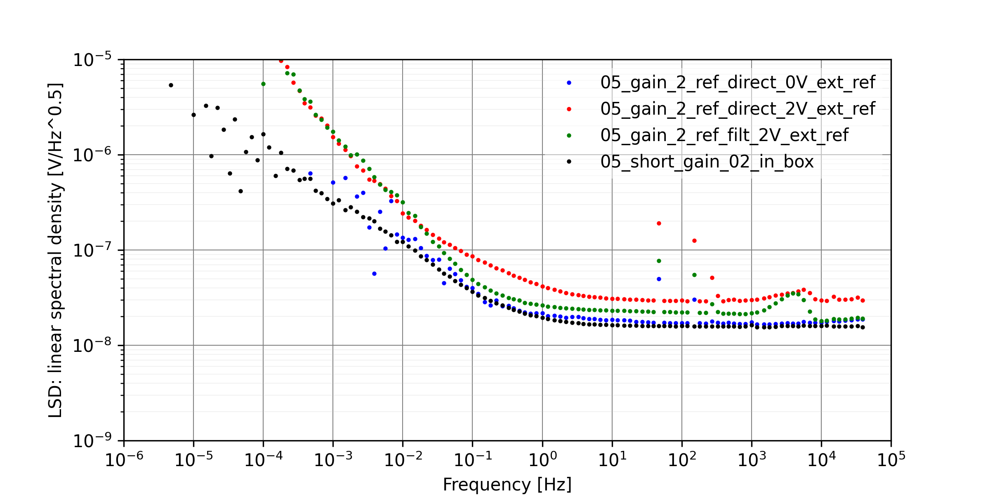

Measurement of external 2V reference. The noise measured is dominated by the noise of the internal voltage reference of the ad_low_noise_float_2023. (The noise of the external 2V reference is much smaller).

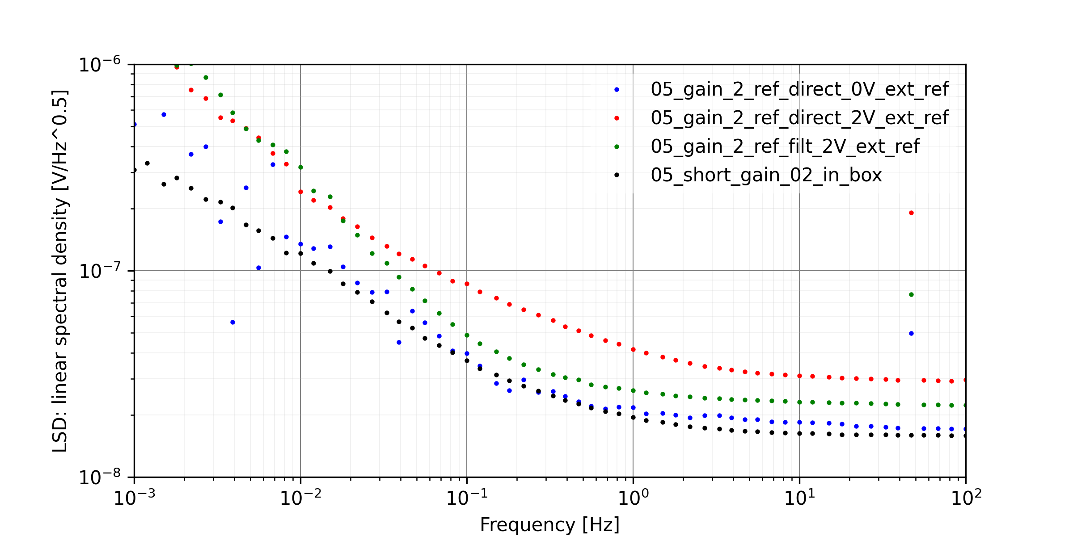

Detail of the last measurement.
- black: short in the box. Noise of AD converter.
- blue: 0V of the external voltage divider.A bit more noise due to the cables (50 Hz peak) and the additional operational amplifiers.
- green: The flicker noise of the voltage reference becomes visible. (The external voltage reference has significantly lower flicker noise and can be neglected.) Above the cutoff frequency of the low-pass filter (around 23 mHz), the noise is also slightly increased. The ADC itself is probably contributing a bit more noise at full scale.
- red: The noise of the voltage reference dominates the noise. (The external voltage reference has significantly lower noise and can be neglected.)

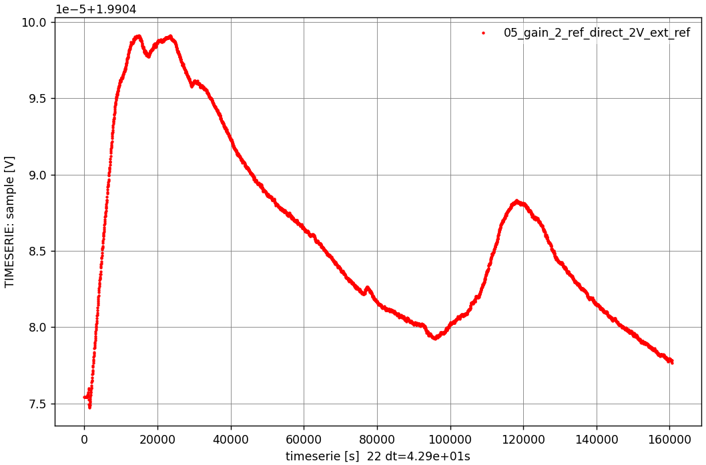
The measured 2 V voltage varies within a range of 25 µV over two days. This variation is most likely caused by the temperature drift of the voltage reference. (The drift of the external voltage reference can be neglected.)

Relative Noise Comparison

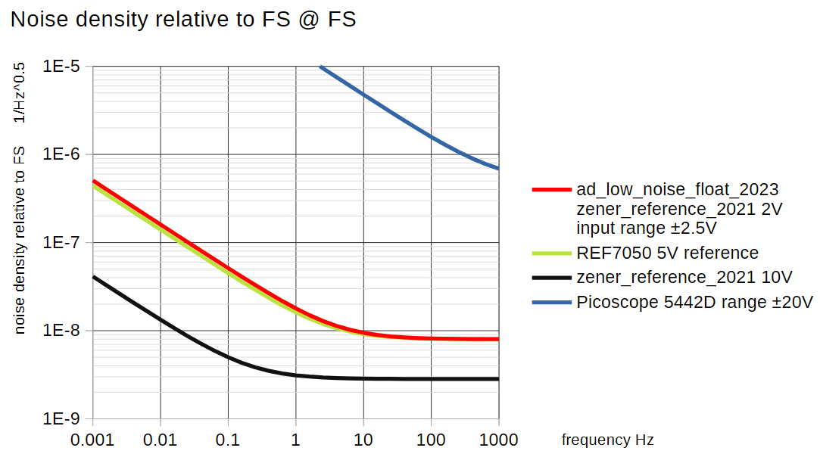

The noise of the PicoScope is considerably higher than that of the ad_low_noise_float.

