PETER MAGDY

1- install git in local - done before on Windows

2- config git in local - done before

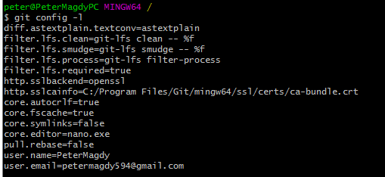

3- create account on GitHub - done before (https://github.com/petermagdy94)

----------------------------------

Each one picks his college

-here is our scenario

1- First person will create his project (any working dir)

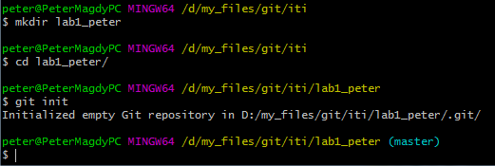

- create any file

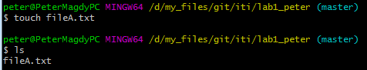

- create remote repo

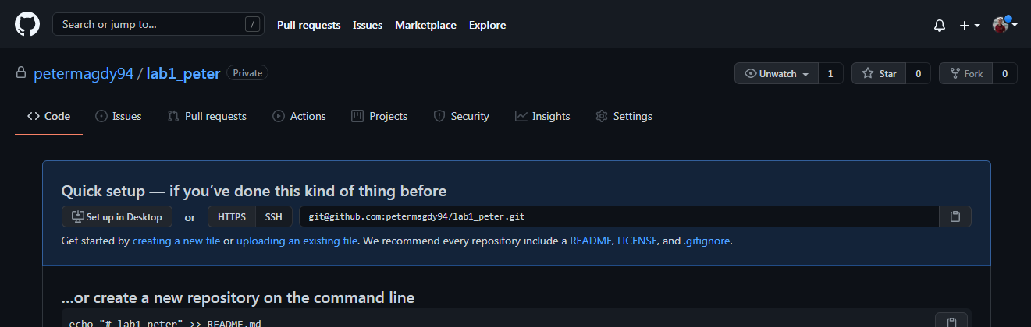

- pushing his file

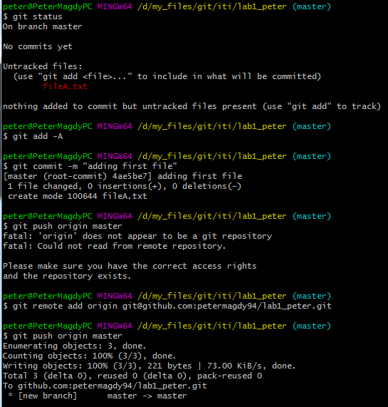

2- another person (ayman side)

- will clone his repo

- modify the file

- pushing modified file

// after Peter Magdy Invited me to his repo

// received invitation Email and accepted it

// clone it ssh

git clone git@github.com:petermagdy94/lab1_peter.git

// then add my changes

3- First person

- getting latest update

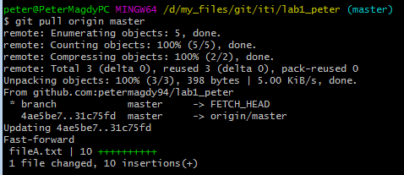

- He will modify this file then pushing it

4- Second person (Ayman side)

- pulling the file

- modify it and pushing it

// after Peter Magdy add his changes

git pull origin master

// then add (Ayman) changes

git add -A

git commit -m “ayman added his steps”

git push origin master

5- Each person logs history and add what you noticed

(Ayman Log)

git log

commit 6ba40d1a1af0ce40064d7289af0c7ef57e49c418 (HEAD -> master)

Author: AymanNagyAhmed <AymanNagy.Ahmed@gmail.com>

Date: Fri Aug 27 23:18:08 2021 +0200

ayman added his steps

:...skipping...

commit 6ba40d1a1af0ce40064d7289af0c7ef57e49c418 (HEAD -> master)

Author: AymanNagyAhmed <AymanNagy.Ahmed@gmail.com>

Date: Fri Aug 27 23:18:08 2021 +0200

ayman added his steps

commit 2612a6157e0f248185f82743cb3dec3af745afd4 (origin/master, origin/HEAD)

Author: PeterMagdy <petermagdy594@gmail.com>

Date: Fri Aug 27 23:06:20 2021 +0200

peter added steps file

commit d646baf39b963f1dea20c76538a789ea943ed495

Author: PeterMagdy <petermagdy594@gmail.com>

Date: Fri Aug 27 23:03:21 2021 +0200

peter added new changes

commit 31c75fd20a5025e5f60c5819966c5ca06603df51

Author: AymanNagyAhmed <AymanNagy.Ahmed@gmail.com>

Date: Fri Aug 27 22:59:26 2021 +0200

ayman added some steps

commit 4ae5be703e4d6dbbce464719607884baeefd4a70

Author: PeterMagdy <petermagdy594@gmail.com>

Date: Fri Aug 27 17:18:33 2021 +0200

adding first file

(peter magdy log)

peter@PeterMagdyPC MINGW64 /d/my_files/git/iti/lab1_peter (master)

$ git pull origin master

remote: Enumerating objects: 10, done.

remote: Counting objects: 100% (10/10), done.

remote: Compressing objects: 100% (5/5), done.

remote: Total 7 (delta 2), reused 7 (delta 2), pack-reused 0

Unpacking objects: 100% (7/7), 26.77 KiB | 148.00 KiB/s, done.

From github.com:petermagdy94/lab1_peter

* branch master -> FETCH_HEAD

2612a61..3a31d57 master -> origin/master

Updating 2612a61..3a31d57

Fast-forward

fileA.txt | 39 +++++++++++++++++++++++++++++++++++++++

lab1_peter.docx | Bin 164873 -> 164463 bytes

2 files changed, 39 insertions(+)

peter@PeterMagdyPC MINGW64 /d/my_files/git/iti/lab1_peter (master)

$ git log

commit 3a31d57ece63ac910f95ba56e18e919f1fa0696f (HEAD -> master, origin/master)

Author: AymanNagyAhmed <AymanNagy.Ahmed@gmail.com>

Date: Fri Aug 27 23:21:11 2021 +0200

ayman added his log

commit 6ba40d1a1af0ce40064d7289af0c7ef57e49c418

Author: AymanNagyAhmed <AymanNagy.Ahmed@gmail.com>

Date: Fri Aug 27 23:18:08 2021 +0200

ayman added his steps

commit 2612a6157e0f248185f82743cb3dec3af745afd4

Author: PeterMagdy <petermagdy594@gmail.com>

Date: Fri Aug 27 23:06:20 2021 +0200

peter added steps file

commit d646baf39b963f1dea20c76538a789ea943ed495

Author: PeterMagdy <petermagdy594@gmail.com>

Date: Fri Aug 27 23:03:21 2021 +0200

peter added new changes

commit 31c75fd20a5025e5f60c5819966c5ca06603df51

Author: AymanNagyAhmed <AymanNagy.Ahmed@gmail.com>

Date: Fri Aug 27 22:59:26 2021 +0200

ayman added some steps

commit 4ae5be703e4d6dbbce464719607884baeefd4a70

Author: PeterMagdy <petermagdy594@gmail.com>

Date: Fri Aug 27 17:18:33 2021 +0200

adding first file

----------------------------------------------

After finishing task

Reverse the scenario

--------------------------------------------

how will you delivery this lap

each one will modify his file with all command

also add history of code

and send me your GitHub link URL