**BCS 2107 Database Systems I**

**Group E**

**Accommodation Management Database**

**Student Name Student Number**

1. PETER MAINGI BSCNRB488720
2. MICHELLE WANJIKU NASIRISI BSCNRB158221
3. ROBERT GITAU NDUTA BSCNRB195521

**GITHUB LINK TO ACCESS OUR PROJECT**

**Entities**

Our model is broken into five main entities areas:

**Accommodation, manager, trailer park , agency and client information.**

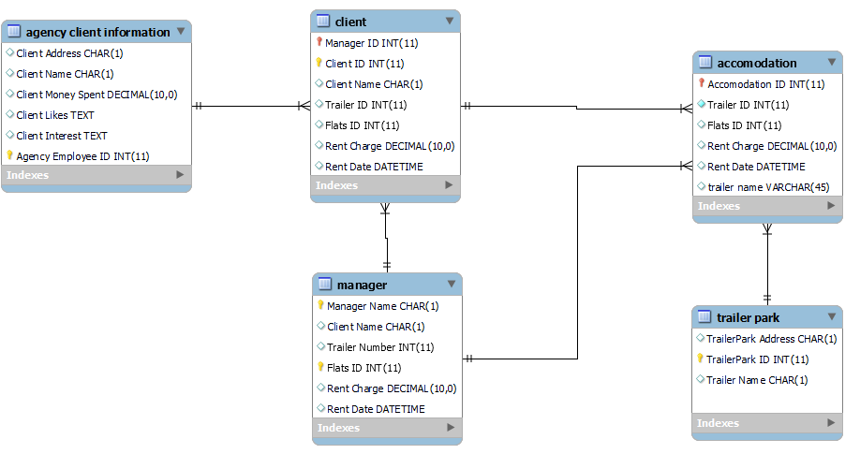

**A trailer park** has a unique ID and an address. A trailer park may contain multiple trailers but could be empty at any point in time. This trailer park is rented out to client to park his or her trailer(s)

The attributes trailer park id which primary key trailer park address and trailer name

**Manage**r: one manager can oversee multiple accommodations this accommodation includes flats and trailer park

The attributes: manager name flat id rent charge, trailer number, managers id (primary key)

**Client.** A client can rent multiple accommodations this accommodation are flats and trailer park as mentioned in flats

Attributes are client id(primary key) clients name, trailer id, rent charge, trailer id

**Agency client information** organize and manage all your customer information, including names, addresses, the amount spent, liking and interests.

**Attributes** agency employees id, clients liking, clients’ interests, clients name clients’ money spent

**Accommodation**

A client can rent multiple accommodations this accommodation are flats and trailer park

flats are rented out by the manager to clients as mentioned in table of manager

Of which clients can rent out multiple accommodation

**attributes**: accommodation id(primary key), flat id, managers name, rent charge, rent date and flat address

**RELATIONSHIP**

#### One-to-Many

**for instance An agency can server many client and hold their specific interest which they can be uniquely identified using there user id**

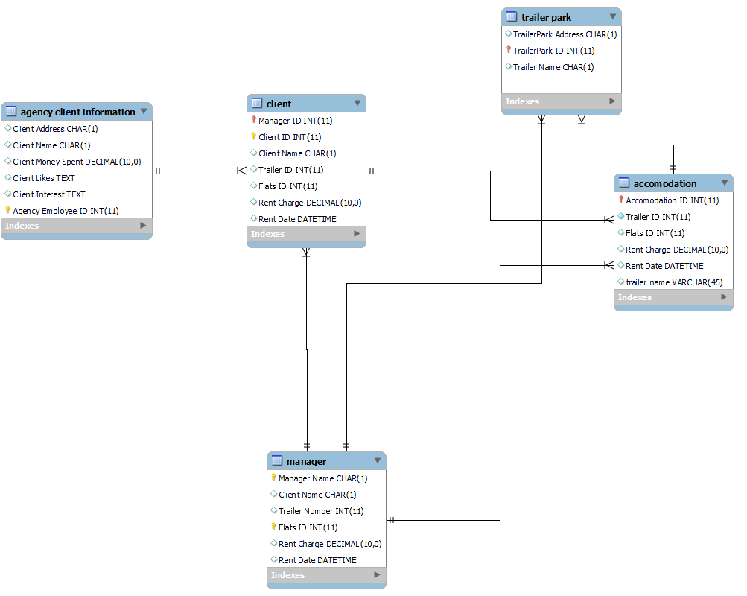

**One client can rent out many accommodations using their user id which use by the manage and agency**

**One manager is assigned to manage the multiple accommodation (flats and trailer park)**



**References**

[**https://www.guru99.com/er-diagram-tutorial-dbms.html**](https://www.guru99.com/er-diagram-tutorial-dbms.html)

**https://vertabelo.com/blog/how-to-use-er-diagram/**