1. <http://127.0.0.1:8000/backend/viewcampus> remove number on the right side.

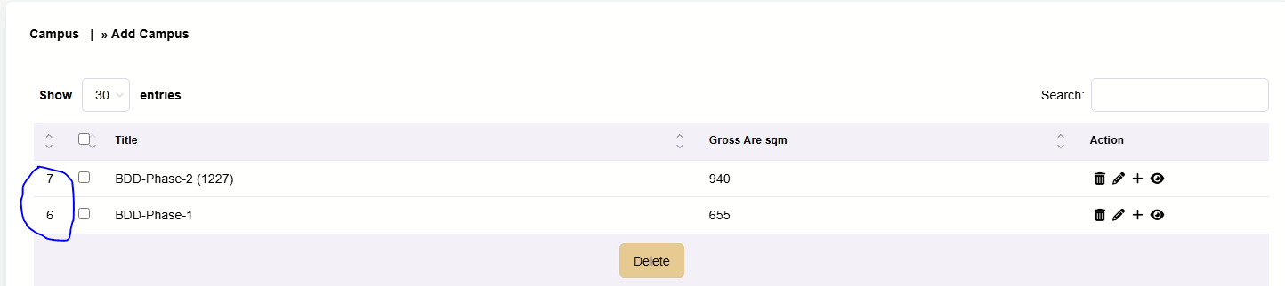

1. <http://127.0.0.1:8000/backend/addarea>: When you create area the edit function on the left does not show.
2. <http://127.0.0.1:8000/backend/viewarea/6>:
   1. Remove number on the left
   2. Gross area not changing
   3. Action menu does not show
   4. Remaining percentage is wrong

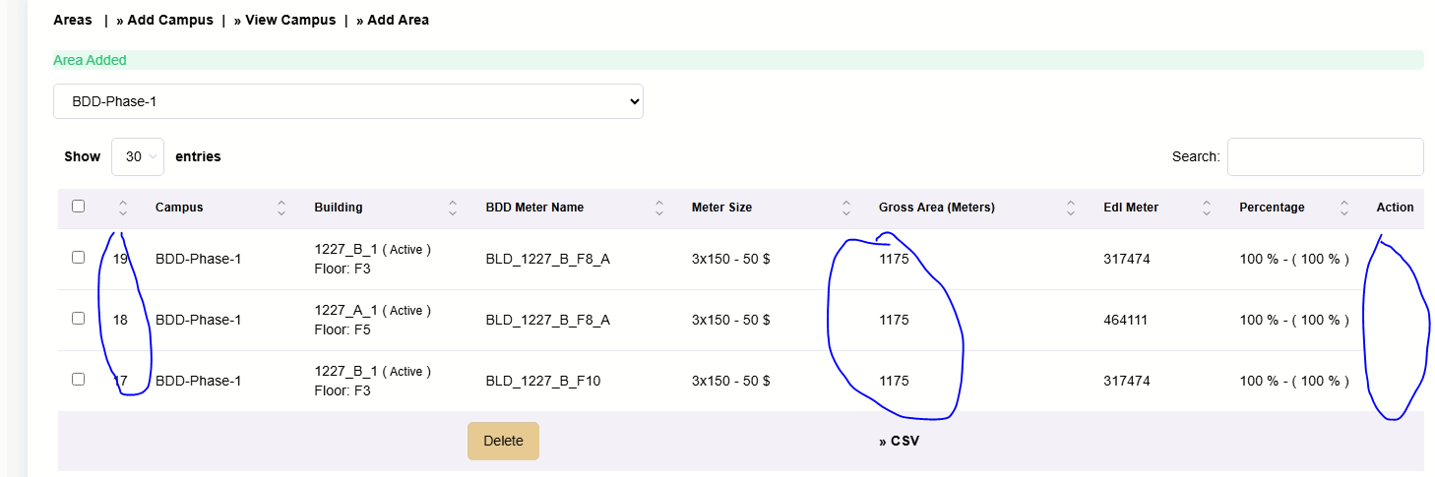

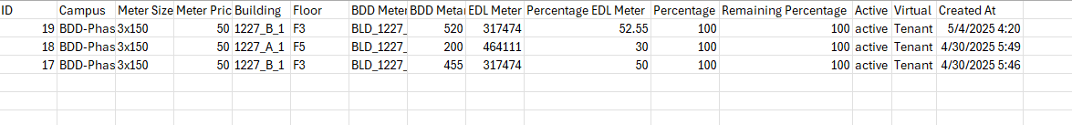

1. <http://127.0.0.1:8000/backend/createtecommonarea>: EDL common area meter size should be drop down menu from fixed cost list

1. <http://127.0.0.1:8000/backend/viewcosterfixmainer>:
   1. Remove numbering on the left
   2. Can not select to delete

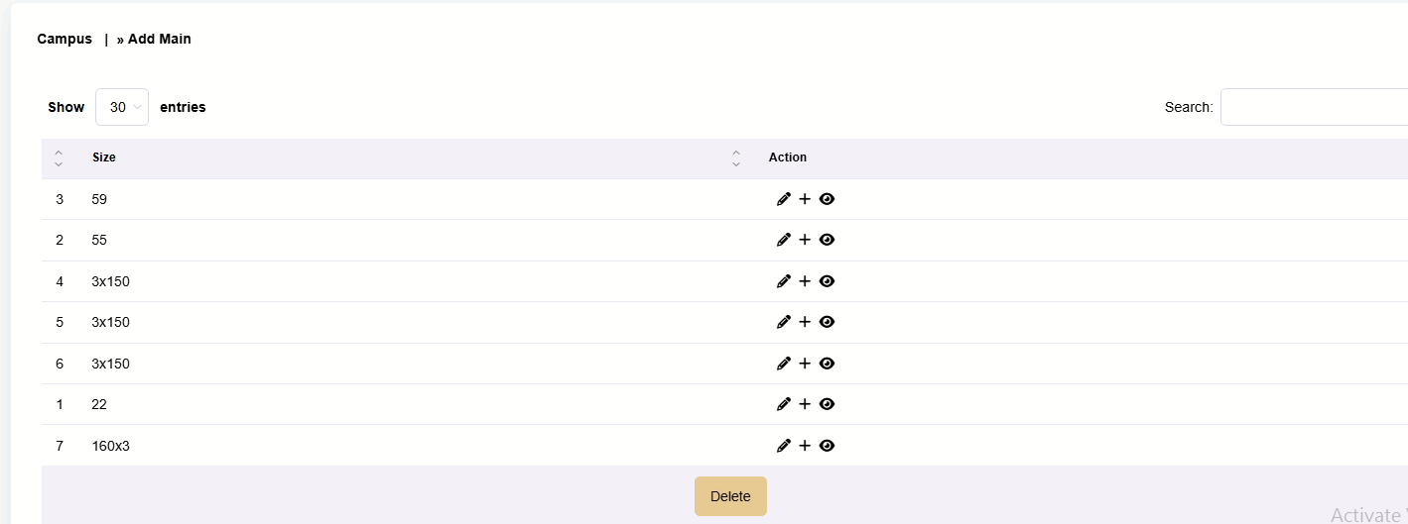

1. <http://127.0.0.1:8000/backend/createtefixcost>
   1. In create fixed cost we should only enter the fixed cost of the EDL meter along with the date
2. We should create a variable cost table that has with date
   1. EDL variable cost USD
   2. Generator operating cost USD
   3. PV power generated in KWH
3. <http://127.0.0.1:8000/backend/viewtenatclient>
   1. Add report to show areas that are not 100% used
   2. When adding a client which is not 100% used the meter name should not be allowed to change
   3. Can not edit menu not showing

