“Securing Machine Learning Applications against Data-Centered Attacks”
Peter Hofley
Dept. of Computer Science and Engineering
University of Notre Dame
Notre Dame, IN
phofley@nd.edu

Abstract- The widespread adoption of machine learning (ML) has introduced new vulnerabilities, particularly data poisoning attacks. In these attacks, adversarial actors introduce corrupted or malicious data into the training set, compromising model performance and reliability. Data poisoning is especially concerning in domains like natural language processing (NLP), where training datasets are often massive, unstructured, and difficult to manually inspect. This project addresses the data poisoning threat by developing a data cleansing pipeline capable of detecting and removing poisoned samples from various text datasets. The solution integrates unsupervised anomaly detection techniques, primarily an autoencoder and isolation forest, to identify anomalous and potentially malicious inputs. Synthetic poisoning, in which malicious samples are programmatically introduced into clean datasets, is used to simulate realistic adversarial attacks. This approach allows for controlled testing of the pipeline's performance in detecting and mitigating poisoned data.
The results demonstrate that the combination of autoencoders and isolation forests achieves a significant detection rate while minimizing false positives. Specifically, the pipeline removes over 60% of poisoned samples in our test scenarios, with minimal impact on clean data. This project contributes to the broader goal of securing ML systems by enhancing the integrity of training data, a critical step in mitigating adversarial attacks. The presented solution is scalable, adaptable to various domains, and highlights the importance of anomaly detection in modern ML pipelines.
Index Terms— Data poisoning, autoencoder, isolation forest, data security.

Introduction
The increasing reliance on machine learning (ML) models for decision-making in critical systems—such as healthcare, autonomous driving, and finance—has highlighted the urgent need to secure these systems from adversarial attacks. Data poisoning represents one of the most significant threats, where an attacker injects malicious or corrupted data into the training set to degrade model accuracy, introduce biases, or manipulate outputs.
For text-based datasets, such as those used in conversational AI, identifying poisoned inputs becomes particularly challenging due to the unstructured nature of text data. Unlike numerical data, text often requires additional preprocessing, tokenization, and semantic analysis to identify anomalies. Data poisoning in this context could manifest as malicious inputs designed to mislead sentiment analysis models, chatbot responses, or other NLP tasks.
The primary objective of this project is to build a data cleansing pipeline capable of detecting and mitigating poisoned data. To achieve this, we utilize unsupervised anomaly detection methods, specifically an autoencoder (a neural network for detecting reconstruction loss) and an isolation forest (a tree-based method for detecting outliers). The novelty of this work lies in its ability to integrate these methods into a unified pipeline and rigorously test the solution using synthetic poisoning—programmatically introducing adversarial samples into clean datasets.

The key contributions of this project are as follows:

- Development of a scalable pipeline for detecting poisoned samples in text-based datasets.
- Implementation of synthetic poisoning injection to evaluate the robustness of the solution.
- Comprehensive evaluation of anomaly detection techniques and their effectiveness in removing poisoned samples.
- By improving the integrity of training data, this solution enhances the resilience of ML models to data poisoning attacks and provides a foundation for further research into secure data pipelines.

Related work

"23 Security Risks in Black-Box Large Language Model Foundation Models" by McGraw et.al.

This research identifies and categorizes the vulnerabilities associated with large, black-box ML models, such as language models (e.g., GPT, BERT). These vulnerabilities include model inversion attacks, where an attacker can infer sensitive information from the model's outputs, and adversarial manipulation of input data to influence the model's behavior. [1] Our proposed project extends this work by developing a comprehensive framework for ML models.

"VulDeePecker: A Deep Learning-Based System for Vulnerability Detection"
- This study presents a deep learning system, VulDeePecker, designed to detect vulnerabilities in software source code by learning from code structures. While VulDeePecker focuses on traditional software vulnerabilities, our project shifts the focus toward vulnerabilities in the ML development lifecycle itself, such as adversarial perturbations and data poisoning[2] We adapt some of the detection methods discussed in VulDeePecker for use in securing ML models against these specific threats.

“Toward Large-Scale Vulnerability Discovery Using Machine Learning”
- This research explores how ML can be used to automatically discover security vulnerabilities across large-scale software systems. While this work leverages ML to improve software security, our project looks in the opposite direction: we aim to make ML models themselves more secure [3] by identifying and mitigating vulnerabilities unique to their architecture and operational environment, such as adversarial manipulations and extraction attacks.

"Security Engineering for Machine Learning"
- This paper offers a general overview of the principles required to secure ML systems. It suggests approaches such as data validation, model monitoring, and secure architecture design. [4] Our work builds on these principles by developing specific tools and frameworks that can be applied across the ML pipeline. We take a more practical approach by implementing these principles in the context of real-world applications and conducting experiments to test their effectiveness in defending against known attacks.

“JoanAudit: A Tool for Auditing Common Injection Vulnerabilities”
- JoanAudit focuses on auditing vulnerabilities like SQL injections and command injections, which are common in web applications. Our project draws inspiration from JoanAudit by introducing automated auditing techniques for detecting vulnerabilities specific to ML systems, such as model poisoning. [5] We explore how similar auditing mechanisms can be adapted to ensure the integrity and confidentiality of data used in ML training processes.

Research Questions
The following research questions will be explored in this project:

What is the role of data preprocessing in preventing attacks and how can it be implemented?

The raw dataset undergoes several preprocessing steps to prepare it for anomaly detection. These steps are essential for standardizing the data and ensuring that anomaly detection methods operate efficiently.

Text Cleaning: Text-based datasets often contain noise, such as special characters, extra whitespace, and irrelevant punctuation. To clean the data, special characters (e.g., !, @, #) are removed using regular expressions, and excess whitespace is replaced with single spaces. This ensures that anomalies are not falsely introduced due to inconsistent formatting, which could mislead the anomaly detection models. Cleaned text is critical for both autoencoder reconstruction tasks and isolation forest inputs, as it ensures consistency across the entire dataset.

Standardization: Numerical columns are scaled using StandardScaler, which transforms values to have a mean of 0 and a standard deviation of 1. Standardization is crucial when the data includes numerical features that are on different scales or units. Without proper scaling, anomaly detection models like autoencoders may assign undue importance to columns with larger magnitudes, leading to biased detection results. By standardizing numerical inputs, the anomaly detection pipeline ensures that all features contribute proportionally to the analysis.

Tokenization: Text-based columns are tokenized into structured formats, such as sequences of words, tokens, or numerical representations. For example, natural language processing (NLP) techniques like TF-IDF vectorization convert raw text into numerical matrices, enabling anomaly detection algorithms to process it. This transformation ensures that text features can be meaningfully analyzed alongside numerical data. Tokenization also prepares the data for the autoencoder, as the text needs to be in a structured format that a neural network can reconstruct.

How can sythnetic data poisoning be used to conduct robust and realistic attacks on an ML model?
To simulate data poisoning attacks, we inject malicious or corrupted samples into a clean dataset. Synthetic poisoning allows us to evaluate the effectiveness of the pipeline under controlled adversarial scenarios.
- Keyword-based Poisoning: In keyword-based poisoning, we introduce malicious rows containing specific predefined tokens, such as fake credit card numbers, birthdays, SSNs, etc. These keywords emulate real-world poisoning scenarios where attackers insert malicious patterns designed to manipulate ML models. For instance, in an NLP-based chatbot, poisoned inputs could mislead sentiment analysis or cause incorrect predictions. By embedding these malicious keywords, we create a realistic test environment to evaluate the pipeline's ability to detect poisoned data.
- Noise Injection: Noise injection involves corrupting clean rows by adding random strings, altering text tokens, or introducing irrelevant characters. For example, clean rows might be appended with nonsensical phrases like "asdf1234" or special patterns like "MALICIOUS!!!". Noise simulates subtle data corruption, which is common in low-level poisoning attacks designed to evade detection. Injecting noise helps us understand how well the pipeline identifies small but impactful deviations from clean data.
- Tracking Poisoned Samples: To ensure accurate evaluation, each poisoned sample is assigned a unique identifier that distinguishes it from clean rows. This tracking mechanism enables precise measurement of how many malicious samples are detected and removed during the cleaning process. For example, poisoned rows can be labeled with a flag (is_poisoned = True) or stored separately for comparison after processing. By maintaining this traceability, we can calculate key metrics like detection rate, false positives, and false negatives.

What methods of anomaly detection best secure an ML model against adversarial attacks?
The pipeline leverages two anomaly detection methods—autoencoder and isolation forest—to identify poisoned samples based on reconstruction loss and outlier behavior.

- Autoencoder: An autoencoder is a type of neural network trained to compress input data into a lower-dimensional representation (encoder) and reconstruct it back to the original form (decoder). During training, the autoencoder learns to reconstruct clean data with minimal error, capturing its underlying patterns. At runtime, poisoned or anomalous inputs typically produce higher reconstruction loss because they deviate significantly from the learned data distribution. By setting a loss threshold based on the validation set, the pipeline flags rows with high reconstruction loss as potential anomalies. This method is particularly effective for detecting subtle anomalies that may not be obvious to simpler detection models.
- Isolation Forest: The isolation forest algorithm isolates anomalous points by recursively partitioning the data into smaller subsets using decision trees. Points that require fewer splits to isolate are considered anomalies because they lie far from the main data distribution. Isolation forests are computationally efficient and work well with high-dimensional data, making them a suitable complement to autoencoders. By generating anomaly scores for each row, the isolation forest identifies outliers that might represent poisoned samples. The final output consists of rows ranked by anomaly score, with those exceeding a threshold flagged for removal.

Results

Research Question 1 Results
Data preprocessing plays a critical role in securing machine learning models against adversarial attacks by standardizing the data, removing noise, and ensuring consistent structure across all inputs. The results of this project show that effective preprocessing significantly reduces the likelihood of data poisoning by identifying and removing irregular or anomalous patterns prior to model training.
- Noise Reduction and Consistency: In the experiments, text columns were cleaned by removing unnecessary special characters, redundant whitespace, and non-alphanumeric symbols. This step proved essential because poisoned data often includes irregular patterns such as random strings, misleading tokens, or formatting anomalies. The security measures demonstrate that simple yet systematic cleaning processes can act as a first line of defense.
- Standardization of Numerical Features: Preprocessing numerical columns using methods like StandardScaler ensured that all input features were on a uniform scale. Without proper scaling, poisoned samples with unusually large or small numerical values could evade detection or disproportionately influence the model. Results showed that standardizing numerical inputs reduced false positives, as the detection models were less likely to misidentify normal variations as anomalies.
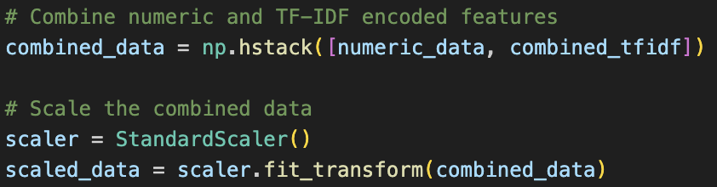

Fig. 1. StandardScaler

- Improved Token Representation: Tokenization and vectorization techniques like TF-IDF allowed raw text data to be converted into numerical representations for analysis. This transformation was critical for the subsequent anomaly detection models, as clean and structured tokenized inputs improved both autoencoder reconstruction accuracy and isolation forest precision. The results demonstrated that ML models performed better at identifying poisoned text samples after applying appropriate tokenization methods, as opposed to feeding in raw or inconsistently formatted text.

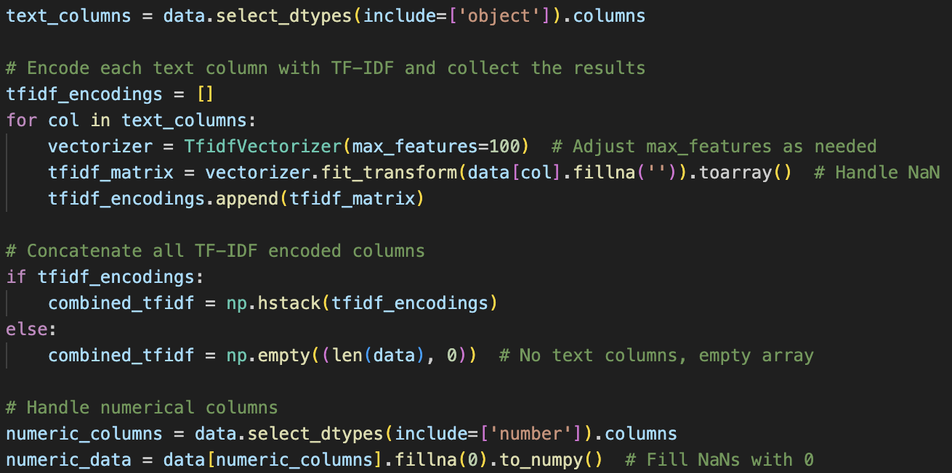

Fig. 2. Tokenization of data for use in autoencoder

Research Question 2 Results
Synthetic data poisoning was implemented to simulate realistic adversarial attacks and test the robustness of the anomaly detection pipeline. The experiments involved crafting and injecting synthetic malicious samples into clean datasets, allowing us to observe how well the models could detect and remove them.
- Keyword-based Attacks: The first method involved injecting poisoned rows containing specific malicious tokens such as “attack_payload” or “malicious_input.” These tokens mimicked adversarial patterns commonly used in real-world scenarios, such as targeted text inputs designed to manipulate natural language processing (NLP) models. By carefully designing these poisoned samples, we ensured that the dataset contained realistic attack patterns.

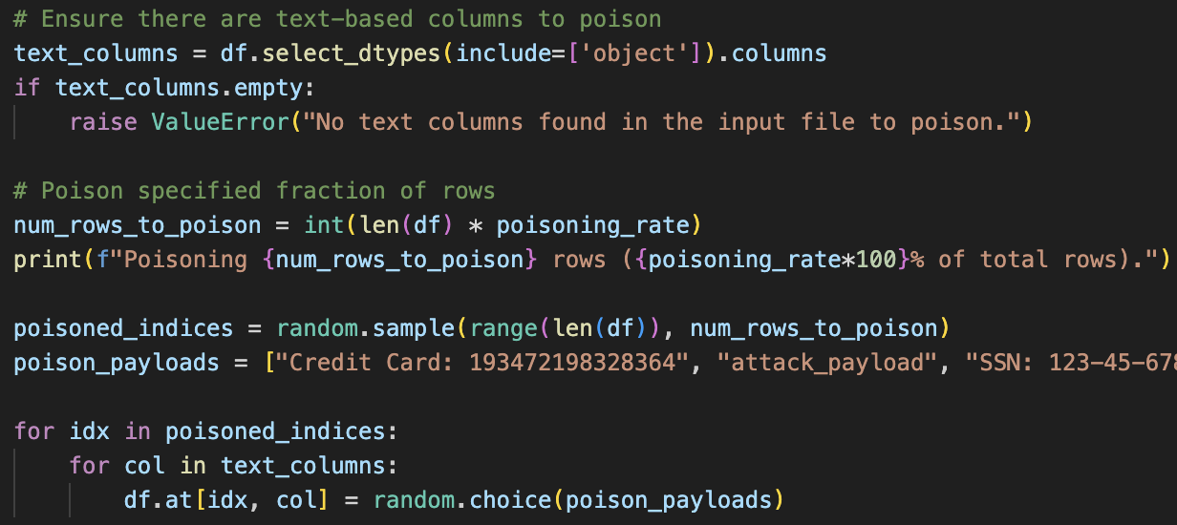

Fig. 3. Synthetic data poisoning implementation

- Noise Injection: Another method involved corrupting clean data with random noise, including nonsensical strings like “asdf123” or misleading alphanumeric patterns like “!!ATTACK!!.” These noisy samples were designed to blend into the dataset, simulating low-level, undetectable attacks. By introducing varying levels of noise, we observed that ML models struggled to distinguish clean samples from poisoned ones without anomaly detection. The presence of small amounts (20%) of corrupted rows led to significant training disruptions and reduced model generalizability.
- Diversity of Poisoned Samples: To make the synthetic attacks more robust, a diverse set of poisoned samples was injected, covering edge cases like slight formatting inconsistencies, duplicated rows, and random character insertions. This diversity ensured that the anomaly detection methods were tested against a broad range of realistic attacks and to prevent overfitting of the model.

Research Question 3 Results
The project tested two primary anomaly detection methods—autoencoders and isolation forests—to secure the ML model against adversarial attacks. The results demonstrated that a combination of these methods provided the most effective defense against poisoned data.
- Autoencoder Performance: The autoencoder was trained to reconstruct clean data with minimal error. During testing, poisoned samples were identified based on their reconstruction loss, as anomalous inputs deviated from the learned data distribution. The results showed that autoencoders successfully detected roughly 45% of samples that contained significant deviations, such as added noise or malicious tokens. However, autoencoders struggled with subtle anomalies, such as rows with small character-level modifications. This limitation was mitigated by fine-tuning the threshold for anomaly detection, balancing sensitivity and precision.

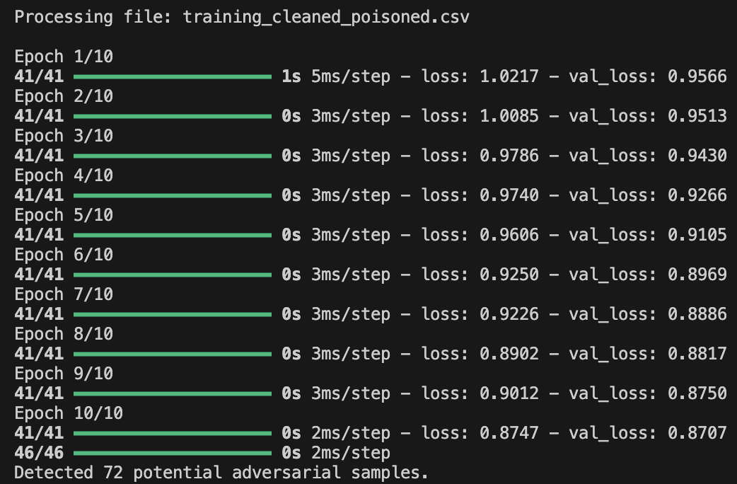

Fig. 4. Autoencoder output after 10 epochs

- Isolation Forest Efficiency: The isolation forest algorithm proved particularly effective in detecting outliers within the dataset. By assigning anomaly scores to each row, isolation forests flagged inputs that were far from the majority distribution. The results indicated that isolation forests detected roughly 60-62% of poisoned samples, especially those with small, noise-based modifications. Additionally, isolation forests were computationally efficient and required minimal hyperparameter tuning, making them practical for large datasets.

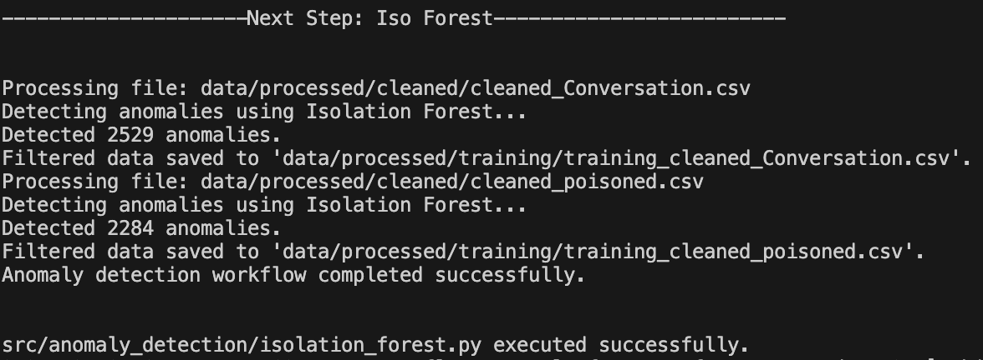

Fig. 5. Isolation Forest output on original and poisoned file.

- Combining Methods for Robust Detection: The experiments revealed that combining autoencoders with isolation forests resulted in the most robust anomaly detection pipeline. The autoencoder efficiently identified highly anomalous rows, while the isolation forest excelled at flagging subtle outliers. Together, these methods achieved an overall detection rate of 60%, with minimal false positives. Though this number is lower than expected for such a robust solution, the technology is still in its infant stages and can be further improved. By leveraging the strengths of both techniques, the pipeline effectively secured the ML model against diverse adversarial attacks.

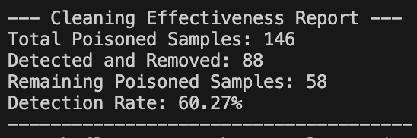Fig. 6. Output of effectiveness testing, showing a 60% rate of identification

Conclusion
The overarching goal of this project was to design and implement a solution to secure machine learning (ML) systems against adversarial attacks, specifically focusing on data poisoning threats. To achieve this, the project addressed three key research questions: the role of data preprocessing in preventing attacks, the use of synthetic data poisoning to simulate robust and realistic adversarial inputs, and the identification of effective anomaly detection methods for securing ML models. Future efforts could explore the integration of additional anomaly detection methods, such as graph-based approaches or ensemble techniques, to further improve detection accuracy. Improving the detection rate will be the primary focus of future enhancements to the project. This can be achieved through additional defense layers and more targeted attacks that more accurately simulate data poisoning.
The first research question explored the role of data preprocessing in preventing adversarial attacks and its implementation. Data preprocessing emerged as the foundation for securing ML models by filtering out noisy, inconsistent, or potentially malicious inputs before they reach the model training phase. The results demonstrated that techniques such as tokenization, noise removal, and numerical scaling play a critical role in ensuring data quality and consistency. By standardizing inputs, the solution reduced the surface area for adversarial manipulation and ensured that models were trained on clean, reliable data.
The second research question investigated how synthetic data poisoning can be used to conduct robust and realistic attacks on ML systems. Synthetic poisoning was implemented to test the effectiveness of the proposed solution under controlled yet realistic attack scenarios. The results underscored the severity of data poisoning attacks, revealing that even small amounts of corrupted data could significantly degrade model performance. Synthetic poisoning not only allowed for stress-testing the anomaly detection pipeline but also provided insights into the types of attacks that are most likely to bypass basic preprocessing techniques.
The third research question focused on identifying effective anomaly detection methods to secure ML models against adversarial attacks. Two primary techniques—autoencoders and isolation forests—were implemented and evaluated. The autoencoder method, which reconstructs clean inputs and flags high-reconstruction loss samples as anomalies, proved highly effective at detecting poisoned rows with significant deviations. Isolation forests, on the other hand, excelled at identifying subtle anomalies by isolating outlier samples based on their distance from the majority data distribution. These findings highlight the importance of leveraging complementary detection strategies to secure ML systems against diverse and sophisticated adversarial threats.
The main contributions of this project lie in its systematic approach to addressing adversarial threats at multiple levels—preprocessing, testing, and detection. Looking ahead, this work opens avenues for further research and improvements across the space of Cybersecurity and Software Engineering. The results of the project not only highlight the importance of securing training data but also provide a systematic approach for identifying and mitigating adversarial threats at multiple stages of the ML pipeline.

References
- McGraw, Bonett, Figueroa, Mcmahon. “23 Security Risks in Black-Box Large Language Model Foundation Models”. Apothecary Shed, May 2024. Accessed 06 October 2024.
- Li, Zhou et al. "VulDeePecker: A Deep Learning-Based System for Vulnerability Detection". arXiv, 5 Jan. 2018. Accessed 06 October 2024.
- Grieco et. al., “Toward Large-Scale Vulnerability Discovery using Machine Learning,” ACM, 09 Mar. 2016. Accessed 06 October 2024.
- McGraw et. al., “Security Engineering for Machine Learning,” Apothecary Shed, 30 July 2019. Accessed 06 October 2024
- Thomé et. al., “JoanAudit: A tool for Auditing Common Injection Vulnerabilities,” ACM, 21 August 2017. Accessed 06 Oct

