BUDGETARY COST
ESTIMATION METHODOLOGY
JMG Solar - Complete Supply and Installation of
1MW, 5MW and 10MW Hybrid Solar Stations
Prepared as an independent budget estimate from publicly available JMG project specifications, Nigerian market price checks and EPC allowances.
Project size | Base planning figure | Conservative ceiling
1MWp + ~1MWh battery | ₦1.30bn | ₦1.70bn
5MWp + ~5MWh battery | ₦6.20bn | ₦7.80bn
10MWp + ~10MWh battery | ₦11.80bn | ₦15.00bn
Date: 16 July 2026
Status: Budgetary estimate - not a quotation from JMG Limited

EXECUTIVE SUMMARY
JMG Limited does not publish a standard selling and installation price for a 1MW, 5MW or 10MW solar station. The estimates in this report were therefore produced using a bottom-up cost model anchored to JMG’s published equipment brands and completed hybrid projects, then expanded to include the balance-of-system, civil, electrical, engineering, installation, logistics and contingency costs required for a complete turnkey project.
Important interpretation: The main figures assume MWp of solar-panel DC capacity, approximately 0.8MW of inverter capacity per 1MWp of panels, and approximately 1MWh of lithium battery storage per 1MWp. A requirement for 1MW AC export, several hours of full-load backup, or a new 11kV/33kV evacuation line would materially increase the price.

Recommended budget figures
Project | Assumed configuration | Budget range | Working figure
1MWp standard hybrid | 1MWp PV, ~0.8MW AC, ~1MWh storage | ₦1.05bn–₦1.70bn | ₦1.30bn
5MWp standard hybrid | 5MWp PV, ~4MW AC, ~5MWh storage | ₦4.70bn–₦7.80bn | ₦6.20bn
10MWp standard hybrid | 10MWp PV, ~8MW AC, ~10MWh storage | ₦8.70bn–₦15.00bn | ₦11.80bn
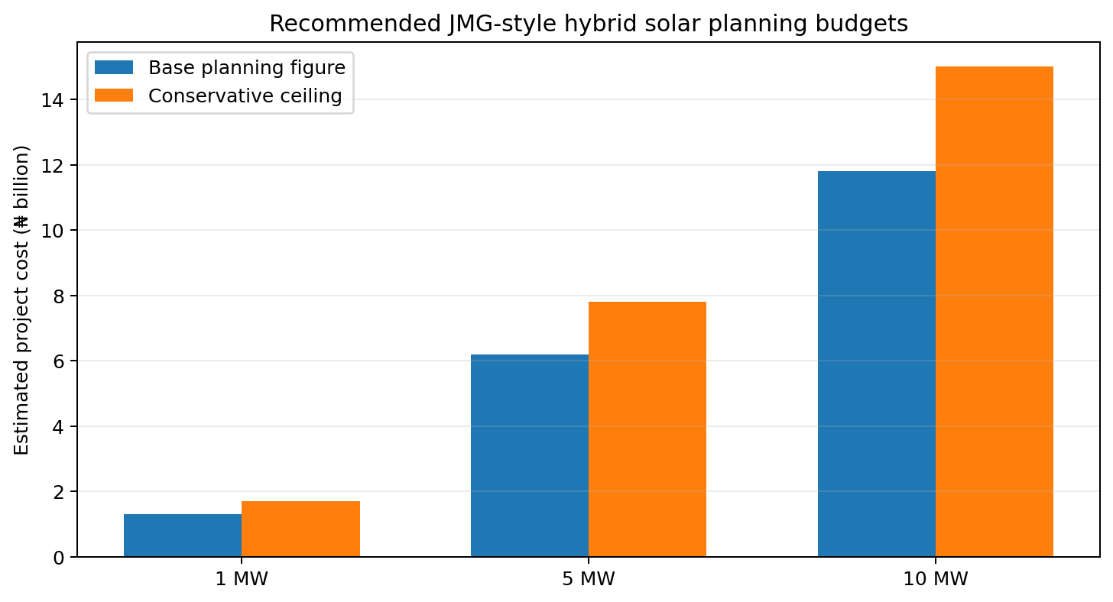
Figure 1. Base planning figures and conservative ceilings for the standard hybrid configuration.

What the figures include
- LONGi solar modules, Deye-type hybrid inverter capacity and high-voltage lithium battery storage.
- Mounting structures, battery racks, protection devices, cables, earthing, transformers, switchgear and metering.
- Civil works, installation labour, engineering design, project management, testing, commissioning, monitoring and initial spares.
- A 10%–15% contingency/contractor-overhead allowance for the 1MW model and estimated economies of scale for 5MW and 10MW.

What is excluded or requires confirmation
- Land purchase or long-term land lease.
- Extraordinary ground improvement, major road construction, extensive rooftop strengthening or long-distance cable routes.
- A dedicated utility substation, long 11kV/33kV evacuation line, grid-impact studies and distribution-company connection charges.
- Financing interest, insurance during a long lease term, withholding tax, VAT treatment and customs changes unless expressly included by JMG.

1. Evidence Used to Define a JMG-Style System
The design assumptions were not selected arbitrarily. They were derived from JMG’s published solar product page and two completed JMG hybrid solar case studies.

1.1 JMG’s published service scope and brands
JMG states that it supplies solar systems for residential, commercial and industrial applications using LONGi panels, Deye hybrid inverters and lithium batteries. It also states that its end-to-end service includes system design, professional installation, commissioning, monitoring and after-sales support. JMG offers lease-to-own and pay-per-kWh structures for systems of 100kVA and above. [1]

1.2 Published JMG project ratios
Published project | PV array | Inverter | Battery | Annual output | DC/AC ratio | Battery/PV
JMG Head Office, Lagos | 129kWp | 100kW | 122.9kWh | 185.76MWh | 1.29 | 0.95kWh/kWp
St Catherine Hospital, Abuja | 92.8kWp | 65kW | 160.8kWh | 133.63MWh | 1.43 | 1.73kWh/kWp
Both projects imply annual production of approximately 1,440kWh per installed kWp. The head-office design uses about 0.775kW of inverter capacity and 0.953kWh of storage for each kWp of solar. The hospital design uses less inverter capacity but substantially more storage. The estimate therefore adopts a practical middle design of 0.8MW AC and 1MWh storage for each 1MWp of panels. [2][3]
Design conclusion: The standard budget model is not a direct scale-up of the hospital’s battery-heavy configuration. It uses the head-office ratio as the main anchor, rounded to a commercially convenient 1MWh battery per 1MWp.

2. Technical Quantity Calculation

2.1 Formulae
Item | Calculation rule
Number of panels | Ceiling[(Project MWp × 1,000,000W) ÷ 575W]
Target inverter capacity | Project MWp × 0.80MW AC per MWp
Number of 50kW inverter equivalents | Ceiling[(Target inverter kW) ÷ 50kW]
Target battery capacity | Project MWp × 1,000kWh per MWp
Number of 5.12kWh battery modules | Ceiling[(Target battery kWh) ÷ 5.12kWh]

2.2 Resulting equipment quantities
PV size | 575W panels | Target AC | 50kW equivalents | Battery target | 5.12kWh modules
1MWp | 1,740 | 0.8MW | 16 | 1MWh | 196
5MWp | 8,696 | 4.0MW | 80 | 5MWh | 977
10MWp | 17,392 | 8.0MW | 160 | 10MWh | 1,954
At 5MW and 10MW, JMG may use larger string inverters, central inverters or a dedicated power-conversion system rather than physically installing 80 or 160 units of 50kW equipment. The 50kW quantities are cost-equivalent units used to make the calculation transparent.

3. Detailed Bottom-Up Calculation for 1MW

3.1 Core equipment assumptions
Component | Quantity | Unit-price range | Basis
LONGi 575W module | 1,740 units | ₦150,000–₦168,200 each | Large-order working range used in the original estimate; public retail can be higher.
Deye 50kW hybrid inverter equivalent | 16 units | ₦5.50m–₦7.36m each | Lower end reflects bulk/competitive procurement; upper end aligns with public retail checks.
Deye BOS-G 5.12kWh battery module | 196 units | ₦1.265m–₦1.650m each | Produces approximately 1.004MWh nominal storage before usable-capacity limits.

3.1.1 Core-equipment cost calculation
Core item | Formula | Lower case | Upper case
Solar panels | 1,740 × unit price | ₦261.0m | ₦292.7m
Hybrid inverters | 16 × unit price | ₦88.0m | ₦117.8m
Battery modules | 196 × unit price | ₦247.9m | ₦323.4m
Core-equipment subtotal | Sum of the three items | ₦596.9m | ₦733.8m

3.2 Balance-of-system and EPC allowances
Cost category | Lower case | Upper case
Battery cabinets, BMS, cooling and fire protection | ₦35.0m | ₦80.0m
Mounting structures and foundations | ₦60.0m | ₦120.0m
DC/AC cables, combiner boxes, breakers, SPDs and earthing | ₦60.0m | ₦110.0m
Transformer, LV/MV switchgear and metering | ₦70.0m | ₦150.0m
Civil works, drainage, fencing and security | ₦40.0m | ₦100.0m
Engineering, load study, design and project management | ₦25.0m | ₦50.0m
Installation, testing and commissioning | ₦25.0m | ₦50.0m
Logistics, insurance, initial spares and mobilisation | ₦30.0m | ₦70.0m
Total before contingency | ₦941.9m | ₦1.46bn
Contingency/overhead applied | 10% | 15%
Calculated turnkey result | ₦1.04bn | ₦1.68bn

3.3 Rounding to the reported 1MW range
The direct arithmetic produces approximately ₦1.04bn to ₦1.68bn. This was rounded to ₦1.05bn–₦1.70bn because the input prices are themselves approximate and a false level of precision would be misleading.
The ₦1.30bn base planning figure is a management working figure selected within the range for a standard site and competitive project procurement. The exact arithmetic midpoint is approximately ₦1.38bn; using ₦1.70bn as the conservative ceiling protects the budget against difficult civil works, exchange-rate movement and additional electrical infrastructure.

4. Scaling the Estimate to 5MW and 10MW
Large solar projects do not normally cost exactly five or ten times a 1MW project. Engineering, mobilisation, monitoring platforms, project management and some civil costs are shared across a larger capacity. Bulk orders also improve panel, battery, inverter, logistics and installation pricing. These effects were represented by an economies-of-scale discount.
Calculation | Formula | Result | Reported figure
5MW lower bound | ₦1.05bn × 5 × (1 − 12%) | ₦4.62bn | Rounded to ₦4.7bn
5MW upper bound | ₦1.70bn × 5 × (1 − 8%) | ₦7.82bn | Rounded to ₦7.8bn
10MW lower bound | ₦1.05bn × 10 × (1 − 18%) | ₦8.61bn | Rounded to ₦8.7bn
10MW upper bound | ₦1.70bn × 10 × (1 − 12%) | ₦14.96bn | Rounded to ₦15.0bn

4.1 Why the lower and upper cases use different discounts
The lower bound assumes standard ground conditions, direct bulk procurement, efficient construction and no unusual grid requirements; it therefore receives the larger scale discount. The upper bound assumes more complex civil/electrical scope, weaker procurement savings and a larger risk allowance; it receives the smaller discount.

4.2 Central planning figures
Project | Midpoint formula | Calculated midpoint | Planning figure
5MW | (₦4.62bn + ₦7.82bn) ÷ 2 | ₦6.22bn | ₦6.20bn
10MW | (₦8.61bn + ₦14.96bn) ÷ 2 | ₦11.79bn | ₦11.80bn

5. Alternative Configuration Ranges
Battery capacity is the most important configuration variable. A project described only as “5MW solar” can mean panels without storage, a 5MWp hybrid plant with 5MWh storage, or a battery-heavy plant intended to serve night loads. The following ranges separate those cases.
Configuration | 1MW | 5MW | 10MW
Solar only - no battery | ₦0.75bn–₦1.20bn | ₦3.40bn–₦5.40bn | ₦6.30bn–₦10.20bn
Standard hybrid - ~1MWh/MW | ₦1.05bn–₦1.70bn | ₦4.70bn–₦7.80bn | ₦8.70bn–₦15.00bn
Battery-heavy - ~1.7–2MWh/MW | ₦1.30bn–₦2.10bn | ₦5.80bn–₦9.50bn | ₦10.80bn–₦18.20bn
Recommended use: Use the standard-hybrid figures for preliminary financial modelling unless the intended battery autonomy has already been defined. Use the solar-only figures only where the grid or generators can absorb intermittency and no night-time solar shifting is required.

6. Sensitivity and Main Cost Drivers

6.1 Equipment-price sensitivity
Input change | 1MW impact | 5MW impact | 10MW impact
Panel unit price changes by ₦10,000 | ₦17.4m | ₦87.0m | ₦173.9m
50kW inverter equivalent changes by ₦500,000 | ₦8.0m | ₦40.0m | ₦80.0m
5.12kWh battery module changes by ₦100,000 | ₦19.6m | ₦97.7m | ₦195.4m

6.2 Battery-duration sensitivity
One additional 1MWh of Deye-type high-voltage storage requires roughly 196 extra 5.12kWh modules. At the working module prices, the battery modules alone add approximately ₦248m–₦323m. Battery racks, BMS, cooling, fire protection and power-conversion integration can increase the installed addition to approximately ₦285m–₦400m per extra MWh. Therefore, moving a 10MW project from 10MWh to 20MWh storage could add roughly ₦2.85bn–₦4.00bn before site-specific electrical upgrades.

6.3 Other material cost drivers
- Whether the stated project capacity is MWp DC or MW AC export capacity.
- Required battery autonomy, permitted depth of discharge, redundancy and end-of-life capacity guarantee.
- Ground-mounted, rooftop, carport or mixed mounting design and the associated structural work.
- Distance to the point of connection and whether a new transformer, substation or evacuation line is required.
- Location, security, access roads, drainage, soil conditions and project schedule.
- Foreign-exchange rate, import duties, VAT treatment, insurance and financing structure.

7. External Reasonableness Check
IRENA’s 2025 global weighted-average total installed cost for utility-scale solar PV was US$667/kW, while the installed cost of a four-hour utility-scale battery was approximately US$140/kWh. These global averages are not directly interchangeable with a privately procured Nigerian hybrid plant: JMG’s likely project would be smaller than many utility-scale projects, use commercial hybrid equipment, incur Nigerian import/logistics costs and include customer-side electrical integration. The benchmark nevertheless confirms that battery storage and balance-of-system scope are major differentiators between solar-only and hybrid costs. [7]
Benchmark limitation: The IRENA figure is a global weighted average. It was used only as a high-level reasonableness check, not as the direct naira pricing formula.

8. Information Needed to Convert the Estimate into a JMG Quote
A formal JMG proposal should be requested using a clear technical specification. The following items should be stated or requested explicitly:
- Confirm whether capacity means MWp DC, MW AC at inverter output, or guaranteed export capacity at the point of connection.
- Provide 12 months of interval load data, generator runtime, grid availability and diesel consumption.
- State the battery requirement in usable MWh and hours of autonomy, not only nominal battery capacity.
- Request panel, inverter, battery, BMS and power-conversion makes/models, quantities and warranties.
- Request a complete bill of quantities for transformers, switchgear, cables, protection, monitoring, civil works and fire safety.
- Request separately priced CAPEX, lease-to-own and pay-per-kWh options, including escalation, term, buyout and ownership conditions.
- Ask for guaranteed annual energy yield, performance ratio, availability, battery degradation and liquidated-damages provisions.
- Ask JMG to list VAT, duties, land, connection fees, grid studies, O&M and all exclusions separately.

Suggested request wording
Please provide a fully itemised turnkey proposal for: (a) 1MWp PV with approximately 0.8MW AC inverter capacity and 1MWh usable lithium storage; (b) 5MWp PV with approximately 4MW AC and 5MWh usable storage; and (c) 10MWp PV with approximately 8MW AC and 10MWh usable storage. For each option, show the equipment models and quantities, transformer and switchgear scope, civil works, delivery, installation, commissioning, warranties, annual energy guarantee, O&M, taxes, exclusions, CAPEX price, lease-to-own price and pay-per-kWh tariff.

9. Conclusion
The estimates were generated by first reconstructing a representative JMG hybrid design from the company’s published projects, calculating the number of panels, inverter equivalents and battery modules, pricing the core equipment, adding all major EPC and balance-of-system categories, applying contingency, and finally applying realistic economies of scale for 5MW and 10MW.
For preliminary budgeting, the recommended figures remain ₦1.30bn for 1MW, ₦6.20bn for 5MW and ₦11.80bn for 10MW, with conservative ceilings of ₦1.70bn, ₦7.80bn and ₦15.00bn respectively. These are defensible planning estimates, but JMG’s final quotation will depend principally on battery duration, site conditions, AC export requirement and grid interconnection scope.

References
[1] JMG Solar Power Solutions - services, brands, lease options and product ratings. Accessed 16 July 2026. Source
[2] JMG Limited, “Hybrid Solar Powering JMG Head Office - A Smart Move Toward Energy Independence,” project specifications and output. Source
[3] JMG Limited, “JMG Solar installs hybrid solar power system for St-Catherine Specialist Hospital in Abuja,” project specifications and output. Source
[4] ZIT Nigeria public listing for Deye 50kW hybrid inverter - market-price cross-check. Source
[5] Fouani Nigeria and Detopsy public listings for Deye BOS-G 5.12kWh high-voltage battery - market-price cross-check. Source
[6] Alabamart public listing for LONGi 575W module - public retail-price cross-check. Source
[7] International Renewable Energy Agency, Renewable Power Generation Costs in 2025: Executive Summary, July 2026. Source
Disclaimer: This report is an independent budget estimate prepared from public information. It is not affiliated with, approved by or issued by JMG Limited. Public product prices and exchange-rate-sensitive imported-equipment costs may change without notice. A site survey, load study and formal JMG bill of quantities are required before an investment or procurement decision.

