Maynooth University – Chinese Summer School 2016

Web-based Mapping – Assignment

Dr. Peter Mooney

You should use the code provided to you as a starting point.

You are required to build a single page web-based map application with the following specifications:
- There are THREE baselayers – These are directly from the Leaflet Providers Page
- There are TWO overlay layers.
- You must create one of the overlayer layers in GeoJSON.io and the other can be created from any source.
- You must apply a style to ONE of the overlay layers so that it is in Choropleth style. You will have to decide on a style – you can pick the classes or criteria to use.
- Both overlay layers must have at least 5 objects
- All properties for all features must be displayed in the feature popup
- You must center the map appropriately
- You must set the initial zoom of the map appropriately.
- You should provide some basic text on the web page to explain your colour scheme choice for the Choropleth map.

A good source of geojson data is https://mapzen.com/data/metro-extracts/ - you should look for the “imposm.geojson” link corresponding to each city.

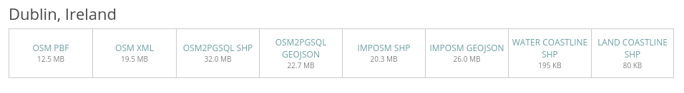

When this is downloaded – you can unzip the file and there will be several geojson files contained within the zip file.

