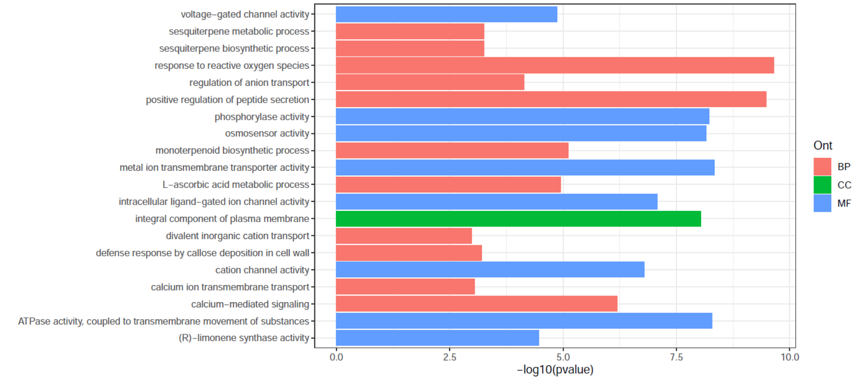

**Supplementary Figure 1. GO enrichment analysis of potential genes under positive selection.**

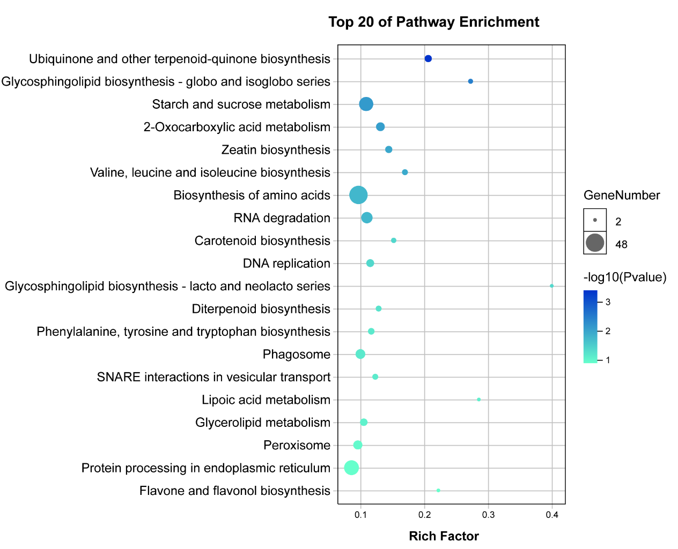

**Supplementary Figure 2. Top 20 KEGG pathways of SV annotated genes shared among three tea plant genomes**

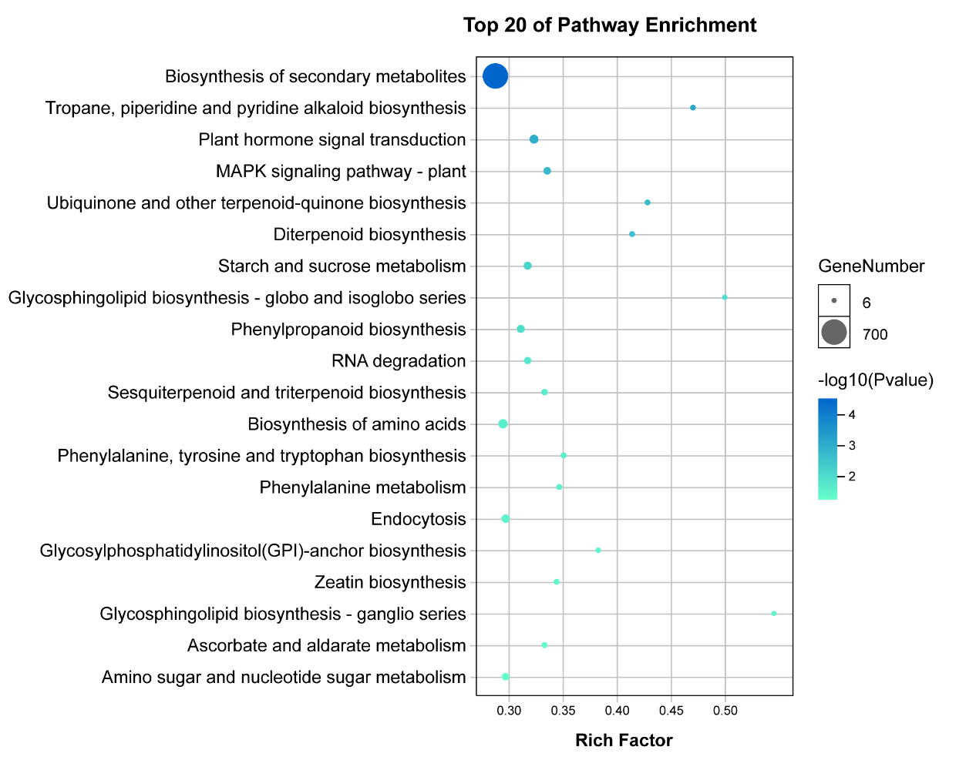

**Supplementary Figure 3. Top 20 KEGG pathways of SV annotated genes between HD and LJ43 genome**

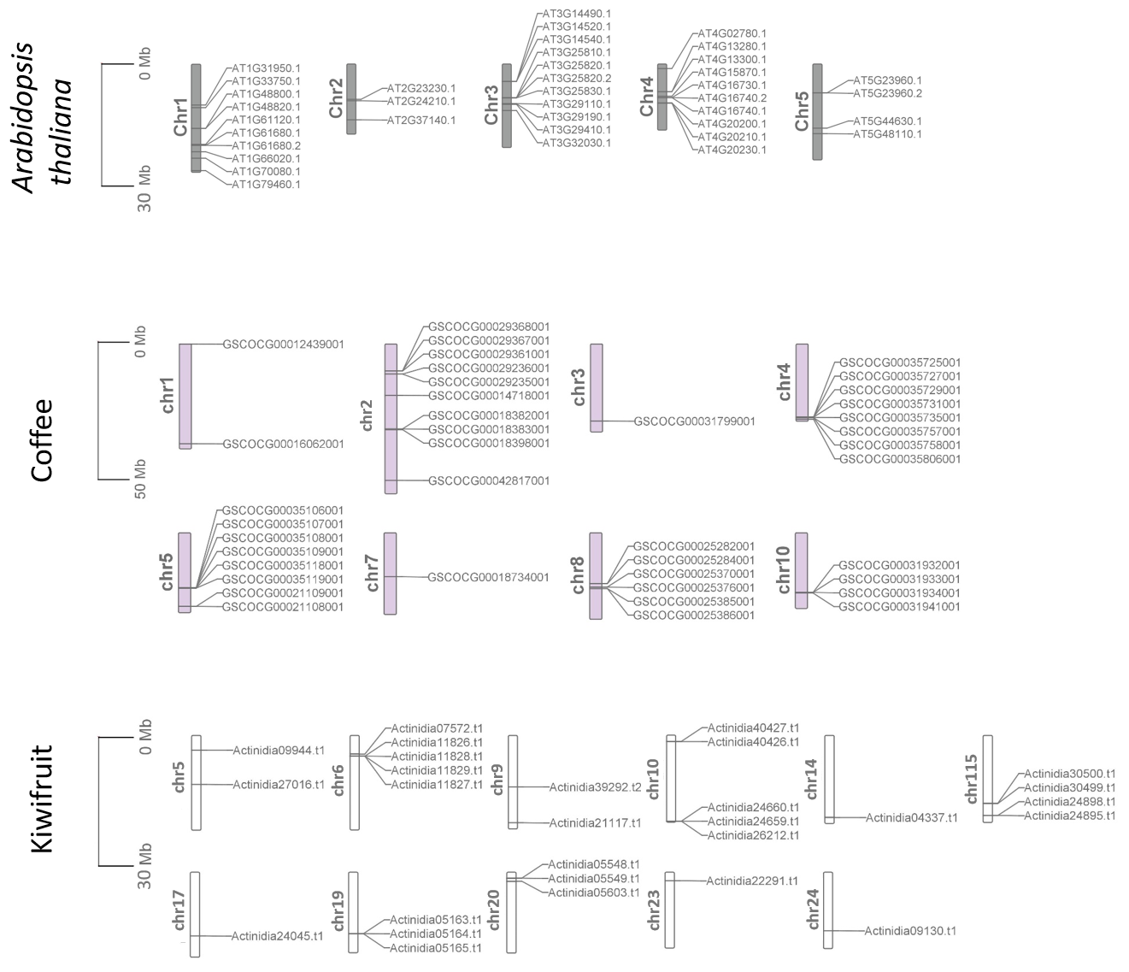

**Supplementary Figure 4. Chromosomal distribution of *TPSs* in *Arabidopsis*, kiwifruit and coffee.**

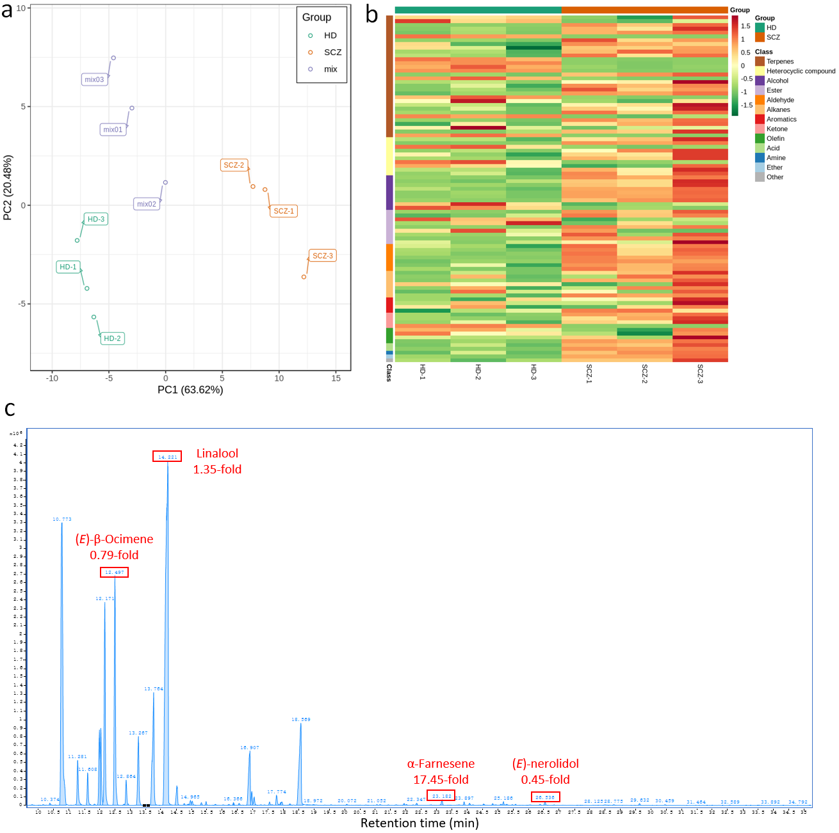

**Supplementary Figure 5. Analysis of volatile compounds (VOCs) between the leaves of HD and SCZ. a** PCA score plot of VOCs between the leaves of HD and SCZ. **b** Heatmap of VOCs. c Total ion chromatogram diagram of VOCs in mix group, where the fold changes (HD/SCZ) of 4 key VOCs are marked.