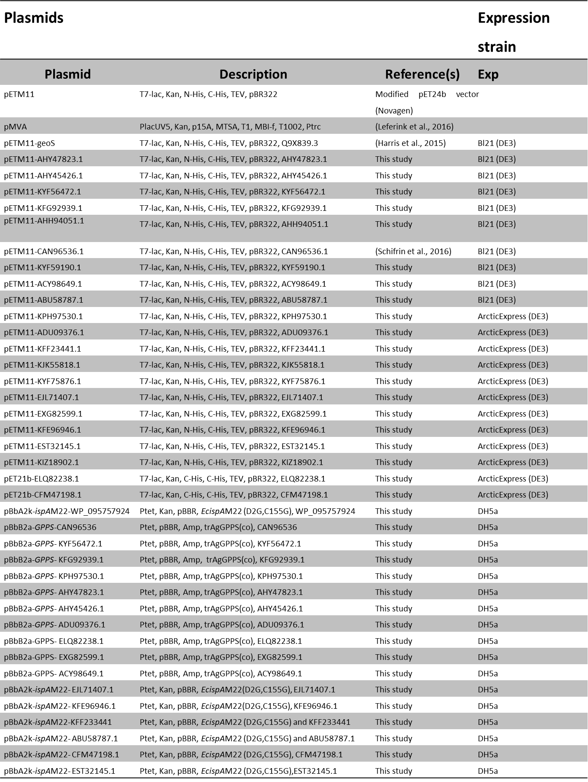

**S3 Table:** Plasmids used in this study