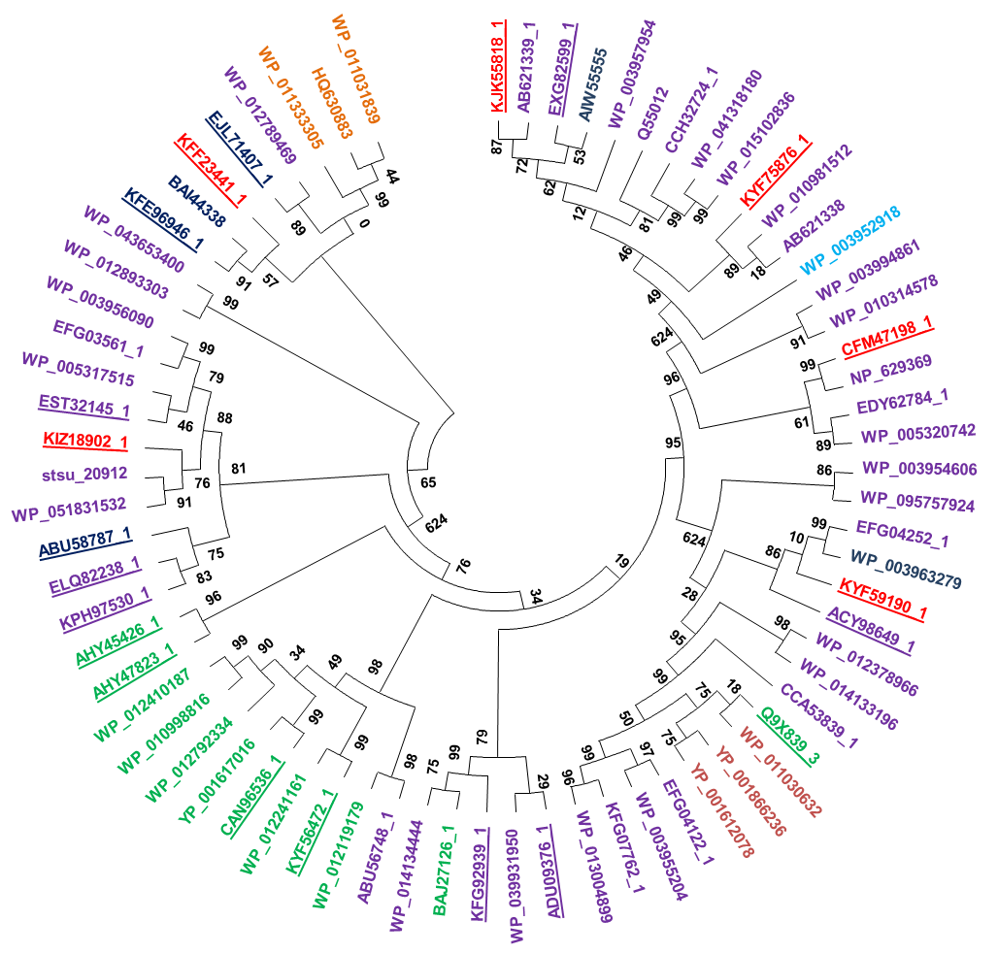

**S1 Fig**: **Bacterial terpene synthases neighbour-joining tree**

Neighbour-joining tree constructed from the amino acid sequences of characterized terpene synthases in this study (underlined) and in previous studies. Geosmin synthases (dark red), 2-methylisoborneol synthases (orange), monoterpene (light blue), diterpene (dark blue) and sesquiterpene synthases (purple) are shown and uncharacterized bacterial terpene synthases in this study (in red).