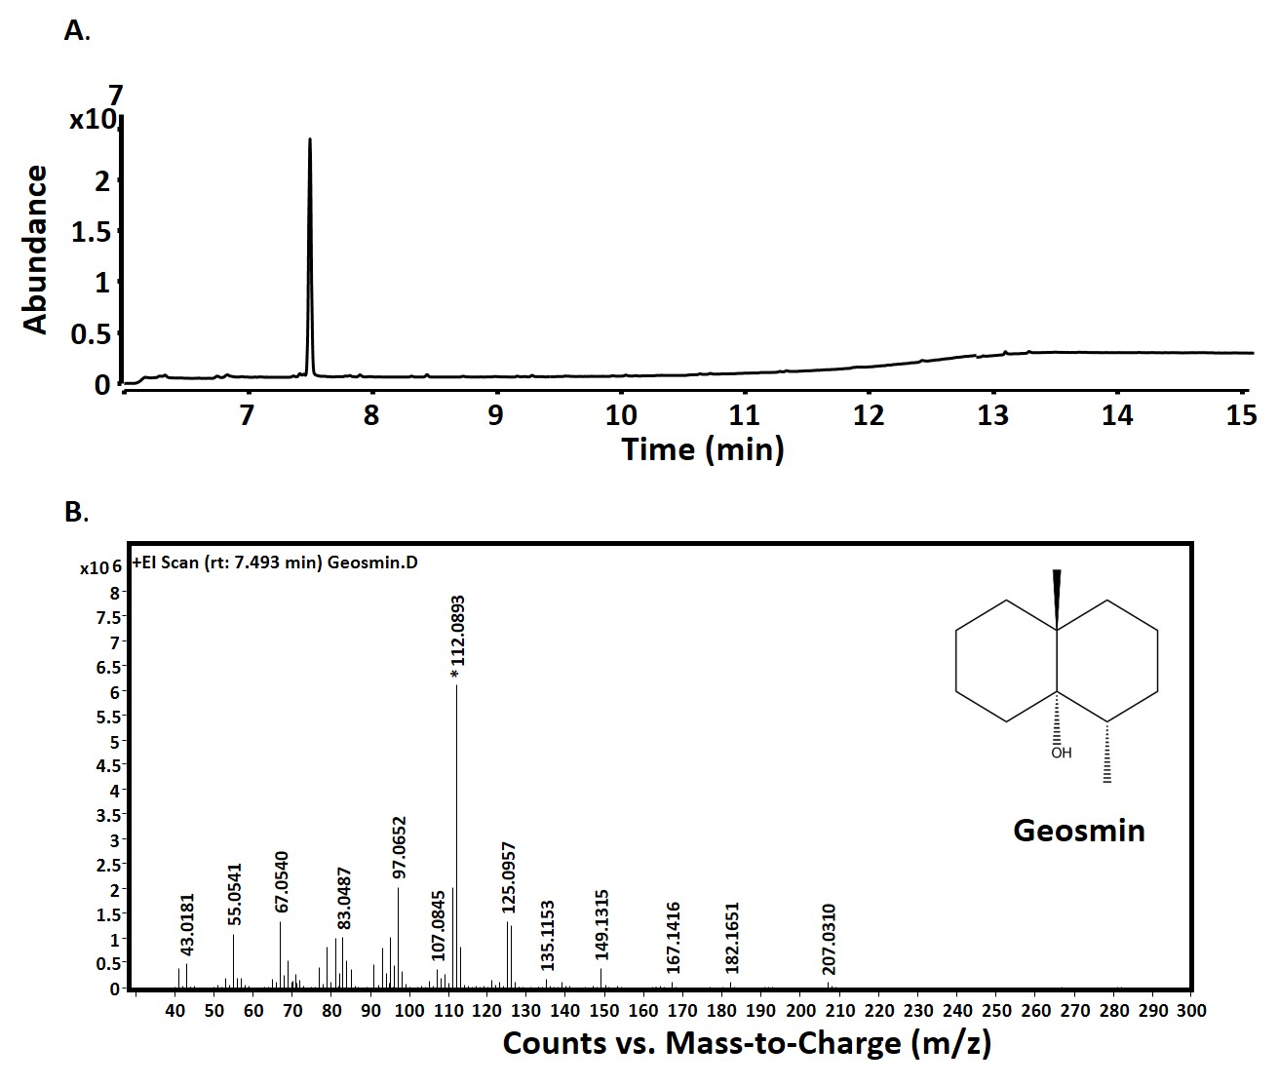

**S2 Fig: GC-MS traces of geosmin standard**.

GC-MS traces showing the separation of geosmin (0.1 mg mL-1) on a HP5 column and its retention time at 7.5 minutes. B. Mass spectra of geosmin.