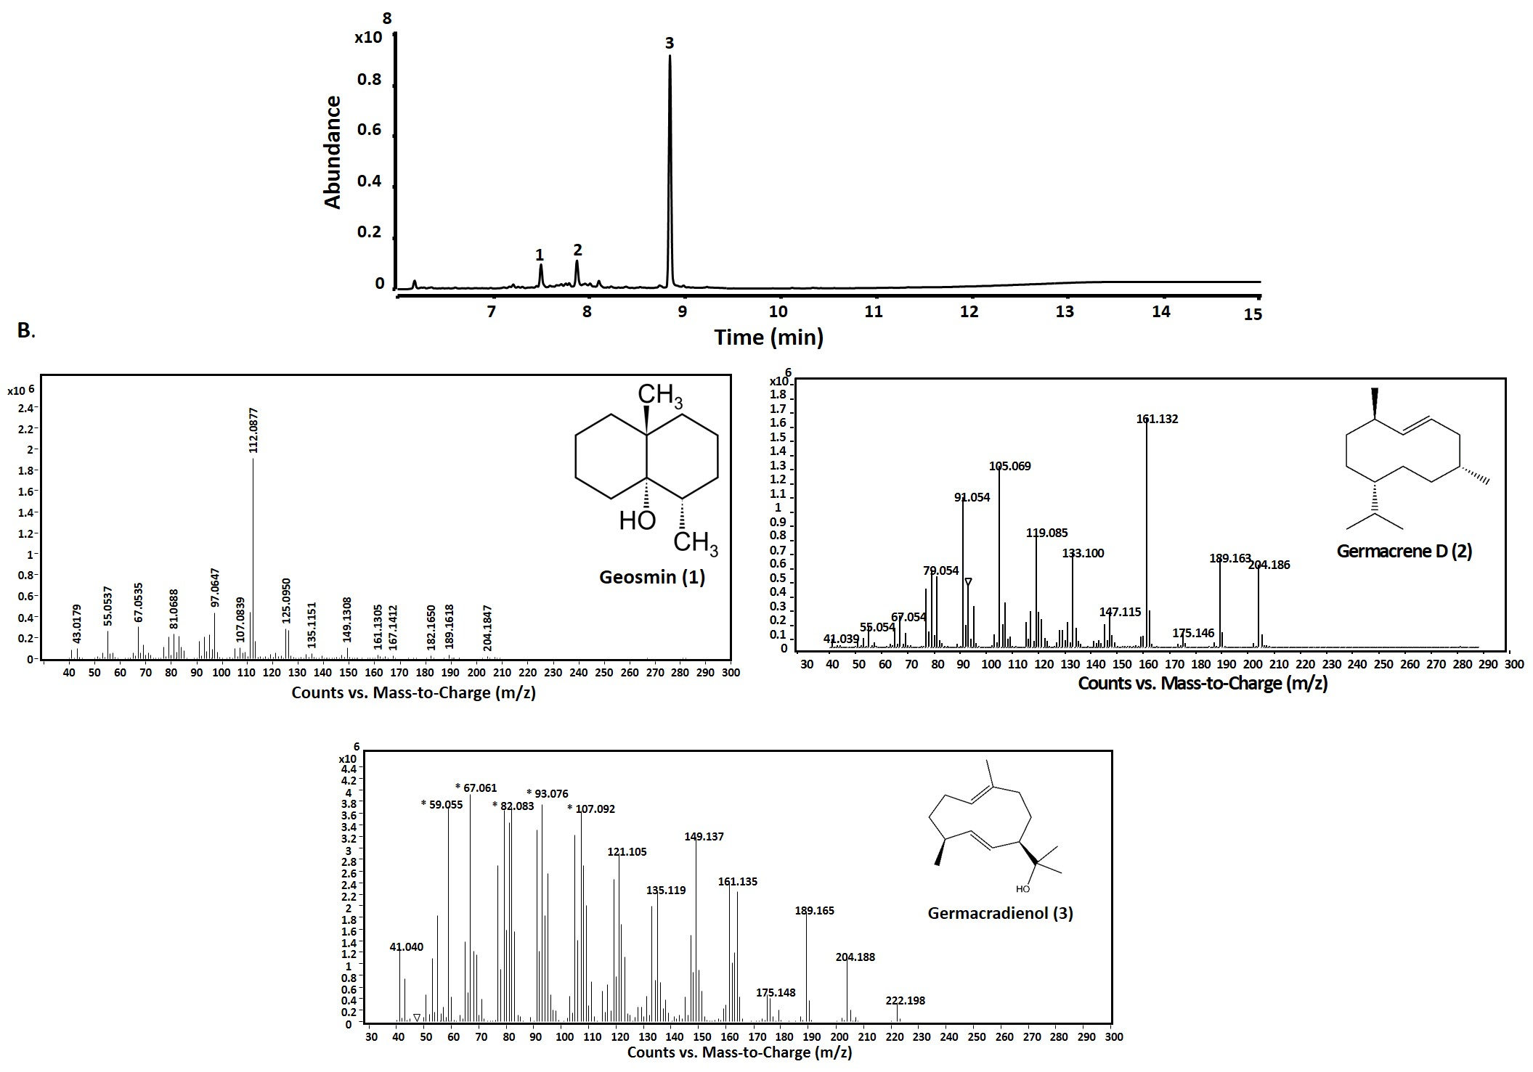

**S3 Fig: GC-QToF analysis of n-hexane extracts obtained from *in vitro* assays**

GC-MS chromatogram of geosmin synthase with 75 µM of FPP. Peak 1: geosmin (rt: 7.5), peak 2: Germacrene D (rt: 7.86), peak 3: germacradienol (rt: 8.84). B. Mass spectra of compounds observed in the extracts.