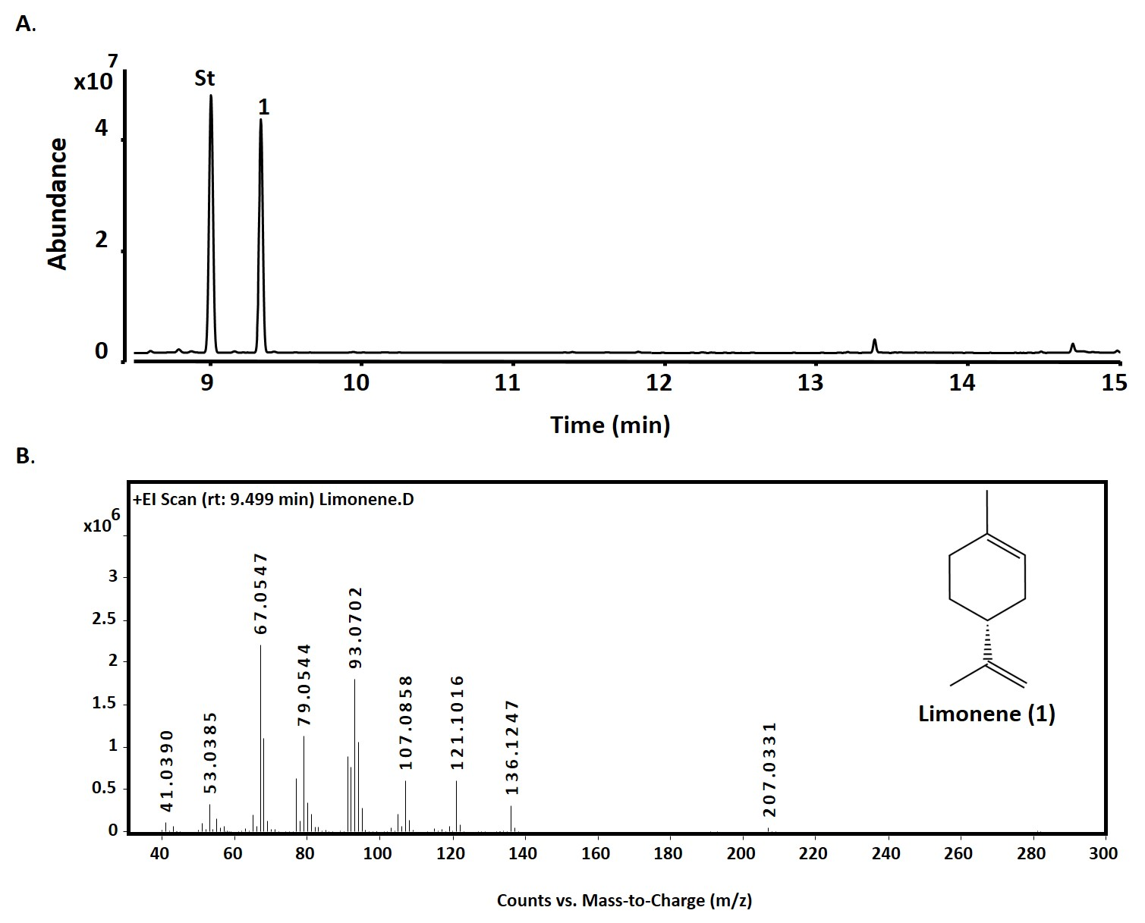

**S4 Fig: GC-QToF analysis of limonene standard**

A. GC-MS traces showing the separation of limonene (0.1 mg mL-1) produced in this study on a HP5 column. The internal standard, sec-butyl benzene (0.1%, v/v), has a retention time of 9.5 minutes. Peak 1: R- Limonene (rt: 9.41). B: Mass spectra of limonene.