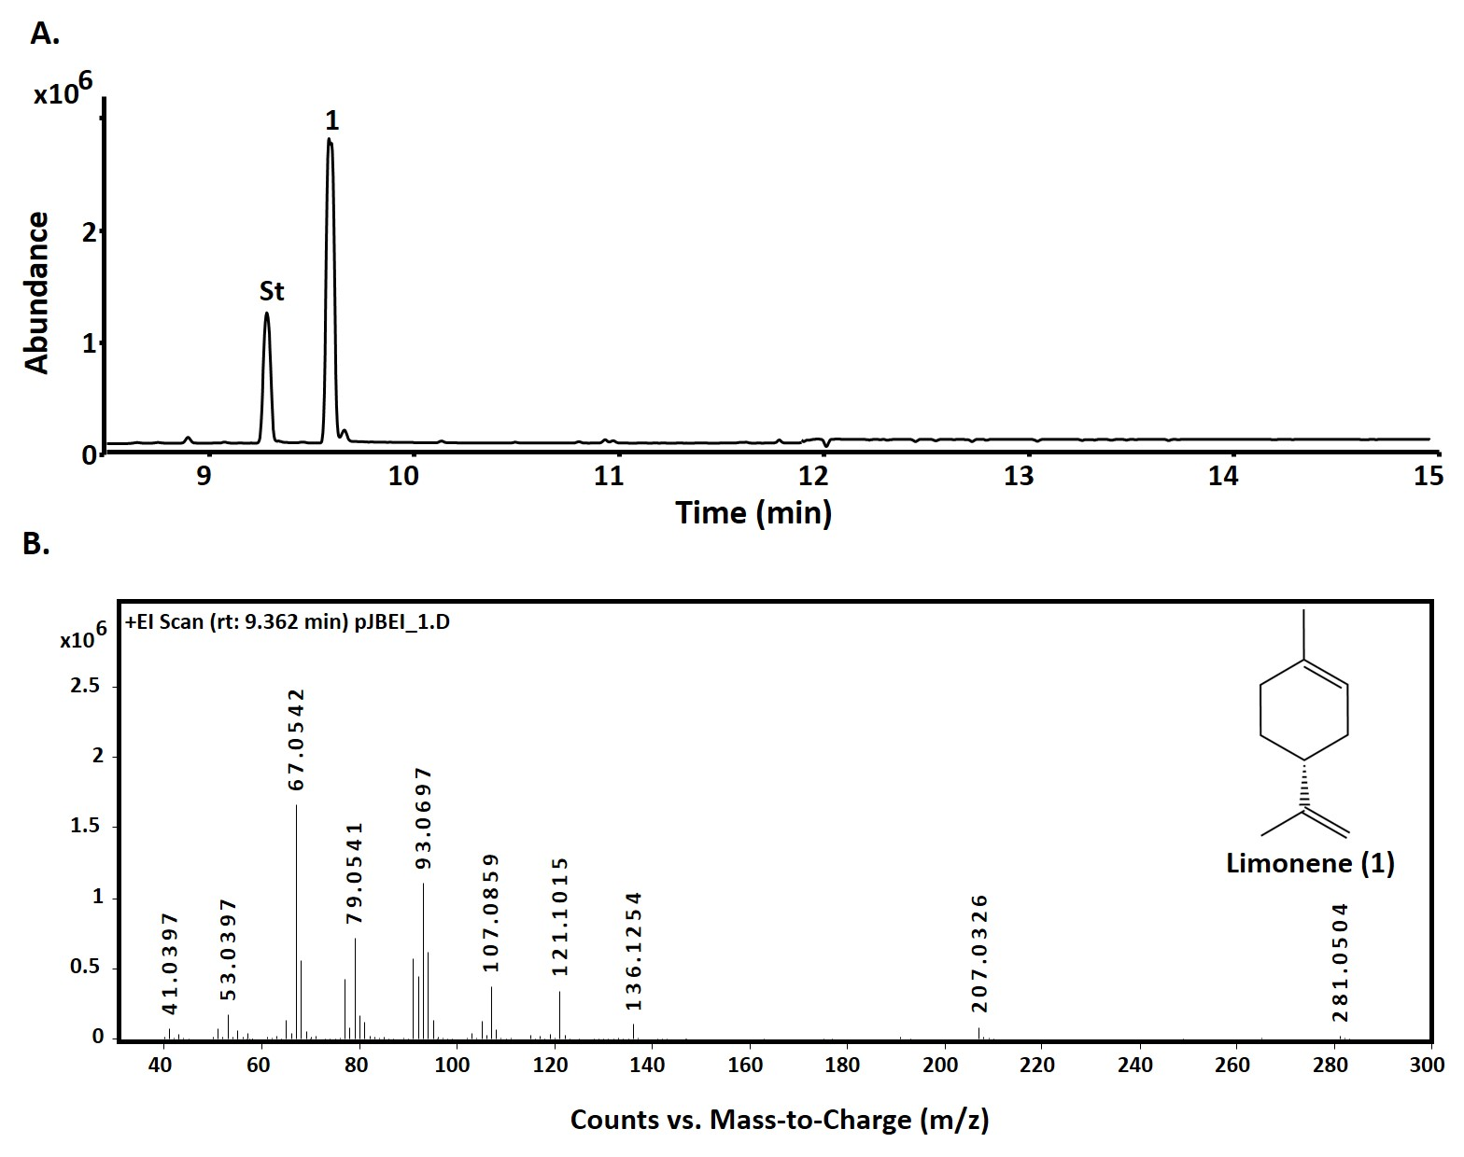

**S5 Fig: GC-QToF analysis of nonane extracts obtained from limonene synthase *in vitro* assays**

**A.** GC chromatogram of 10 µg of limonene synthase (pJBEI-6410) crude extracts with 75 µM of GPP. Peak 1: limonene (rt: 9.41). B. Mass spectra of limonene.