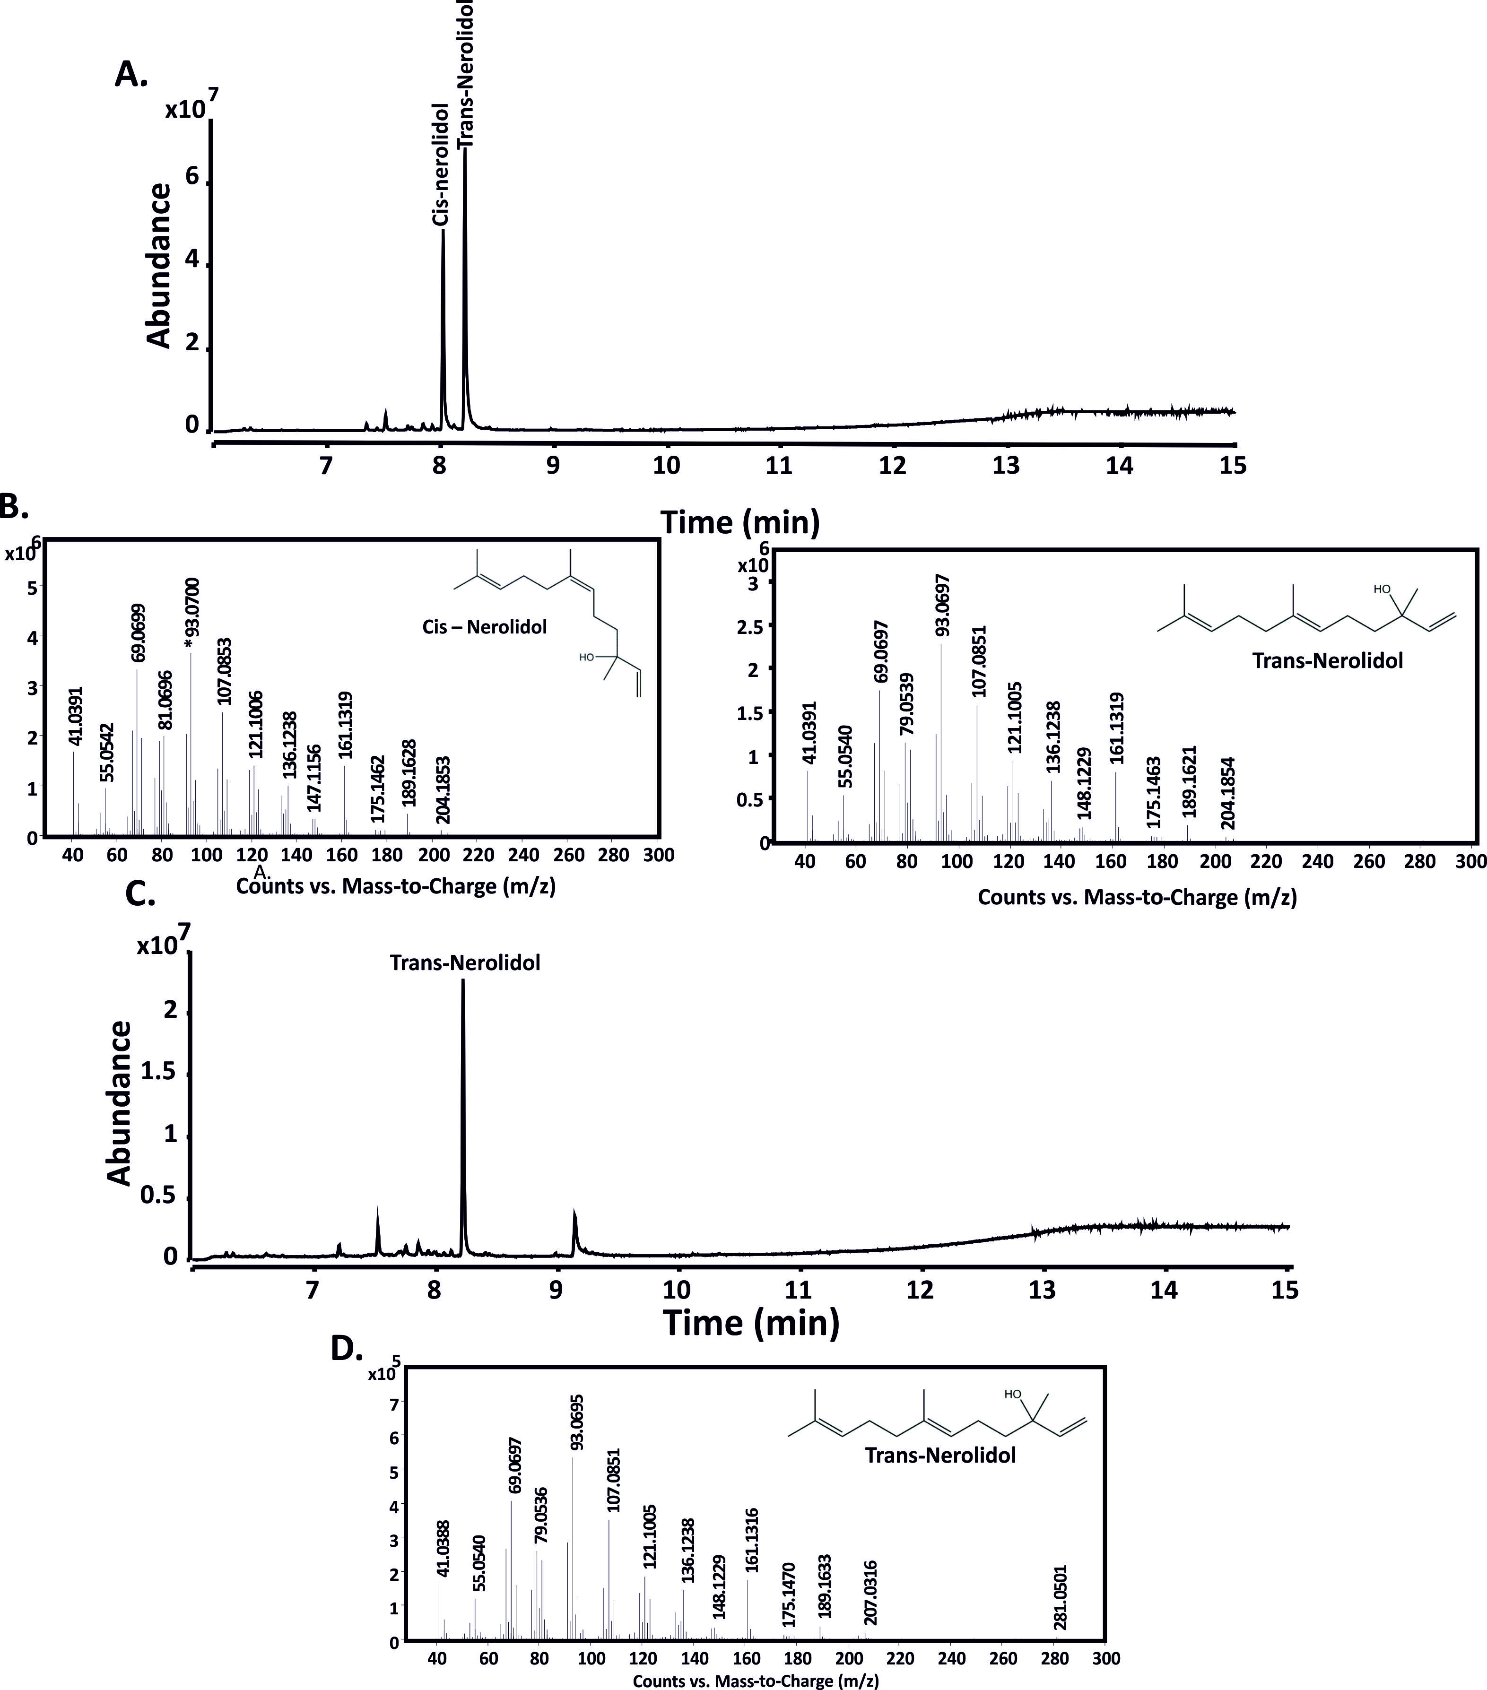

**S6 Fig: GC-QToF analysis of nerolidol standard mix and products obtained by AHY47823 upon incubation with FPP.** **A.** GC-MS traces showing the separation of standard nerolidol mix (0.1 mg mL-1) on a HP5 column. **B.** MS spectra of -cis and -trans Nerolidol. **C**. GC-MS chromatogram of trans-nerolidol produced by AHY47823 with FPP. **D.** Mass spectra for trans-nerolidol produced by AHY47823.