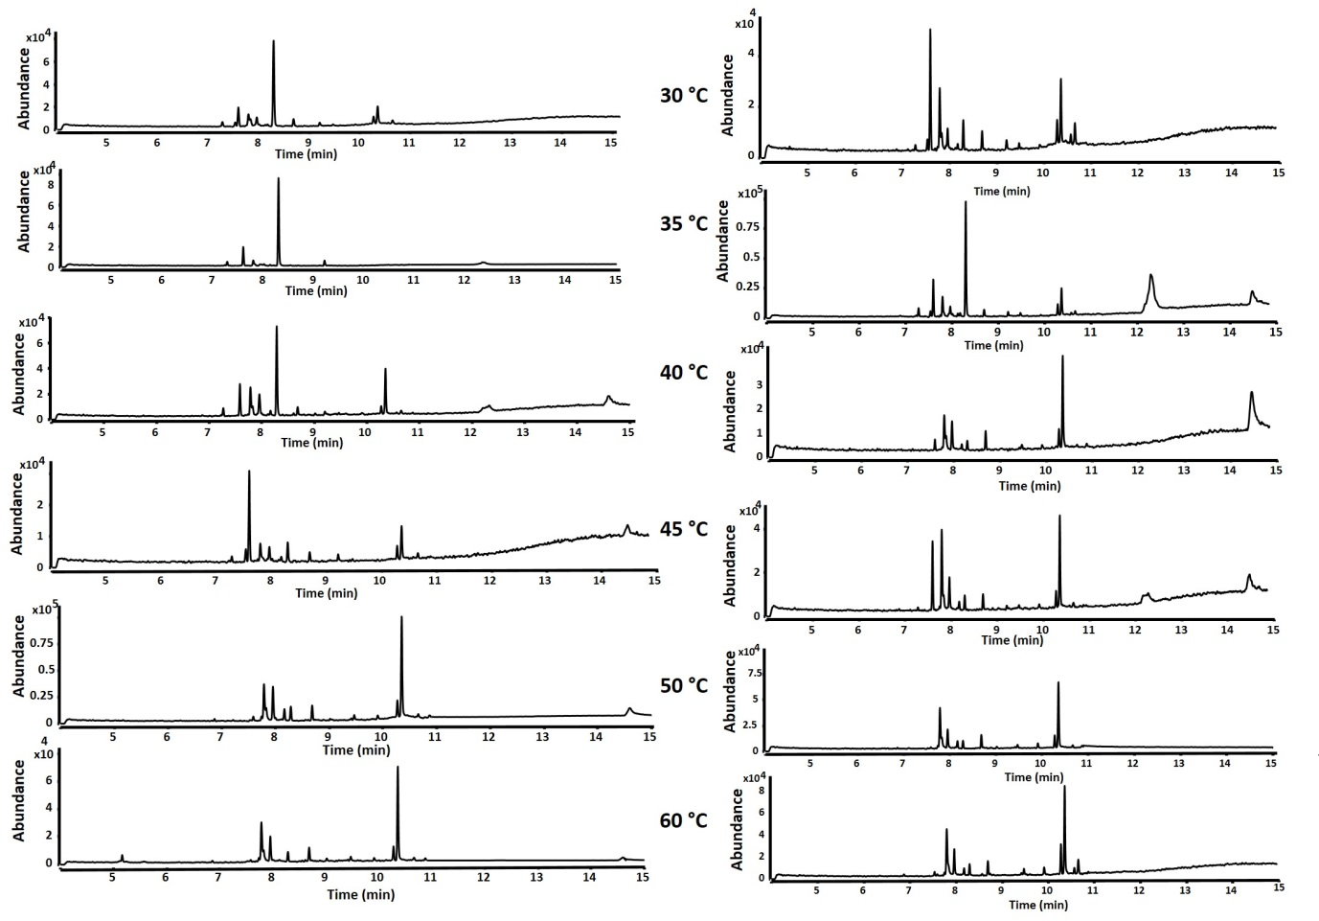

**S9 Fig:** Total ion chromatograms of products obtained from an incubation RrNerS (left) and RrBerS (right) with FPP for 3 hours at variable temperatures. Samples were analyzed by GC-QToF on HP5 column.