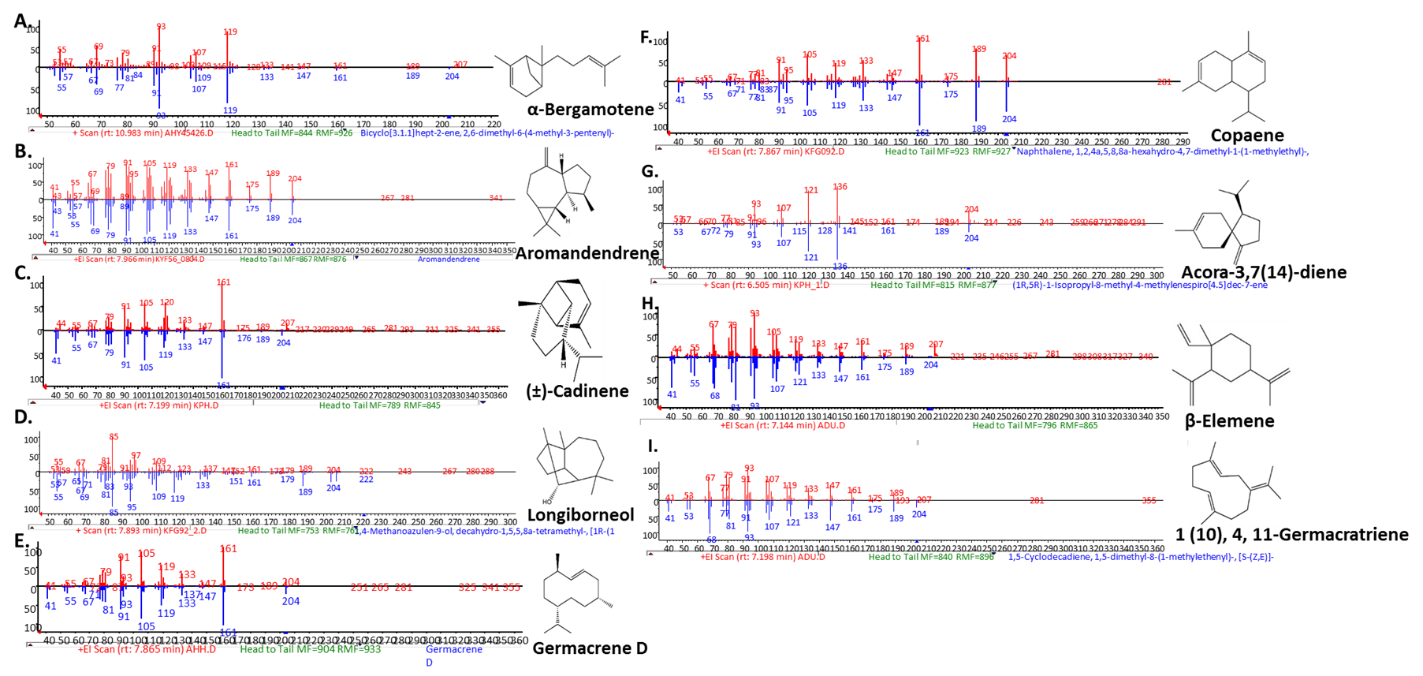

**S10 Fig**: **Comparison of obtained mass spectra with NIST Library spectra.** The reference spectra from the NIST library shown in blue and the compound spectra shown in red.**A.** α – bergamotene produced by RrBerS, **B.** Aromandendrene produced by ScAroS, **C and D**. cadinene and longiborneol produced by BpLonS, **E.** germacrene D produced byKaGerS , **F** and **G.** copaene and acora-3,7(14)–diene produced byAbAcoS , and **H** and **I.** β-elemene and 1(10),4,7(11)-germacra-triene produced by MiGerS.