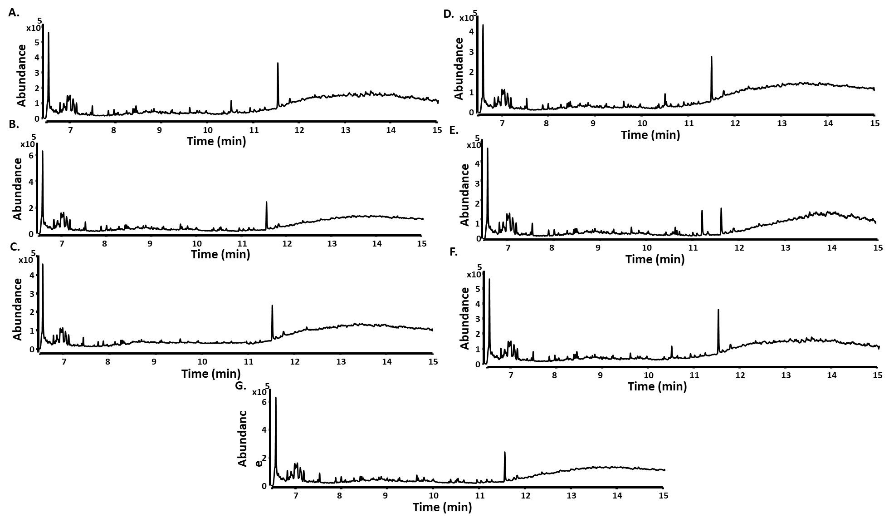

**S12 Fig**: **GC-QToF analysis of n-hexane extracts from *in vitro* assays obtained with selected TSs**.

GC-MS chromatograms of extracts profile with FPP are shown for **A.** BpTPS; **B.** ScTPS1; **C.** CvTPS; **D.** SsTPS; **E.** ScTPS2; **F.** SniTPS; **G**.SnaTPS. The peaks in the chromatogram do not correspond to any terpenoids.