

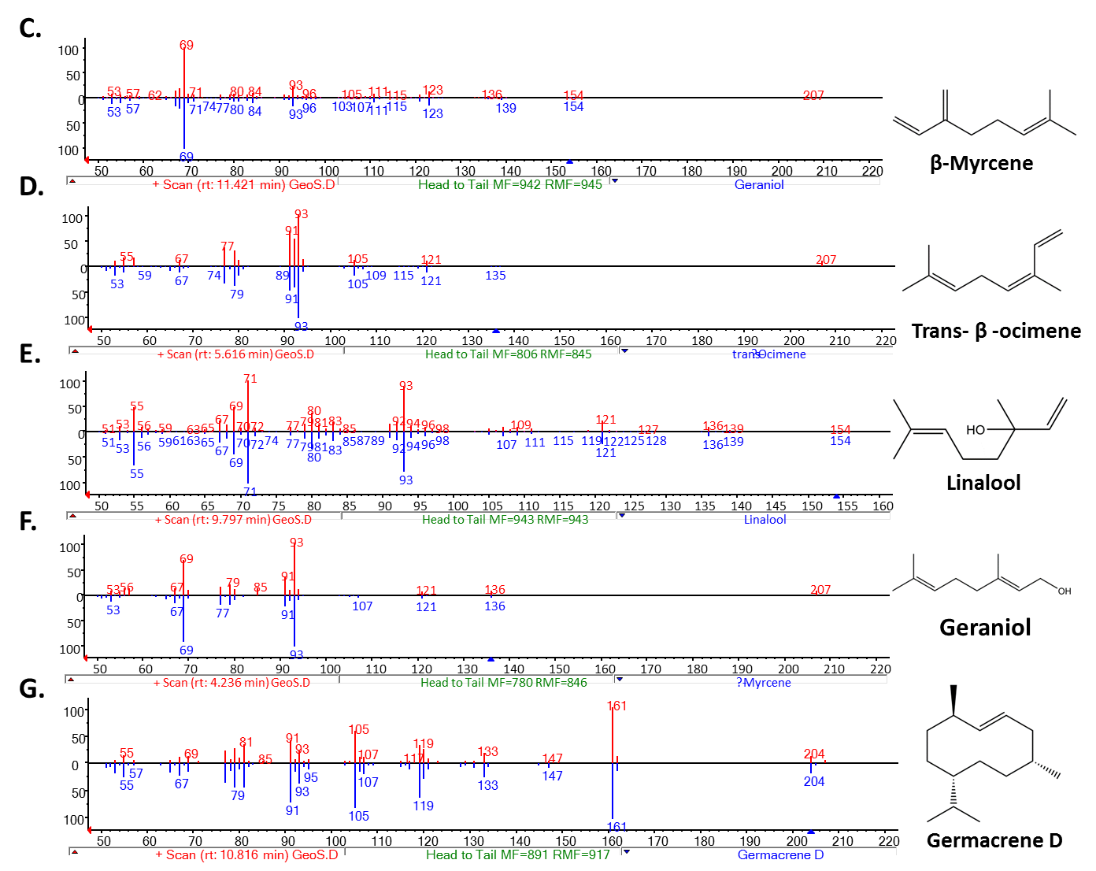

**S13 Fig: Comparison of obtained mass spectra with NIST Library spectra of products yielded by geosmin synthase in *in viv*o conditions**. **A.** GC-MS chromatogram for geosmin synthase products, **B.** mass spectra for Germacradienol, **C - G**. Comparison of obtained mass spectra with NIST Library spectra of products yielded by GeoS.