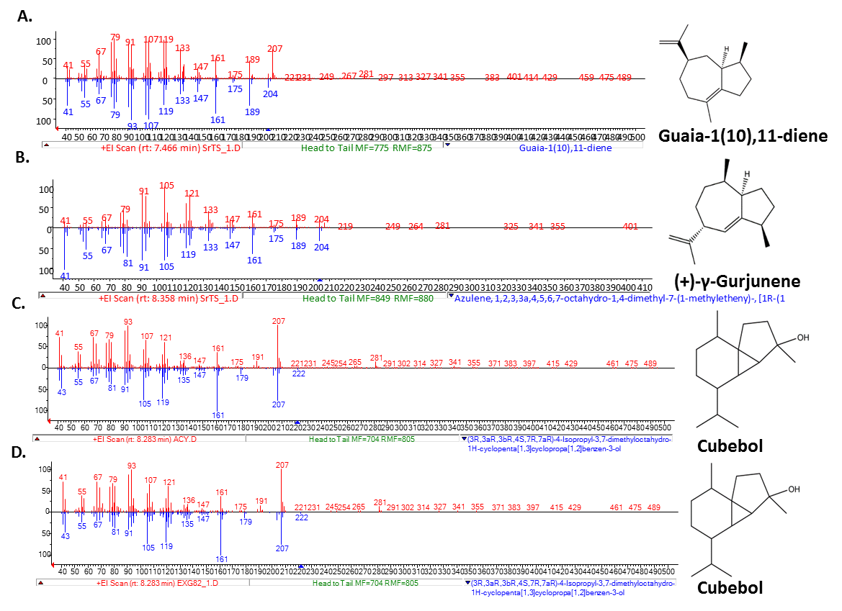

**S14 Fig:** Comparison of obtained mass spectra with NIST Library spectra of products yielded by TSs in *in vivo* conditions. **A – B.** SrGuaS **C.** TcCubS **D.** CaCubS.