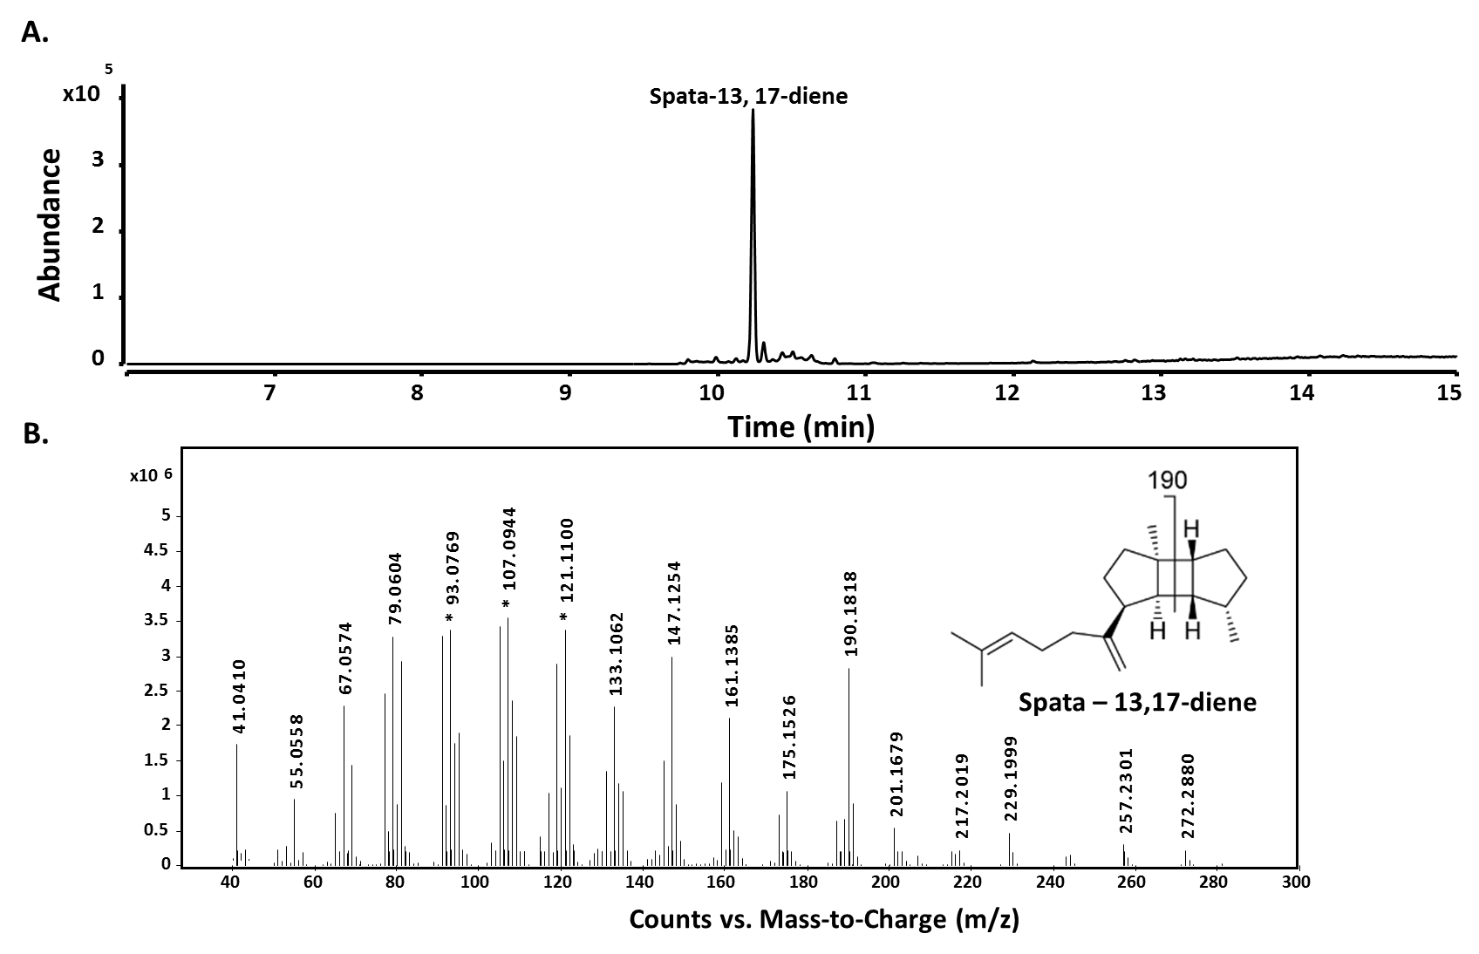

**S15 Fig: GC-QToF analysis of spata-13, 17-diene from nonane extracts of *in vivo* production in *E. coli*. A.** spata-13,17-diene produced by overexpression of ispAM22 and WP_095757924 in *E. coli.* B. Mass spectra of produced spata-13,17-diene.