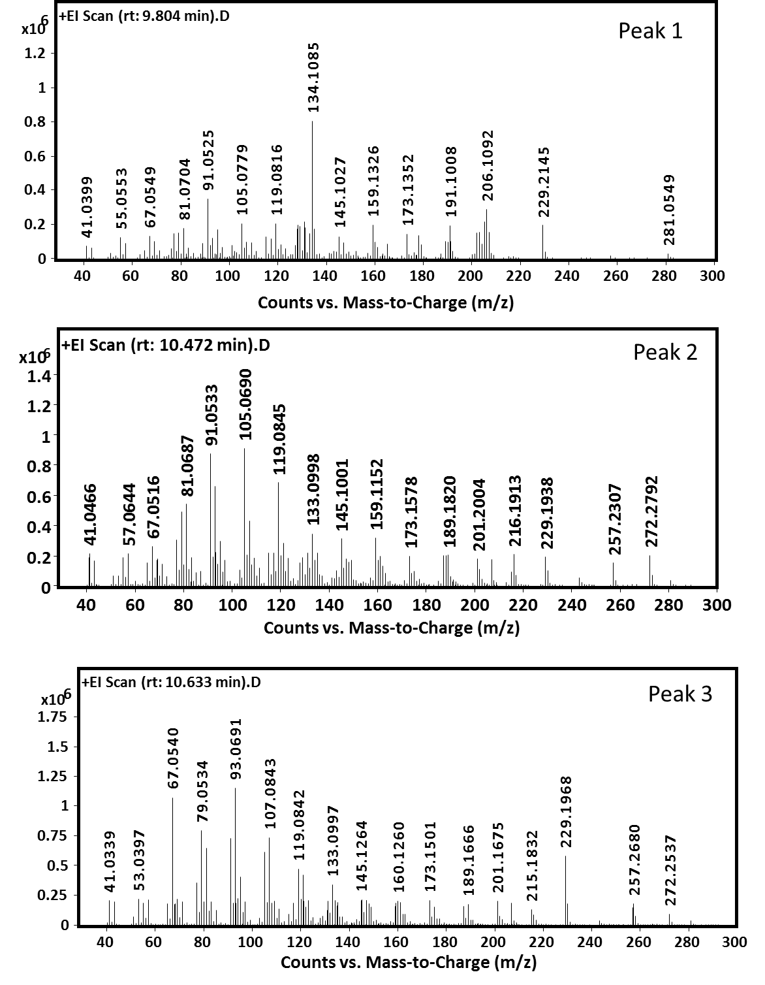

**S16 Fig:** Mass-spectra of diterpenoid compounds produced by RcDTPS from *Roseiflexus castenholzii* DSM 13941corresponding to the peaks annotated in Fig. 5A.