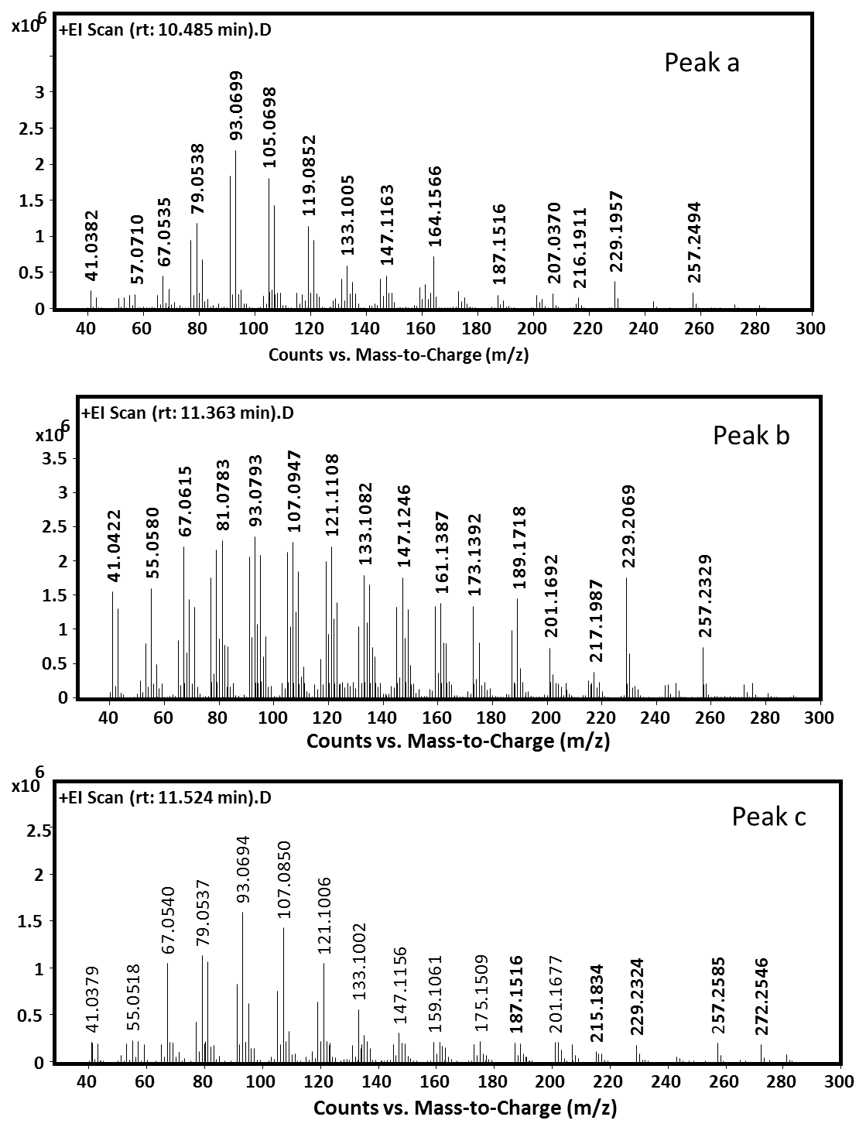

**S17 Fig:** Mass-spectra of diterpenoid compounds produced by CsDTPS from *Chryseobacterium sp.* CF314corresponding to the peaks annotated in Fig. 5B.