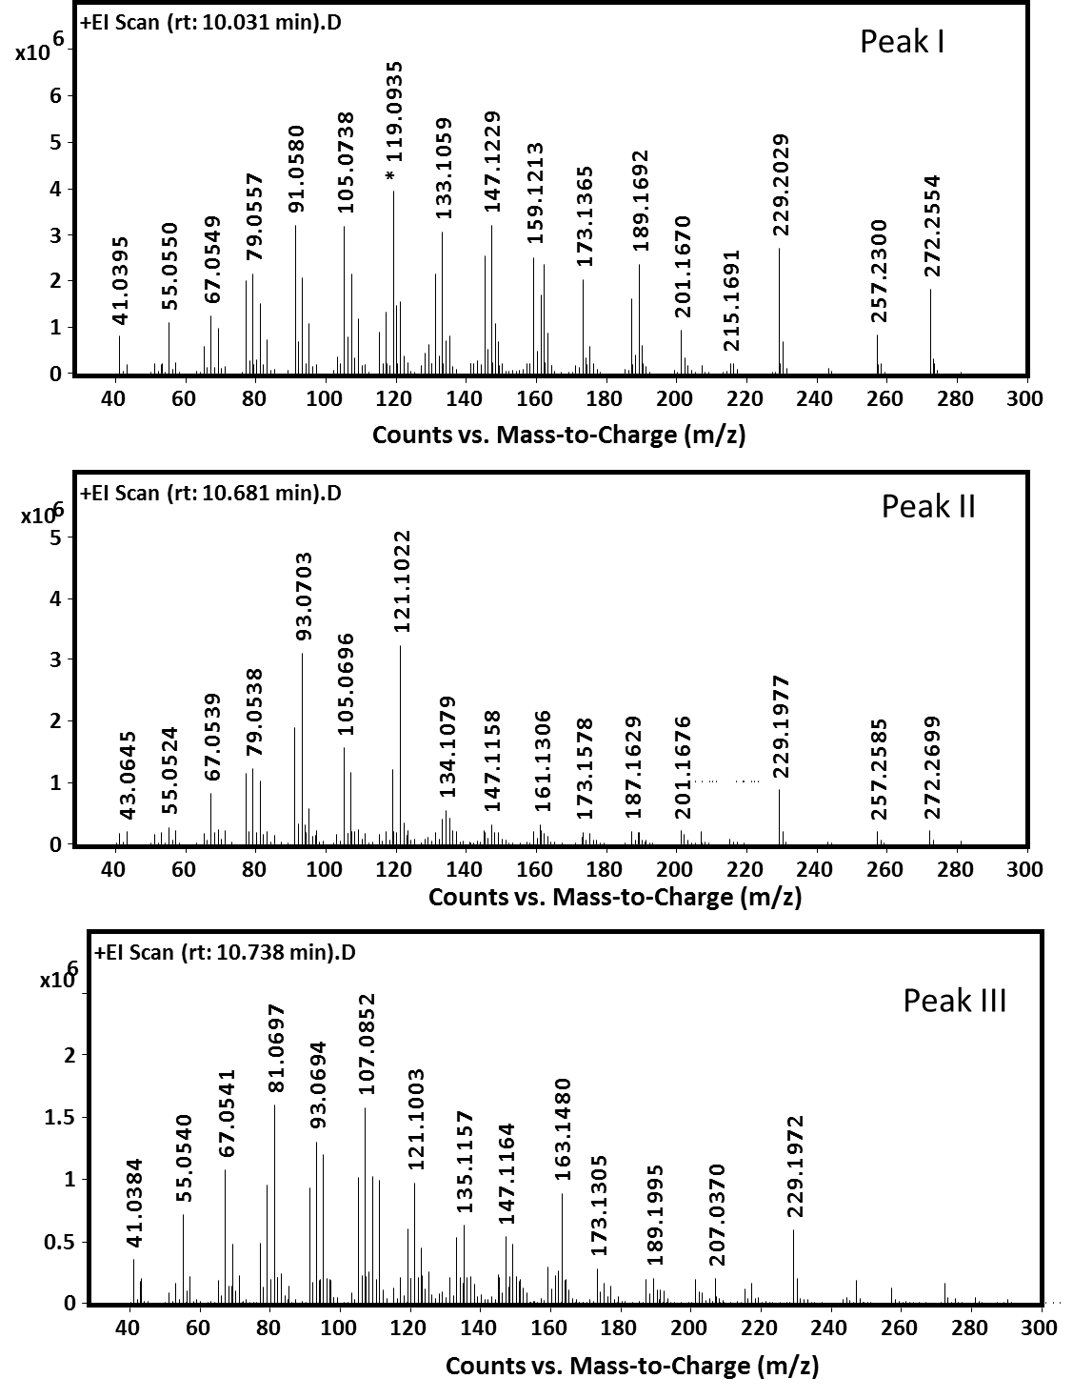

**S18 Fig:** Mass-spectra of compounds diterpenoid produced by ClDTPS corresponding to the peaks annotated in Fig. 5C.