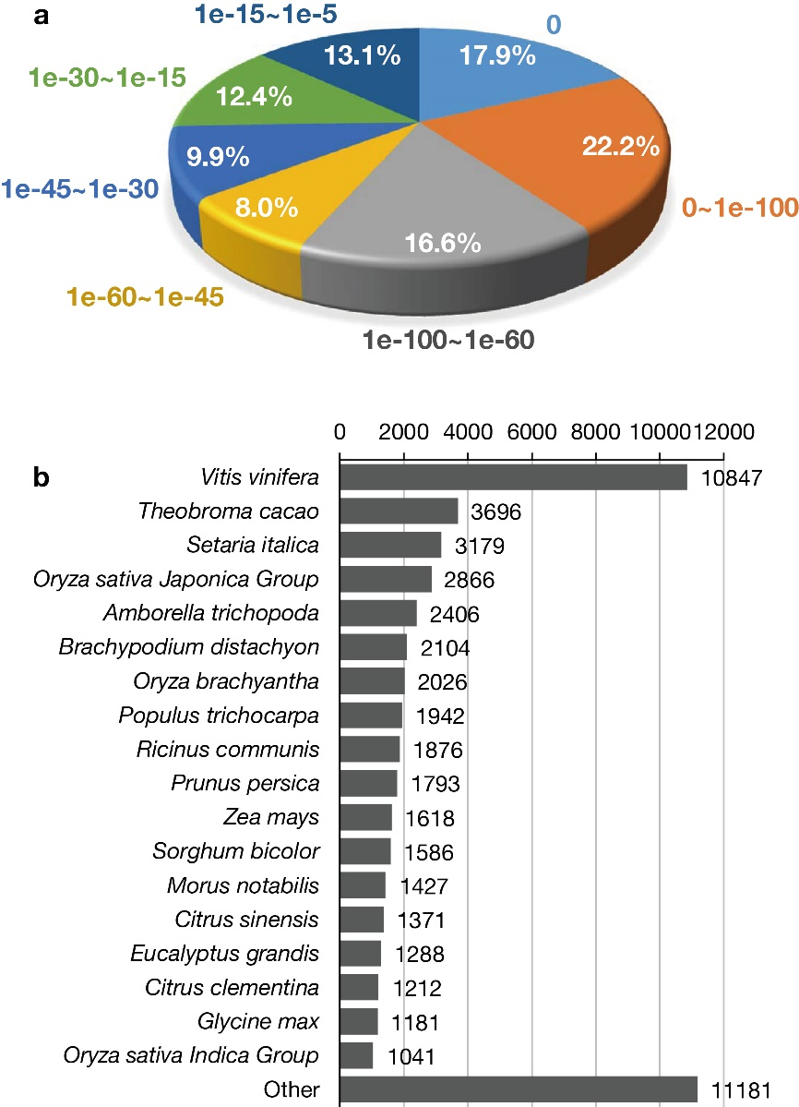**Additional file 2: Figure S2 BLAST result analysis of the *C. goeringii* floral transcriptome against the NR database.** **(a)** The E-value distribution. **(b)** The top 20 species contributing to the annotation results.