Supplementary information for following article

De Novo transcriptome characterization of Rhodomyrtus tomentosa leaves and identification of genes involved in α/β-pinene and β-caryophyllene biosynthesis

Si-Mei He^{1†}, Xiao Wang^{2,5†}, Sheng-Chao Yang¹, Yang Dong³, Qi-Ming Zhao¹, Jian-Li Yang⁴, Kun Cong¹, Jia-Jin Zhang¹, Guang-Hui Zhang¹, Ying Wang^{6*}, Wei Fan^{1*}
¹ State Key Laboratory of Conservation and Utilization of Bio-resources in Yunnan, The Key Laboratory of Medicinal Plant Biology of Yunnan Province, National& Local Joint Engineering Research Center on Germplasm Innovation & Utilization of Chinese Medicinal Materials in Southwest China, Yunnan Agricultural University, Kunming, 650201, China.
² State Key Laboratory of Genetic Resources and Evolution, Kunming Institute of Zoology, Chinese Academy of Sciences, Kunming 650201, China.
³ Province Key Laboratory, Biological Big Data College, Yunnan Agricultural University, Kunming 650201, China.
⁴ State Key Laboratory of Plant Physiology and Biochemistry, College of Life Sciences, Zhejiang University, Hangzhou 310058, China.
⁵ Kunming College of Life Science, University of Chinese Academy of Sciences, Kunming 650204, China.
⁶ Key Laboratory of South China Agricultural Plant Molecular Analysis and Genetic Improvement, South China Botanical Garden, Chinese Academy of Sciences, Guangzhou 510650, China.
†These authors have contributed equally to this work
*Corresponding authors: Ying Wang, Wei Fan
Telephone number: +86-871-65228927
Fax number: +86-871-65227712
E-mail: yingwang@scib.ac.cn, fanwei1128@aliyun.com

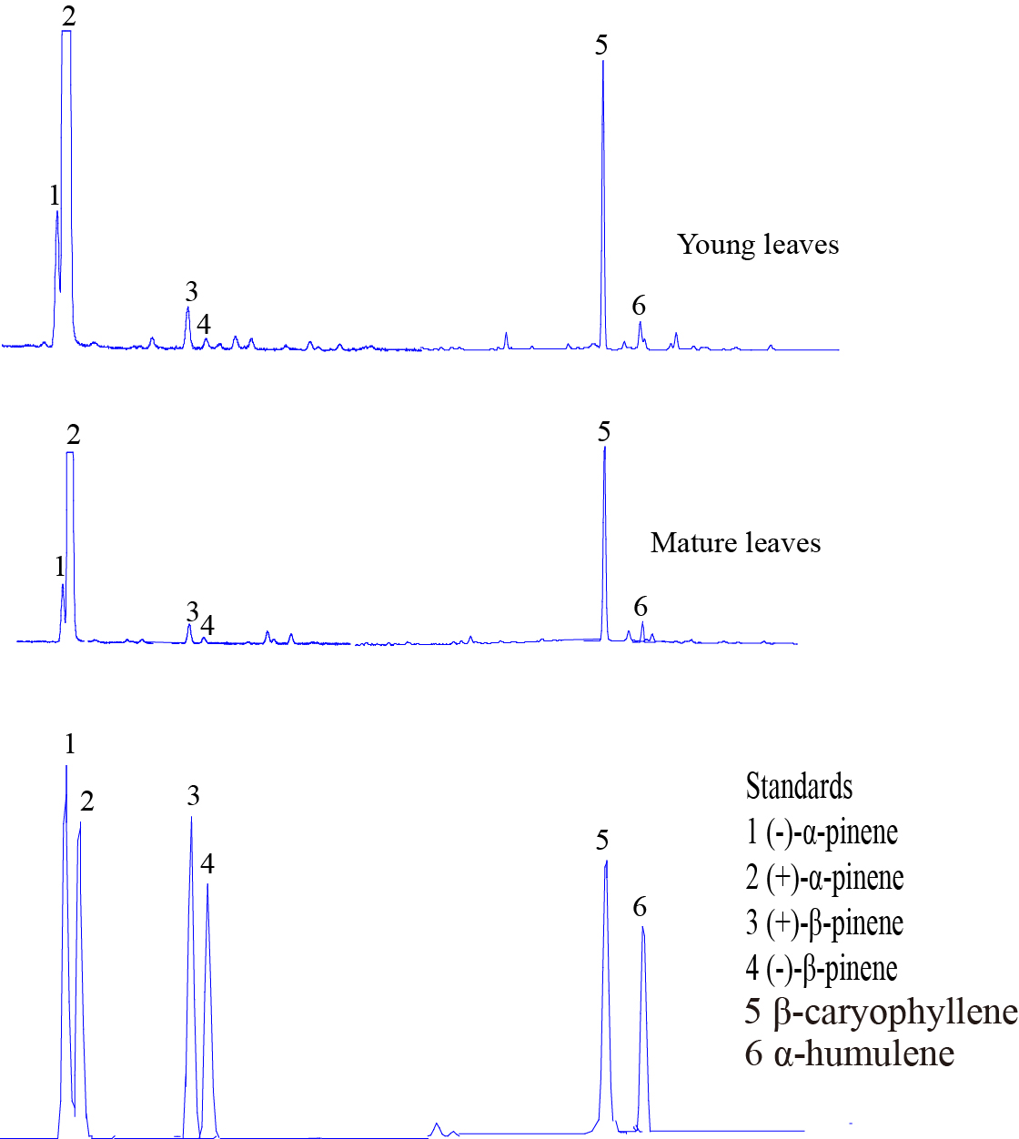
Supplemental Fig. 1. GC−MS and GC-FID results indicating the major terpenoids produced by R. tomentosa. GC−MS and GC-FID analysis of major terpenoids in R. tomentosa young leaves and mature leaves.

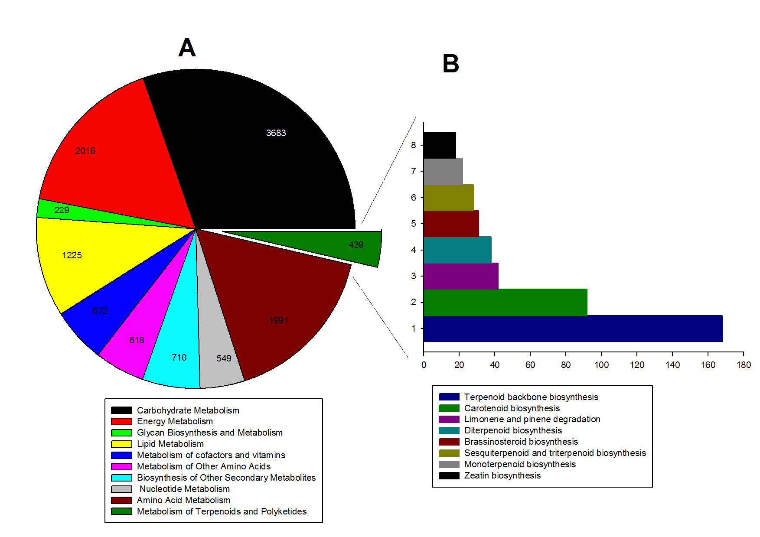
Supplemental Fig. 2. Pathway assignment based on KEGG. (A) Classification based on metabolism categories; (B) classification based on metabolism of terpenoids and polyketides.

